Applied Project
Submission Form


LEARNER NUMBER | 51807203
NAME | Mariel Romaneth Heredia Alban
COURSE | BA in International Business
REPORT TITLE | Social media and AI influence tourists on their planning and decision making about traveling and its effects in the traditional travel agencies
SUPERVISOR NAME | Christina De Muylder
WORD COUNT
DUE DATE | 14/12/2025
DATE SUBMITTED

I certify that:
· This project report is all my own work, and no part of this report has been copied from another source: Yes ☒ No ☐
· I understand that this report may be checked by electronic or other means for plagiarism and/or content created by generative AI and may be transferred and stored in a database for the purposes of data-matching/data-analysis to help detect plagiarism and/or content created by generative AI: Yes ☒ No ☐
· This report has not previously been submitted in part or in full for assessment to any other institution: Yes ☒ No ☐

· I consent to the inclusion of my report in the publicly accessible (open access) electronic database maintained by the library:
Yes ☒ No☐
· I have emailed a back-up copy of this report to locker@independentcollege.ie:
Yes ☒ No ☐

(Note that if no check boxes are selected, this Project will be regarded as NOT properly submitted, and may be subject to a late submission penalty)

Name: Mariel Heredia Alban
Date:

For the report to count as a valid submission, the student must provide:
1 electronic copy via Moodle. There is no requirement for a hard copy .

Evidence of the Primary Research MUST be included in the appendix of the report. That includes a copy of questionnaires, interview schedules, or observation diaries. One interview transcript should be included as a full transcript and a summary of all other interviews must be kept as a backup by the student. See template on Moodle for what should be included in all aspects of the report. All data must be anonymised.

The text should be double-spaced throughout and single column format (A4) with 2cm for left and right-hand margins and 2.5cm at head and foot. Text should be justified, standard 12 point, footnotes 10 point, and in Calibri. Page numbers should be at the bottom-right. Do not use line and paragraph spacing. Keep formatting to a minimum and avoid underlining.

Harvard Referencing shall apply.

Explore how social media and AI influence tourists on their planning and decision making about traveling and its effects in the traditional travel agencies?

Compiled by:

Mariel Romaneth Heredia Alban

This project is submitted in part fulfillment of the Degree of Bachelor of Arts ( Hons) in International Business

Independent College

Dublin, December 2025

Acknowledgements

I want to express my eternal gratitude to my beloved family and friends to always supporting me in every step of my life, I would like to thank all my lectures and academic supervisors that help me to accomplice this project with all their knowledge and patience, and lastly express my gratitude to all the people that participate and contribute with this project.

Abstract

The aims of this project are to analyze and explore the most relevant information to understand the needs and perspective of international students about the use of social media and AI for traveling purposes and use this information to improve my career development.
For this research the principal samples to be contacted are the tourist, as we all know Ireland in this case Dublin currently has a big affluence of tourist and international residents traveling around Europe in their free time and holidays. Travel agencies employees will be the first contact to obtain clear and truthful information about how these tools like AI and social media are being used to promote tourism.
In the present project we are using mix methods, surveys for the tourist and interview for travel agencies employees, to gather as much primary information as possible to develop the themes and be able discuss the finding, according to the answers of the survey and interviews with the secondary research that we find relevant to the themes in the literature review.

Table Content
Acknowledgements 4
Abstract 5
CHAPTER 1 8
Introduction 8
1.1. Background 8
1.2. Research Purpose 8
1.3. Themes, Sub Questions and Objective 9
1.4. Chapter Overview 9
CHAPTER 2 11
Literature Review 11
2.1. Introduction 11
2.2. Social Media 11
2.2.1. Definition 11
2.2.2.Social media platforms 12
2.2.3.Benefits of the use of social media 12
2.3. Artificial Intelligence (AI) 13
2.3.1.Definition 13
2.3.2. Importance, Benefits and limitations of AI 14
2.3.3.The use of AI for traveling purpose 14
2.4.Traditional travel agencies 15
2.4.1.Interaction with social media and AI 15
2.4.2.Advantages and disadvantages 15
2.4.3.Challenges and Opportunities 16
2.5. Influence of social media and AI in tourists about traveling decision making 17
2.5.1.Tourist benefits about decision making using AI and social media 17
2.5.2.Security and Limitations 18
CHAPTER 3 19
Methodology 19
3.1. Introduction 19
3.2. Theoretical Paradigm 19
3.3. Research Method 19
3.4. Research Sample 20
3.5. Data Analysis 21
3.6. Ethical Forms 21
CHAPTER 4 22
Findings and Discussion 22
4.1. Introduction 22
4.2. Theme 1: Social Media Use and Influence 22
4.3. Theme 2: Artificial Intelligence influence and use 24
4.4. Theme 3: Traditional Travel Agencies 26
4.5. Theme 4: Influence of Social Media and AI in tourist about travelling decision making 28
CHAPTER 5 31
Conclusion and Recommendation 31
5.1. Introduction 31
5.2. Limitation 31
5.3. Conclusion 31
5.4. Recommendations 32
Appendix 1: Ethical Form A 33
Appendix 2: Informed Consent Form 38
Appendix 3: Survey Questionary 40
Appendix 4: Survey Results 43
Appendix 5: Interview Questionary 47
Appendix 6: Interview Transcription 47
Appendix 7: Literature Review Table 49
Appendix 8: Methodology Table 51
Reference 52

CHAPTER 1

Introduction

1.1. Background
The constant innovation of social media and AI around the world causes companies and all types of businesses to improve and adapt their service and products to satisfy the need and preference of the customers in the digital market.
The tourism industry has become more open to new technology and adapting its services to the digital era of marketing, using social media to attract more customers and promote travel destinations, activities with influencers collaboration, trend, etc. and using AI to improve the customers service, support and also to bring a more efficient service.
On the other hand, tourists are becoming more independent in terms of planning trips with the use of social media platforms to obtain information from other tourist’s experience sharing vlogs, images, videos, and obtain a real point of view of the travel destination and using AI for booking flights and creating a suitable itinerary.
In this research we will be able to explore, learn and understand the importance and impact of social media and AI in the tourism industry, especially focusing on travel agencies and tourists, investigating the main advantages, disadvantages, opportunities and limitations about these tools.

1.2. Research Purpose
The innovation and opportunities that Social Media and AI developing the independence of the tourists in travel planning, and these changes impact the functions of the traditional travel agencies, the purpose of this project is to explore, analyze and understand how Social Media and AI influence on tourists planning and decision making about traveling and its effect in travel agencies.

1.3. Themes, Sub Questions and Objective
Theme 1: Social Media Use and Influence
Sub - Question: How social media influences tourist decision making?
Objectives: Identify the platforms tourists use for traveling purposes and its influence.

Theme 2: AI Influence and Use
Sub - Question: How has the use of AI changed the independence and decision making in tourism?
Objectives: Identify the use tourists do with AI in traveling planning.

Theme 3:Traditional Travel Agencies
Sub - Question: How travel agencies interact with Social Media and AI?
Objectives: Find ways to adapt Social Media and AI into the Travel Agencies working area.

Theme 4: Influence of social media and AI in tourists about traveling decision making
Sub - Question: What benefits, limitations and advantages has the tourist using Social Media and AI for traveling purposes?
Objectives: Find the ways that AI and social media can help tourists in the decision making in traveling planning.

1.4. Chapter Overview
Chapter 1 Introduction.- Background, research purpose, themes, sub questions and objective overview.
Chapter 2 Literature Review.- The collection of secondary research of existing information to have a clear and solid definition of every theme for the correct development of the study project.
Chapter 3 Methodology.- Method explanation about primary research and Data collection analysis and interpretation approach.
Chapter 4 Findings and Discussion.- Analysis and comparison of secondary research and primary research that help to find the answers for the questions of every theme and the main research question of the project.
Chapter 5 Conclusion.- Provide information about limitations, recommendations according to the findings of the project.

CHAPTER 2

Literature Review

2.1. Introduction

This chapter is about the gathering of existing information to understand the multiple themes and sub themes of this project and have clear definition and analysis from the literature review. This theoretical research information is based on looking for and finding a definition of each theme according to the knowledge and point of view from different authors.

Main findings are based on the data and information about the use of Social Media and Artificial Intelligence that tourists do in travel planning and how these tools impact the traditional Travel Agencies and in order to answer this question it is necessary to have a deep understanding of the terms and defined what are this tool?Why are they important? and How it works?.

The analysis of the secondary research finding will help with the correct development and structure of the project giving a deeper understanding of the theoretical cited authors provided.

2.2. Social Media

2.2.1. Definition
The rapid development and growth of technology over the year had impact into the communication ways looking for a fast and easy accessibility to everyone, in the past people were only able to make or receive a phone call in a specific places this could be their home office or public phone service until the mobile phone came on the market on make the communication more independent in the way that you could be anywhere in the city and be able to make and receive phone calls as long as you have enough signal.
Nowadays the evolution of the mobile phones and making them smart with more accessibility of the internet and the creation of applications that make people's lives easier in terms of communication and information, all these innovations in communication devices start a new way to create relationships, communities and express themselves known as social media.
Social media is considering a powerful wild range network where people interact online with each other all around the world, people is able to share photos, videos and thoughts and any kind of information and also see other people content, the creation of communities according to their believes, life style, interest and point of view are the same or similar to the other group of people.

2.2.2.Social media platforms
Along with the years social media platforms have been developed and innovating in the way people communicate, share and create content online in different platforms, in order to mention some of the most popular the platforms or apps are the next:
Facebook: Based on sharing thoughts, images, short video, memes, and the creation of community groups according to the interest and need of people like accommodation, sales and much more.
Instagram: Focus on sharing stories with images and videos (reels) in a very stylish way. This app is apparently more aesthetic in terms of uploading content about food, outfits, trends, etc as images or videos.
Tik Tok: Based in the creation of video content about trends that involves music and dances, challenges, storytelling, etc.
X: Short text updated about any topic or point of view.
YouTube: Video sharing platform, this video can be long or short depending about the topic and audience, from personal to professional vlogs.

2.2.3.Benefits of the use of social media
There are many areas that can be benefited by the use of social media, to mention the most important benefits could be the following:
Communication and connectivity
Social media can be used anywhere at any time, where an internet connection is available (Library of Parliament 2010), this means that people can still be in contact with their family, friends, work and communities and also create new relationships all around the world across long distances.

Information and awareness
The access to real time news that happens all over the world, be tuned to the most recent trends and global events, also let people be aware about the environmental issues, social and political events, social media provide webinars, tutorial, academic groups for educational purposes.
Business and marketing
The use of social media networks to brand growth, direct engagement with the customers, promotion, selling and advertising of product and services in order to increase customer base and trust and get quick updated feedback.

2.3. Artificial Intelligence (AI)

2.3.1.Definition
Refers to the simulation of human intelligence in machines that are designed to perform tasks typically requiring human cognitive functions (Time.com, Business source Premier, 2025). Computer science and cognitive science focused on the development of machines and systems capable of simulating and simulating tasks that involve specific aspects of human intelligence (Ionita, Leovaridis, Popescu, 2025). AI is the replication of human or animal intelligence in computing systems, with the goal of programming them to think like intelligent beings and copy their activities. (Pothen, 2021).
Artificial Intelligence is considered as a new tool that can be used in order to get more quick and efficient results in searching information about any topic and can be used in almost every professional area like health, finance, education, software development, customer service, entertainment, manufacturing and production etc.

2.3.2. Importance, Benefits and limitations of AI
Nowadays AI has become an important tool in almost every industry. Because of the growth and the innovation of technology, AI provides innovative and sophisticated solutions to challenges or issues across different industries, this means that AI is capable of learning, understanding, solving and adapting to new information and tasks.
Benefits of AI
Some of the benefits of AI are the following:
Complete tasks in a short time.
Reduces faults and mistakes.
Better decision making according to data analysis.
Increase productivity and reduce maintenance costs in the industry.
Data analysis and optimize information.
Provides fast and accurate information to solve important issues or decision making.
Recognition of speech, images, language translation,
Limitations of AI
High cost many small businesses can’t afford the cost of integrate AI into its operations.
Jobs can use AI to replace some areas where human force will be no longer necessary and this will cause an unemployment increase.
The vulnerability of privacy and security about personal or sensitive information.

2.3.3.The use of AI for traveling purpose
The tourism and hospitality sectors can remain a competitive, improve customer satisfaction and drive growth in the coming years by embracing AI and investing in the development of new technology (Štilić, Puška, and Nicić, 2024), for the tourism industry and for the tourists the use of AI has become a very useful tool from trip planning to customer service support and or this main reason tourism industry feel the need to improve their services according to the technological advances.
The use of AI for traveling purposes is to obtain information and options at the moment of the decision making of the travellers, this type of information can have content about accommodation, tourist spots, restaurant, flights, transportation and much more, but at the same time can give to the traveller more options about similar destinations.

2.4.Traditional travel agencies

2.4.1.Interaction with social media and AI
The role of travel agencies is to help tourists to plan and organize their trip and ensure an enjoyable experience during the booking of tickets, hotels and arranging activities and tours. Travel agencies to stay competitive today the are adapting their services by using AI and social media to connect and interact with the customers, social media became a virtual word of mouth where the customer share their experience with a product or service to other customers and this sharing of information cause a big difference in the decision making of the customer at the moment to buy any service or product, using social media as a communication tools to promote their services in different platforms like Facebook, Instagram, Tik Tok, etc, to keep track of customer preference and behaviour so in this way travel agencies can build a stronger relationship with its customer.
The use of AI in the services of the travel agencies has become more common nowadays, because they can offer a personalized online service to their customers with 24/7 support like virtual assistance, smart itinerary options, smart booking systems, providing recommendation of destinations, activities according to the customer needs improving travel efficiency.

2.4.2.Advantages and disadvantages
Some of the advantages of the use of social media and AI in travel agencies are the following:
Personalized marketing, advertisement in social media platforms with influencers collaboration, trends and customers travel experiences is the best way to retain and attract more customers.
24/7 customer support, with the use of AI the continuous support to customers will create trust and loyalty.
Efficient booking and recommendation, AI can help with instant information and recommendations about travel destinations, prices, flights, accommodation, activities, etc.
Brand growth monitoring, with the data of the previous customers and the activity of social media AI can track the acceptance of the agencies and bring more opportunities and strategies to the online market.
Disadvantages
Security is an issue for both internet buyers and browsers, when making an online purchase customers are especially concerned about credit card security (Portelli, 2024).
The increase of the use of AI in the functions of the travel agencies could cause a reduction in the need of human travel agents reducing the jobs opportunities in this area.
Dependence on AI and social media tools may cause vulnerability to system failures or breakdowns and create errors in customer services and purchases.

2.4.3.Challenges and Opportunities
Due the growth and use of AI and social media, travel agencies are facing are the following:
Challenges:
Adapting to the technological changes and innovation, travel agencies must keep track and learn how to adapt and adjust their functions with new technologies.
Maintaining human touch, the use of AI tools for customer service can be helpful most of the time, but customers tend to appreciate an empathy for human customer service.
Data information security, travel agencies handle personal and payments information and with the use of social media and AI this information can be vulnerable to cyberhackers.
Keeping the visibility of the brand in social media platforms can be a challenge because there is a big amount of advertisement of other products and services that can reduce the brand awareness.
Opportunities
Digital marketing is the new way to attract customers to use travel agencies services and social media platforms are the main point to promote services, using influencers, trends and creating content are important to be visible in the digital market.
Personalized travel recommendation, suggesting travel destination, transportation, hotels, restaurants, activities according to the needs and preference of the customer.
The use of AI and social media to offer visual previews of travel destinations are changing how travellers choose and plan their trips.
Customer interaction and support are being managed in a digital way which can be helpful to have a fast response to customers questions and issues 24/7, and also the use of AI help with the tasks like booking itinerary planning increasing efficiency.

2.5. Influence of social media and AI in tourists about traveling decision making
Today tourists are able to be more independent in terms of planning and organizing their trips with the use of AI and social media, the influence of these new technological tools are strong at the moment of the decision making of the tourists.

2.5.1.Tourist benefits about decision making using AI and social media
Social media adds a further dimension of the tourist experience and provides new channels of communities to socialize and communicate about tourism. (Munar, Gyimothy, Cai, 2013), the tourist shares their traveling experience in social media platform with images, video, tutorial, vlogs, storytelling, reviews, etc, this information can go from rating the service in hotels, restaurant, transportation, airports, travel destinations and so much more, so tourists before start planning their trop, they search in social media to gather information and inspiration to decide where will be the best travel destination that suits their needs and preferences.
The use of AI for the travel decision making is focused on the multiple personalized options about booking flight tickets, hotels, activities, created itineraries, prices, etc, with this tool tourists can make decisions according to their budget, preference and expectations with 24/7 virtual assistance.

2.5.2.Security and Limitations
In terms of security retaliated to social media and AI for tourist could be the following actors:
Personal privacy and safety, using social media means that every single person around the world can have access to the profiles in every platform and known what are you doing, who you are with, and where you are so in this aspect is important to have extremely caution what people share in social media especially when the tourists is travelling alone.
AI can sometimes be able to have personal information like credit card bank accounts, email accounts, and personal documents that can be vulnerable to cyberhackers, so it is important to be aware of the information that is being shared with AI at the moment of purchase a flight or book a hotel.
Some of the limitations of social media and AI are the limited access to internet and connection in remote areas, making them less useful, other limitations could be the misunderstanding in language and cultural information and communications.
The dependence of the use of technology or all the decision making can reduce critical thinking and enjoyment of a natural environment with no internet or technology access.

CHAPTER 3

Methodology

3.1. Introduction
This chapter is about the methodology process that the project followed to obtain all the primary research information findings and data to compare with the secondary research information and to discuss if this new information can answer the project questions and satisfy the needs and aims of this project.
The explanation of the research method was used to gather data and information with interviews and surveys to a determined amount of people that are involved or can contribute with their knowledge or experience.

3.2. Theoretical Paradigm
The project is conducted under an interpretative epistemology focused on understanding the nature of the interview's interaction to analyze the answers about the questions of the research and compare with the primary research to validate, justify and discuss the existing information and data. It deals with how we know things and what we can regard as acceptable knowledge in a discipline (Nicolas Walliman, 2021).
The deductive approach was used as a theoretical drive to test the hypothesis of the project through all the data and information obtained with the surveys, and also the inductive theoretical drive to explore, understand, compare and discuss the information and data collected with the interviews.

3.3. Research Method
The research methods are tools that are going to be used to collect all the data and information that is relevant and necessary to the development and discussion of the research questions of the project.
Mix methods were used in order to obtain and gather all the information and data possible to analyze, discuss and answer the research question of this project, we used qualitative research and quantitative research such as surveys and interviews. The overall goal of mixed methods research, of combining qualitative and quantitative research components, is to expand and strengthen a study conclusion and, therefore, contribute to the published literature (J. Schoonenboom, R. B. Johnson, 2017).
The application of mixed methods brings a better understanding and analysis according to the experiences and interaction with the people who are involved or have knowledge about main and important points that help to approach to the best result or answer to the project, in this project we used quantitative and qualitative research tools in order to gather the most clear, correct and logic information.
Qualitative research will help the project to find and analyze information based on experience, actitudes and behavior. In order to get these results we used the interviews with open questions so in this way the people who are interviewed can express and deepen their point of view and thoughts. Qualitative research depends on careful definition of the meaning of words, the development of concepts and variables, and the plotting of interrelationships between these (Nicolas Walliman, 2021).
Quantitative research will help to measure the preferences and information in a numerical way being more exact, according to the requirements of the project, the tools that are used in this project are the surveys with close questions to obtain exact results according to the needs that the project required. Quantitative research generates statistics through the use of large-scale survey research, using methods such as questionnaires or structured interviews (Catherine Dawson,2002).

3.4. Research Sample
This project is about the influence of social media and artificial intelligence in tourists and its impacts on travel agencies. The samples that are going to use are the tourists and the employees of travel agencies, tourists are given a structured closed questions survey and to the travel agencies employees a structured open questions interview.
Qualitative - Interview
2 travel agency employees were interviewed successfully.
Travel agencies employees are going to be the main point for references and information according to their experiences and point of view about the impacts of social media and AI in the development and improvement of the functions of a traditional travel agency.
Quantitative - Survey
40 participants completed the survey.
The tourists are the main point for reference and measurement of the use of social media and AI they do in travel planning, what type of digital platforms they use to obtain recommendations, reviews about accommodations, flights, activities, food, etc.

3.5. Data Analysis
All the information and data gathered from the interviews and survey were analyzed and interpreted separately and combined according to the needs of the questions of the research to have a clear and truthful answer to each question of the project.
Quantitative research results were analyzed according to the answers of the survey and represented in graphics to a better numerical visualisation and understanding of the information collected from the tourists.
Qualitative research results were transcribed according to the answers of the interviews to allow a deeper understanding of the experiences and point of view of the travel agencies employees.
Both research results were analyzed and compared to all the data and information gathered from the literature review and led to triangulation of the primary and secondary research to answer the research question and the sub questions of the four themes of this project.

3.6. Ethical Forms
- Ethical Form A
- Informed Consent to participants in survey and interviews to protect their well- being, privacy and anonymity.
- Harvard Referencing

CHAPTER 4

Findings and Discussion

4.1. Introduction
This chapter is about the analysis and discussion of the results and findings gathered through the mixed method using quantitative and qualitative practices in the project to collect all the primary information and data to answer the research question of this project.

4.2. Theme 1: Social Media Use and Influence
How does social media influence tourist decision making?
Quantitative Findings:
With the information collected with the surveys, we asked the tourist about the platform of social media they use the most and what kind of information or material they get from it for their traveling planning and we also asked if they feel comfortable and safe using social media as a tool for traveling purposes.
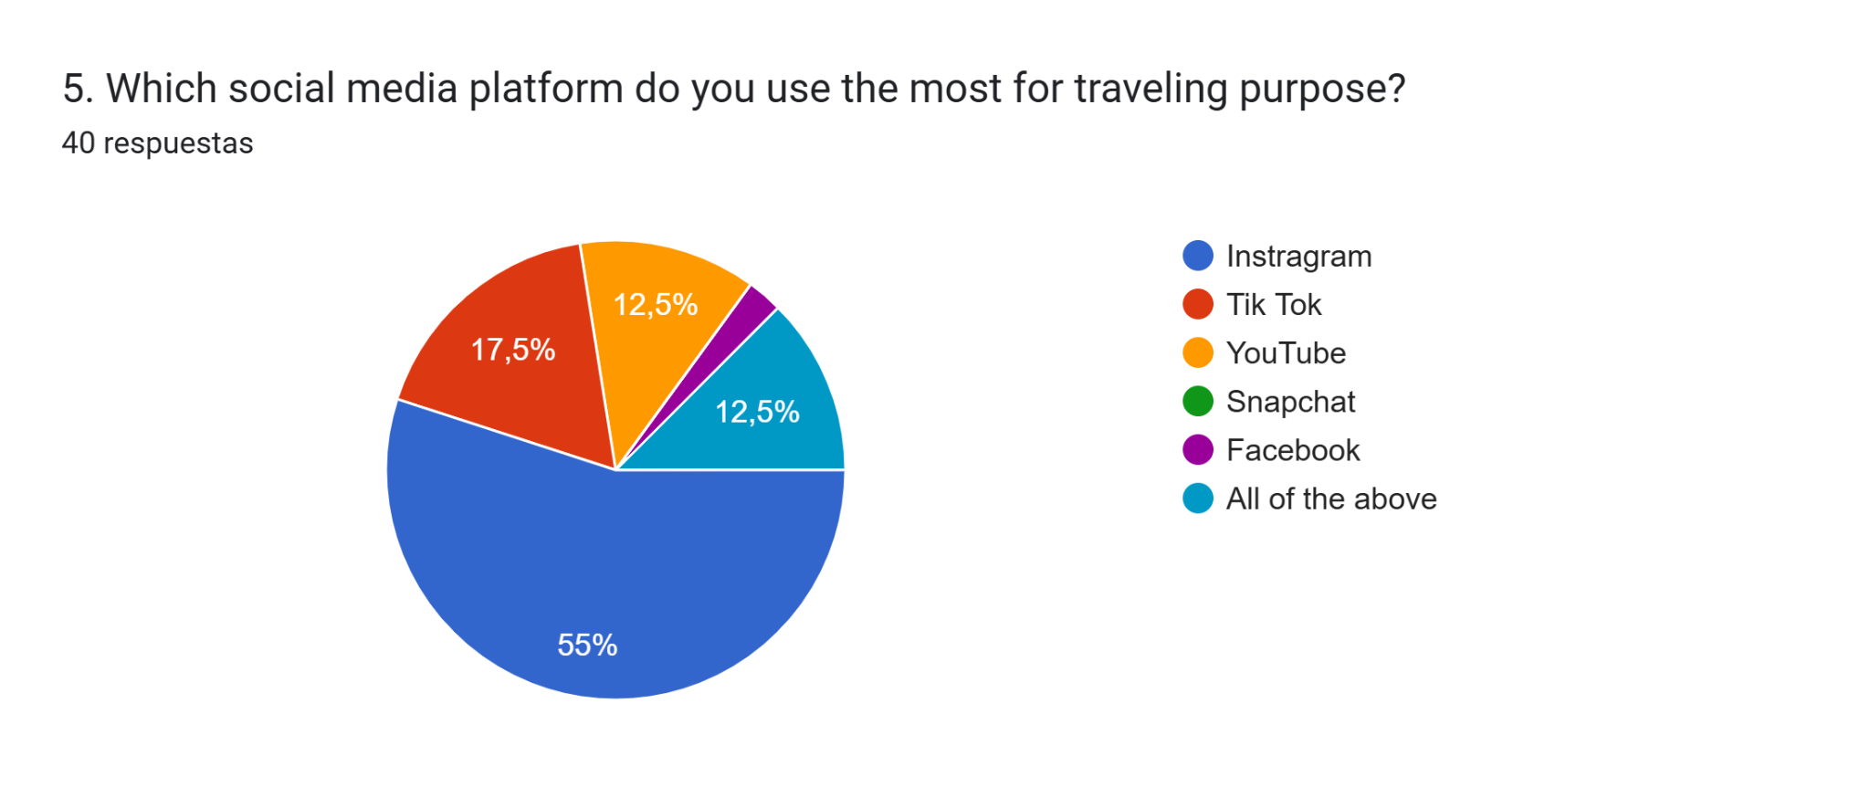

Social media platforms has become an important tools for the daily basis, for this project we focus on the tourist and how they use social media platforms for traveling purposes, and according to the results collected through the surveys we can say that the Social media Platform most use for traveling purpose is Instagram with a 55% following with Tik Tok with a 17.5% and Youtube with 12.5%.
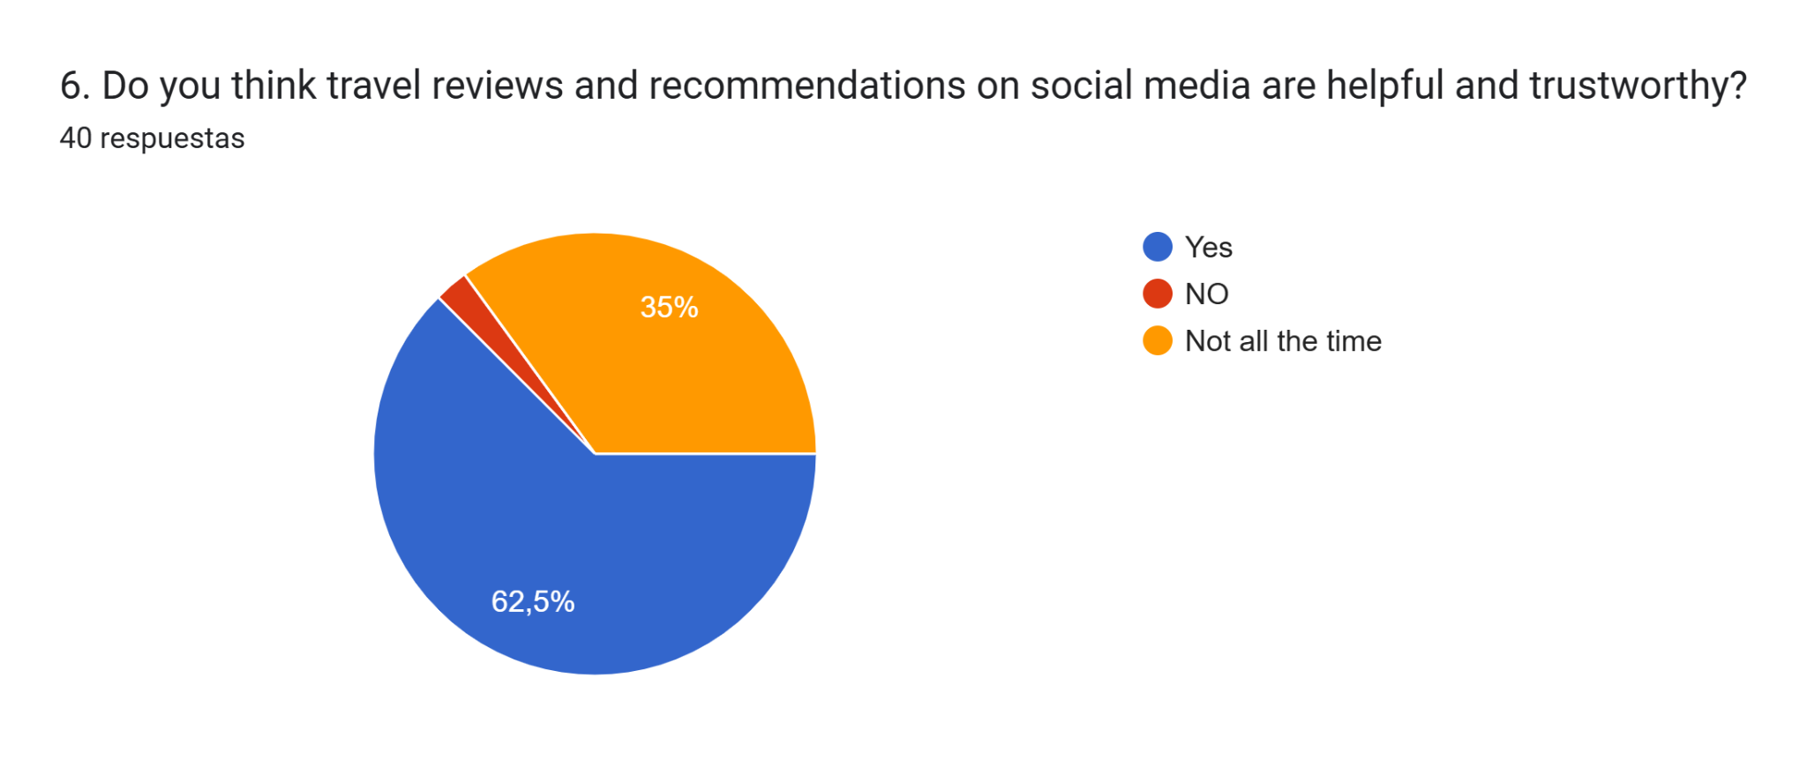

According to the results of the surveys we can say that the tourists think travel reviews and recommendations on social media are helpful and trustworthy for travel with a 62.5% and the 35% of the tourists think that social media are not helpful or trustworthy all the time.
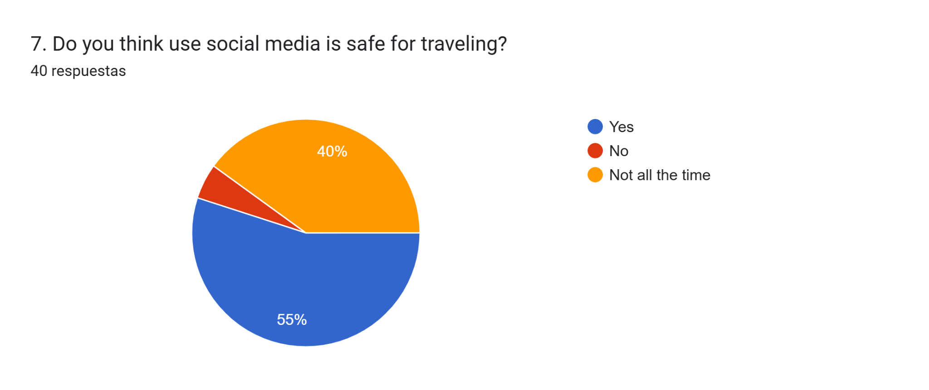

55% of the tourists that answered the survey said they feel comfortable and safe with the use of social media for traveling purposes and the other 40% of the tourists says that they don't feel safe and comfortable with the use of social media most of the time.

Discussion: According to the literature review,Social media is considering a powerful wild range network where people interact online with each other all around the world, people are able to share photos, videos and thoughts and any kind of information and also see other people content, the creation of communities according to their believes, lifestyle, interest and point of view are the same or similar to the other group of people.
From the data and information we gather through the surveys we can say that social media is a very helpful and useful tool for tourist at the moment to planning or organise their trip, using social media platforms mainly Instagram for helpful and trustworthy travel reviews, recommendation and tourist activities, tourist feel comfortable and safe using social media for traveling purpose.

Conclusion: Social media and its platforms have become important tools for tourists for traveling purposes, finding multiple travel reviews, recommendations, activities, and experiences from other tourists that have been to the travel destination before.
Social Media created a fast change of mind in the consumption of products and services in customers and bad reviews, posts, or videos can affect the credibility and profitability of a business or make a small business growth faster because of the good reviews or virality.

4.3. Theme 2: Artificial Intelligence influence and use
How has the use of AI changed the independence and decision making of tourists?
Quantitative Findings:
From the information we gather from the surveys, it is possible to have clear information about the use of Artificial Intelligence (AI), of tourists in their travel planning. We asked tourists how they use AI for traveling purposes, if they feel safe and comfortable using this tool at the moment to travel.
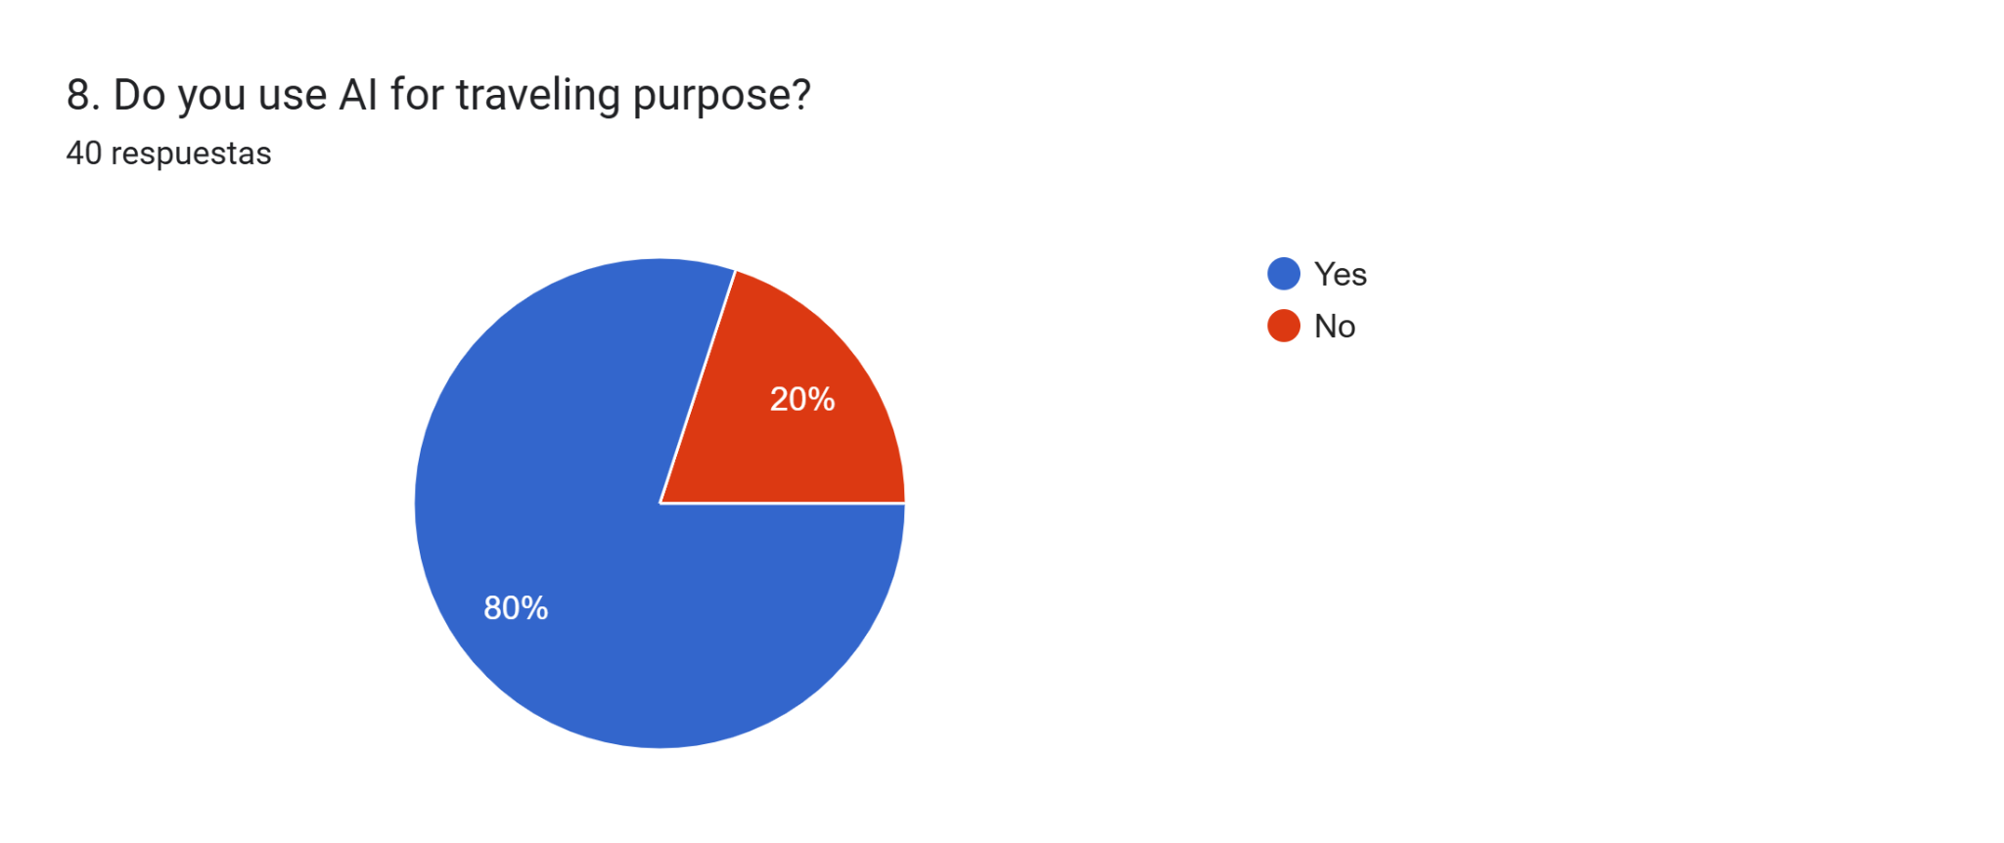
80% of the tourists that answer the surveys use AI for traveling purposes, and on the other hand the 20% don't use AI for travelling planning.

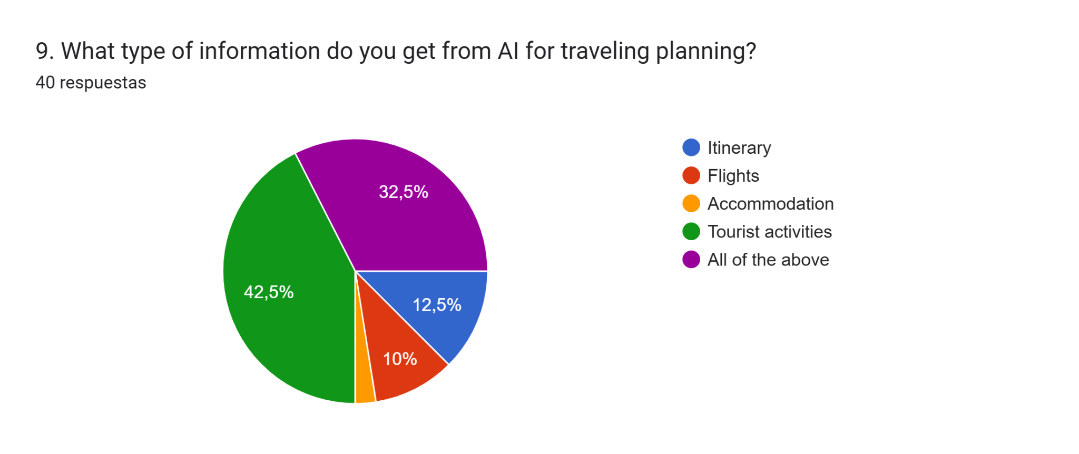
42.5% of the tourists use AI to get information about tourist activities, 32.5% use AI for the flights, itineraries, flights and accommodation, 12.5% use AI for itinerary and the 10% for flight information.
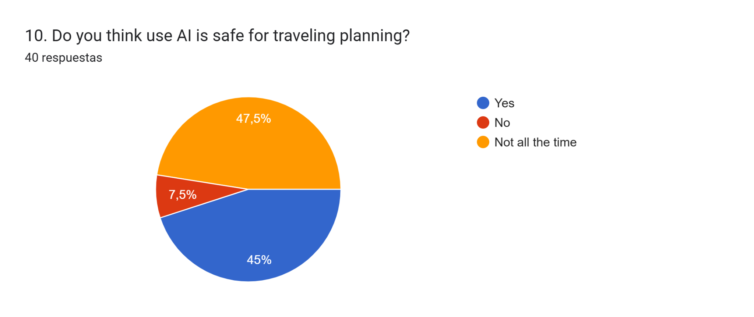

47.5%of the tourists said that the use of AI is not safe all the time, 45% of the tourists said that the use of AI is safe for tourists purposes and 7.5% of the tourists said that the use of AI is not safe for traveling purposes.

Discussion: According to the literature review AI, refers to the simulation of human intelligence in machines that are designed to perform tasks typically requiring human cognitive functions (Time.com, Business source Premier, 2025).
The primary results information and data from the surveys reveals that tourists use AI for traveling purposes looking for information about itinerary, flights, accommodation, tourist activities, feeling safe and comfortable using AI.
Conclusion: The innovation of new technology like AI have made human ordinary activities much easier and simple, the impact of Artificial Intelligence in human behaviour and Business improvement and development. There is a certain concern about the replacement of human talent in some working areas, but this can be disrupted in the ethical and political way.

4.4. Theme 3: Traditional Travel Agencies
How travel agencies interact with Social Media and AI?

From the results of the surveys and interview, we gather information about how tourists use the travel agencies and how travel agencies react and interact with this new technology such as Social Media and AI and how these new tools impact the functions and development of travel agencies.

Quantitative Finding:

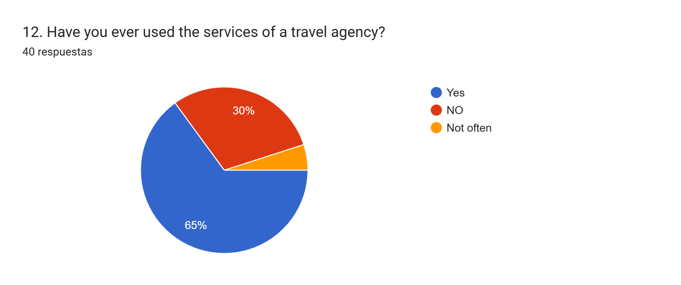

65% of the tourists have used traditional travel agencies for travel purposes, 30% never used travel agencies for travel assistance, and the 5% don't use travel agencies very often.

Qualitative Findings:
Interview:
- How social media and AI have affected the function of travel agencies?
Today, many people can plan their trips and get advice from AI.
Tasks like researching the best flights, creating an itinerary, recommending activities, and booking experiences—things that a travel agent used to do—are now handled by AI, allowing travelers to be less dependent on travel agencies.
On the other hand, social media can be used to promote and publicize tourist destinations. However, as in the case of Japan, it can also lead to overtourism in specific locations. If a new destination is to be included, it's very difficult to convince tourists to visit if it's not popular on social media or hasn't been previously promoted.
As an agency, we find it difficult to sell destinations outside the traditional ones because people want to go to the places they see on social media and say that they were there too.
- How travel agencies adapt social media and AI into their functions?
We realized that a large part of the clients we receive are because they follow different influencers on various media who recommend and show places and cultural issues, so we also turn to networks like Instagram and TikTok to attract the profile that is willing to hire our services.
Discussion: The literature review explains that the role of travel agencies is to help tourists to plan and organize their trip and ensure an enjoyable experience during the booking of tickets, hotels and arranging activities and tours. Travel agencies to stay competitive today are adapting their services by using AI and social media to connect and interact with the customers.
The primary research results in the quantitative and qualitative findings demonstrate that the most people who use the services of travel agencies are people that are travelling for the first time to a completely different destination in terms of distance, language and culture aspects on their own to avoid being scammed, and also that tourist can be attract using this new tools in benefit to the travel agencies.
Conclusion: Many travel agencies are adapting AI in their functions and using Social Media to promote their services and attract more customers or tourists. Travel agencies are aware that they need to keep improving and adapting to technological innovation to stay competitive in the tourism industry.

4.5. Theme 4: Influence of Social Media and AI in tourist about travelling decision making
What benefits, limitations and advantages has the tourist using Social Media and AI for traveling purposes?
The information and data collected from the surveys and interviews where we asked about how Social Media and AI can affect the decision making of the tourist for travelling purposes and also how the use of these tools can impact the human thinking, spontaneity, enjoyment and independence of the tourist.
Quantitative Findings:
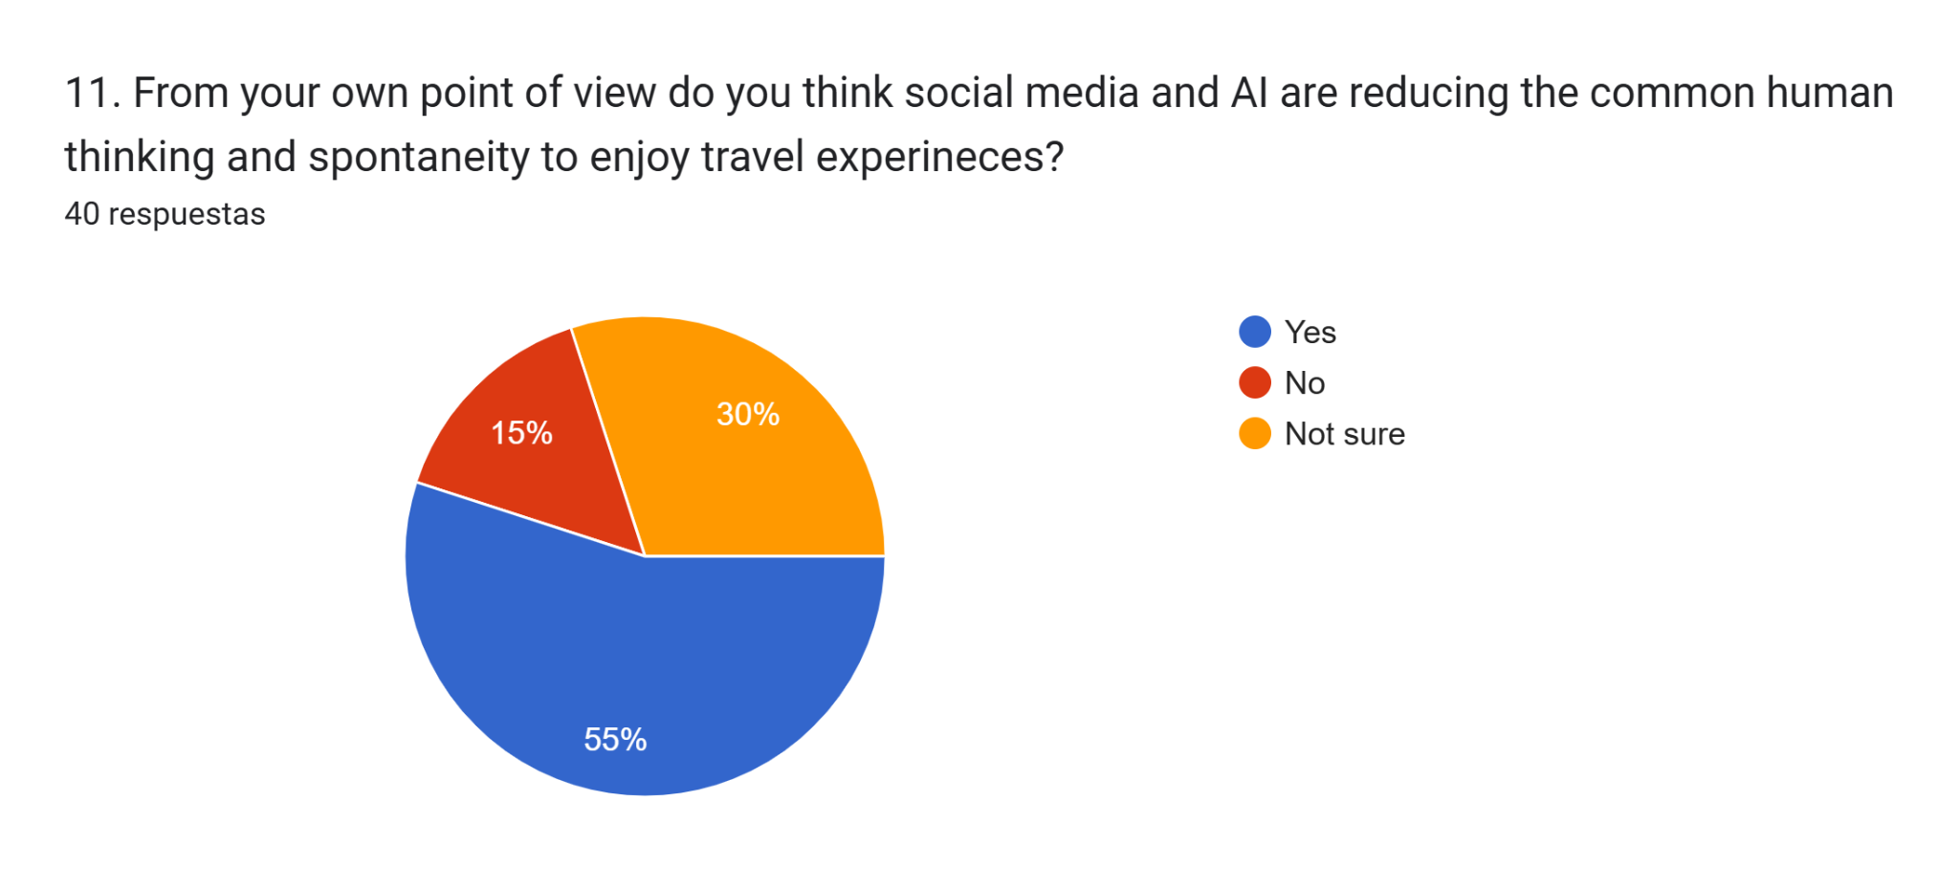
55% of the tourists said that they think Social Media and AI are reducing the availability of common human thinking, spontaneity and enjoyment of the travel experience. 30% are not sure of the impact of these tools in human natural behaviour and the 15% think that Social media and AI are not changing or reducing the natural human thinking.
Qualitative Findings:
Interview:
- Are tourists more independent in travel planning because of social media and AI influence?
Yes, lately we've noticed that more people are coming to Japan independently because they've planned their trips well in advance and don't want to hire guides. As a result, many agencies have started offering audio guides or manuals so that people can travel independently and have assistance in case of emergency.
- Is social media and AI reducing the common human thinking and spontaneity to enjoy nature?
I think it depends on the person and their travel intentions.
Lately, we've seen people who want to be "influencers" come just for the photos or to record videos doing things that are frowned upon in Japanese culture and thought. They do this because they saw others doing it. We also noticed them using GPT chat while on tours, even with a guide right in front of them, and they're constantly paying attention to their phones rather than the scenery.
It's also very difficult to break people's expectations because they saw it on social media and believe it will look the same in real life.
Discussion: According to the literature review the use of AI for the travel decision making is focus in the multiple personalized option about booking flight tickets, hotels, activities, created itineraries, prices, etc, with this tool tourists can make decisions according to their budget, preference and expectations with 24/7 virtual assistance. Social media adds a further dimension of the tourist experience and provides new channels of communities to socialize and communicate about tourism. (Munar, Gyimothy, Cai, 2013).
The primary results shows that the use of Social Media and AI can affect the human thinking, spontaneity, enjoyment and independence of tourists, because tourist are putting all their attention in the digital world and this can affect simple action like enjoy the travel experience and nature just caring about to post on social media, the use of AI can simplify the life of tourist in many way like creating Itineraries, tourist activities, booking accommodation, flights, etc., and this can create a huge dependence to digital tools.
Conclusion: Tourist are actively using AI and Social Media at the moment of planning their travel, gathering the necessary information like Flight prices, accommodation, touristic activities, itinerary, recommendations and reviews, making their experience more easy and independent, but at the same time creating dependence in this technological tools, taking their natural ability to experience and enjoy the destination and the nature.

CHAPTER 5

Conclusion and Recommendation

5.1. Introduction
This chapter will bring the analysis and conclusion of all the information collected in this project according to the discussion of the data we gather from the theme 4, also highlighting the limitations we faced during the development of this project and some recommendations about the most interesting point of aspect from this project to a better understanding of the reader.

5.2. Limitation
Some of the limitations we faced during the development of this project are the following:
- Language Barrier: Most of the tourist and the travel agencies employees have English as their second language, as an effect sometimes the communication was not the best but as foreign people we try our best to understand each other and be able to answer the question form the survey and the interviews.
- Interview Participants: We tried to contact and convince many travel agencies employees to accept the interview but we get a negative answer most of the time and because of the time we only get one full interview with one employee.
- Survey Participants: The survey for this project was easy to understand and answer, we had enough questions to gather the information we were looking for to answer the question and sub question of the project, but the participation was low and not many people answered the survey as we were expecting.

5.3. Conclusion
Research Question:
Explore how social media and AI influence tourists on their planning and decision making about traveling and its effects in the traditional travel agencies?

- Social media Platforms like Instagram, TikTok and Youtube are the most used for tourists in order to be able to choose and make decisions in traveling needs such as Flights, accommodation, recommendations, reviews, touristic activities, etc.
- The use of AI nowadays is more common and useful to tourists creating more independence and optimizing the time creating itineraries and offering different options in touristic activities and destinations.
- Travel agencies are improving their functions by adapting the use of AI and Social Media to attract tourists that are starting their travel adventures and guarantee a safe and professional work, offering 24/7 online assistant support, a fast and personalized customer service and also using Social Media to increase the company awareness in the digital market.
- Tourists are becoming more independent at the moment to planning a trip using digital platforms and technology, but the dependence of these tools can affect the perception and enjoyment of Nature and traveling experience focusing only on showing in Social Media where they are or what they are doing as a main priority.

5.4. Recommendations
New technology are always innovating the way human communicate and see the world, these new tools are fast, easy, and helpful on people daily basis, creating a more independent lifestyle, talking about Tourism, Social Media and AI has become the first reference to tourist at the moment to planning a trip, looking for recommendation, reviews and past experiences from past visitors.
Travel agencies must learn and adapt the new technology trends in this case Social Media and AI to keep and attract new customers, using social media to promote their services and interact with the tourists through storytelling, blogs, popular trends and be able to study and explore new markets, and the use of AI to increase the efficiencies of their services, such as 24/7 customer support, bring a fast and relevant information, customize the customer service, etc.

