Applied Project
Submission Form


LEARNER NUMBER | 51792559
NAME | Lizet Camacho Olivera
COURSE | BA (Hons) in Business Studies
REPORT TITLE | How can Dublin’s restaurant sector leverage the use of AI tools and other technologies to improve customer experience?
SUPERVISOR NAME | Klaus Walter
WORD COUNT | 6000
DUE DATE | 12/05/2025
DATE SUBMITTED | 12/05/2025

I certify that:
- This project report is all my own work, and no part of this report has been copied from another source: Yes ☒ No ☐
- I understand that this report may be checked by electronic or other means for plagiarism and/or content created by generative AI and may be transferred and stored in a database for the purposes of data-matching/data-analysis to help detect plagiarism and/or content created by generative AI: Yes ☒ No ☐
- This report has not previously been submitted in part or in full for assessment to any other institution: Yes ☒ No ☐
- I consent to the inclusion of my report in the publicly accessible (open access) electronic database maintained by the library:
Yes ☒ No☐
- I have emailed a back-up copy of this report to locker@independentcollege.ie:
Yes ☒ No ☐

(Note that if no check boxes are selected, this Project will be regarded as NOT properly submitted, and may be subject to a late submission penalty)

Name: _____Lizet Camacho Olivera___
Date: __12/05/2025__

For the report to count as a valid submission, the student must provide:
1 electronic copy via Moodle. There is no requirement for a hard copy .

Evidence of the Primary Research MUST be included in the appendix of the report. That includes a copy of questionnaires, interview schedules, or observation diaries. One interview transcript should be included as a full transcript and a summary of all other interviews must be kept as a backup by the student. See template on Moodle for what should be included in all aspects of the report. All data must be anonymised.

The text should be double-spaced throughout and single column format (A4) with 2cm for left and right-hand margins and 2.5cm at head and foot. Text should be justified, standard 12 point, footnotes 10 point, and in Calibri. Page numbers should be at the bottom-right. Do not use line and paragraph spacing. Keep formatting to a minimum and avoid underlining.

Harvard Referencing shall apply.



HOW CAN DUBLINS RESTAURANT SECTOR LEVERAGE THE USE OF AI TOOLS AND OTHER TECHNOLOGIES TO IMPROVE CUSTOMER EXPERIENCE?

Compiled by: Lizet Camacho Olivera
This project is submitted in part fulfilment of the Degree of Bachelor of Arts (Honours) in Business Studies.

Independent College
May 2025

Acknowledgements

I want to thank Dr. Daniel O’ Sullivan and the supervising lecturer Klaus Walter for their teaching, support, and recommendations provided throughout the development of this project.
To Independent College and to all my teachers, for having transmitted their knowledge and experiences to me during this stage of academic development.
I also want to thank my parents for all the support they provided me to achieve this academic goal; despite the distance, they are always supporting me in all my decisions.

Abstract

Currently most people are now aware of all the advances that have occurred in technologies in recent years, and even more so in the wake of the COVID-19 pandemic.
The post – pandemic has led many companies in different sectors to adopt digital tools, including artificial intelligence (AI), to remain competitive in the market.
For the restaurant industry, AI tools and other technologies offer many opportunities and benefits to increase productivity, streamline operations, and significantly improve the customer experience.
The aim of this study is to analyse how Dublin restaurants can leverage AI tools and other technologies to improve customer service.
This project will be conducted using a mixed technology, relying on qualitative data collection through interviews with restaurant managers and supervisors to understand the current state of technology use and customers interaction. We will also collect quantitative data through a survey of different restaurant visitors.
The study focuses on five main themes: The impact of the new technologies on the restaurant sector, AI tools to improve customer experience in restaurants, advantages and disadvantages of use AI tools in restaurants, personalization of services in restaurants, enhanced customer engagement in restaurants.
AI tools can be very useful for restaurants if they use them in the right way. It will allow them to provide better service, save time, and attract more customers. Not forgetting the personal treatment of customers, which is stills highly valued by customers.

Table Content

Chapter I: Introduction 7
1.1. Introduction – Background of Research 7
1.2. Rationale for the study 8
1.2.1. Justification 8
1.2.3. Purpose 8
1.2.4. Research question 8
1.3. Statement of the research objectives 8
1.3.1. Objective 8
1.3.2. Specific Objectives 9
1.3.3. Sub research question 9
1.4. Information gathering & data collection 9
1.5. Expected Outcomes of the study 10
1.6. Chapter by Chapter Overview 10
Chapter II: Literature Review 11
2.1. Introduction 11
2.2. The impact of the new technologies on the restaurant sector. 11
2.3. AI tools to improve customer experience in restaurants. 13
2.4. Advantages and disadvantages of use AI tools in restaurants. 16
2.5. Personalization of services in restaurants. 18
2.6. Enhanced customer engagement in restaurants. 20
Chapter III: Methodology 21
3.1. Introduction 21
3.3. Research Philosophy 21
3.4. Research Approach 22
3.5. Research Method 22
3.5.1. Type of research: 22
3.5.2. Methodological Approach 23
3.6. Data Collection Method 23
3.7. Sampling 24
3.8. Research Process 24
3.9. Data Analysis Method 25
3.10. Ethical Consideration 25
Chapter IV: Finding and Discussion 26
4.2. Introduction 26
4.3. Finding 27
Chapter V: Conclusion and Recommendations 36
5.1. Conclusion 36
5.2. Recommendation 36
5.3. Suggestion 36
5.4. Limitation 36
6. References 37
7. Appendix 40
7.1. Appendix I: Informed Letter of Consent Plain Language Statement 40
7.2. Appendix 2: Sample Questionnaire 42
7.3. Appendix 5: One Interview Transcript 46
7.4. Appendix 6: Literature Review Table 49
7.5. Appendix 7: Copy of Ethical Form A 51

List of Figures
Figure1. Digitalization options for restaurants………………………………………………………………………….13
Figure 2: The proposed model…………………………………………………………………………………………………15
Figure 3. SWOT of AI applied to gastronomy……………………………………………………………………………18
Figure 4: Stakeholder Table……………………………………………………………………………………………………..25
Figure 5: Survey’s question 5 result………………………………………………………………………………………….28
Figure 6: Survey’s question 8 result………………………………………………………………………………………….29
Figure 7: Surveys question 9 result…………………………………………………………………………………………..30
Figure 8: Survey’s question 10 result……………………………………………………………………………………….30
Figure 9: Survey’s question 11 result……………………………………………………………………………………….30
Figure 10: Survey’s question 12 result……………………………………………………………………………………..31
Figure 11: Survey’s question 13 result……………………………………………………………………………………..32
Figure 12: Survey’s question 16 result……………………………………………………………………………………..33
Figure 13: Survey’s question 18 result……………………………………………………………………………………..33
Figure 14: Survey’s question 20 result……………………………………………………………………………………..34
Figure 15: Surveys question 21 result………………………………………………………………………………………34
Figure 16: Survey’s question 22 result…………………………………………………………………………………….35

Chapter I: Introduction

Introduction – Background of Research
The restaurant sector has always been an important part of the economy, and for the present study we will consider the city of Dublin, where there is a wide variety of restaurants. After the COVID-19 pandemic this sector had to quickly adapt to new of working, including the use of digital technologies.
This topic is of interest to me because I have worked in a restaurant and have seen up close how technology, and artificial intelligence (AI) tools, can improve the way we serve customers. In addition, I am struck by how these tools can help personalize the service and make customers more satisfied and have a better experience.
I also believe that many times small restaurants do not know how to use these technologies, and with this research I want to better understand how they can benefit.
Therefore, this project seeks to analyse how restaurants in Dublin can use AI tools and other technologies to improve the customer experience and be more competitive.

1.2. Rationale for the study

1.2.1. Justification
After COVID-19 pandemic, the restaurant sector has had to adapt to new ways of working, adopting digital technologies such as artificial intelligence (AI) to improve service and continue to be present in the industry. There are currently many restaurants that are not taking advantage of these tools due to lack of knowledge.
This research seeks to analyze how the sector can take advantage of digital tools to improve customer experience providing useful information that drives its growth, efficiency and connection with consumers in an increasingly digital environment.

1.2.3. Purpose
The purpose of this project is to analyze how restaurants in Dulin can use artificial intelligence tools and other technologies to improve customer service and generate a better experience. Through interviews with personnel in the sector and surveys of restaurant consumers, the aim is to identify the advantages and disadvantages of AI in this context, in order to propose practical strategies for its effective implementation.

1.2.4. Research question
The main question of the project is:
How can Dublin’s restaurant sector leverage the use of AI tools and other technologies to improve customer experience?

Statement of the research objectives

Objective
To analyse how the restaurant sector in Dublin can leverage artificial intelligence tools and other technologies to improve the customer experience.

Specific Objectives
- The impact of the new technologies on the restaurant sector.
- AI tools to improve customer experience in restaurants.
- Advantages and disadvantages of use AI tools in restaurants.
- Personalization of services in restaurants.
- Enhanced customer engagement in restaurants

Sub research question
- What is the impact of the application of new technologies in the restaurant sector?
- What specific AI tools and technologies can restaurants use to improve the customer experience?
- What are the advantages and disadvantages of using AI tools in the restaurants sector?
- How can personalisation of services, through AI tools, improve the customer experience?
- How can restaurants in Dublin use AI technologies to create interactive experiences for customer and encourage repeat visits?

Information gathering & data collection
For this project we will use the mixed methodology, that is quantitative and qualitative methodology, to respond to the objectives of the research and answer the questions.
Quantitative Methodology: Through this method, an online survey will be carried out using Google Forms, to the people who visit the restaurants to find out their experiences, expectations and satisfaction with the use of AI technology.
Qualitative methodology: With this method, elaborate interviews will be conducted with the managers and supervisors of the restaurants in Dublin. The aim of the interviews is to gather information on the current use of AI tools and other technologies and to learn about the challenges they face and how technology is contributing to personalising services.

Expected Outcomes of the study
This study is expected to identify how AI technologies can improve efficiency and personalisation in Dublin’s restaurants, as well as contributing to a better experience ant he competitive growth of the restaurant sector.

Chapter by Chapter Overview
This project is structured in five chapters:
- Chapter I: This chapter presents a brief summary of the research topic, background, justification, main objectives research questions, and methodology used to conduct the study.
- Chapter II: This chapter show a review of the literature focused on the use of artificial intelligence (Ai) and other technologies within the restaurant industry.
- Chapter III: This chapter focuses on the methodology of the study’s, detailing the qualitative and quantitative data collection techniques used, such as interviews and surveys, as well as the rationale for their selection.
- Chapter IV: This chapter refers to the findings obtained in the fieldwork, analyzing the results from the perspectives of restaurant staff and customers who visit restaurants in Dublin.
- Chapter V: This chapter includes a key summary of the study conducted and also includes recommendations.

Chapter II: Literature Review

Introduction
The literature review is an important component in any research process, since it allows the identification, analysis and synthesis of existing knowledge on a specific topic. This project presents a review of literature related to the use of AI tools and other technologies in restaurants to improve the customer experience, addressing the main academic contributions, as well as the most relevant methodologies and result.

The impact of the new technologies on the restaurant sector.
Through this topic we want to answer this question “What is the impact of the application of new technologies in the restaurant sector?”, information was sought regarding the topic shown below.
This sector of the restaurant industry has suffered the severe consequences of the recent post-pandemic closures as well as having to adapt to the changes in digital technologies.
Alt (2021), examines how restaurants should embrace more touch points, provide more individualized offerings and pursue more automation and integration of their services and of their systems.
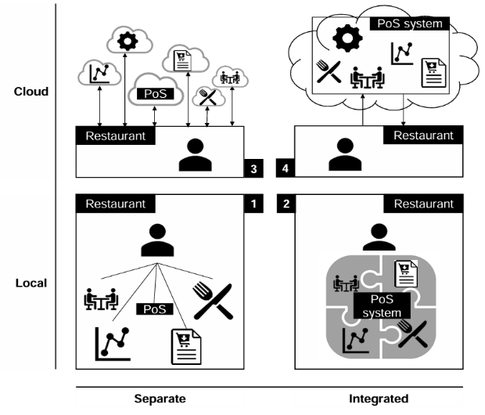

Figure1. Digitalization options for restaurants

According to Milton (2024), the integration of Artificial Intelligence (AI) into restaurant processes, especially in menu design and customer interactions, AI based systems analyse customer preferences, optimize menu selection and provide personalized recommendations.
AI is driving operational efficiency and sustainability in hospitality, addressing challenges related to resource management, waste reduction and environmental impact. AI based kitchen automation systems streamline food preparation processes and reduce waste, resulting in cost saving and increased efficiency.
Restaurants are now increasingly using AI-based chatbots, recommendation systems and smart kitchens to reduce costs and improve service quality. Limna (2023) concludes that AI not only improves operational efficiency but also presents opportunities for better resource management and marketing.
Kansakar, Munir and Shabani (2019) refer to technologies such IoT, digital service platforms and smart devices that are transforming the foodservice sector. Innovations include automated ordering systems. These tools increase the efficiency of operations and improve the customer experience.
Esposito (2022) commented that technology adoption is critical to adapt to involving consumer expectations and overcome crisis- induced challenges during the pandemic.
Conclusion: The use of new trends in technologies in the restaurant industry has become paramount, especially after the pandemic. Authors such as Milton (2024) and Limna (2023) show how AI improves efficiency, personalizes customer service, and supports customer sustainability. For his part, Alt (2021) highlights the need for automation and digital integration, therefore suggesting that restaurants must adapt to remain competitive.
For this work, it is important to explore how restaurants apply these technologies and how customers respond.
Solution: The authors mention that technology, especially AI, improves efficiency and the customer experience in restaurants. The implementation must be balanced and adapted to the needs of the customer.
The main questions that can be asked based on this topic are the following:
- Have digital technologies made restaurant service fester your experience?
- How do you prefer to place your order in a restaurant?
- Do you think digital menus (e.g., QR codes) are more convenient than paper menus?
- In your opinion. What is the biggest benefit of using technology in restaurant?

AI tools to improve customer experience in restaurants.
Through this topic we want to answer this question “What specific AI tools and technologies can restaurants use to improve the customer experience?”, information was sought regarding the topic shown below.
Ameen (2021) explains the transformative role of AI in the customer experience through AI tools such as chatbots and personalized recommendations have increased efficiency and customer satisfaction.

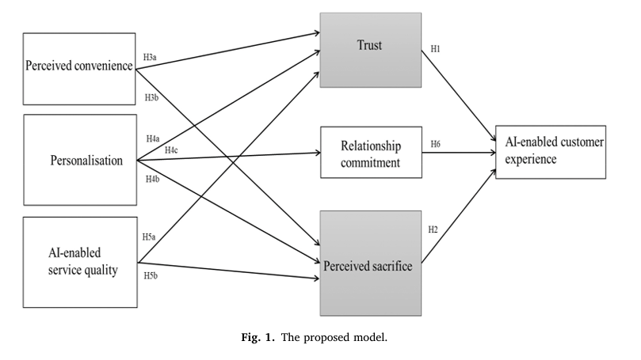

Figure 2: The proposed model
Digitalization has transformed the restaurant industry by shifting the focus from suppliers to consumers. AI plays a key role in adapting to these changes by enabling advanced customer experience management systems, such as real- time feedback collection and automated service optimizations. Rimma Akhmedova (2024).
Tuyet-Mai Nguyen (2022) finds in their analysis that high- quality AI systems, characterized by accurate, flexible ad reliable service, foster good experiences. In the case of restaurants, integrating AI to optimize reservation systems can strengthen customer loyalty and bran reputation.
Bart Goldenberg (2024) believes that AI tools improve the customer experience by automating routine queries and enabling 24/7 support. However, he believes that staff is still indispensable, especially for complex issues.
Jackie Morales (2024) says the integration of AI into customer service to improve personalization and streamline operations. AI can also affect:
- Digitize advisor-client workflows through better.
- Engagement and collaboration tools.
- Leverage and protect customer data to improve the customer experience personal optimized and actionable.
- Eliminate inefficiencies in operating models.
Conclusion: AI in restaurants is revolutionizing the customer experience by delivering real-time efficiency, personalization, and service improvements. Tools such as chatbots and recommendations systems (Ameen, 2021) provide immediate support and personalized options, improving satisfaction. Real -time feedback and automated adjustments (Akhmedova, 2024) ensure response service, while AI – enhanced booking systems (Nguyen, 2022) indicates that they help build brand loyalty, while Morales (2024) highlights the optimization of workflows and the use of data to personalize service, enhancing the relationship with the customer.
Although automation takes care of many tasks, Goldenberg (2024) underscores the importance of human staff for complex problems, suggesting a hybrid model.
Solution: AI improves the customer experience, allows you to optimize services and manage data in real time. Human presence remains essential, especially in complex situations.
The main questions that can be asked based on this topic are the following:
- Have you ever used a restaurants digital service (e.g., mobile apps, self- services, kiosks, AI chatbots)?
- If yes, how was your experience?
- Do you believe AI can improve customer service efficiency in restaurants?

Advantages and disadvantages of use AI tools in restaurants.
Through this topic we want to answer this question “What are the advantages and disadvantages of using AI tools in the restaurants sector?”, information was sought regarding the topic shown below.
In the restaurant industry, AI is transforming operations such as order taking, staff scheduling, inventory management, and food preparation, and more. Therefore, there are benefits and challenges in the implementation of technologies, among the main benefits of this transformation is the increase in efficiency, the reduction of costs and the improvement of the customer experience through personalization.
Among challenges such s decreased contact with customers, the high cost of implementing new technologies, and the need for technical know-how, through this article Brown (2024) clarifies the importance of using AI as a complement to human work, not as a replacement, and provides practical recommendations for a successful transition.
AI has become an essential element in the area of gastronomy, not only facilitating the work of chefs, but also fostering business innovation through cost reduction. Millan and Vazquez (2024).
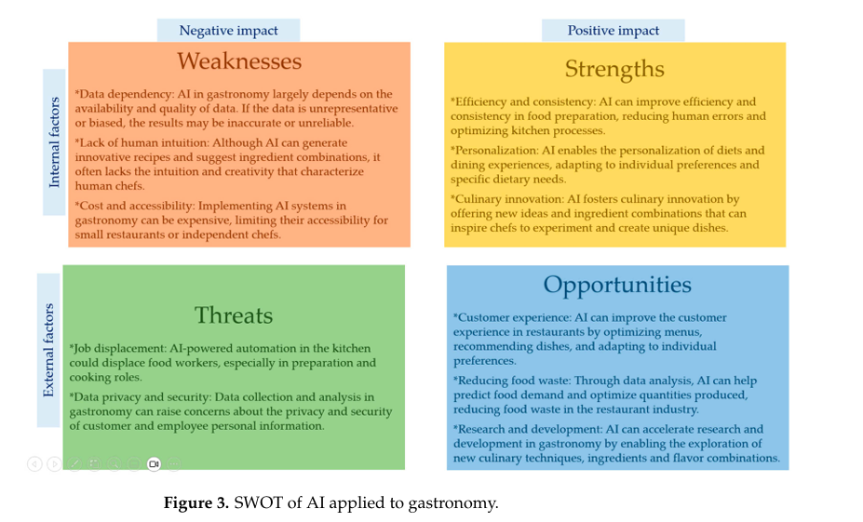
Figure 3. SWOT of AI applied to gastronomy
Kumar (2021) says that AI tools improve restaurant operations through predictive sales analytics, inventory management, and food quality control. Automation reduces human error and increases efficiency, allowing for faster service and lower costs.
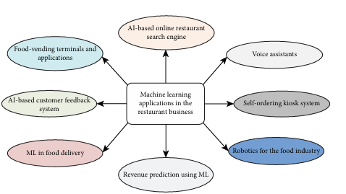

While AI in restaurants brings benefits to customers, there are also potential disadvantages, including customer resistance to fully automated services and the technology gap in smaller establishments that lack the resources to invest in AI. (Dani, 2022).
The integration of AI with tools such as machine vision and electronic sensors optimizes quality control and food safety in restaurants. These technologies improve customer satisfaction by ensuring product consistency. (Mavani, 2021).
Sousa (2024) says that AI powered tools such as chatbots and kiosks and others improve customer service, and progress the experience. However, the emotional disconnect customers feel when interacting with machines rather than humans is still a disadvantage, especially in high – touch service industries.
Conclusion: The benefits of AI tools are increased efficiency, cost reduction, and personalized service (Kummar, 2021; Millan & Vasquez, 2024). There are also challenges that each company has to face, such as emotional disconnection and limited access for small business according to (Dani, 2022; Sousa, 2024).
There must also be a balance between AI and humans means that AI should not replace workers, (Brown, 2024).
Solution: AI improves efficiency challenges such as emotional disconnection. High implementation costs in small businesses. Complement human labour, not replace it.
Question to this topic is key exploring how restaurant staff and customers perceive the use of AI tools.
The main questions that can be asked based on this topic are the following:
- In your opinion. What is the main advantage of AI tools in Restaurants?
- What is the biggest disadvantage of AI in restaurants?
- If your answer is yes. What types of issues?

Personalization of services in restaurants.
Through this topic we want to answer this question “How can personalisation of services, through AI tools, improve the customer experience?”, information was sought regarding the topic shown below.
Alexander Titov (2017), comments that modern consumers are accustomed to personalized brand experiences so personalization: its involvers both interpersonal warmth and personalized services, which are critical to meet demands of the contemporary market and improve customer satisfaction.
The Harvard Business Review (2018) identifies that personalization, when applied strategically, significantly increases revenue and customer retention. Restaurants that implement personalization achieve competitive advantages.
According to (Kim, H., Jung, S. & Ryu, G., 2020). The personalization system that allows users to quickly and accurately find the information they want, selecting information that meets their needs and interests. Personalization information is using user profiles to analyze the user.
The search terms used, the order of website visits, and user behavior within the websites store and apply text analytics.
Derivation of personalization information is used to improve recommendation satisfaction by using the collaborative filtering method.
Chatbots make it easier to access services and data efficiently, evolving into intelligent personal assistants capable of more natural communication. Finally, restaurant recommendation systems are examined, which are increasingly popular for the ease they provide to access information, reviews, and promotions.
Conclusion: Personalizing services using artificial intelligence (AI) tools can significantly improve the customer experience in restaurants. Today’s consumers value experiences adapted to their preferences, combining technology with interpersonal warmth as indicated (Titov, 2017), also by opting for an appropriate personalization strategy can increase revenue and customer loyalty (Harvard Business Review, 2018),
According to Kim (2020), the use of user profiles a customer behaviour analysis allows more accurate recommendations to be offered through methods such as chatbots and recommendation systems that facilitate access to useful information and promotions. In primary research, it is relevant to explore customers’ expectations of personalization, their perception of automated recommendations.
Solution: According to the theory, personalization improves the restaurant experience, but the balance between technological innovation, respect for privacy and a human approach to service is important.
The main questions that can be asked based on this topic are the following:
- How important is personalized service to you when you visit a restaurant?
- Would you prefer a restaurant to remember your food preferences for future visits?
- How likely would you be to visit a restaurant that offers personalized discounts or promotions based on your history?
- Would you like to receive personalized recommendations for drink or food when you visit a restaurant?

Enhanced customer engagement in restaurants.
Through this topic we want to answer this question “How can restaurants in Dublin use AI technologies to create interactive experiences for customer and encourage repeat visits?”, information was sought regarding the topic shown below.
The restaurant sector is highly competitive where the role of customer is of great importance, therefore they must build strong relationship with customer by creating remarkable gastronomic experiences and fostering genuine connections
Customer engagement in the restaurant industry is very important and the impact on revenue and strategies that are implemented to improve engagement levels.
If good strategies are implemented in restaurants, the outcome of the strategies can generate customer loyalty, increase customer satisfaction, and thrive in an ever- evolving market.
Anshari (2019) says how big data improves CRM strategies to create personalized customer experiences. CRM systems with big data allow businesses to predict customer preferences, improving satisfaction and loyalty.
Kabadayi (2022) analyzes customer engagement in restaurants using the model showed that the physical environment, such as lighting and ambiance, positively influences brand and customer engagement.
Digital transformation in customer value creation in fast food restaurants propose the use of dynamic digital capabilities, like detection and capture of customer needs through digital tools, to improve customer engagement. (Daradkeh, 2023).
Conclusion: AI technologies can significantly improve customer engagement in Dublin restaurants, offering personalized experiences, for example, the integration of CRM and AI- powered digital tools allows companies to predict preferences and adapt in real time, fostering loyalty and satisfaction according to (Anshari, 2019; Daradkeh, 2023).
The physical environment and the way they perceive it also plays a very important role in customer engagement according to (Kabadayi, 2022).
Solution: According to the theory, an integration of digital tools can be achieved in a balanced way with authentic human experiences, attractive environments and a genuine respect for the needs of customers.
Which this topic we want to know the importance of AI in the adaptation of interactions and atmospheres.
The main questions that can be asked based on this topic are the following:
- How often do you engage with a restaurant’s digital platforms (apps, chatbots, social media)?
- How important is it for you that a restaurant actively interacts with customers on social media?
- Do you feel more connected to a restaurant when they respond to your feedback

Chapter III: Methodology

3.1. Introduction
The objective of this chapter is to describe the philosophy and methodologies that were applied to carry out this project. The methodologies used were the mixed approach, that is, quantitative and qualitative techniques. To carry out the data collection, quantitative methods of descriptive type were applied that allowed the objective and systematic analysis of the data collected, the qualitative method was also applied through semi-structured interviews that complemented the data with deeper and more detailed perceptions.

3.3. Research Philosophy
Theorethical Paradigm / Philosophy employed :
Given that the goal is to understand and understand how in the restaurant sector in Dublin can leverage artificial intelligence tools and other technologies to improve the customer experience, this research is based on the philosophy of pragmatism, since it allows combining quantitative and qualitative methods providing a more complete view.
According to (Elkjaer and Simpson 2011). For a pragmatist, research starts with a problem, and aims to contribute practical solutions that inform future practice. Researcher values drive the reflexive process of inquiry, which is initiated by doubt and a sense that something is wrong or out of place, and which re-creates belief when the problem has been resolved.

3.4. Research Approach
The study was conducted a mixed research approach because it combined quantitative and qualitative methods to gain a better understanding of the research topic. It was carried out using a deductive approach because it started with a literature review that allowed for the identification of key concepts and relevant theories on digital transformation in the restaurant sector. Based on the theory, instruments such as surveys and interviews were formulated and designed to collect data.

3.5. Research Method
For the present study, a mixed research method was conducted that integrates quantitative and qualitative techniques. This methodological choice responds to the complex nature of the research problem, which involves both customer perceptions and strategic decisions of actors in the restaurant sector.

3.5.1. Type of research:
- Exploratory and descriptive: The study is exploratory because it seeks to investigate the use of artificial intelligence and technology in restaurants, for which there is little information available specifically in the context of Dublin.
- It is descriptive because the research aims to specify the properties, characteristics, and profiles of individuals, groups, communities, processes, objects, or any other phenomena that undergo analysis. (Hernández Sampieri, Fernández Collado & Baptista Lucio, 2014).

3.5.2. Methodological Approach
This paper uses mixed methods, combining quantitative and qualitative methods to gain a more comprehensive perspective on the topic.
Data were collected through semi-structured online surveys of restaurant customers to understand their experiences with the use of technologies. The qualitative method used semi-structured interviews with restaurant managers and supervisors allowed for a better understanding of the processes, challenges, and opportunities perceived in the implementation of technologies and artificial intelligence in their businesses.
This method allowed for a complementary analysis of the quantitative and qualitative results, enabling better interpretation for industry decision-making.

3.6. Data Collection Method
Data collection was carried out through two processes, quantitative and qualitative, to gain insight into the research topic.

To obtain quantitative data, structured surveys were conducted with restaurant customers in Dublin. The surveys included key questions based on the five research themes, allowing us to understand customers' opinions on the use of AI tools and other technologies in restaurants.
Through qualitative data collection, semi-structured interviews were conducted with restaurant managers and supervisors to gather information about their experiences and perceptions regarding the integration of technologies into their businesses. The interview questions were based on the five key research themes.

3.7. Sampling
For the present study, non-probabilistic sampling was used due to the nature of the topic and the need to select participants who could provide relevant information. Convenience sampling was employed where customers who had visited restaurants in Dublin were selected through online surveys. Additionally, 1 manager and 2 restaurant supervisors were selected, who are responsible for managing the restaurants and can provide direct information about the advantages and disadvantages of AI and other technologies in this type of business.

Stakeholder Table
Code | Participants | Location | Data Collection Method
C1 – C53 | Restaurant Customer | Dublin | Surveys Online
M1 | Restaurant Manager A | Dublin | Semi Structured-Interview
S1 | Restaurant Supervisor B | Dublin | Semi Structured-Interview
S2 | Restaurant Supervisor C | Dublin | Semi Structured-Interview
Figure 4: Stakeholder Table

3.8. Research Process
The research process was conducted through the following steps:
First, the study was conducted through secondary research, which consisted of a detailed review of academic literature, reports, and case studies related to the research topic on artificial intelligence and other technology tools applied in the restaurant sector.
As a second step, primary data collection was conducted using a mixed-method approach. Quantitative data was collected through online surveys of 53 people who visited restaurants in Dublin. The surveys were sent through a link obtained from Google Form. Qualitative data was then collected through interviews with supervisors and managers of three different restaurants in Dublin.
To conduct the interview, a semi-structured survey was conducted with restaurant managers and supervisors on the five research topics.
Before conducting the interview, an informed consent form was sent to the managers and supervisors to determine their consent to the interview. Once they signed the informed consent form, the interview proceeded.

3.9. Data Analysis Method
To conduct data analysis, we began with a literature review to link the data obtained through a mixed-methods approach. The quantitative data, obtained from surveys of 53 clients, were analyzed using descriptive statistics (frequencies and percentages).
A thematic analysis was performed, which, according to Boyatzis (1998), is a method for identifying, analyzing, and reporting patterns (themes) within the data. It organizes and describes the dataset in a minimalist and detailed manner. However, it often goes further and interprets various aspects of the research topic. This analysis served to obtain qualitative data through interviews with managers and supervisors, and when generalized, this allowed the analysis to find answers to the research questions.

3.10. Ethical Consideration
This study was conducted following ethical research guidelines. All participants were informed about the purpose of the research and gave their voluntary consent. They were also informed that they could withdraw at any time.
For the surveys, the informed consent form was provided, and participants were free to answer the questionnaire or not.
For the interview’s, informed consent was also provided to determine their agreement or disagreement so that the interview could be conducted in person. All information was securely stored and used exclusively for academic purposes.

Chapter IV: Finding and Discussion

4.2. Introduction
This chapter presents a detailed analysis of the results of the research conducted, combining quantitative data from customer surveys and qualitative data from interviews with restaurant managers and supervisors in Dublin.
The objective is to analyze how the restaurant sector in Dublin can use AI tools and other technologies to improve the customer experience.
The analysis is conducted using the five main themes found in the literature review, allowing for a comparison of existing theories with the actual data obtained in this study.

4.3. Finding
Theme 1: The impact of the new technologies on the restaurant sector
- Literature Review
According to Milton (2024) and Limna (2023) show how AI improves efficiency, personalizes customer service, and supports customer sustainability
- Survey
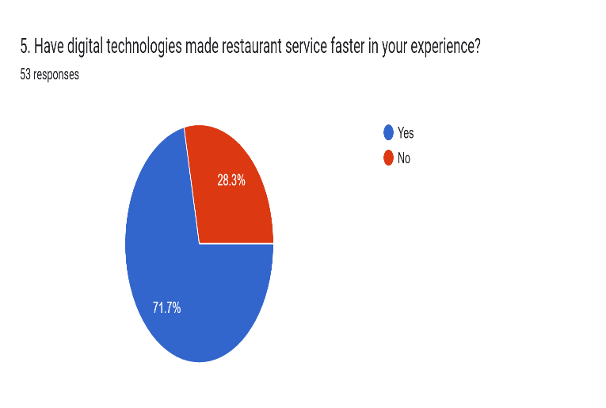
The results of this question indicate that 71.70% of all respondents say that digital technology has made their restaurant experience easier.

Figure 5: Survey’s question 5 result
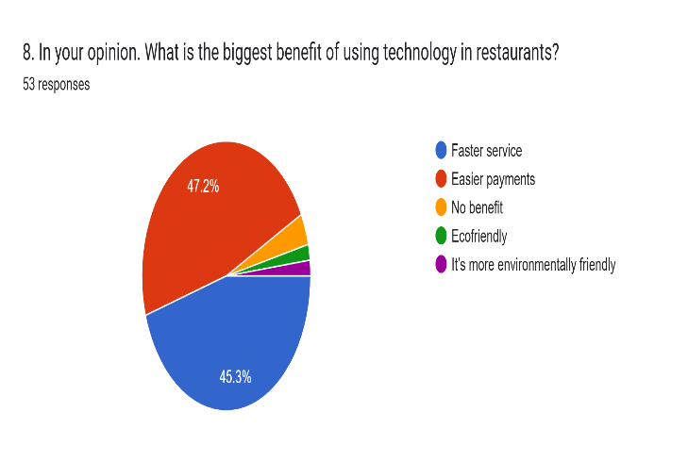
The results show that 47.20% of all respondents indicate that easier payments are one of the major benefits of using technology in restaurants, and 45.30% indicate that ease of service is a major benefit.

Figure 6: Survey’s question 8 result

Interview
Through the interviews we conducted, we obtained the following responses regarding the topic, the answers are detailed below:
M1: AI is essential to streamline operations.
S1: New technologies allow for more efficient order processing.
S2: Implementing good strategies is key to improving operational efficiency and increasing customer satisfaction.
Conclusion: The results analyzed through surveys and interviews an according to theory, confirm that the implementation of AI and other technologies is a strategic necessity for restaurants to remain competitive.
Theme 2: AI tools to improve customer experience in restaurant sector
- Literature Review
Bart Goldenberg (2024) believes that AI tools improve the customer experience, he believes that staff is still indispensable, especially for complex issues.

- Survey
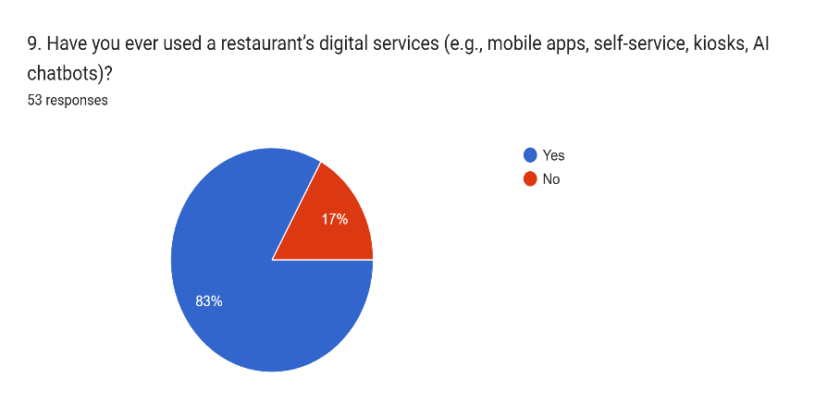
The result to this question indicates that out of the total respondents, 83% have used digital services in restaurants, such as mobile apps, self-services, kiosks, AI chatbots, etc.

Figure 7: Surveys question 9 result
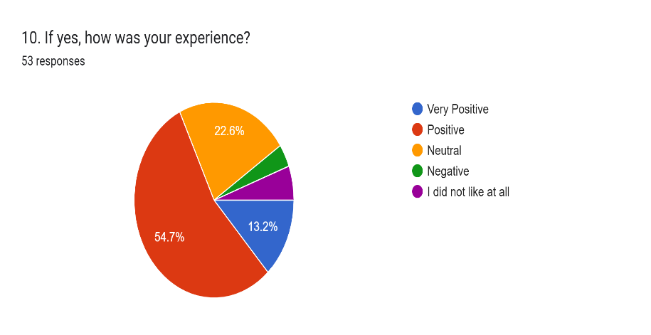
54.70% of respondents indicate that they have had a positive experience in restaurants regarding the use of AI tools.

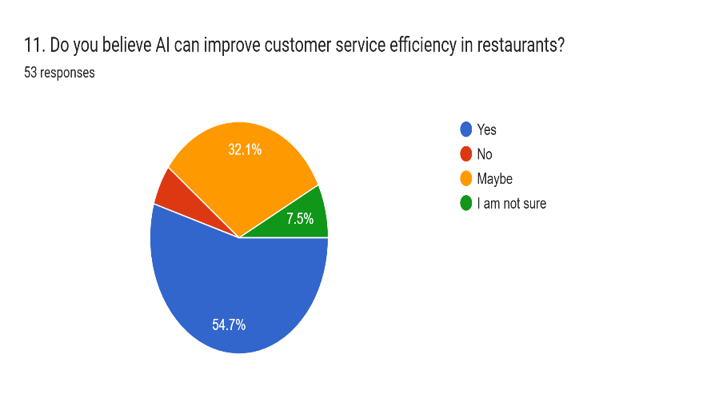
Figure 8: Survey’s question 10 result

Of the total respondents, 54.70% indicate that they believe AI can improve the efficiency of customer service in restaurants.

Figure 9: Survey’s question 11 result
- Interview
M1: We use technology such as QR code ordering, self – service kiosks, we have advantages using these systems.
S1: Craft personalized menu suggestions based on previous orders, for a more personalized dining experience.
S2: QR code system speeds up the receipt of orders, allowing more customers to be served in less time.
Conclusion: The results highlight that the use of technologies tools helps streamline processes.
Respondents accept the use of AI, although not in its entirety.
It can be concluded that technology complements, but may replace human attention.
Theme 3: Advantages and disadvantages of use AI tools in restaurants
- Literature Review
The benefits of AI tools are increased efficiency, cost reduction, and personalized service (Kummar, 2021; Millan & Vasquez, 2024).
There must also be a balance between AI and humans means that AI should not replace workers, (Brown, 2024).
- Survey
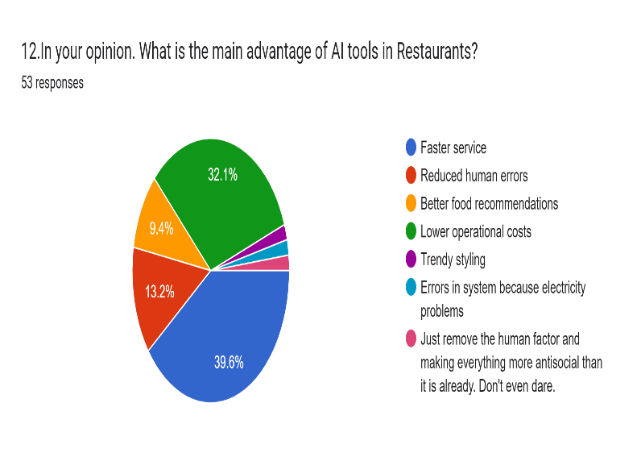
The response obtained from the survey respondents about their opinion on the main advantage of using AI tools in restaurants was that 39.60% indicated that the greatest advantage is fast service, and in second place, 32.10% mentioned low operational costs.

Figure 10: Survey’s question 12 result
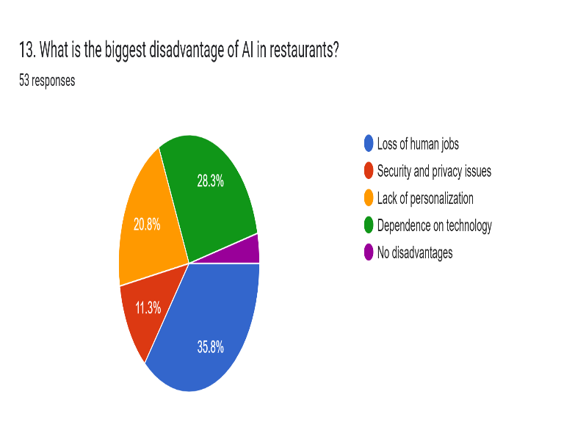
The response to this question indicated that 35.80% said the biggest disadvantage of using AI in restaurants is the loss of human jobs, followed by dependence on technology.

Figure 11: Survey’s question 13 result
- Interview
M1. Customer value good personalised treatment, aspects that technology cannot replace.
S1: These tools help to shorten the roles of workers and allow you to focus more on the customer experience.
S2: AI helps optimize staff schedules, reduces overtime, and allows you to interact more with customers.
Conclusion: The theory and answers agree that AI improves efficiency and reduces costs, but there can also be job losses, the interviewees reinforce the idea that AI should support staff, improving service while maintaining human interaction, key in hospitality.
Theme 4: Personalization of services in restaurants
- Literature Review
Alexander Titov (2017), personalization involves both interpersonal warmth and personalized services.
According to Kim (2020), the use of user profiles through methods such as chatbots and recommendation systems that facilitate access to useful information and promotions.
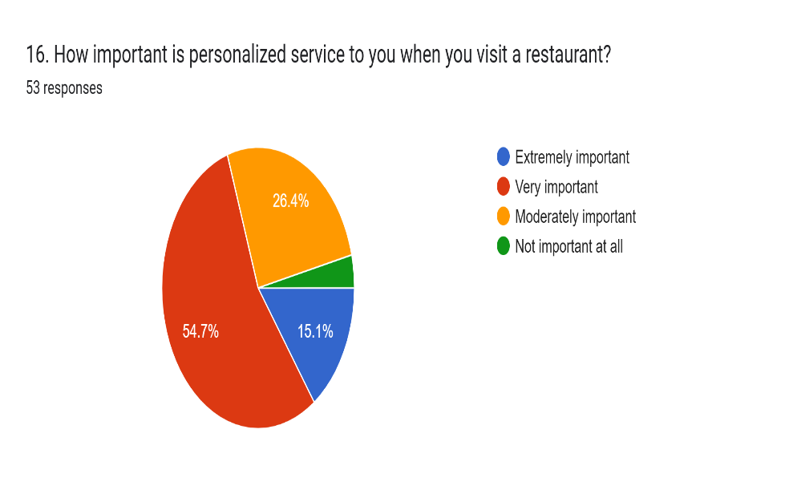
- Survey

El 54.70% de los encuestados respondieron que el servicio personalizado cuando uno visita un restaurante es muy importante.

Figure 12: Survey’s question 16 result

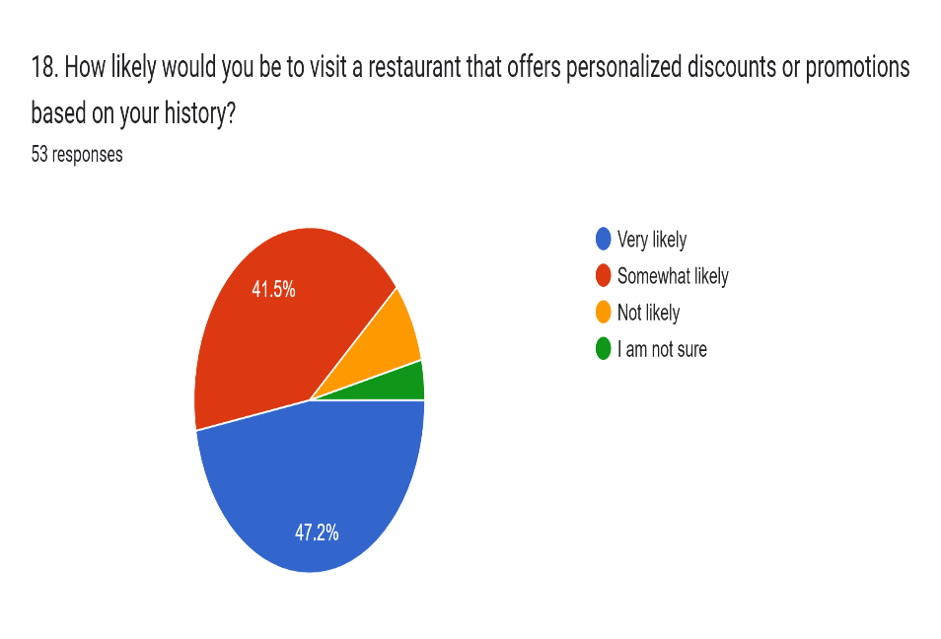
Existe un 47.20% de probabilidad que los clientes visiten un restaurante donde ofrezcan descuentos o promociones en base a su historial.

Figure 13: Survey’s question 18 result

- Interview
M1: We offer quick recommendations, adjusting the speed of service based on flight schedules and maintaining friendly and welcoming attitude.
S1: In my opinion, AI has the potential to analyze customer data and create more personalized offers.
S2: We offer a warm smile, advising customers when needed and making sure they leave satisfied with their dining experience.
Conclusion: The literature review surveys and interviews, it is concluded that personalization, both technological and human, is key to improving the customer experience in restaurants.
Theme 5: Enhanced customer engagement in restaurants
- Literature Review
Anshari (2019); CRM systems with big data allow businesses to predict customer preferences, improving satisfaction and loyalty.
Kabadayi (2022) analyzes customer engagement in restaurants using the model showed that the physical environment.
- Survey

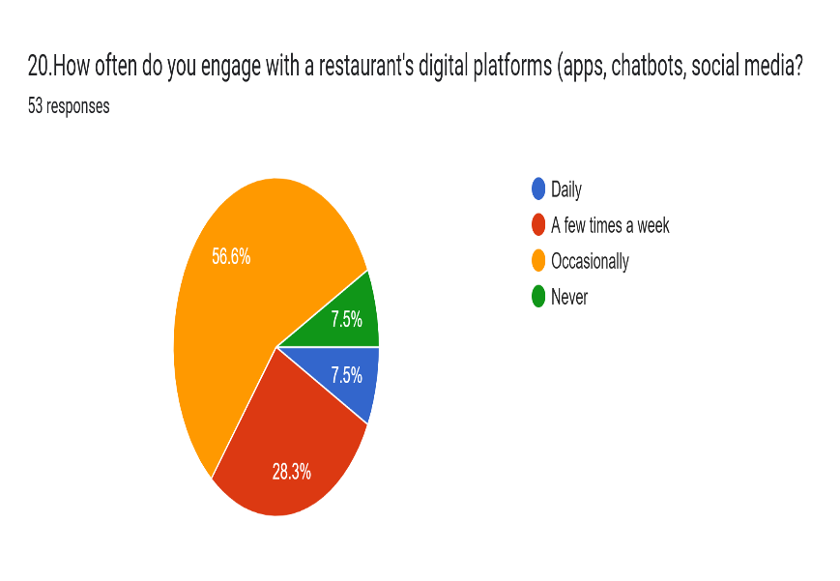
56.60% of respondents indicate that they occasionally interact with restaurants through digital platforms such as apps, chatbots, social media, etc.

Figure 14: Survey’s question 20 result

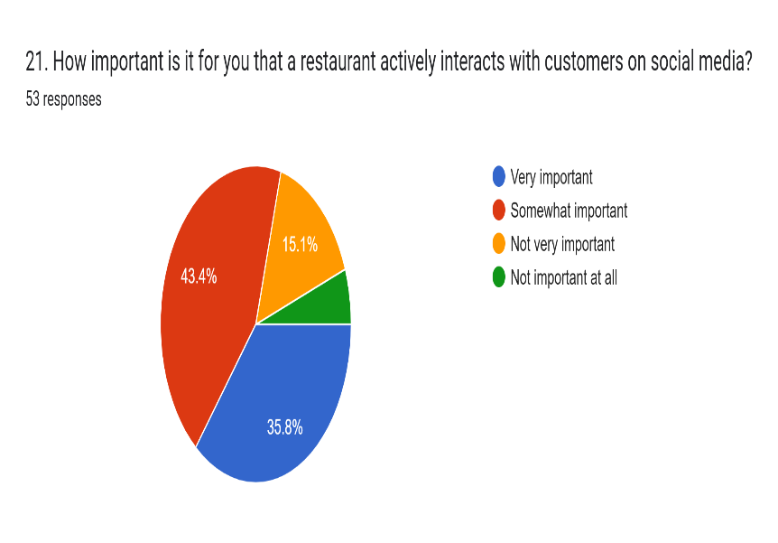
Del total de los encuestados el 43.40% indica que es poco importante que los restaurantes interactúen con los clientes mediante las redes sociales y en segundo lugar el 35.80% indica que si es muy importante.

Figure 15: Surveys question 21 result

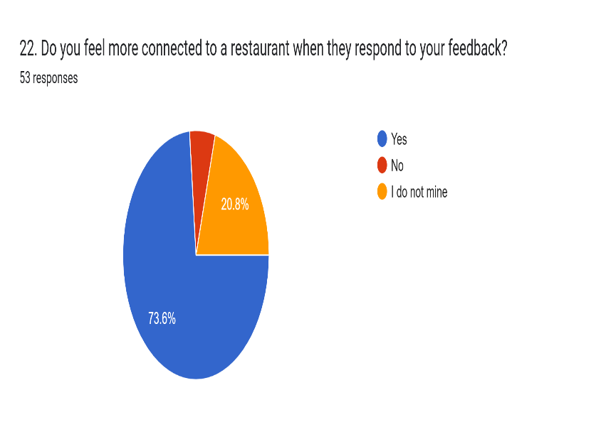
En base a los resultados el 73.60% de los encuestados indica que si se siente más conectados con un restaurante cuando responden sus comentarios.

Figure 16: Survey’s question 22 result

- Interview
M1: Many customers are transient, we focus on creating a memorable impression during their visit, offering loyalty programs encouraging them to visit us again during future trips.
S1: We use is the post-dinner survey via email. We offer complimentary drinks or special discounts as a gesture of goodwill, encouraging customers to return.
S2: We create a positive environment, providing attentive service and leaving them with good vibes so that they want to come back.
Conclusion: Based on the results obtained and in relation to the theory, satisfaction increases when restaurants respond to comments and create memorable experiences.
General conclusion of the chapter: It is concluded that the theories of the authors who talk about the research topic are related to the results obtained from the research carried out, using quantitative techniques (surveys) and qualitative techniques (interviews).

Chapter V: Conclusion and Recommendations

5.1. Conclusion
In conducting the study, we can conclude that the use of artificial intelligence tools and other technologies is a significant contribution to businesses, and in this particular case, it is a great opportunity to enhance the customer experience in the restaurant sector of Dublin. Through the study conducted and the results obtained from surveys, interviews, and the literature review of some authors who discuss the topic, we have been able to identify that the implementation of these tools increases operational efficiency, allows for a deeper personalization of the service, and improves customer engagement with the restaurants. Additionally, there are disadvantages such as reduced interaction with the customer and the high cost of implementing these technologies, which may complicate matters for smaller restaurants to adopt these tools.
New technologies are constantly advancing every year, where there are several AI tools, which is a benefit for all types of businesses and in this particular case, restaurants that must take advantage and establish new strategies to be able to offer good service to their customers with ease, speed, and quality of customer service, because customers still expect good treatment in service.

5.2. Recommendation

Themes | Recommendations
The impact of the new technologies on the restaurants | It is recommended that restaurants take advantage of the use of tools, as for the majority of respondents, the use of these tools helps provide faster service.  New technologies have positive impacts, but there are also disadvantages, but in this regard, restaurants must find the best way to implement new technologies in their businesses. Initially, it may be difficult until they can adapt to the new AI tools that will benefit them by optimizing their time and providing better service.
AI tools to improve customer experience in restaurant | It is recommended to implement AI tools because customers have benefited from their use when visiting a restaurant and have had a better experience.
Advantages and disadvantages of use AI tools in restaurants | It is recommended that they use the tools as a complementary aid to provide better service and not as a replacement. There needs to be an integration between technology and human interaction.
Personalization of services in restaurants | It is recommended to always interact with customers, provide better service, and by collecting customer data, offer promotions and discounts to achieve customer loyalty so they can revisit the restaurant.  Achieving customer loyalty is important because we don't lose the customer, but rather we retain them, and this same customer can recommend us to other customers so they can visit our restaurant due to the good service they have received.
Enhanced customer engagement in restaurants | It is very important to have a good physical environment in the restaurant to generate trust in the customer and make them feel comfortable while enjoying their meal. Always providing a good smile and kindness in customer service.  When a restaurant's physical environment is clean, organized, and the staff is friendly, customers can feel comfortable in the restaurant. It's very important to consider all of these aspects at all times.

5.3. Suggestion
It is suggested that restaurants that implement AI tools train their staff in their use, and that these tools serve as a support for achieving operational efficiency, rather than replacing them. It is also suggested that restaurants leverage customer-provided data to offer discounts, promotions, and build customer loyalty. Some restaurants have CRM systems, which provide customer data, and through this system, they can learn about their tastes and typical orders. Therefore, this represents an opportunity for restaurants to use this data and begin interacting with their customers.

5.4. Limitation
One of the limitations for conducting this study was that, when carrying out the interviews, it was a bit complicated to contact the supervisors or managers to give us the opportunity and time to interview them, but we were able to successfully conduct interviews with 1 manager and 2 restaurant supervisors in Dublin. Many of them did not have much time or were in meetings, etc. But we were able to conduct the interview.

6. References
- Alt, Rainer. (2021). Digital Transformation in the Restaurant Industry: Current Developments and Implications. 1. 69-74. 10.52255/smarttourism.2021.1.1.9.
- Milton, Dr.T.. (2024). Artificial Intelligence Transforming Hotel Gastronomy: An In-depth Review of AI-driven Innovations in Menu Design, Food Preparation, and Customer Interaction, with a Focus on Sustainability and Future Trends in the Hospitality Industry. International Journal for Multidimensional Research Perspectives. 2. 47-61. 10.61877/ijmrp. v2i3.126.
- Limna, P. (2023). Artificial Intelligence (AI) in the hospitality industry: A review article. International Journal of Computing Sciences Research, 7, 1306-1317.
- Kansakar, Prasanna & Munir, Arslan & Shabani, Neda. (2019). Technology in the Hospitality Industry: Prospects and Challenges. IEEE Consumer Electronics Magazine. 8. 60-65. 10.1109/MCE.2019.2892245.
- Esposito, B, Sessa, M.R. Sica, D & Maladrino, O. (2022). Service Innovation in the Restaurant Sector During COVID-19: Digital Technologies to Reduce Customers Risk Perception. The TQM Journal, Vol. 34 No7, pp. 134-164.
- Ameen,N. Tarhini, A, Reppel, A& Anand, A (2021). Customer experiences in the age of artificial intelligence. Computer in Human Behavior, 114, 106548.
- Akhmedova, R. (2024). Transformation of customer experience management in the restaurant business in the context of digitalization. BIO Web of Conferences, 113, 03008.
- Nguyen, T-M, Quach, S, & Thaichon, P. (2022). The effect of AI quality on customer experience and brand relationship. Journal of Consumer Behavior, 21(3), 481-493.
- Goldenberg, B. 2024. Applying AI successfully to customer service: Manage the challenges, realize the benefits. Customer Relationship Management, September 2024, 24-35.
- MORALES, J. Modernizing the Customer Experience with AI. Wealth Management Real Estate, [s. l.], p. 32, 2024. Disponível em: https://search.ebscohost.com/login.aspx?direct=true&AuthType=shib&db=buh&AN=176380388&site=ehost-live.
- Millan, M, G, D. & Vazquez (2024) An economic perspective on the implementation of artificial intelligence in the restaurant sector. Administrative Sciences, 14 (214), 1-24.
- Kumar. I., Rawat, J., Mohd, N., & Husain, S. (2021). Opportunities of Artificial Intelligence and machine learning in the food industry. Journal of Food Quality, 2021 (4535567), 1-10.
- Dani, R. Rawal, Y.S. Bagchi, P, & Khan, M (2022). Opportunities and challenges in implementation of artificial intelligence in food & beverage service industry. AIP Conference Proceeding, 2481(050002),1-8.
- Brown, C. (2024) AI in Restaurants: How Can You Leverage Technology for Greater Efficiency? Paris Gourmet. Available at: https://www.parisgourmet.com/blog/ai-in-restaurants (Accessed: 21 April 2025).
- Manavi, N. R., Ali, J.M, Othman, S, Hussain, & Hashim, H. (2021). Application of artificial Intelligence in the food industry a guideline. Food Engineering Reviews,14 (134-175), 1_42.
- Sousa, A. E, Cardoso. P & Dias, F (2024). The use of Artificial intelligence systems in tourism a hospitality: The tourists perspective. Administrative Sciences, 14(165), 1-23).
- Titov, A. (2017). Examining the increased focus on personalized customer services in the hospitality sector: A service quality and customer satisfaction perspective.
- Harvard Business Review Analytic Services. (2018). The age of personalization: Crafting finer edge.
- Kim, H., Jung, S. & Ryu, G., 2020. A study on the restaurant recommendation service app based on AI chatbot using personalization information. International Journal of Advanced Culture Technology, 8(4), pp.263-270. DOI: 10.17703/IJACT.2020.8.4.263.
- Anshari, M. Almunawar, M,N,Lim, S.A & Mudimigh. A. (2019) Customer Relationship management and big data enabled: Personalization & customization of services. Applied Computing and Informatics, 15(2), 94-101.
- Kabadayi, E,T, Aksoy, N. C & Turkaya, P.B. (2023). How does customer engagement value occur in restaurants? Astimulus organism- response. The Service Industries Journal, 43 (7-8), 497-524.
- Daradkeh, F. M. Hassan, T, H, Pale, T, Helal, M. Y, Mabrouk, S, Saleh, M.I, Salem, A.E. (2023) Enhancing digital presence for maximizing customer value in fast -food restaurants. Sustainability, 15(7) 5690.
- Hernández Sampieri, R., Fernández Collado, C. & Baptista Lucio, P., 2014. Research methodology. 6th ed. McGraw-Hill.
- Braun, V. and Clarke, V. (2006) Using thematic analysis in psychology. Qualitative Research in Psychology, 3(2), pp. 77–101. Available at: https://www.researchgate.net/publication/235356393_Using_thematic_analysis_in_psychology (Accessed: 7 May 2025).

