Applied Project
Submission Form


LEARNER NUMBER | 51726556
NAME | Patricia Veronica da Silva Ferreira
COURSE | BA Marketing
REPORT TITLE | Applied Project
SUPERVISOR NAME | Daniel O’Sullivan
WORD COUNT | 10167
DUE DATE | 12/05/25
DATE SUBMITTED | 12/05/25

I certify that:
- This project report is all my own work, and no part of this report has been copied from another source: Yes ☒ No ☐
- I understand that this report may be checked by electronic or other means for plagiarism and/or content created by generative AI and may be transferred and stored in a database for the purposes of data-matching/data-analysis to help detect plagiarism and/or content created by generative AI: Yes ☒ No ☐
- This report has not previously been submitted in part or in full for assessment to any other institution: Yes ☒ No ☐
- I consent to the inclusion of my report in the publicly accessible (open access) electronic database maintained by the library:
Yes ☒ No☐
- I have emailed a back-up copy of this report to locker@independentcollege.ie:
Yes ☒ No ☐

(Note that if no check boxes are selected, this Project will be regarded as NOT properly submitted, and may be subject to a late submission penalty)

Name: Patricia Veronica da Silva Ferreira
Date: 12/05/2025

For the report to count as a valid submission, the student must provide:
1 electronic copy via Moodle. There is no requirement for a hard copy .

Evidence of the Primary Research MUST be included in the appendix of the report. That includes a copy of questionnaires, interview schedules, or observation diaries. One interview transcript should be included as a full transcript and a summary of all other interviews must be kept as a backup by the student. See template on Moodle for what should be included in all aspects of the report. All data must be anonymised.

The text should be double-spaced throughout and single column format (A4) with 2cm for left and right-hand margins and 2.5cm at head and foot. Text should be justified, standard 12 point, footnotes 10 point, and in Calibri. Page numbers should be at the bottom-right. Do not use line and paragraph spacing. Keep formatting to a minimum and avoid underlining.

Harvard Referencing shall apply.

(Insert work here)

Independent College

"How can small businesses effectively utilize social media to increase brand visibility and engage customers?"

Complied by:
Patricia Veronica da Silva Ferreira
Supervisor: Dr Daniel O'Sullivan

This Project is submitted in part fulfilment of the Degree of Bachelor BA (Hons) in Marketing
May 2025

Acknowledgements

First, I am so grateful to my supervisor and professor Dr. Daniel O’ Sullivan for his guidance, feedback and support throughout this project. He was very generous with his time and expertise which helped develop my project with the topic: How can small businesses effectively use social media to increase brand visibility and engage customers? And the impact of this on small businesses in digital marketing. Daniel also encouraged me to proceed with the information I had, being very attentive with all the information, and very dedicated, always helping me with ideas for this project, I will always be grateful for all his support.
I would like to thank you also for my family but special thanks to my 86-year-old grandmother Olivia for her unconditional love, encouragement and patience even from so far away, always supporting me, listening when I needed, and for being the reason for do not give up.
Another thank you to my boss John who always supported, encouraging and helped me, I will be forever grateful for all his support and understanding, he motivated me to give my best in this project. He also gave me good feedback and suggestions on how to be better which my project.
Finally, I would like to thank the café owners, small businesses owners, and customers who took part in my online survey and interviews. These responses and opinions were very important to the realization of this project.
I am deeply grateful to all these people for their involvement and assistance in this project, thanks so much.

Abstract

﻿This objectives to establish the ways via which small companies take advantage of social media to boom brand attention and customer engagement. A quantitative and qualitative research design was used which involved the use of questionnaires and interviews. This research outlines the various platforms that are used, approaches that are deemed successful and the issues faced by the small businesses. The research presents the key findings that points to the necessity of using videos, targeting the community, and advertisement. ﻿It also considers challenges including insufficient funding, change of algorithms, and absence of abilities in computer programming. This research provides recommendations that may assist the small business in enhancing the use of social media marketing to achieve the intended goals of brand promotion, customer engagement, and profitability.

List of Figures
Figure 1. Social Media Platforms Currently Used by Businesses
Figure 2. Main Reasons for Choosing Social Media Platforms
Figure 3. Frequency of Social Media Posting
Figure 4. Confidence in Using Social Media for Business
Figure 5. Methods Used to Promote Brand on Social Media
Figure 6. Usage of Paid Advertising on Social Media
Figure 7. Impact of Paid Ads on Customer Acquisition
Figure 8. Perceived Importance of Hashtags for Brand Visibility
Figure 9. Partnership with Influencers for Business Promotion
Figure 10. Influence of Partnerships on Customer Interest
Figure 11. Customer Engagement Methods on Social Media
Figure 12. Frequency of Customer Interaction with Posts
Figure 13. Perceived Impact of Engagement on Customer Loyalty
Figure 14. Most Engaging Content Types
Figure 15. Challenges Faced in Social Media Marketing
Figure 16. Actively Asking for Customer Feedback via Social Media
Figure 17. Visibility Decline Due to Algorithm Changes
Figure 18. Use of Free Tools for Social Media Management
Figure 19. Need for Training or Workshops on Social Media Marketing
Figure 20. Metrics Used to Measure Social Media Marketing Success
Figure 21. Regular Monitoring of Social Media Analytics
Figure 22. Most Important Factor in Evaluating Social Media Success

Contents
Acknowledgements 4
Abstract 5
List of Figures 6
Chapter -Introduction 8
1.1 Background of the Research 8
1.3 Statement of the Research Objectives 8
1.4 Information Gathering & Data Collection Technique Used 9
1.5 Expected Outcomes of the Study 9
1.6 Chapter by Chapter Overview 10
Chapter 2- Literature Review 10
Social Media Platforms Utilized by Small Businesses 10
Strategies for Increasing Brand Visibility 11
Customer Engagement through Social Media 12
Challenges in Social Media Marketing 13
Measuring Social Media Success 14
Synthesis and Critical Analysis 16
Chapter 3: Methodology 16
3.1 Theoretical Paradigm / Philosophy Employed 16
3.4 Explanation of Analysis Method Employed 18
3.5 Ethical Considerations 20
Quantitative Findings 20
Chapter 5- Discussion 36
Theme 1: Social Media Platforms Utilized by Small Businesses 36
Theme 2: Strategies for Increasing Brand Visibility 37
Theme 3: Customer Engagement Through Social Media 39
Theme 4: Challenges in Social Media Marketing 41
Theme 5: Measuring Social Media Success 42
Conclusions 44
References 46

Chapter -Introduction

1.1 Background of the Research
The use of social media has greatly influenced the business environment especially for the small businesses. These have become core tools through which small business can improve on their brand awareness and customer relations. This evolution is of great interest because social media allows the small businesses to compete for the markets that they could not previously afford due to limited capital. ﻿Social media platforms including Facebook and Instagram are specifically famous among small organizations because of the big variety of users and the opportunity of direct communique.
1.2 Rationale for the Study
The rationale for this research stemmed from the desire to fill the gap of research on the use of social media in the marketing of small business. It is a well-known fact that social media has lots of opportunities but many small businesses fail to use them properly. Challenges that they face include; limited funds, lack of technical knowledge, and constantly changing nature of the social media platform. This paper therefore aimed at not only establish the strategies that are used by small businesses but also the challenges facing the businesses and their solutions.
The research question guiding this study was: "How can small businesses effectively utilize social media to increase brand visibility and engage customers?"

1.3 Statement of the Research Objectives
Theme 1: Social Media Platforms Utilized by Small Businesses
  - Sub-research question 1: Which social media platforms are used most often by small businesses?
  - Sub-research question 2: How can these small businesses decide which platforms to adopt?
Theme 2: Strategies for Increasing Brand Visibility
  - Sub-research question 3: How do small business owners navigate to ensure that their brands are well-featured on the social media platforms?
  - Sub-research question 4: To what degree do these strategies work for customer acquisition?
Theme 3: Customer Engagement through Social Media
  - Sub-research question 5: How can small businesses harness marketing social media to enhance customer engagement, attraction, and loyalty in the long term?
  - Sub-research question 6: To what extent does customer engagement affect brand loyalty in small business organizations?
Theme 4: Challenges in Social Media Marketing for Small Businesses
  - Sub-research question 7: What difficulties can be met when small businesses apply social media?
  - Sub-research question 8: What strategies do small businesses adopt to deal with these challenges?
Theme 5: Measuring Social Media Success
  - Sub-research question 9: How do small businesses measure the success of their social media marketing efforts?
  - Sub-research question 10: Which KPIs are applied in the analysis of social media campaigns?

1.4 Information Gathering & Data Collection Technique Used
To collect data for this study, a mixed-methods approach was used in order to obtain detailed information. ﻿Using online questionnaires, quantitative facts was amassed to determine the cutting-edge developments inside the use of social media and the belief toward it most of the small commercial enterprise and their customers. Semi structured interviews were used to collect qualitative data from the small business owners and customers to get their experiences and perception. This approach made it possible to have a more elaborate view of the research problem.

1.5 Expected Outcomes of the Study
This study expected to offer useful knowledge and guidelines for the small business companies that aim to enhance their social media marketing. The expected outcomes were to understand the most suitable social media platforms and their strategies for small businesses and the challenges that the businesses encounter. In this connection, the purpose of this study was to help advance the best practice of social media marketing for small businesses and, therefore, to increase their brand awareness, customer interactions, and profitability.

1.6 Chapter by Chapter Overview
- Chapter 2: Literature Review: This chapter reviewed existing literature on digital marketing for small businesses.
- Chapter 3: Methodology: ﻿This bankruptcy distinctive the research methods hired in the examine, consisting of the use of each quantitative (surveys) and qualitative (semi-established interviews) methods.
- Chapter 4: Quantitative Findings: This chapter presented the findings from the online surveys & interviews.
- Chapter 5: Discussion: This chapter presented the findings derived from the semi-structured interviews, and compares to literature review to address the topic and research questions.
- Chapter 6: Conclusion: This chapter summarizes key findings, state limitations and recommendations of the research.

Chapter 2- Literature Review
This literature review will, therefore, follow the existing literature to build up knowledge in the area of digital marketing for small businesses. It defines what practices can still be implemented such as activity choice and content distribution, what difficulties appear such as limited funds and algorithm changes, and how such difficulties can be addressed. Besides, it discusses how businesses define and quantify success by evaluating engagement metrics and key performance indicators. The knowledge derived from this research will therefore serve as a reference point for counselling the small businesses on how to harness social media as a tool to improve on branding and hence the engagement of the customers.

Social Media Platforms Utilized by Small Businesses
In this respect, social media platforms have become crucial channels through which small businesses need to increase brand awareness and boost customers’ relations. As there are many platforms to choose from, small businesses strategically focus on a limited number of platforms depending on factors like the demography of the customers they need to attract, the requirements of the industry they belong to, as well as the functionality of the platforms they select. It was also considered crucial to identify which of the platforms are frequently employed and by virtue of which criteria the platforms were selected.
Facebook and Instagram have once more emerged as some of the most frequently reported platforms by the small businesses. Adeola, Hinson, and Evans (2020) posit that these platforms are popular due to captivation by their cost-free nature, huge customer base, and the interactive nature of the platforms to reach as many clients as possible. In a similar vein, Aydin (2020) underscores how Instagram comes out on top of the list in predominantly visual business sectors that include the Hospitality sector since Instagram provides a higher level of customer engagement because of its image bias. Advertising integrated in the social network and flexible targeting of diverse population layers make Facebook one of the most popular platforms for businesses targeting various customer groups.
However, there are some small businesses that engage especially in LinkedIn and TikTok to achieve certain marketing objectives. According to Khanum (2023), from the growing list of platforms, business targeting professional users are gravitating to linked in while small businesses targeting younger generation such as Tiktok offer them a chance to explore new markets. Such platforms offer specific benefits that allow firms to target subsets of the audience successfully.
Decision making for platform selection is discussed by Malesev and Cherry (2021) in greater detail. In their study, they identify factors including, the ability of Instagram to engage in visual narratives, and the extent of comprehensive advertising tools in Facebook as influential in the adoption of the platforms. Notably, Twitter is least preferred by the small businesses because of having fewer engagement tools, and a shrinking user base, and yet it can certainly provide real-time updates.

Strategies for Increasing Brand Visibility
Small businesses try many unique ways of promoting themselves in order to capture markets that compete fiercely. For these media resources, aims compared with conventional media range from broader public awareness to targeted promotion; due to their constraints of budgets and funds, tools like ads, hashtags, and influencer marketing create their affordable means of increasing visibility and engaging with the audience. Such approaches assist companies to achieve the goal of familiarizing its brands to the market and creating customer interest. This section assesses the application and success of these approaches based on articles and case studies.
Probably the most effective way of making your brand be visible to the targeted audience is through advertising. The same result was supported by Dolega, Rowe and Branagan (2021), who determined that the advertisement on social platforms such as Facebook is very effective in raising traffic to the firm’s website and increased sales. These campaigns help small businesses reach the audiences with specific characteristics and behaviours, which means that the marketing messages will go only to the likely buyers. For instance, an online bookstore that aims its services at readers aged between 18 and 35 can achieve tangible outcome growth of brand awareness and sales by using highly relevant ads.
Another great tactic is the wise use of hashtags as part of the hashtag marketing strategy. According to Utomo et al. (2023), LoMaL by utilising hashtags as promotional tools is able to open a door to other significant audiences, especially when associated with trending themes or the specific industries. Companies that implement relevant hashtags usually record massive engagement and reach improve massively. For example, a small fitness studio using those tags as #FitnessGoals or #HealthyLiving will target health-conscious people and get more visibility within a particular niche.
Influencer marketing also happens to be effective for small businesses. According to Ren, Tan, and Wan (2023) micro influencers, thanks to their highly relevant audience for a given product or service, it is possible to obtain a high level of exposure at a relatively low cost. For instance, a bakery that works together with an influential food blogger would expand the bakery product coverage in a particular section of the market without compromising the credibility of the work.
While these strategies work, they have to be used flexibly with changes in algorithms and or users’ habits in mind. Khanom (2023) It, therefore, called for sustained awareness and improvement on strategies through which business can meet the growing competition. This way, the strategies are put in compliance with the likes of the target clients and trends in the market hence the success of the small businesses.

Customer Engagement through Social Media
Enticing the customer remains the key focus of social media marketing since it is the primary base of customer acquisition, customer retention and ultimate business success. Engagement metrics including number of likes, comments, and number of shares are used by small businesses to enhance the bond with clients, promote higher satisfaction and have them loyal in the long run. This section looks at how interaction with social media impacts these outcomes and the consequence for small business.
Customer attraction cannot be possible if the social media accounts will not be engaging the public in a highly relevant and meaningful manner. In a poll or quiz type of post, Adeola, Hinson, and Evans (2020) noted that the use of interactive content drives the attention of the intended customers. For instance, a tiny fitness studio that engages its audience with some fitness tips or who shares a new workout set and answers questions in retweet benefits from a highly active and loyal audience that is eager to participate. Such interactive communication causes one to occupy the mind of the customer thereby pulls new customers.
Another of the most important benefits in this case is the ability to gain the client’s loyalty due to constant usage. According to Ren, Tan, and Wan (2023), brief and timely replies to questions, an effective response to feedback and constructive engagement with customer retain trust and foster an emotional bond. For example, a local bakery that acknowledges the positive comment made about it or tries to work on issues raised by a customer is establishing some form of a working friendship with its audience, thus encouraging consumers to wait for the next issue to be sorted out before they visit the bakery again.
The use of social media also leads to business success because it gives the business a transparent view of what the customers want. This is according to Utomo et al. (2023) , who stated that focusing on engaging metrics like the posts with most shares or comments enables a business to create a strategy that fulfils customers’ expectations. For instance, a clothes store that has interactions with its clients on the social media platforms can enhance its products and thus boost sales and customer satisfaction.
But it is sad to note that, success in engagement requires, honest and consistent engagement. Based on Aydin (2020), generic or templated messages harm the relationship, while deliberate messages build it. There is also the need of quantity in terms of engagement since this is in relation to the company’s goals and objectives and the depth of the customers’ interactions with the businesses in question.

Challenges in Social Media Marketing
Lack of funds has remained a major problem, Due to scarcity of funds, the government health care systems cannot meet its financial obligations. Chen and Burgess (2020) point out that small business largely fail to devote sufficient funding to paid advertising, hiring professional content creators and using sophisticated analytical tools. Lack of good and consistent funding will result in brand visibility and customer engagement being irregular. For example, you have a small café; it will be hard to support advertisement promotion, thus making it hard to compete with other companies.
Algorithm changes even make these troubles worse. Obar and Wildman (2015) state that the material which users tend to see in their Facebook, Instagram, and TikTok Feed are often more personal, and therefore businesses have less organic exposure for their posts. This leads to relying on paid advertisement that may sometimes be unaffordable due to small finances available. The dynamics presents a real notion of challenges to businesses trying to smoothen their strategies in line with changing trends.
Furthermore, there is a negligible in skills and technical know-how among stakeholders which is a significant factor. For instance, Schultz and Peltier (2013) have revealed that small business owners are generally unaware of how to leverage social media tools, read social data and create bespoke campaigns. This gap leads to poor utilisation of resources and below par marketing outcomes. For instance, a fitness studio could struggle to use social media data to improve its sales campaigns and therefore has difficulty in getting to the right consumers.
To overcome these challenges, there are several cost-effective solutions that small business can and should adopt. According to Fischer and Reuber (2011), businesses should use free applications such as Canva for designing their content and Hootsuite for posting content on social media platforms. Sharing the work with customers to develop user-generated content is more genuine and cost-efficient.
Algorithm changes, in my opinion, are unavoidable but they can be controlled or reduced by concentrating on the audiences and content with actual value. Like De Vries, Gensler, and Leeflang (2012) pointed out, increasing the number of brand followers engaged and creating long-term relationships with fans through posting update frequency, informative, and entertaining content to exact less reliance on the edge rank. Similarly, knowledge gaps that need to be overcome to address technical skills entail carrying out training or workshops to enhance marketing knowledge and flexibility.
Therefore, lack of capital, changes in algorithms, and talent deficiencies heavily impact small business’ social media advertising. But, using inexpensive tools, making appropriate content, and gaining technical abilities, these issues can be controlled that allow SMEs to achieve sales growth in digital marketing.

Measuring Social Media Success
Evaluating performance of social media campaigns is essential in determining the effectiveness of the strategies being implemented by the small business with the primary goal of improving on their marketing strategies for evidently increased expansion. The levels of engagement on posts, conversion rates, and the ROI (Return on Investment) definitely offer important information about how well such strategies work so that businesses can adjust them. This section looks at how these KPIs are implemented and will also seek to explain why these metrics are important in evaluating social media.
Engagement rates are considered the first level of measuring the effectiveness of the shared posts on social media platforms. De Vries, Gensler and Leeflang, (2012) argue that likes, comments and shares convey a significant bond between the business and the people. In light of this assumption, it can be concluded that C2C communication is vital for creating awareness because posts that are visually appealing, and those that elicit an emotional response, achieve higher engagement. For instance, a firm that owns a start-up jewellery store that has created a brand with vibrate and inspiring graphic appeals can keep and lure customers through consistent communication.
Uses conversion rates as distinct parameters to demonstrate how social media campaigns affect the attainment of certain objectives. Fischer & Reuber (2011) note that when adapted to audiences, there is sure to be the best-performing calls-to-action (CTAs). A local bakery, for example, having advertisements that feature a “limited-time discount” on its website can assess the campaign’s success by visitors making an online order.
Then, ROI is still one of the most crucial metrics that reflects the organization’s financial performance in social media activities. Taneja and Toombs (2014) can support for this by stating that it is always important to know the ROI to realise whether the resources spent, whether these are in the form of paid advertisement or content creation, is worth it. Those businesses that have rather specific goals defined, such as the desire to boost sales or attract more customers, have more chances to determine ROI properly. For instance, awareness of how an organic clothes selling company can determine the ROI could include consideration of revenue generated through specific campaigns against overall additional expenses on ad spaces and campaign content.
The above KPIs are best measured using the tools like Facebook Insights, Instagram Analytics, or Google Analytics. According to Chaffey & Smith (2017) these tools allow small businesses to control the activity of users, and the effectiveness of campaigns and audience characteristics. For example, it can find out what kind of posts get most attention at a fitness studio and shift its focus to such types of posts.
Thus, to interpret data, a small business often lacks experience, which can make it confusing. Schultz and Peltier (2013) suggest that just three are desirable: engagement, conversion, and ROI if those match business goals. Thus, streamlining the analytical process ensures that smaller firms derive insights that will benefit them while also not turning them into data.

Synthesis and Critical Analysis
The literature analysis reveals that social media plays a very significant function in raising brand awareness and customer interaction for small entrepreneurial ventures. In the most fundamental level, key findings are made across topics of commonly used platforms, fundamental approaches like targeted adverting and hashtags, and the role of metrics like likes, comments, and shares for loyalty. Nonetheless, budget and lack of high technical skills, change of algorithm, and general sophistication of analytics reduces chances of small businesses to fully harness these platforms. Studies are still lacking though of course there are some tips and issues that emerged on the importance of the research: the lack of information about specific target market categories and how to assess customer engagement programs within a targeted, niche industry and the lack of information on the flow of funds coming in with the customer engagement program and how it has an effect on the business in the long run. Such gaps inform the channel’s reliance on quantitative surveys to establish such aspects as, the use of the platform, effective engagement and perceived success. By focusing on these aspects, the study hopes to come up with recommendations that can be of great assistance to small businesses aspiring to move to the online platform.

Chapter 3: Methodology
This chapter explains the method used in the study on how small businesses can use social media to improve brand awareness and interact with customers. ﻿The have a look at hired both quantitative and qualitative studies designs to ensure that the studies questions were answered correctly. The quantitative component of the study used a survey while the qualitative part involved conducting semi structured interviews.

3.1 Theoretical Paradigm / Philosophy Employed
The study was based on the constructivist ontological assumption with an inductive epistemology. This philosophical approach is suitable for studying the various aspects of social media use by small businesses and the variety of perspectives of the business managers and consumers (Ahmed,2008). ﻿In an ontological angle, constructivism assumes that fact is not a concrete truth but is built socially through individuals and groups. This means that what is considered effective in the use of social media depends with the various interpretations made by the various small businesses and their customers in different contexts. In epistemological terms, inductive reasoning was used in the study. This implies that the study aimed at constructing meaning of the phenomenon by trying to establish understanding of the participants’ experiences. Unlike the research that assumes a hypothesis and then tries to prove it (hypothetical deduction), the study sought to gain new knowledge and look for patterns in the data gathered. The use of the interview questions without a structure enabled the participants to give their opinions and experiences on the topic of the research which made the research more elaborate. This constructivist-inductive approach enabled the development of the research question given that experiences on social media are relative and thus the themes and patterns emerging from the data collection process. ﻿This approach is extra suitable for qualitative research since it focuses more on the intensity rather than the breadth of the research have a look at. While the quantitative survey furnished a broader evaluate of tendencies, the qualitative interviews offered in-intensity insights into the "how" and "why" in the back of social media practices and perceptions (Ahmed,2008).
3.2 Justification for the Adoption of Methods
Therefore, the study used both quantitative and qualitative research methods in collecting and analyzing data. This approach was chosen to take the advantages of the two methodologies and give a better and more reliable insight into the research question.

3.2.1 Quantitative Method: Survey
The quantitative part of the study entailed the use of a structured questionnaire with closed questions. In this study, the survey was adopted to gather data on the use of social media, choice, and disposition towards social media activity among the customers (Haq,2015). The survey tool used was Google Forms, which enabled its administration through the internet. This made the data collection to be more structured and easily analyzed statistically since most of the questions asked were closed-ended. ﻿The survey questions have been precise to become aware of the details of the social media usage which incorporates the desired platform, content, and the manner customers interact in it.

3.2.2 Qualitative Method: Semi-Structured Interviews
The qualitative part of the study was the collection of data through administering semi-structured interviews to the owners of small businesses and customers. ﻿Semi-based interviews permit the studies to awareness into the members’ reviews, views, and perceptions. The interview questions have been established in a manner that recommended the individuals to offer problematic responses to the questions posed (Orobia, 2013).
3.3 Outline of Sampling Technique and Sample Size

3.3.1 Sampling Technique
The technique used in the study to recruit participants was through convenience sampling. Convenience sampling is a type of non-probability sampling technique in which the participants are chosen depending on their accessibility (Golzar, et.al, 2022). The participants for the survey were contacted via social media platforms. The survey link was posted on various sites and the people who agreed to participate and were qualified according to the criteria (for example, a customer of the small business or an owner of small business) were selected into the sample. ﻿The participants for interviews were additionally diagnosed via personal contacts and guidelines, where efforts were made to select person with know-how and familiarity with the research subject matter.

3.3.2 Sample Size
The quantitative of the study received 20 respondents who filled the online survey. This sample size was considered adequate for the purpose of identifying the general tendencies and trends regarding the use of social networks and attitudes towards them. In the qualitative part of the study, the participants included 4 people.

3.4 Explanation of Analysis Method Employed

3.4.1 Quantitative Data Analysis
The quantitative data that was collected from the online survey was analyzed using the Microsoft Excel. Frequency and percentage were used to analyse the data as they are basic forms of descriptive statistics. The findings were summarized in tables and figures that would help in the interpretation of the results and to show the trends in the study. This type of analysis gave a broad picture of the social media usage and inclination of the respondents of the survey.

3.4.2 Qualitative Data Analysis
The data collected from the semi-structured interviews were analyzed through thematic analysis. Thematic analysis is a method of identifying, analyzing and reporting patterns of phenomena in qualitative research. The thematic analysis was done using an inductive method, whereby themes were developed from the data collected and not the other way round. The procedure followed in the analysis process included the following: The first step involved taking a word by word record of the interviews conducted in order to come up with a written record of the interviews. Second, to become familiar with the data by going through the transcripts and reading them through several times with a view to getting an idea on what is contained in them. Third, the transcripts were analyzed by categorizing them into labels or codes in a systematic manner. The initial codes were sorted and categorized into superordinate themes. The themes were derived from patterns and important concepts that emerged throughout the study. Finally, the themes were analyzed and revised in order to capture the main ideas of the data collected. Some of them were combined while other were split or changed. Sixth, the final themes were clearly identified and labeled, and an account was given to explain each theme and its relevance. Finally, the themes were discussed in relation to the research question and the existing literature to make conclusions and findings (Maguire & Brid, 2017).

3.4.3 Thematic Coding Table
Transcript Excerpt | Initial Code | Theme
"Always nice seeing pics of coffee and delicious food but also what I think gives the extra edge to any business is their content based on connections with the staff, customers, locals and their dogs that come in every day." (Respondent 1) | Visual appeal, Community connection | Content Preferences and Engagement
"Visual appeal since he is drawn to “nice looking coffee” which supports research on marketing through images." (Respondent 2) | Visual appeal | Content Preferences and Engagement
"The blend of put up types consists of visuals, tales, special at the back of-the-scenes content material, UGC, and promotions which drives maximum target market attain and establishes emotional bonds." (Respondent 3) | Content variety, Emotional connection | Social Media Strategies
"Her digital capabilities are restricted because she uses only Instagram without understanding alternatives—this strengthens the idea of limited digital scope." (Respondent 4) | Limited platform use | Challenges in Social Media Utilization

3.5 Ethical Considerations

3.5.1 Informed Consent
The participants were read and signed a simple consent form that outlined the study objectives, activities to be conducted, the possible risks and benefits of the study and their right to withdraw from the study at any time. The study involved participants were only allowed to participate in the study after they had given their informed consent. In the survey, the consent was taken by accepting the information mentioned in the form and then submitting the form. In interviews, the participants filled consent form (Govil, 2013).

3.5.2 Confidentiality and Anonymity
The identity of all the participants was kept anonymous and their information was kept confidential. In the survey, no personal details were taken unless the participant wanted to give them. In interviews, the participants were named as (Respondent 1, Respondent 2, Respondent 3, Respondent 4) to avoid the identification of the participants in the reporting of the findings. All the data was kept securely and discarded after the study is over (Govil, 2013).

Quantitative Findings
Which social media platforms does your business currently use
Instagram is the dominant platform, used by 45% of businesses. Facebook and Instagram together 1are used by 15% of the businesses. Facebook, Instagram, LinkedIn, TikTok, and YouTube are used by another 15. Advertising features drive 5% of businesses to use Instagram, TikTok, and LinkedIn. Another 5% use Instagram and LinkedIn as well.
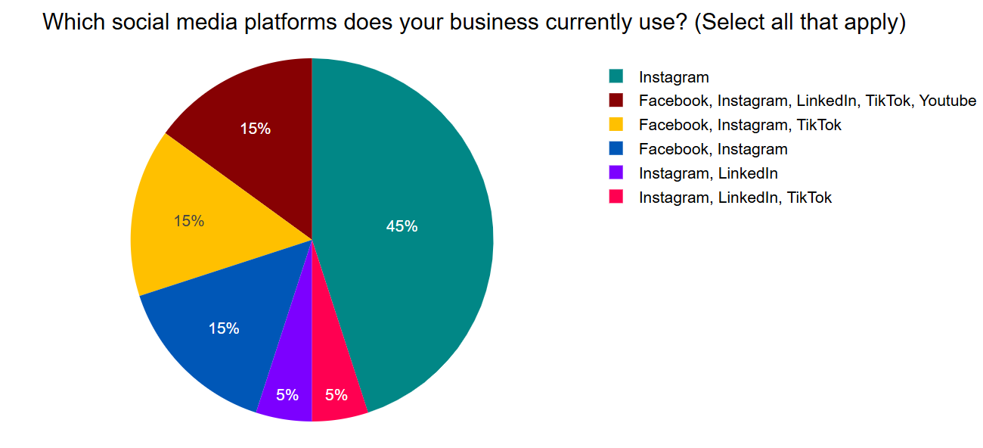
Figure 1
What was the main reason for choosing these platforms?
Small businesses primarily choose platforms based on customer demographics (45%) and ease of use (30%). Another portion also values advertising features (20%), the remaining 5% cited competitor presence.

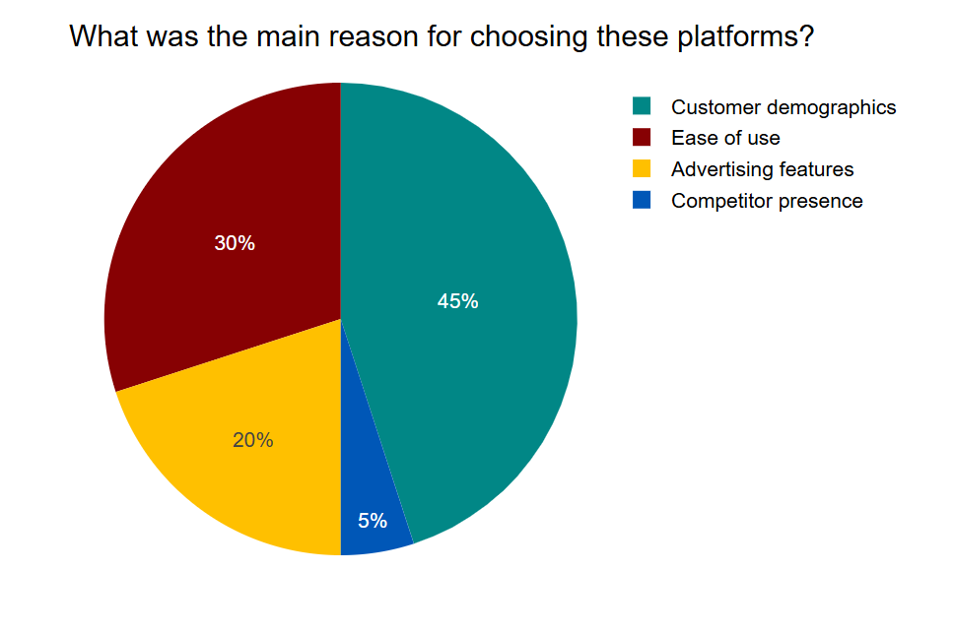
Figure 2
How often do you post on social media?
Around 35% of businesses post multiple times a day, while 30% post a few times a week, and 25% post once a day. The remaining 10% post less than once a week.

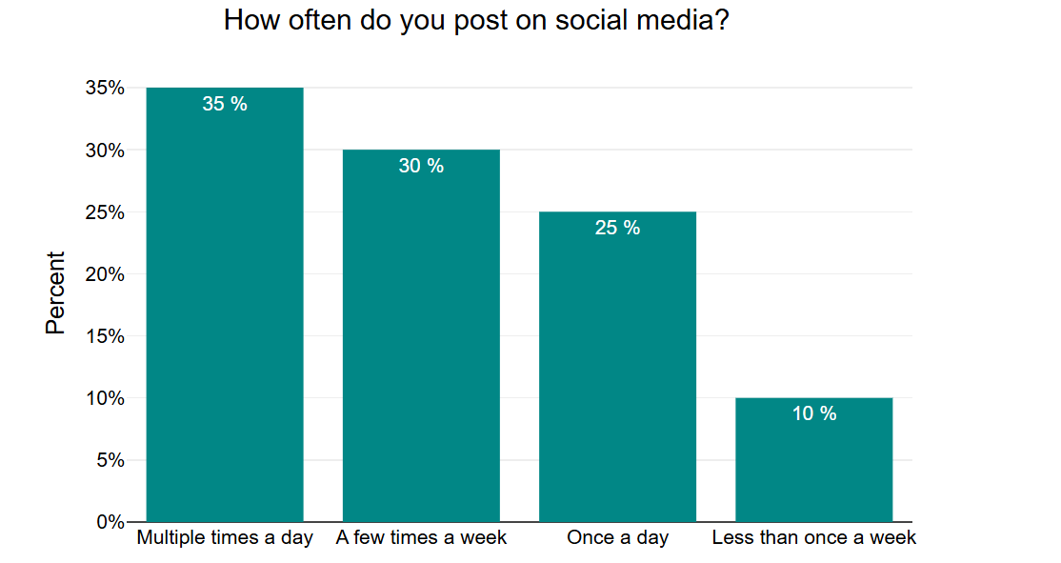
Figure 3
Do you feel confident about using social media for your business?
A strong majority (90 %) of businesses feel confident using social media for their marketing efforts, with only 5% indicating uncertainty and remaining 5% indicating they don’t feel confident.
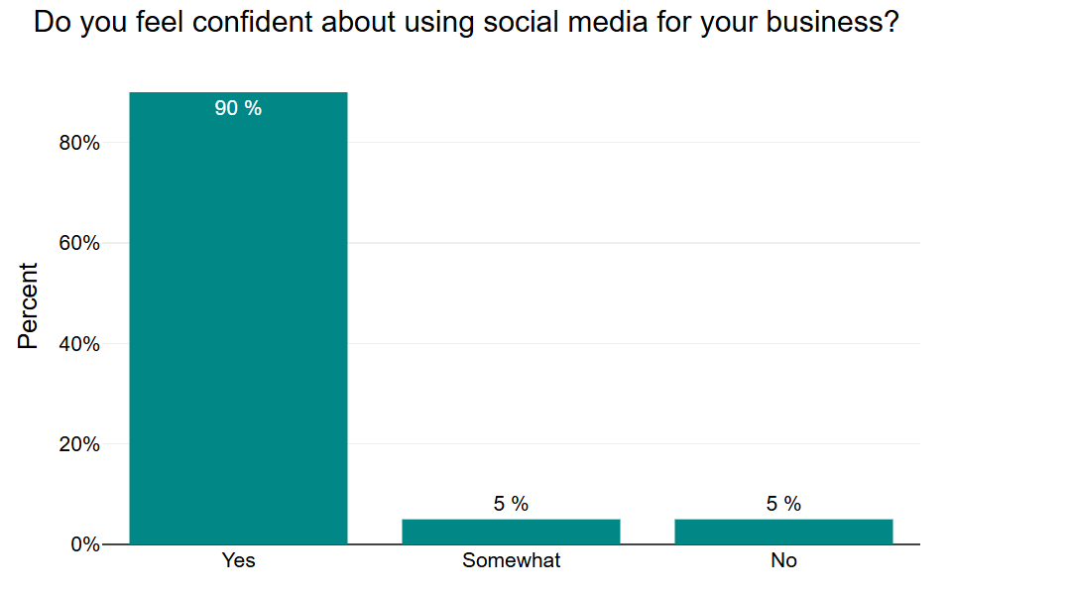
Figure 4

Methods used to promote Brand on social media
The most popular method small businesses use to promote their brand on social media is "Regular posting and engagement," accounting for 29.4% of the responses. Then 6.9% utilize "Paid advertisements, Hashtags and trending topics, Influencer collaborations, Regular posting and engagement." Another 6.4% combine "Paid advertisements, Influencer collaborations, Regular posting and engagement." Similarly, 5.9% use "Paid advertisements, Hashtags and trending topics." "Influencer collaborations, Regular posting and engagement" is employed by 5.9%, while "Paid advertisements, Influencer collaborations" accounts for 5.4%. Lastly, both "Paid advertisements, Hashtags and trending topics, Regular posting and engagement" and "Hashtags and trending topics, Regular posting and engagement" are used by 16.2% of the businesses surveyed.
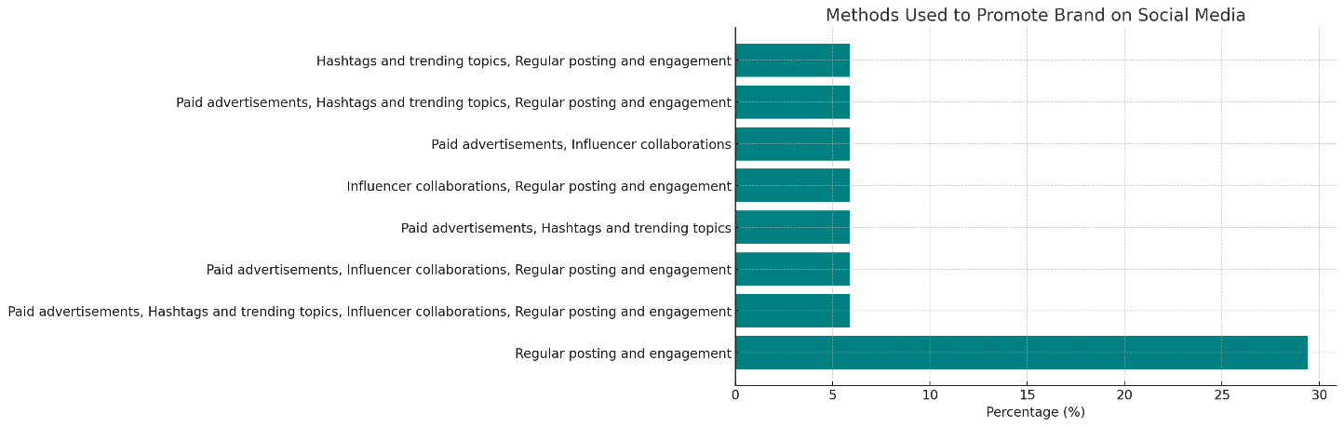
Figure 5
Have you used paid advertising on social media?
A significant portion, 55%, of businesses report using paid advertising on social media occasionally, while a smaller segment, 15%, utilizes it regularly. Notably, 30% of businesses indicate that they do not use paid advertising on social media at all.
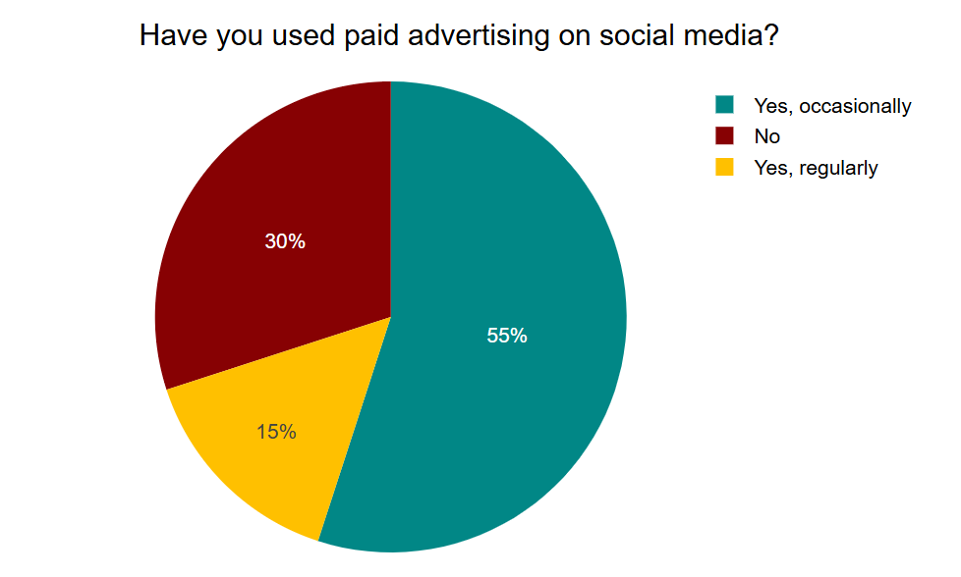
Figure 6
If you use paid ads, do they bring more customers to your business?
From the data, 40%, find that paid ads bring in customers "a little." with 30% reporting that paid ads do "not really" bring in more customers and another 30% experiencing that they bring in customers "a lot."
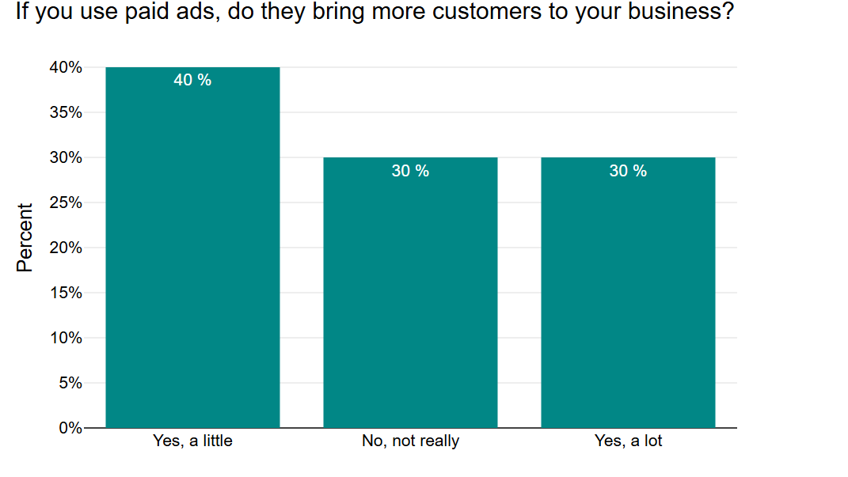
Figure 7
How important do you think hashtags are for increasing brand visibility?
A substantial 45% of businesses consider hashtags to be "somewhat important." Following this, 30% believe hashtags are "very important" for increasing brand visibility. The remaining 25% hold the view that hashtags are "not important" in this regard.
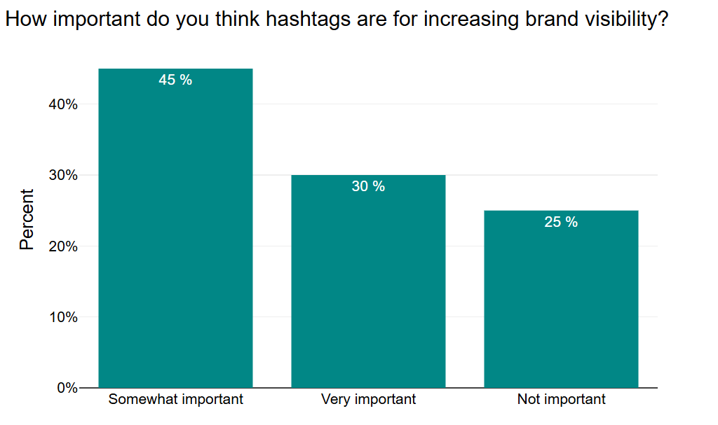
Figure 8

Have you ever partnered with influencers to promote your business?
A significant majority, 70%, of businesses report having partnered with influencers to promote their business. In contrast, a smaller proportion, 30%, indicate that they have not engaged in influencer partnerships for business promotion.
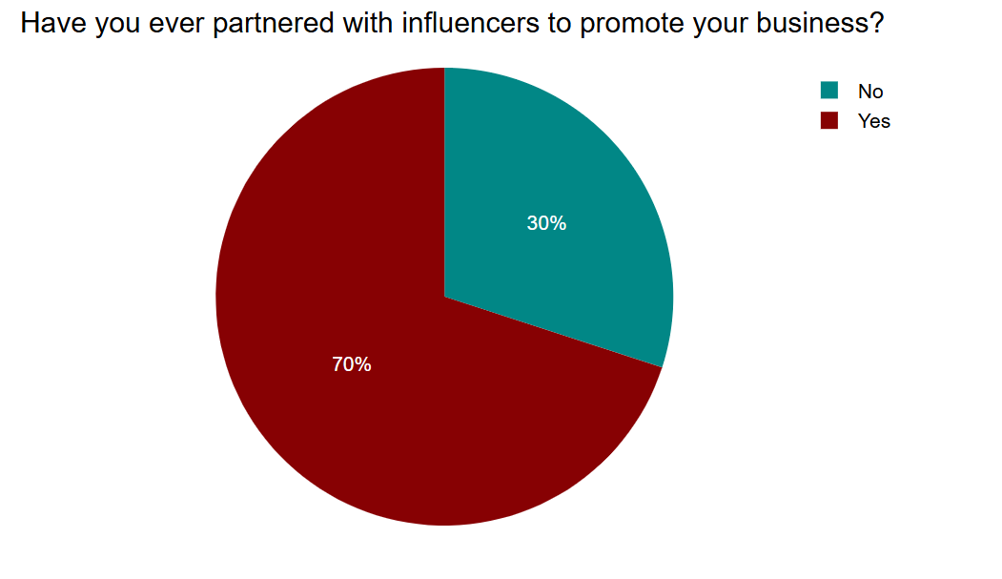
Figure 9
If yes, did the influencer partnership help increase customer interest?
A substantial 50% found that these partnerships increased customer interest "significantly." Another 20% experienced "a little" increase in customer interest. However, a notable 30% reported that their influencer partnerships did not lead to an increase in customer interest.
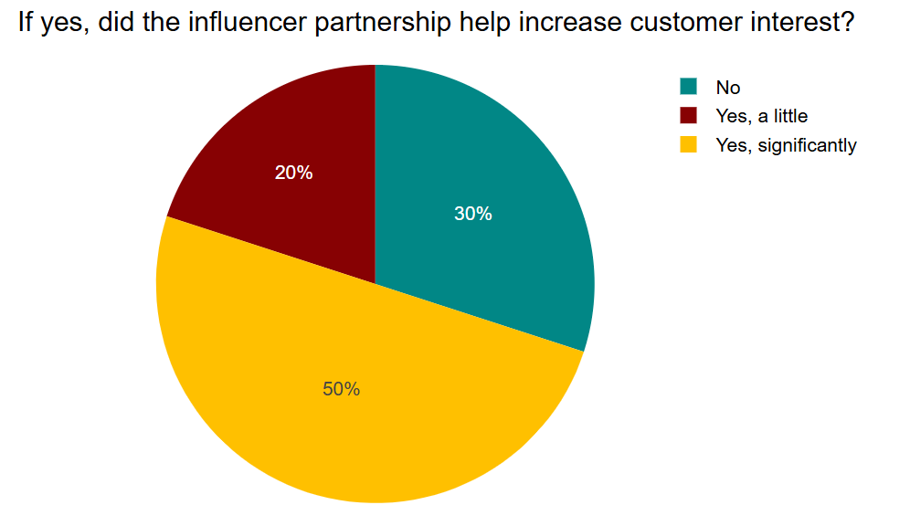
Figure 10

How do you engage with customers on social media?
The most prevalent approach, utilized by 25%, involves responding to comments and messages, as well as sharing customer reviews and testimonials. A slightly smaller percentage, 20%, engage by responding to comments and messages, posting polls and interactive content, and sharing customer reviews and testimonials. Responding to comments and messages combined with running contests and giveaways is used by 15% of businesses. Sharing customer reviews and testimonials alone, as well as running contests and giveaways independently, are each used by 5%. Posting polls and interactive content as a sole engagement method is the least common, at 3%.

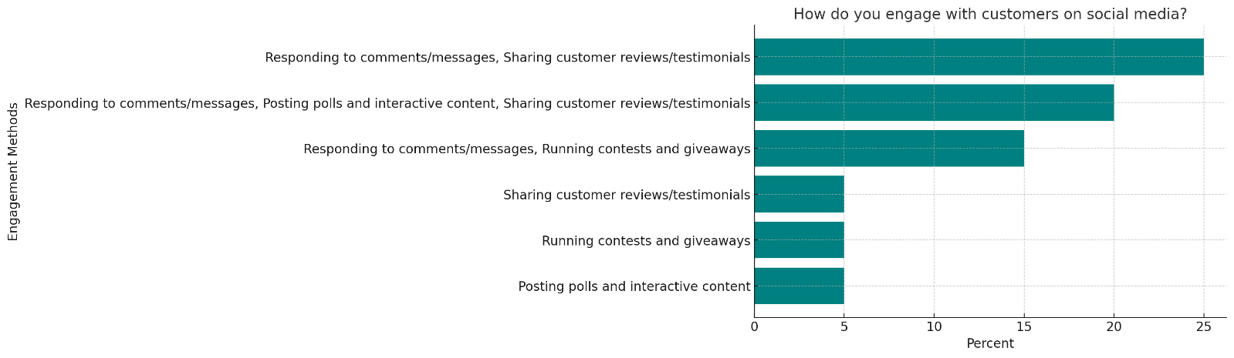
Figure 11

How often do customers interact with your posts (likes, comments, shares)?
A majority of businesses, 55%, experience customer interaction "often." A substantial 35% report that customers interact with their posts "sometimes." The remaining 10% indicate that customer interaction with their posts is "rare."
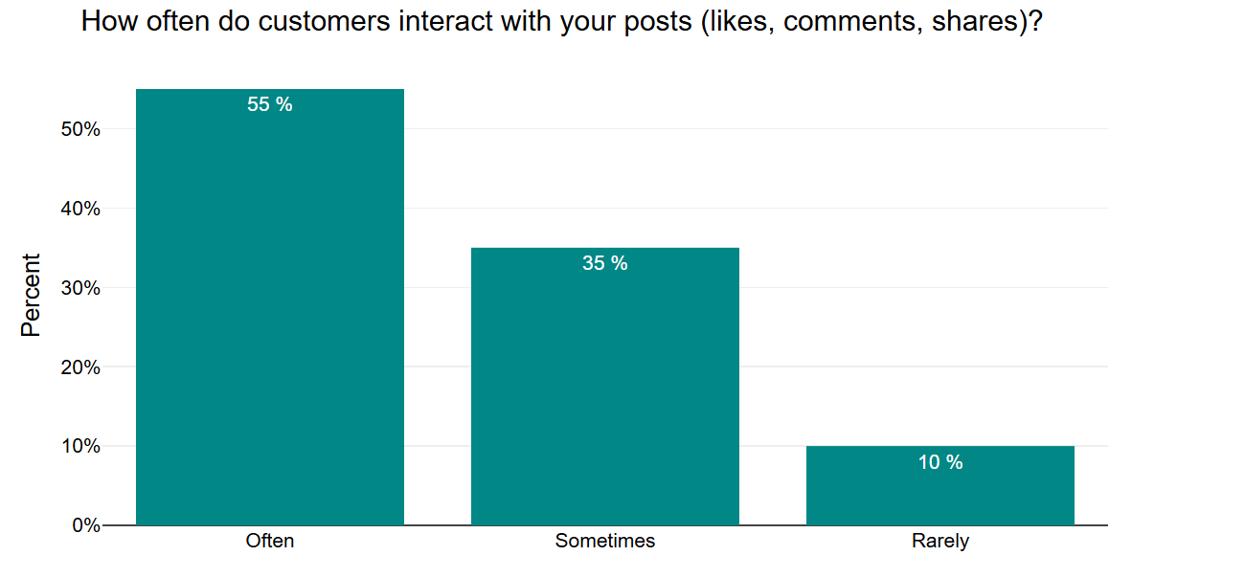
Figure 12
Do you think engaging with customers on social media increases their loyalty to your business?
An overwhelming majority, 85%, of businesses believe that engaging with customers on social media does indeed increase their loyalty to the business. A smaller proportion, 15%, are less certain, responding with "maybe."
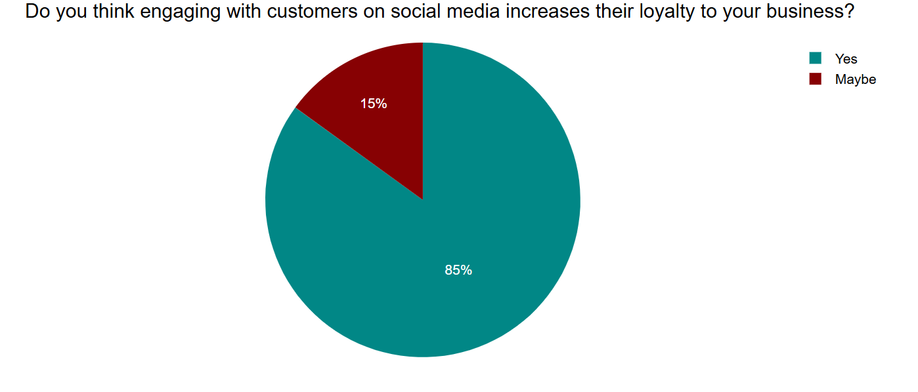
Figure 13
What type of content gets the most engagement for your business?
The most engagement, videos stand out significantly, capturing the attention of 60% of businesses. Photos also perform well, accounting for 30% of the most engaging content. Text posts and live streams receive considerably less engagement, each cited by only 5% of businesses as the content type that resonates most with their audience.
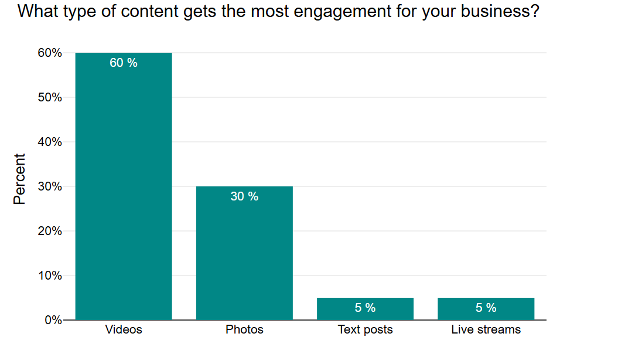
Figure 14
What challenges do you face with social media marketing?
The most significant challenge, reported by 30%, is the lack of time to manage social media effectively. Budget constraints for advertising are also a substantial hurdle for 15% of businesses. Difficulty keeping up with platform changes affects 10% of respondents. Several combinations of challenges are also noted: a lack of time to manage social media, budget constraints for advertising, and difficulty keeping up with platform changes are experienced by 5%. Similarly, a lack of time to manage social media and difficulty keeping up with platform changes is a challenge for another 5%. Budget constraints for advertising combined with difficulty keeping up with platform changes are faced by 5%. Finally, not knowing what type of content to post is a challenge for 5% of businesses.
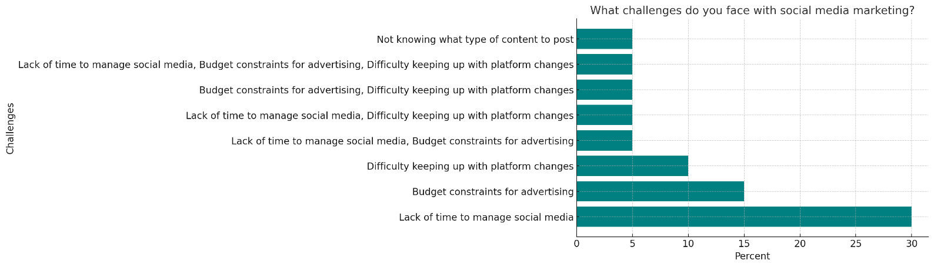
Figure 15
Do you actively ask customers for feedback through social media?
A slight majority, 55%, of businesses actively seek customer feedback through social media. Conversely, 45% of businesses do not actively ask for customer feedback on these platforms.
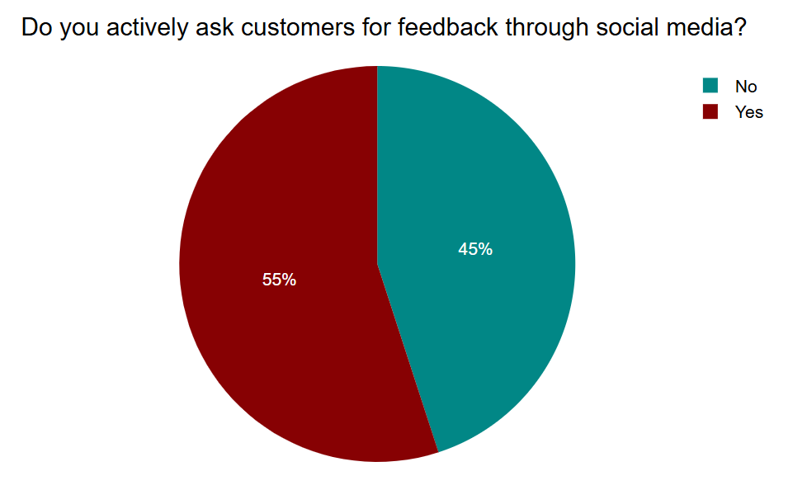
Figure 16

Have you noticed a decline in post visibility due to social media algorithm changes?
A significant 55% of businesses have observed a decline in their post visibility that they attribute to social media algorithm changes. A further 30% are unsure whether algorithm changes have impacted their post visibility. In contrast, only 15% of businesses have not noticed a decline in their post visibility due to these changes.
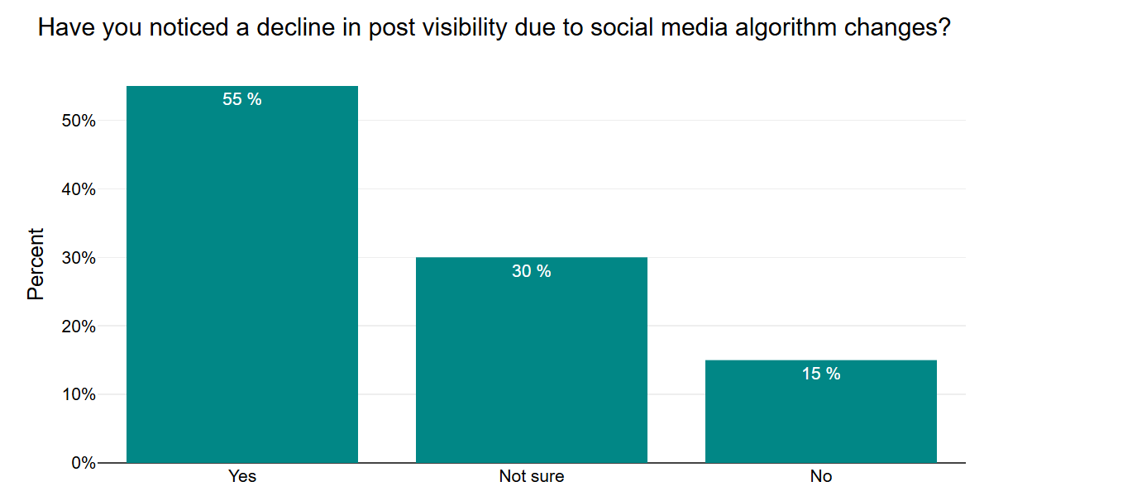
Figure 17
Do you use any free tools to help manage your social media (e.g., Canva, Hootsuite)?
A large majority, 80%, of businesses utilize free tools to assist in managing their social media activities. A smaller segment, 20%, do not employ any free tools for their social media management.
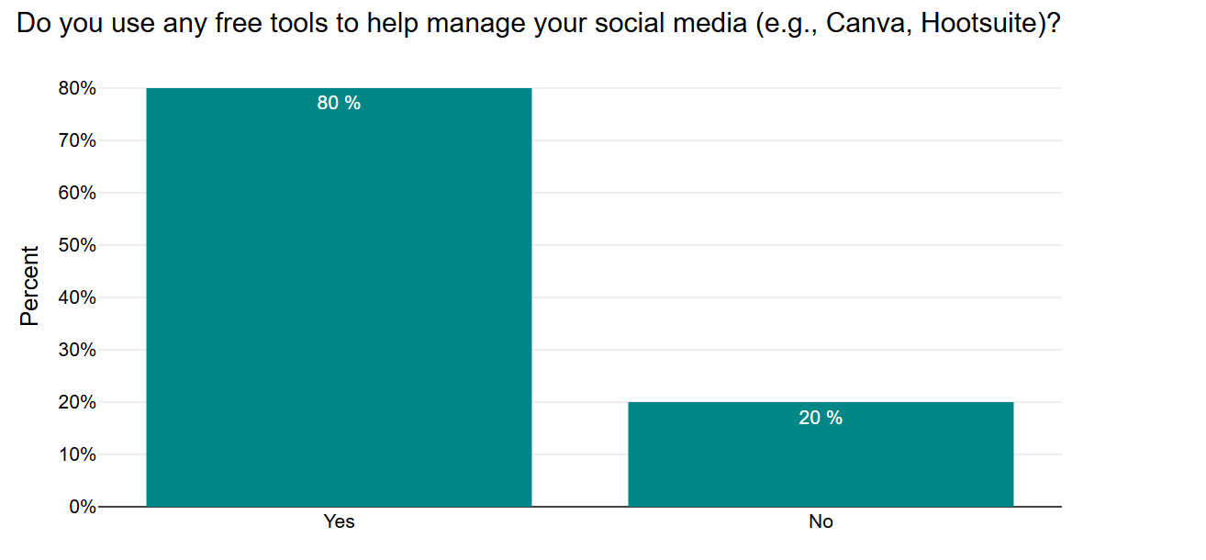
Figure 18

Would training or workshops on social media marketing help improve your business?
An overwhelming majority, 85%, of businesses believe that training or workshops on social media marketing would be beneficial in improving their business. Only a small fraction, 15%, do not think such training would lead to business improvement.
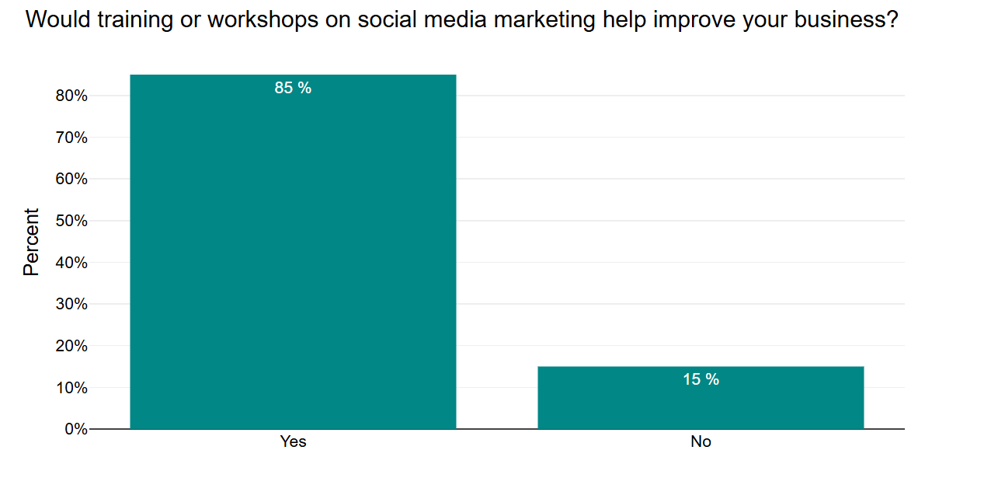
Figure 19

How do you measure the success of your social media marketing?
The most comprehensive approach, used by 25%, involves tracking the number of likes, comments, and shares, the number of new followers, website visits from social media, and sales generated from social media. A combination of sales generated from social media, the number of likes, comments, and shares, and the number of new followers is used by 20% of businesses. Tracking the number of new followers, website visits from social media, and sales generated from social media is employed by 15%. Focusing on the number of new followers and sales generated from social media is how 5% of businesses measure success. Similarly, 5% each track sales generated from social media, website visits from social media, the number of new followers, and the number of likes, comments, and shares as their primary measures of success.
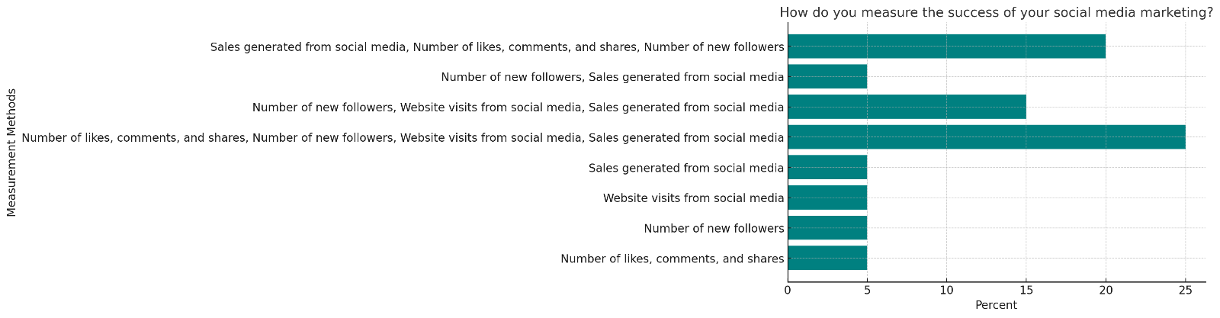
Figure 20
Do you regularly check social media analytics (e.g., Facebook Insights, Instagram Analytics)?
A significant majority, 70%, of businesses report that they regularly check their social media analytics. Conversely, 30% of businesses do not regularly monitor these analytics.
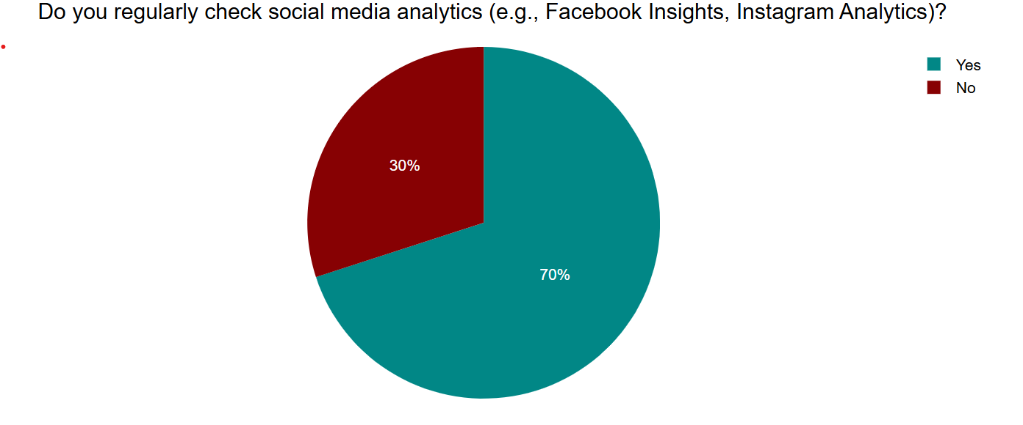
Figure 21
What is the most important factor for you when evaluating social media success?
When evaluating the success of their social media efforts, businesses prioritize different factors. The most significant factor for a plurality of businesses, 45%, is sales and revenue growth. Customer engagement is considered the most important factor by 30% of businesses. Brand awareness is the top priority for 20% of respondents. The number of followers is deemed the most important factor by the smallest segment, at 5%.
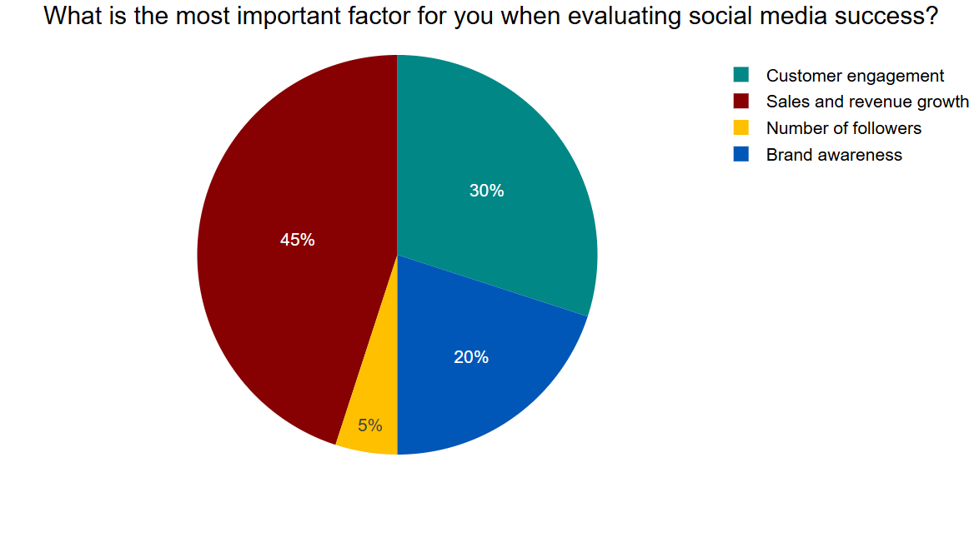
Figure 22
Qualitative findings
Theme | Key Finding | Supporting Quote
Social Media Platforms Utilized by Small Businesses | Small businesses use a variety of social media platforms, with Instagram being a popular choice for its visual appeal and Facebook for its community functions. Some businesses are also exploring TikTok to reach a broader audience. | “I generally use Instagram for social media purposes and sometimes but rarely Facebook just for checking in with friends.” (Respondent 1) “The business utilizes Instagram aesthetics and FB community functions while deploying TikTok to reach a broader audience which demonstrates its adherence to platform standards.” (Respondent 3) “Her digital capabilities are restricted because she uses only Instagram without understanding alternatives—this strengthens the idea of limited digital scope.” (Respondent 4)
Strategies for Increasing Brand Visibility | Visual content, community engagement, and strategic partnerships are crucial for increasing brand visibility. | “Always nice seeing pics of coffee and delicious food but also what I think gives the extra edge to any business is their content based on connections with the staff, customers, locals and their dogs that come in every day.” (Respondent 1) “Partnering on events /promotions with local charities is also a great attention catcher.” (Respondent 1) “Pay-to-click advertisements operate with local audience filters which validate return on investment and customer walking in data.” (Respondent 3) “The organization has not engaged in partnership strategies which leads to restricted natural market exposure.” (Respondent 4)
Customer Engagement through Social Media | Engaging content, humor, and responsiveness to customers are key to fostering engagement. Customer recommendations and loyalty programs also play a significant role. | “If it’s an important event that the coffee shop has partnered on with a local charity etc I would definitely comment or share.” (Respondent 1) “I am more engaged with services that add a bit of humour to their posts.” (Respondent 1) “The business interacts with every comment and message to establish a relationship with customers while offering stellar service.” (Respondent 3) “Customer recommendations play a stronger role than brand content in forming public perception about brands.” (Respondent 2)
Challenges in Social Media Marketing for Small Businesses | Small businesses face challenges such as maintaining consistency, dealing with algorithms, generating content, and managing budgets. Lack of digital skills and understanding can also be a hurdle. | “Standard SME restrictions such as maintaining consistency, developing algorithms, generating content and managing budgets appear as roadblocks for this platform alongside others.” (Respondent 3) “A lack of understanding among employees stands as the main hurdle which impedes business expansion.” (Respondent 4)
Measuring Social Media Success | Success is measured through a combination of engagement levels, reach, conversion rates, sales numbers, and customer feedback. However, some businesses rely solely on social media reactions and foot traffic, lacking comprehensive tracking. | “Tracking success relies on four complete metrics which involve engagement levels and reach extent alongside conversion rates and sales numbers.” (Respondent 3) “Success measurement at the business depends solely on social media reaction numbers and in-person building traffic but offers no comprehensive performance tracking.” (Respondent 4)

Chapter 5- Discussion

Theme 1: Social Media Platforms Utilized by Small Businesses
Analyzing the quantitative results, it can be stated that the most popular social media platform is Instagram, which is used by 45% of the small businesses. Another 15% use both Facebook and Instagram. Other platforms such as Facebook, Instagram, LinkedIn, TikTok, and YouTube also contribute to 15% of the usage. Similarly, the advertising features make 5% of the businesses to use Instagram, TikTok, and LinkedIn while 5% of the businesses use Instagram and LinkedIn only.
Customer demographics are cited as the main platform selection criterion by 45% of businesses, while ease of use is cited by 30%. 20% of the respondents value advertising features while only 5% of them value the competitor presence.
The findings of the qualitative data are in line with the findings of the quantitative data regarding the popularity of Instagram and Facebook and the growing importance of TikTok. Respondent 1 states, "I generally use Instagram for social media purposes and sometimes but rarely Facebook just for checking in with friends." This means that there is a certain bias towards personal use while conducting business. Respondent 3 notes, "The business utilizes Instagram aesthetics and FB community functions while deploying TikTok to reach a broader audience which demonstrates its adherence to platform standards." This is a more tactical approach, taking advantage of the features that are unique to each of the platforms. Conversely, Respondent 4's comment, "Her digital capabilities are restricted because she uses only Instagram without understanding alternatives—this strengthens the idea of limited digital scope," points to a potential lack of awareness of the benefits of diversifying platform usage.
The primary research supports the literature review’s claim that Facebook and Instagram are commonly used by small businesses (Adeola et al., 2020). The reasons mentioned in the literature such as cost-free, large number of customers, and interactive features are in line with the quantitative analysis that revealed that ease of use and customer characteristics are the major factors influencing the selection of a particular site.
Aydin (2020)'s point about Instagram's dominance in visually-driven sectors like hospitality is implicitly supported by the high overall usage of Instagram in the survey. The qualitative data from Respondent 3, mentioning "Instagram aesthetics," further reinforces this.
The research also supports Khanum (2023)’s finding regarding the usage of linked in for the business that targets the professional audience and tik tok for targeting the young generation. The 15% of businesses using a combination including these platforms, and the 5% driven by advertising features on them, indicate that there is a growing appreciation of their specific advantages.
The literature review’s statement about the avoidance of Twitter for its low number of engagement tools and a diminishing user base is not directly countered by the quantitative data, which aims at the current usage. However, the fact that Twitter is not included in the list of the primary responses might indicate that this observation is true within the sample of the survey.
This is because most of the users are familiar with the site, it is easy to use and has a large number of customers. Nevertheless, the usage of such platforms as LinkedIn and TikTok proves the enhancement of target audience classification and platforms’ peculiarities.
When it comes to the use of social media for enhancing brand awareness and reaching out to the customers, it is important for small businesses to be strategic in the choice of the platform. Depending on the most visited sites, the reach of the advertisement to certain demographics will be restricted. The focus on customer demographics as the primary criterion is a good sign, as it means that businesses are gradually starting to choose the platform based on their audience.
This way, the qualitative data reveals the best practices as well as the risks associated with platform usage. While some firms are intentionally using the advantages of various platforms, other firms may be limited by habit, or simply unaware of other possibilities. This implies the need to provide counsel and knowledge on the proper use of social media that is informed by the nature of the business and the intended market.

Theme 2: Strategies for Increasing Brand Visibility
The quantitative data reveals that the most popular method for promoting brand visibility is "Regular posting and engagement," accounting for 29.4% of responses. Combinations involving "Paid advertisements, Hashtags and trending topics, Influencer collaborations, Regular posting and engagement" (6.9%), "Paid advertisements, Influencer collaborations, Regular posting and engagement" (6.4%), "Paid advertisements, Hashtags and trending topics" (5.9%), "Influencer collaborations, Regular posting and engagement" (5.9%), "Paid advertisements, Influencer collaborations" (5.4%), and "Paid advertisements, Hashtags and trending topics, Regular posting and engagement" and "Hashtags and trending topics, Regular posting and engagement" (both 16.2%) also demonstrate the use of varied strategies.
Paid advertising is also used occasionally by 55% of the businesses while 15% use it frequently. Regarding hashtags, 45% consider them "somewhat important," and 30% believe they are "very important" for increasing brand visibility. It was also found that about 70% of organizations have used influencers in the marketing of their business.
The qualitative data focuses on the aspects of the use of visuals, the engagement of the community, and the partnerships. Respondent 1 notes, "Always nice seeing pics of coffee and delicious food but also what I think gives the extra edge to any business is their content based on connections with the staff, customers, locals and their dogs that come in every day." This shows the relevance of using real life images and items in the content. The same respondent also mentions, "Partnering on events /promotions with local charities is also a great attention catcher," emphasizing community engagement. Respondent 3 points to the effectiveness of "Pay-to-click advertisements operate with local audience filters which validate return on investment and customer walking in data," supporting the use of targeted advertising. Conversely, Respondent 4 observes, "The organization has not engaged in partnership strategies which leads to restricted natural market exposure," highlighting the potential benefits of such collaborations.
The primary research relates to the literature review section that discusses different approaches to brand awareness enhancement. The prominence of "Regular posting and engagement" supports the fundamental importance of consistent content creation and interaction highlighted implicitly throughout the literature.
The fact that paid advertising is used frequently (70% of the businesses use it at least occasionally) supports Dolega, Rowe, and Branagan (2021)’s findings concerning its effectiveness in increasing website traffic and sales. The qualitative mention of "pay-to-click advertisements" further supports this.
The perceived importance of hashtags by 75% of businesses ("somewhat important" or "very important") aligns with Utomo et al. (2023)'s assertion about their role in reaching wider audiences, especially when associated with trending themes or specific industries.
This is in line with Ren, Tan, and Wan (2023)’s assertion that micro-influencers are effective in creating high exposure at a relatively low cost, given that 70% of the firms have adopted influencer marketing.
The focus on the visual aspect of content corresponds to what Aydin (2020) discussed about the visual aspect of platforms such as Instagram and its ability to reach the customers especially in the hospitality industry. The mention of "community engagement" in the qualitative data aligns with the broader theme of building relationships discussed in the literature.
The study shows that small business using the following approaches in the promotion of their brand on social media. The combination of consistent organic content ("Regular posting and engagement") with paid approaches, hashtag utilization, and influencer collaborations suggests a multi-faceted approach.
The high confidence in the importance of hashtags, despite some businesses finding them only "somewhat important," suggests a general understanding of their potential, even if their strategic implementation might vary. The high popularity of the influencer marketing strategy can be explained by the perceived usefulness of targeting the audience and establishing trust.
The qualitative data enriches the study by highlighting the significance of high-quality and appealing visuals and the opportunities of cooperation with the community. This is evident from Respondent 4 where the lack of collaborative strategies that businesses fail to adopt is underlined.
For the small businesses that want to leverage on social media, it is important to maintain a healthy balance of the organic and paid campaigns, hashtags and collaborations with influencers. Additionally, concentrating on high-quality, appealing graphics and searching for the ways to interact with the communities can also increase their impact.

Theme 3: Customer Engagement Through Social Media
The quantitative data reveals that the most prevalent approach to customer engagement (25%) involves "responding to comments and messages, as well as sharing customer reviews and testimonials." Other significant methods include "responding to comments and messages, posting polls and interactive content, and sharing customer reviews and testimonials" (20%), and "responding to comments and messages combined with running contests and giveaways" (15%).
A majority of businesses (55%) experience customer interaction "often," while 35% report "sometimes," and 10% "rarely." An overwhelming 85% of businesses believe that engaging with customers on social media "does indeed increase their loyalty," with only 15% responding with "maybe."
The qualitative data highlights the aspects of entertainment, fun, and promptness. Respondent 1 states: “If it is an important event that the coffee shop has collaborated with a local charity etc. I would definitely comment or share” which underscores the effectiveness of timely and locally relevant content. The same respondent also states, "I am more engaged with services that add a bit of humour to their posts," indicating the appeal of entertaining content. Respondent 3 points out, "The business interacts with every comment and message to establish a relationship with customers while offering stellar service," emphasizing the importance of responsiveness. Respondent 2 adds, "Customer recommendations play a stronger role than brand content in forming public perception about brands," highlighting the value of user-generated content and social proof.
The primary research is consistent with the literature review on the importance of the interactive content (Adeola, Hinson, & Evans, 2020), timely responses (Ren, Tan, & Wan, 2023), and engagement metrics (Utomo et al., 2023) in attracting and retaining customers.
The popularity of "responding to comments and messages" as an engagement strategy directly supports Ren, Tan, and Wan (2023)'s point about brief and timely replies building trust and fostering emotional bonds. This is in line with Adeola, Hinson, and Evans (2020) on the fact that polls and interactive content increase customer attention.
The fact that 85% of the businesses consider that engagement leads to loyalty supports the literature in asserting that the use of social media to build relationships is important. This is supported by the qualitative quote from Respondent 3 who noted that they interact with every comment and message, which shows that the company is actively engaging with its customers.
The qualitative finding about the power of humor is consistent with the notion of creating something that is interesting and easy to recall. The focus on customers’ recommendations aligns with the literature concerning social proof and the way it affects the public.
The fact that there are more strategies related to direct interaction (replying to comments and messages) and social proof (sharing reviews) shows that there is awareness of basic engagement tactics.
The high percentage of agreement with the statement regarding the relationship between engagement and customer loyalty further supports the notion that engagement enhances customer ties (85%). The qualitative insights show that the content should be relevant, engaging and should meet the needs and wants of the target customers.
When it comes to the use of social media to interact with the customers especially for the small business, it is important to be aggressive and personal. This entails addressing comments and questions, inviting user participation, and using customer endorsements and reviews. Other aspects such as using humor and targeting content that will be of interest to the community can also be added to increase engagement and foster better customer relations.

Theme 4: Challenges in Social Media Marketing
The quantitative data identifies the most significant challenge as "lack of time to manage social media effectively" (30%). "Budget constraints for advertising" (15%) and "difficulty keeping up with platform changes" (10%) are also substantial hurdles. Combinations of these challenges, as well as "not knowing what type of content to post" (5%), also contribute to the overall difficulties faced.
The qualitative data echoes these challenges, with Respondent 3 mentioning "Standard SME restrictions such as maintaining consistency, developing algorithms, generating content and managing budgets appear as roadblocks for this platform alongside others." This includes time issues (consistency), changes in the algorithm, content development, and financial constraints. Respondent 4 highlights "A lack of understanding among employees stands as the main hurdle which impedes business expansion," pointing to a lack of digital skills and technical know-how.
The main research findings are in a general agreement with the problems outlined in the previous literature. These include the absence of funds (Chen & Burgess, 2020), algorithm modifications (Obar & Wildman, 2015) and overall, a deficit of skills and technical expertise (Schultz & Peltier, 2013) are all evident in the survey responses and qualitative data.
The concern mentioned—time—can be regarded as a subtype of resource constraints (including both monetary and personnel), which impede sustained action and proper planning, as Chen and Burgess (2020) noted.
This shows that it is not easy to follow the changes on the platform in line with what Obar and Wildman (2015) said about the dynamic nature of social media algorithms on the organic reach.
The challenge of "not knowing what type of content to post" can be linked to the lack of skills and technical know-how discussed by Schultz and Peltier (2013), as it indicates a difficulty in understanding audience preferences and leveraging social media tools effectively.
The qualitative data strengthens these links by directly referring to budget issues, algorithmic problems, and the problem of maintaining content quality. The emphasis on the "lack of understanding among employees" directly supports the literature's point about skill deficiencies.
The most significant concern is time, which may be attributed to the scarcity of employees and the responsibilities of managing a small enterprise. This is compounded by the problem of budget constraints which do not allow them to spend much money on paid advertising and professional services.
The challenge of following up with the changes indicates that social media is ever evolving and requires constant learning. The issue of identifying what content to share reveals one of the possible shortcomings in comprehending the audience and content marketing.
To achieve these objectives and to ensure that small business can overcome these challenges and make efficient use of social media, it is necessary to address the time constraint. It may require prioritizing the tasks in social media, using the free management tools as suggested by Fischer & Reuber (2011) or using inexpensive ways of creating content such as crowd sourcing. To minimise the effects of the decreased organic reach, one has to follow the changes in the algorithms through the available resources and concentrate on producing quality content that would encourage people’s engagement (De Vries, Gensler, & Leeflang, 2012).The lack of knowledge on how to properly use social media platforms for marketing can be solved by training or workshops to improve the knowledge in this field.

Theme 5: Measuring Social Media Success
The quantitative data shows that the most comprehensive approach to measuring social media success (25%) involves tracking "the number of likes, comments, and shares, the number of new followers, website visits from social media, and sales generated from social media." Others, which are also used, are sales, engagement, and follower growth combinations.
A significant majority (70%) of businesses report that they "regularly check their social media analytics." When evaluating success, the most important factor for 45% of businesses is "sales and revenue growth," followed by "customer engagement" (30%), "brand awareness" (20%), and "the number of followers" (5%).
The qualitative data highlights that success is measured through a combination of "engagement levels and reach extent alongside conversion rates and sales numbers" (Respondent 3). However, Respondent 4 notes that success measurement at their business "depends solely on social media reaction numbers and in-person building traffic but offers no comprehensive performance tracking," indicating a less sophisticated approach.
The primary research is in line with the literature review that discussed the engagement rates, conversion rates, and ROI as the measures of social media campaign performance (De Vries et al., 2012; Fischer & Reuber, 2011; Taneja & Toombs, 2014).
The fact that "sales and revenue growth" is the most important factor for evaluating success underscores the ultimate business objective of social media marketing, as supported by Taneja and Toombs (2014)'s argument about the importance of ROI. It is in this regard that the emphasis on the engagement metrics (likes, comments, shares) is in harmony with De Vries, Gensler, and Leeflang (2012) view them as the measure of the connection between the business and the target market.
The high percentage of businesses that are frequently using analytics (70%) reinforces Chaffey & Smith (2017)’s statement regarding the role of these tools as a way to monitor user behavior and campaign performance. Yet, qualitative example from Respondent 4 suggests that not all the businesses employ elaborate tracking mechanisms.
The qualitative focus on the levels of engagement, the coverage, the conversion rates, and the sales reflects the multifaceted approach to the evaluation discussed in the literature.
This is encouraging as it shows that the focus on sales and the generation of revenues is the most critical aspect of social media initiatives. The emphasis on customer engagement also points to the understanding of its importance for the development of long-term cooperation.
Nevertheless, the qualitative data shows that some businesses use fewer parameters, which may lead to the lack of important information regarding their performance. This implies that there is a need to advise on how to adopt a more comprehensive approach of evaluating the effectiveness of social media by using other forms of KPIs.

Conclusions
The study reveals that social media is a vital factor in these businesses since it provides opportunities for promoting brands, engaging with customers, and expanding the business. From social media platforms, Instagram and Facebook continue to be used frequently due to their ease of use and popularity, although new platforms such as TikTok and LinkedIn are also being adopted for the ability to target specific audiences. There are several ways that the small businesses use to ensure that they increase the visibility of their brand; these include posting frequently, paid promotions, and partnering with influencers. Customer engagement is mainly achieved through reply to comments and messages, reposting customer reviews and sharing engaging content. But these are some of the challenges that are likely to hamper these efforts; time and resources, challenges in tracking changes in algorithms, and lack of technical know-how. Despite the fact that many businesses monitor social media, the level of the analysis can be quite different. Most importantly, sales and revenue growth are two main measures of success, which underlines the direct correlation between the social media activity and company’s performance.

Limitations
However, it has the following limitations that should be taken into consideration: The number of respondents in the quantitative part of the study is 20, and in the qualitative part – 4, which may be insufficient to generalize the results to the entire population of small businesses. The study employed convenience sampling, which might be prone to selection bias since the participants were selected based on their availability rather than through a random procedure. This sampling method may have led to a systematic bias of the businesses whereby only those with specific characteristics or a certain level of engagement on social media were selected. The qualitative data, which gives more contextual details, is obtained through a limited number of interviews, and thus may not represent all the different viewpoints and experiences of the small business.

Recommendations
Small businesses need to be more selective in choosing the platforms and spread across the various platforms to cover as many groups of users as possible and use the peculiarities of each platform. However, the corporation should also consider the use of other platforms such as LinkedIn and TikTok for certain marketing goals. Focus on creating good, quality, interesting, and well-designed content that will be of interest to the intended audience. Businesses should be regular in their posting and should engage with their followers in order to gain their trust and favour.
As a result, small businesses should consider the following useful tips when implementing marketing strategies due to the limitations of time and budgets. It is also important for the companies to invest in training and workshops in order to improve social media marketing competencies of their personnel. Again, businesses should ensure that they have a good measure to use in assessing the returns on the social media investment that they are making. This implies that they should define key performance indicators, use analytical tools to track their performance and review and refine their strategies from the data collected periodically.

References
Adeola, O., Hinson, R.E., and Evans, O., 2020. Social media in marketing communications: A synthesis of successful strategies for the digital generation. Digital Transformation in Business and Society: Theory and Cases, pp.61-81.
Ahmed, Abdelhamid. "Ontological, Epistemological and Methodological Assumptions: Qualitative versus Quantitative." Online submission (2008).
Ashley, C., and Tuten, T., 2015. Creative strategies in social media marketing: An exploratory study of branded social content and consumer engagement. Psychology & Marketing, 32(1), pp.15-27.
Aydin, G., 2020. Social media engagement and organic post effectiveness: A roadmap for increasing the effectiveness of social media use in hospitality industry. Journal of Hospitality Marketing & Management, 29(1), pp.1-21.
Berthon, P.R., Pitt, L.F., and Campbell, C., 2008. Ad lib: When customers create the ad. California Management Review, 50(4), pp.6-30.
Chaffey, D., and Smith, P.R., 2017. Digital Marketing Excellence: Planning, Optimizing and Integrating Online Marketing. 5th ed. Routledge.
Chen, Y., and Burgess, B., 2020. Social media marketing for small businesses: Addressing budgetary constraints and maximizing ROI. Journal of Business & Industrial Marketing, 35(2), pp.88-102.
Constantinides, E., 2014. Foundations of social media marketing. Procedia-Social and Behavioural Sciences, 148, pp.40-57.
De Vries, L., Gensler, S., and Leeflang, P.S.H., 2012. Popularity of brand posts on brand fan pages: An investigation of the effects of social media marketing. Journal of Interactive Marketing, 26(2), pp.83-91.
Dolega, L., Rowe, F., and Branagan, E., 2021. Going digital? The impact of social media marketing on retail website traffic, orders and sales. Journal of Retailing and Consumer Services, 60, p.102501.
Erdogmus, I.E., and Cicek, M., 2012. The impact of social media marketing on brand loyalty. Procedia-Social and Behavioural Sciences, 58, pp.1353-1360.
Felix, R., Rauschnabel, P.A., and Hinsch, C., 2017. Elements of strategic social media marketing: A holistic framework. Journal of Business Research, 70, pp.118-126.
Fischer, E., and Reuber, A.R., 2011. Social interaction via new social media: (How) can interactions on Twitter affect effectual thinking and behaviour? Journal of Business Venturing, 26(1), pp.1-18.
Gensler, S., Völckner, F., Liu-Thompkins, Y., and Wiertz, C., 2013. Managing brands in the social media environment. Journal of Interactive Marketing, 27(4), pp.242-256.
Golzar, Jawad, Shagofah Noor, and Omid Tajik. "Convenience sampling." International Journal of Education & Language Studies 1, no. 2 (2022): 72-77.
Govil, Punita. "Ethical considerations in educational research." International journal of advancement in education and social sciences 1, no. 2 (2013): 17-22.
Haq, Muhibul. "A Comparative Analysis of Qualitative and Quantitative Research Methods and a Justification for Adopting Mixed Methods in Social Research." (2015).
Kaplan, A.M., and Haenlein, M., 2010. Users of the world, unite! The challenges and opportunities of social media. Business Horizons, 53(1), pp.59-68.
Khanom, M.T., 2023. Using social media marketing in the digital era: A necessity or a choice. International Journal of Research in Business and Social Science (2147-4478), 12(3), pp.88-98.
Maguire, Moira, and Brid Delahunt. "Doing a thematic analysis: A practical, step-by-step guide for learning and teaching scholars." All Ireland journal of higher education 9, no. 3 (2017).
Malesev, S., and Cherry, M., 2021. Digital and social media marketing-growing market share for construction SMEs. Construction Economics and Building, 21(1), pp.65-82.
Mangold, W.G., and Faulds, D.J., 2009. Social media: The new hybrid element of the promotion mix. Business Horizons, 52(4), pp.357-365.
Martin, K.D., and Todorov, A., 2010. How will digital platforms transform marketing? Marketing Intelligence & Planning, 28(5), pp.547-550.
Obar, J.A., and Wildman, S., 2015. Social media definition and the governance challenge: An introduction to the special issue. Telecommunications Policy, 39(9), pp.745-750.
Orobia, Laura A., Warren Byabashaija, John C. Munene, Samuel K. Sejjaaka, and Dan Musinguzi. "How do small business owners manage working capital in an emerging economy? A qualitative inquiry." Qualitative Research in Accounting & Management 10, no. 2 (2013): 127-143.
Packer, J., and Higham, R., 2021. Engagement metrics for SMEs: Leveraging social media analytics to grow customer bases. Small Business Economics, 56(4), pp.1123-1138.
Ren, F., Tan, Y., and Wan, F., 2023. Know Your Firm: Managing Social Media Engagement to Improve Firm Sales Performance. MIS Quarterly, 47(1).
Rust, R.T., Lemon, K.N., and Zeithaml, V.A., 2004. Return on marketing: Using customer equity to focus marketing strategy. Journal of Marketing, 68(1), pp.109-127.
Schultz, D.E., and Peltier, J., 2013. Social media's slippery slope: Challenges, opportunities, and future research directions. Journal of Research in Interactive Marketing, 7(2), pp.86-99.
Taneja, S., and Toombs, L.A., 2014. Putting a face on small businesses: Visibility, brand development, and social media engagement in SMEs. Journal of Strategic Marketing, 22(6), pp.465-478.
Utomo, S.B., Nugraha, J.P., Indrapraja, R., and Panjaitan, F.A.B.K., 2023. Analysis of the effectiveness of integrated digital marketing communication strategies in building MSMEs brand awareness through social media. Journal System Informs dan Technology, pp.8-13.

