Applied Project
Submission Form


LEARNER NUMBER | 51738970
NAME | Nairton Pereira Fontes
COURSE | Bachelor of Arts in Marketing
REPORT TITLE | Consumer purchasing behaviour in small Local grocery stores: exploring Psychological, Social, and Economic Influences
SUPERVISOR NAME | Klaus Walter
WORD COUNT | 6734
DUE DATE | 12/05/2025
DATE SUBMITTED | 12/05/2025

I certify that:
- This project report is all my own work, and no part of this report has been copied from another source: Yes ☒ No ☐
- I understand that this report may be checked by electronic or other means for plagiarism and/or content created by generative AI and may be transferred and stored in a database for the purposes of data-matching/data-analysis to help detect plagiarism and/or content created by generative AI: Yes ☒ No ☐
- This report has not previously been submitted in part or in full for assessment to any other institution: Yes ☒ No ☐
- I consent to the inclusion of my report in the publicly accessible (open access) electronic database maintained by the library:
Yes ☒ No☐
- I have emailed a back-up copy of this report to locker@independentcollege.ie:
Yes ☒ No ☐

(Note that if no check boxes are selected, this Project will be regarded as NOT properly submitted, and may be subject to a late submission penalty)

Name: Nairton Fontes
Date: 11/05/2025

For the report to count as a valid submission, the student must provide:
1 electronic copy via Moodle. There is no requirement for a hard copy .

Evidence of the Primary Research MUST be included in the appendix of the report. That includes a copy of questionnaires, interview schedules, or observation diaries. One interview transcript should be included as a full transcript and a summary of all other interviews must be kept as a backup by the student. See template on Moodle for what should be included in all aspects of the report. All data must be anonymised.

The text should be double-spaced throughout and single column format (A4) with 2cm for left and right-hand margins and 2.5cm at head and foot. Text should be justified, standard 12 point, footnotes 10 point, and in Calibri. Page numbers should be at the bottom-right. Do not use line and paragraph spacing. Keep formatting to a minimum and avoid underlining.

Harvard Referencing shall apply.

(Insert work here)



“Consumer purchasing behaviour in small Local grocery stores: Exploring Psychological, Social, and Economic Influences”

Applied Project presented to Independent College Dublin as a partial requirement for the bachelor’s degree in marketing.
By: Nairton Fontes
Supervisor: Klaus Walter
May 2025

Abstract

This research explores the key factors influencing consumer purchasing behavior in small grocery stores, a context often overlooked in academic literature, which tends to focus on large supermarkets or even retail chains. The study addresses this gap by applying a mixed-method approach, quantitative surveys data collected with customers and qualitative interviews with grocery stores managers to measure consumers motivations, preferences and behavior in a small grocery stores environment. Key findings reveal that factors such as price and product quality, emotional and social influences which include trust, community belonging, convenience and personalized service, significantly shape purchasing decision. These insights contribute to a better understanding of small local retail dynamics and offer practical recommendations to support small local grocery retailers to adapt to consumers’ expectations and enhance competitiveness in this increasing market.
Key words: Consumer Behavior, Small Grocery Stores, Purchasing Decision, Cultural/Social Influences, Retail Marketing

Table of Contents

Chapter I 6
1.1 Introduction 6
1.2 Rationale for the Study 6
1.3 Statement of the Research Objectives 7
1.4 Information Gathering & Data Collection Technique Used 8
1.4 Anticipated Outcomes of the Study 8
1.6 Chapter-by-Chapter Overview 9
Chapter II 10
2. Literature Review 10
2.1 Psychological Factors Influencing Consumer Behavior 10
2.2 Social and Cultural Influences on Shopping Patterns 12
2.3 Tangible Factors Driving Purchase Decisions 13
2.4 Impact of Marketing Strategies on Consumer Choices 14
2.5 Community Engagement and Customer Loyalty 16
Chapter III 18
3. Methodology 18
3.1 Theoretical Paradigm / Philosophy Used 18
3.2 Research Design 19
3.3 Population and Sampling 19
3.4 Data Collection Methods 20
3.5 Data Analysis Techniques 20
3.6 Ethical considerations 21
3.7 Reliability and Validity 22
3.8 Limitations of the Methodology 23
Chapter IV 24
4. Findings and Discussion 24
4.1 Psychological Factors Influencing Consumer Behavior 25
4.2 Social and Cultural Influences on Shopping Patterns 27
4.3 Tangible Factors Driving Purchase Decisions 29
4.4 Impact of Marketing Strategies on Consumer Choices 32
4.5 Community Engagement and Customer Loyalty 36
Chapter V 39
5.1 Conclusion and Recommendation 39
5.2 Recommendations 40
References 42
Appendices 46

Chapter I

1.1 Introduction
Small grocery stores are independently owned and are often family-run retail spaces that serve local communities by offering everyday food and house essentials products. Unlike large retailers’ chains, these stores operate on a small scale, usually whit limited floor space, few product lines and more personalized shopping experience, they relay close relationships whit regular customers, convenience location and sense of community. This study aims to explore how consumers engage with those local stores, and what drives purchasing decisions in this important retail environment.
The intersection of psychology, sociology, and economics in consumer behaviour creates an added level of interest. Psychological drivers like habit, brand loyalty, and emotional connection, social drivers like peer influence and family heritage, and economic drivers like price and perceived value all play a role in decision-making. This multi-faceted aspect of behaviour created the impetus to explore the subject from a more holistic and research-based approach (Dirwan and Latief, 2023).

1.2 Rationale for the Study
The research rationale stems from an increasing need to comprehend consumer decision-making in a changing marketplace environment. Whereas most of the current literature concerns consumer behaviour across larger retail store formats or the internet, less is known regarding the behavioural forces at work in local grocery stores. This knowledge gap is considerable for local entrepreneurs, marketers, and policymakers interested in fostering sustainable local commerce.
The central research question that drives this study is:
“What psychological, social, and economic factors influence consumer purchasing behaviour in local grocery stores?”
The study aims to find actionable facts that will be able to inform local store owners on how best to meet customer demands, optimise store performance, and stay ahead of increasing market pressures.

1.3 Statement of the Research Objectives
The general purpose of this study is to investigate and learn the determinants of purchasing behaviours in neighbourhood grocery environments. This involves assessing internal (psychological) and external (social and economic) determinants affecting consumer behaviour. The sub-study purposes are:
- To analyse ways in which psychological factors like motivation, perception, and attitude affect consumers in neighbourhood grocery stores.
- To identify the influence of social factors such as culture, family, and peer pressure in affecting buying behaviour.
- To analyse the effect of economic and tangible factors such as price consciousness, promotions, quality and convenience influence purchasing decision.
- To understand the importance of marketing strategies like promotions and loyalty programs influencing consumer purchasing behaviour
- To explore the role of community engagement in fostering customer loyalty within small local grocery stores.
These objectives will inform the literature review, shape the questionnaire design, and serve as the basis for thematic analysis during the data interpretation phase.
Sub-research question
- How do trust, fear, and satisfaction affect consumer decisions?
- What role do word of mouth and social proof play in the choices that consumers make when shopping at grocery stores?
- what is the impact of pricing policies on consumer behaviour?
- What effect does a promotion and sale, or introducing a membership card entailing special offers have on consumers’ behaviour?
- Which social bonds arise from consumers’ engagement with local grocery stores through community-related activities?

1.4 Information Gathering & Data Collection Technique Used
The study will use a mixed-methods design, integrating both quantitative and qualitative data. A standardised questionnaire will be given to consumers who shop frequently at small local grocery store. The tool will be developed from themes found in the literature review and will consist of Likert-scale, multiple-choice. Semi-structured interviews with three store managers might also be used to obtain richer qualitative information. Data analysis will include triangulation technic, pattern identification, and interpreting correlations between influencing factors, consumer behaviour and stores actions.

1.4 Anticipated Outcomes of the Study

The research will help towards the creation of excellent model for explaining local consumer buying behaviour. It should uncover not only which factors drive behaviour, but also how and why they do so, in ways specific to local grocery environments. Such insights may help local retailers create more tailored marketing strategies and enhance customer experience. It is accepted that certain research aims might only be partially satisfied by virtue of time limitations, sample size constraints, or respondent biases that arise unexpectedly, but partial understanding will be worth something.

1.6 Chapter-by-Chapter Overview

Chapter 1: Introduction – Introduces the comparison between small grocery shops and large retailers in terms of size, rationale, objectives, methodology, and organisation of the dissertation.
Chapter 2: Literature Review – Critically examines current academic theory and research on consumer behaviour, with an emphasis on psychological, social, cultural, marketing strategies, tangible drives and community engagement.
Chapter 3: Methodology – Outlines the research design, data collection techniques, sampling methods, and ethical issues.
Chapter 4: Findings – Reports the findings from the survey and interviews, employing thematic triangulation together with literature review.
Chapter 5: Conclusion and Recommendations – Condenses the most important findings and offers important recommendations for small local grocery stores.

Chapter II

2. Literature Review

This literature review explores the diverse factors that influence consumer purchasing behaviour in local grocery stores. The selection of the themes: Psychological influences, social and cultural patterns, tangible drives, marketing strategies and community engagement was chosen by their importance in understanding both emotional and rational aspects behind consumers choice. By bringing together insights from these areas, this chapter provides a conceptual basis for analysing consumer motivation and identifying potential areas for improv customer retention and satisfaction.

2.1 Psychological Factors Influencing Consumer Behavior

According to Shahid and Paul, (2021), the purchase patterns of consumers are heavily influenced by their thoughts, emotions, and intrinsic motivations. These elements influence an individual's consumption and subsequent purchase of a product. Consumer conduct can be analysed through the perspective of psychological demands such as safety, belonging, and self-esteem. People's purchases, for example, often reflect their psychological requirements. Since it is intended for family eating, food safety must be of high quality. People prefer to buy items manufactured in their local communities because they make them feel more connected to those individuals. Moreover, decisions are made using a combination of rational cognition and subjective feelings. The research of Ryba and Zimon, (2021), highlights that trust in the company, satisfaction with previous purchases, and regret over wasted spending are all examples of emotional triggers that can influence consumer behaviour. When valued customers receive personalised services, they are more likely to become loyal customers at grocery stores. Grocery stores cannot provide a compelling shopping experience unless they build relationships that elicit emotions throughout the buying process.

However, Pignatiello, Martin, and Hickman, (2018), highlighted in their research that decision fatigue, induced by having too many choices, is a psychological issue that influences consumer behaviour. When confronted with a wide range of choices, customers engage in regular and impulsive buying by utilising algorithms, which are cognitive shortcuts. Due to familiarity, the buyer continues to buy the same brand without considering alternative options. It is vital to streamline product offerings and give a targeted range. When making purchases, buyers place a high value on the perceived worth and quality of a product. People are more likely to buy things that make them happy. Organic items that promote health and environmental sustainability are one example. Smart packaging and in-store marketing help companies influence customer decisions by deepening these connections. Moreover, the research done by Chan, (2024), reveals that Anchoring and framing are two additional cognitive biases that influence behaviour. Presenting incentives as "limited time offers" provides a sense of urgency, encouraging customers to act swiftly. Fixing increases the psychological attraction of the deal by emphasising the perceived value for money when comparing the original, higher price to the reduced sale price. In the same manner, the research done by Alzoubi, Ahmed, and Alshurideh (2022), presented that grocery stores can modify their operations to establish an environment conducive to rational decision-making by learning about these underlying psychological aspects. Businesses that cultivate these attributes can increase customer happiness and loyalty, which leads to increased sales through stronger buyer relationships.

2.2 Social and Cultural Influences on Shopping Patterns

As per the views of Sondos et al., (2023), in grocery stores, social and cultural variables influence consumer purchases the most. Similarly, family, societal, and peer influences are the factors that affect purchasing habits. High-value or branded goods chosen by other consumers will motivate one to buy them to seek social approval or escape emotions of inferiority and poor social status. Social market situations like festivals and community fairs are where the behaviour is most visible. However, the research of García et al., (2020), highlighted that culture influences shopping behaviour because consumers buy according to others' values and traditions. In small communities, cultural values like supporting local producers always increase consumer loyalty. Dublin customers are more likely to buy Irish items like milk or artisanal bread for cultural reasons and to support the local economy. Culturally conscious shoppers may feel at home in grocery stores with local product signs or advertising. Consumer loyalty and behaviour are also influenced by community involvement. Furthermore, Alagarsamy, Mehrolia, and Singh, (2021), suggested that grocery businesses can build emotional bonds with customers by participating in local activities. This includes food drives for local charities and community cooking sessions that highlight local produce. Such initiatives boost the store's brand and make customers feel connected. A Dublin grocery store might arrange a "Meet the Producers" day with local farmers to let customers meet suppliers. Customers feel like they are joining a community, which fosters loyalty.
The research done by Mensah and Oyinlola Oyebode, (2022), presented that, peer pressure from family and friends also heavily influences decision-making. Friends often suggest trying a new grocery or department shop or product. Large families' bulk buying behaviours influence buyers' product and site choices. Understanding and using these social and cultural influences could help grocery companies meet customer expectations. On the other hand, Qun et al., (2024), present that personalised shopping experiences, cultural promotions, and community-oriented strategies boost customer pleasure and loyalty.

2.3 Tangible Factors Driving Purchase Decisions

According to Yu, (2024), tangible factors, such as price, quality, and convenience, are arguably the most important and measurable factors in influencing consumer purchasing decisions. These factors have a direct influence on how customers perceive the grocery store and whether they return.
Pricing strategies play an essential role in building customer trust and loyalty. Moreover, Rane, Achari, and Choudhary, (2023), found that fair pricing and honest promotions attracted repeat visits since customers responded well to honest and affordable offers. For instance, a store with consistent discounts or loyalty-based rewards makes the customers feel fair and reliable. However, inconsistent pricing and extra charges would likely discourage repeat business. Special pricing, which involves "buy one, get one free" and the like, also creates value for the customer, thus persuading them to make a purchase and making people walk into the establishment.
Availability and variety of products are similarly important to customers' satisfaction. Furthermore, Kullak, Baier, and Woratschek, (2022), reveal in their research that customers like to shop in places with a variety in stock that regularly meets their needs. Low product assortment or stockouts lead to dissatisfaction and customer loss, mainly when dealing with staples such as bread, milk, or fresh produce. An example is that a supermarket offering both organic and gluten-free products besides normal ones is more likely to attract health-conscious customers. Moreover, seasonal and culturally relevant products are also factors, as they make the customers believe that the store caters to their specific needs.
However, according to Dinah et al., (2022), another tangible factor that can be used positively is the quality of the products. Consumers will often associate higher quality with better pricing, increasing their willingness to pay more. For example, fresh fruits and vegetables sourced locally will attract shoppers who value quality and sustainability. Furthermore, customers who perceive a grocery store’s products as consistently high-quality are more likely to remain loyal, as they feel they are receiving value for their money. Convenience is the final critical factor influencing purchasing behaviour. A well-organized store layout that facilitates quick and efficient navigation significantly enhances customer satisfaction. Moreover, a study by Culleton, (2023), emphasized that Shoppers in urban environments, such as Dublin, also prioritize proximity and parking availability. A grocery store located near residential areas with easy parking and a simple layout is likely to retain a customer who values saving time and convenience. For example, the convenience of self-checkout lanes or clearly labeled aisles adds an extra layer of convenience to the shopping experience. All these tangible factors could be directly approached to harmonize grocery store operations with customer expectations. Competitive pricing, diversified inventory, and convenient store design are some of the strategies, which are necessary for aligning with the needs of modern consumers and maintaining customer loyalty.

2.4 Impact of Marketing Strategies on Consumer Choices

According to Hecht et al., (2020), in the grocery retail business, marketing strategies are essential for the influence of consumer behaviour. Good marketing attracts customers but also helps improve their experience, increasing their chances of returning again and again. In-store promotions, loyalty programs, and personalized marketing are some of the most effective strategies. In-store promotions and discounts are appealing incentives that drive consumer choices. Pallikkara et al., (2021), found that impulse buy levels increase vastly with strategically used signage and discounted prices, especially at checkout counters, because of their immense foot traffic. For instance, bundle offers or limited-period offers will create an urge that makes the customer buy something they did not originally plan for. At a grocery store, placing discounted snacks or beverages by the checkout will make shoppers add those items to the cart as they wait in line. These offers not only raise short-term sales but also enhance the overall shopping experience as it gives a sense of reward. However, Alshurideh et al., (2020), suggested another important grocery store marketing pillar is loyalty programs. The power of loyalty programs in customer retention, considering that customised rewards make it more rewarding to retain customers; this makes customers feel exclusive and more valued, receiving discounts, cashback, and even early access to new products. For example, a Dublin grocery store might introduce a points-based system where customers earn rewards for each purchase, encouraging them to return frequently. Such programs not only increase spending but also strengthen the emotional connection between the store and its customers.
In the same manner, (Chabane et al., 2022), highlighted in their study that personalization is an emerging trend in grocery marketing, driven by advancements in data analytics and digital tools. By considering customers' individual preferences and shopping histories, the company should utilize machine learning techniques such as those implemented in the MyGroceryTour platform. This system uses customer preferences and past behaviour to offer personalized weekly grocery list, enhancing customer satisfaction and loyalty though meaningful engagement. The research done by Zhang, (2024), highlighted that with effective use of such marketing strategies, grocery stores can gain a competitive advantage through promotions, loyalty programs ensuring retention and personalization ensuring engagement with customers. These aspects help stores build long-term loyalty, drive consistent revenue, and differentiate themselves in a crowded market. For local grocery stores in Dublin, integrating these approaches will be sure to lead to a more satisfying shopping experience and a loyal customer base.

2.5 Community Engagement and Customer Loyalty

The views of Finegan and Buckley, (2022), present that community involvement is very important in local loyalty. As stated, engaged stores in local activities and sometimes even donate to the community involved, this building an emotional link with the customer. According to Nolan, (2023), Customers are more likely to prefer or patronize a store that is involved in community activities since the customers would feel that they are doing business with an honest corporation that understands the values they uphold. Beyond mere transactions, this connection can create a sense of belonging, perhaps convincing customers to return regularly.
Consumer perceptions also have a strong influence on corporate social responsibility (CSR). Moreover, Gelderman et al., (2021), pointed out that shoppers are much more likely to favour businesses that promote environmental concern or engage in social activities. For example, adopting a practice to reduce plastic-packaged products will most likely attract eco-warriors. Through such practices, stores end up saving the environment and connect with customers who think sustainability is significant for their purchasing decisions. It is a strategy that adds to the building of a responsible and visionary concern through reputation. Trust and reputation lie at the heart of customer retention. Moreover, according to Dahab, Agag, and Abdelmoety, (2021), consumers tend to remain loyal only if stores are transparent and adopt ethical practices. For instance, for a grocery store based in Dublin, this might be manifest by vivid communication on the sources of the produce grown locally or fair-trade products. This kind of openness to such matters reveals a commitment to ethical standards and accords with the values customers have, which inspires confidence and loyalty. The research done by Aldalaty and Piranej, (2024), highlighted that incorporating community engagement and CSR initiatives not only enhances a store's reputation but also helps to build strong emotional ties with customers. These ties are essential for ensuring long-term loyalty and consistent patronage. When customers feel that their values align with a store’s actions, they are more likely to return and recommend the business to others. By instilling trust, as well as demonstrating a commitment to ethical practices, businesses will find that the ideal customer base will be loyal, not just in pocketbook value but also in their sincere interest in seeing the store succeed.

Chapter III

3. Methodology

3.1 Theoretical Paradigm / Philosophy Used

Understanding local grocery store consumer purchasing behaviour calls for a philosophical basis that is in accord with the goals and the nature of the investigation. For this research, a constructivist ontological strategy paired with an inductive epistemology has been utilised, which is indicative of a mixed-methods research design.
Ontology: Constructivism
Ontology is the definition of reality and what is known about it. For this research, it takes a constructivist ontology approach, in which reality is perceived as being subjective and conditioned by personal experience and social context. This is especially important when analysing consumer behaviour, as buying choices are rarely objective or solely rational. Rather, they are driven by a mix of psychological reasons, social environments, and economic situations, all of which are, by nature, interpretive (Pilarska, 2021). In presuming that there is not no fixed, unique reality about why and how people consume in neighbourhood food stores, it seeks to experience various outlooks and everyday experiences. Customers' behaviours are framed by their values, necessities, cultural influences, and environments, hence why it's so important to gain insight into their worldviews as opposed to inserting a solitary fact.
Epistemology: Inductive Knowledge Construction
An inductive epistemological strategy is complementary to the constructivist ontology of this research. Instead of starting with a hypothesis or preconceived model, the research process attempts to construct knowledge from the ground up by gathering detailed accounts from the respondents and discovering patterns or themes that emerge from the data. While quantitative aspects through structured questionnaires are part of this study, the inclusion of open questions and possible semi-structured interviews indicates an intention to obtain richer meanings considering respondents' perceptions (Akotia, et al., 2023). Thus, the study does not posit an absolute truth but aims to co-construct knowledge through analysis of one's experience.

3.2 Research Design

- Quantitative data is collected through standardised questionnaires with closed questions, distributed at the checkout tills of three different local grocery stores to capture trends and behavioural patterns from a range of customers.
- Qualitative data was collected through follow-up interviews conducted via Zoom and face to face voice recorded whit managers from three different grocery stores, aiming to gather deep insights into consumer behaviour from managerial perspective.

3.3 Population and Sampling

Non-probability purposive sampling of participants is employed based on their experience and expertise in the topic area to yield meaningful contributions to the research (Shamsudin, et al., 2024). The sample features a diverse mix of respondents across age, gender, and cultural background to enable exploration of how various socio-demographic characteristics could affect buying decisions. Every attempt was made to feature participants from urban areas to reflect environmental factors as well. A quantitative aim of 50-60 responses to the survey was set, with 3 follow-up interviews with managers as a qualitative in depth were necessary.

3.4 Data Collection Methods

Data collection was mainly carried out by a self-administered questionnaire, administered both online and offline. The questionnaire consisted of a number of sections according to the research goals:
- Demographics: Age, gender and shopping frequency.
- Psychological Elements: measure of trust, decision fatigue, brand familiarity and perception of value.
- Social Elements: Family, friends, peer, culture, and social influence.
- Economic Elements: perception of quality, price sensitivity and willingness to pay more for convenience.
- Marketing and loyalty influences: reactions to promotions, loyalty programs and personalized offers.
- Community engagement: CSR efforts and store transparency.
The survey had both closed-ended questions (Likert scales and multiple choice) for statistical analysis and interview with open-ended questions with store managers to enable the respondent to express their own individual experiences and rationale in their own words.

3.5 Data Analysis Techniques
Quantitative Data Analysis
quantitative data were collected through a structured questionnaire completed by 52 consumers. The data was analysed using descriptive statistics that focus on frequency distribution to identify trends. According to (Ali, 2021), qualitative data analysis involves systematically collecting and analysing measurable data utilizing mechanisms such as frequency distributions to summarize observations. This method allows for an understanding overview of consumers preferences for future trends.
Qualitative Data Analysis
Qualitative data from open-ended questions and interviews were examined using thematic analysis. Responses were initially coded into meaningful units, and themes that recurred were noted. This analysis allowed the researcher to uncover not only what store managers observe in consumer behaviour, but also their interpretation and strategies in response to this behaviour, providing rich contextual insight that statistical summaries might miss. Thematic analysis facilitated interpretation of the data against social and psychological theory, connecting individual viewpoints to wider patterns of behaviour (Peel, 2020).

Triangulation Approach
This study employed a data triangulation strategy by comparing finding from primary research (quantitative surveys and qualitative interviews) with the literature review. This approach allowed the validation and depending on insights where theorical perspective aligned or diverged from real world observations. This triangulation process enhances the credibility of the results and provides a more comprehensive understanding of how community engagement, social, tangible and psychological factor shape consumer purchasing behaviour in small grocery stores.

3.6 Ethical considerations
Ethical integrity is the focal point of this study. The research was performed following the university's ethical standards. Some of the most important ethical considerations are:
- Informed Consent: The participants were informed about the goal of the research, the extent of their participation, and that they had the right to withdraw at any moment without penalty.
- Confidentiality and Anonymity: All answers were anonymised to ensure the confidentiality of participants. Data was safely stored and utilised only for academic purposes.
- Voluntary Participation: No participant was coerced or incentivised in a manner that could affect their answers.
- Respect for Participants: Questions were framed sensitively and neutrally to prevent leading responses or causing distress.

3.7 Reliability and Validity
Reliability
Reliability is the consistency and reproducibility of results. To guarantee high reliability:
- A pilot test was carried out using a small sample to verify the clarity and coherence of the questionnaire.
- Standardised procedures were used in the administration of the survey.
- Clear definitions and explanations were given for potentially vague terms.
Validity
Validity is the issue of whether the research properly captures what it is trying to study. Two forms of validity were given top priority:
- Content Validity: Questions were constructed following thorough literature review to ensure they were aligned with major theories and constructs in consumer behaviour.
- Construct Validity: Attempts were made to ensure that the survey items captured the psychological, social, and economic factors as intended.
In qualitative responses, credibility was increased through thematic saturation and by permitting participants to report their genuine experiences without researcher bias.

3.8 Limitations of the Methodology
Although the mixed-methods method gives both breadth and depth, some of the limitations are realised:
- Sample size and scope: The number of people who answered the survey was limited which might results not reflect the opinions of all types of customers.
- Interview in depth: Only few store managers were interviewed which miss the point of view from general staff.
- Follow up time: The study did not track changes over longer period
- Geographic limitations: All data was collected only in Dublin, which finding might not apply to other parts of Ireland or different countries.

Chapter IV

4. Findings and Discussion

In this chapter, the reader will be presented with an in-depth thematic analysis of consumer’s purchasing behavior within small local grocery stores as developed using a triangulated methodological design. Findings were made from three main sources of data included: quantitative responses from a customer survey, qualitative data from a highly structured interview with a store manager and the literature review. These source approaches allowed for verification of findings and greater ability to comprehend consumer decision making processes holistically.
The analysis process was focused on Braun & Clarke’s (Braun & Clarke, 2006) reflexive thematic analysis process where flexibility in the quality interpretation is promoted while maintaining though systematic coding. A form of open coding was used initially to find recurring patterns in data that were subsequently categorized into broad themes through constant comparative methods.
Five main themes have been identified: Psychological Factors; Social and Cultural Influences, Tangible Factors, Marketing Strategies and Community Engagement. Appropriate topics for discussion consider both internal and external limitations in purchasing behavior and are highly consistent with previously published literature on consumer psychology, behavioral economics, and community-based marketing. Verbatim participant quotes and thematic codes are embedded within the chapter to support analytical understandings and draw attention to lived experience. This is a multi-perspective analysis capturing not just the actualities of shopping choices but also spilling out the subconscious emotional and social factors that determine consumer loyalty in small scale value-oriented retail shops.

4.1 Psychological Factors Influencing Consumer Behavior
In this study one of the key themes emerged, which is the psychology of consumers’ purchasing behavior. Trust, decision fatigue, familiarity, safety, and value perception were among the psychological drivers which stood out. These internal factors are very important in the creation of the consumer’s choice, particularly in the case of small, local grocery stores where transactions are human and routine behavior is key.
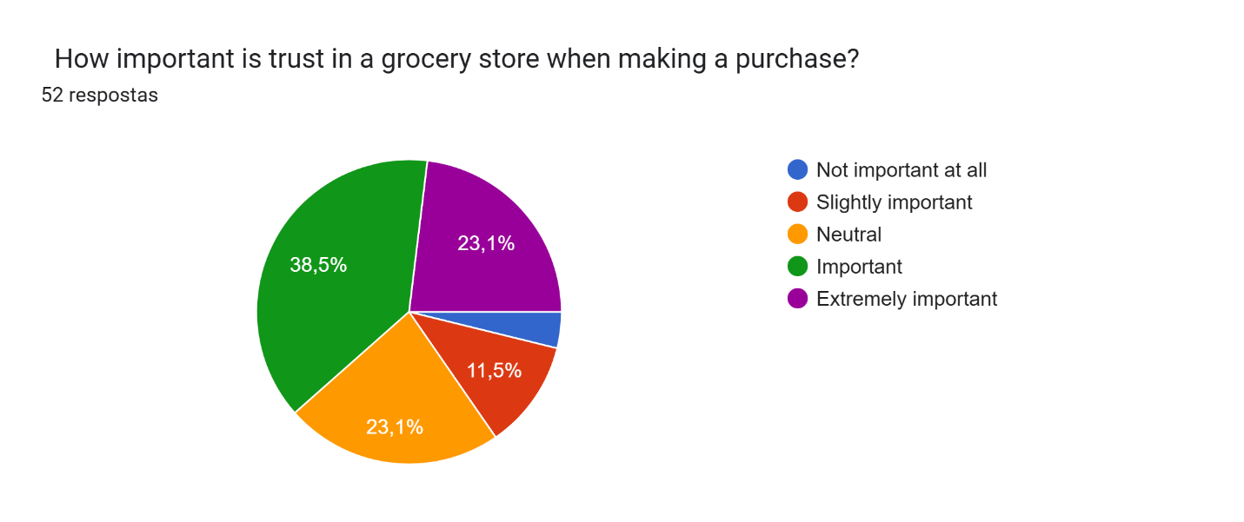
Trust was identified as a necessary key element of consumer decisioning. The research found that trust was rated “important” by 38.5% of customers, while a further 23,1% of customers said it was “extremely important” in their purchasing decisions. The store manager supported this view as well, he said, “we build trust by consistently pricing the same and always dealing directly with people”. Even if there's a complaint, we resolve it openly, which keeps them coming back.” This justifies Shahid literature review findings that sheeting emotional experience such as trust and belonging hold significant meaning in retaining customers especially in small grocery business.
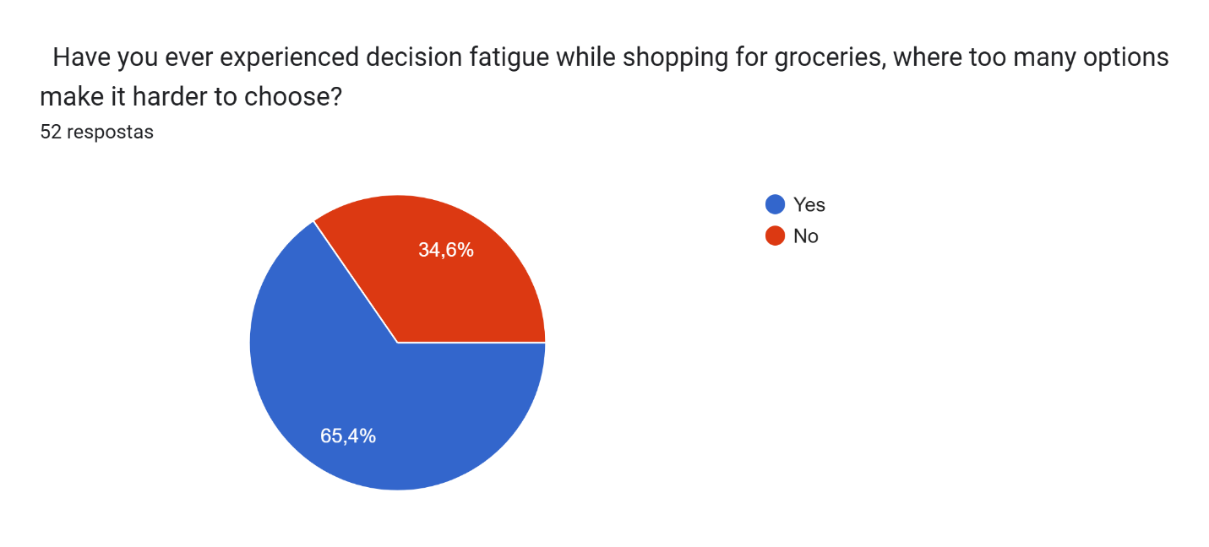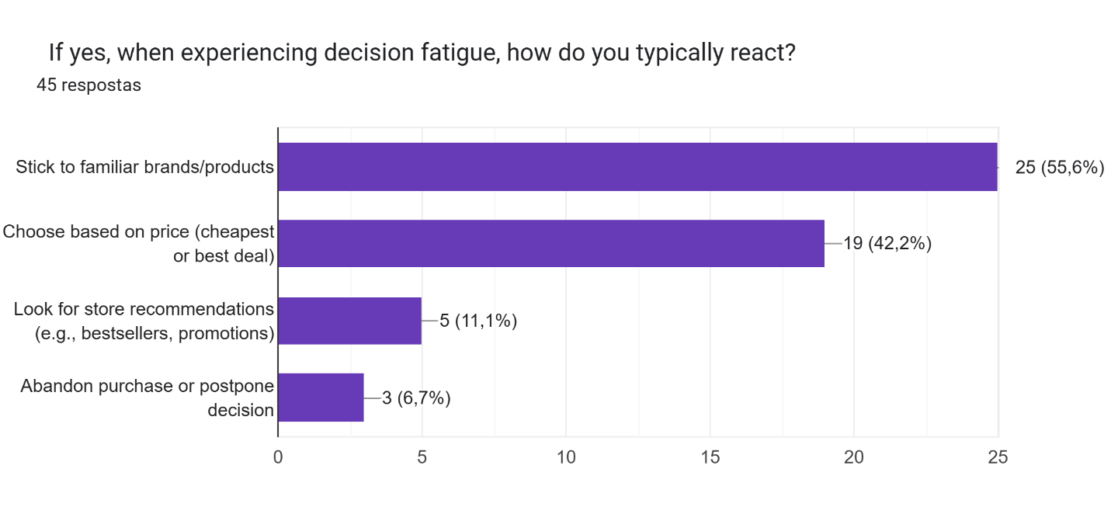
Another psychological concern affecting shopping behavior was decision fatigue. A notable 65.4% of customers confessed to experiencing mental fatigue while shopping and, of these, 55.6% admitted to coping by defaulting to familiar brands or habitual choices. Store manager said, “To minimize fatigue, we emphasize store shelves with signs, and our layout is uncomplicated, so customers do not feel overwhelmed.” Such measures are meant to make shopping easy and decrease cognitive stress. The above practices are consistent with the theory of rational-emotional regulation as the process of simplifying decision making alleviates mental exhaustion and retrenches customers’ satisfaction.
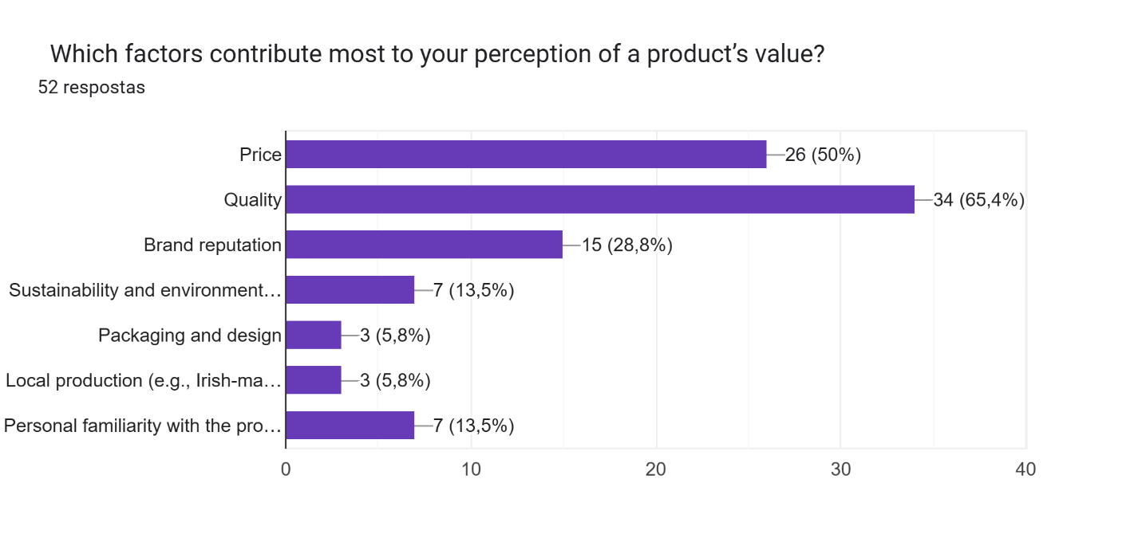
Psychological comfort was also determined by perceptions of value. During respondents’ consultation on what defined value in products, 65.4% of respondents indicated that it is the quality, while 50% of them mentioned price. This is an indication that the internal satisfaction of a smart, balanced purchase wherein affordability is matched with the quality enhances positive consumer experience. Such psychological reinforcers are important in creating customer loyalty and repeat visits especially in environments in which customers seek for economic and emotional reassurance.

4.2 Social and Cultural Influences on Shopping Patterns
The influence of social and cultural factors plays a very important role in determining how the consumers behave in representing an environment of a small local grocery store. From the results of the thematic analysis, customers appear to be greatly influenced by the family as well as peers, cultural influences, and word of mouth communication. These factors are both awareness of the product and its purchasing decisions.
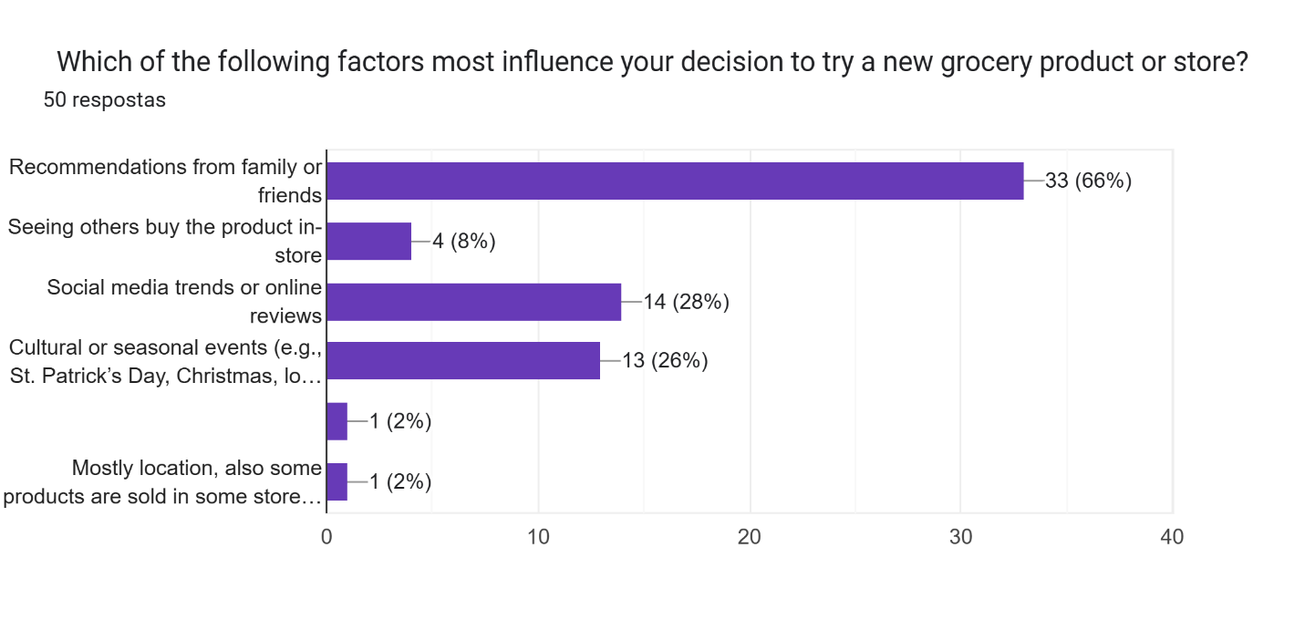
Survey findings reveal that 66% of respondents admitted to being influenced by family and friends when it came to experimenting with new products. This underlines the power of informal social networks in influencing purchasing decisions. Some utterances represent the social construct of trust and familiarity, the endorsements by closely connected individuals are given more weight than the official advertising.
Social media trends also arose as a second order effect, with 28% acknowledging that social media could have affected their shopping patterns recently. Although this percentage is smaller, it means the growth of digital-social impact on a traditionally interpersonal environment. These results only back the argument by literature review that emphasized that peer impact and cultural stimuli largely influence consumers’ choice.

Moreover, the survey data revealed that 44.2% of customers sometimes purchase local products and 17.3% often purchase local products. These figures, however, also imply the potential for improving the level of local product branding and visibility to strengthen cultural loyalty. The literature review emphasized that community values and common traditions greatly influence shopping decisions, especially in localized economies where cultural identity is of utmost importance. The result emerges from this theme cultural alignment, recommendation chain, and family-oriented consumption- show how social approval and cultural identity go beyond mere habit, as psychological anchor of consumer loyalty and brand trust in local shopping environments.
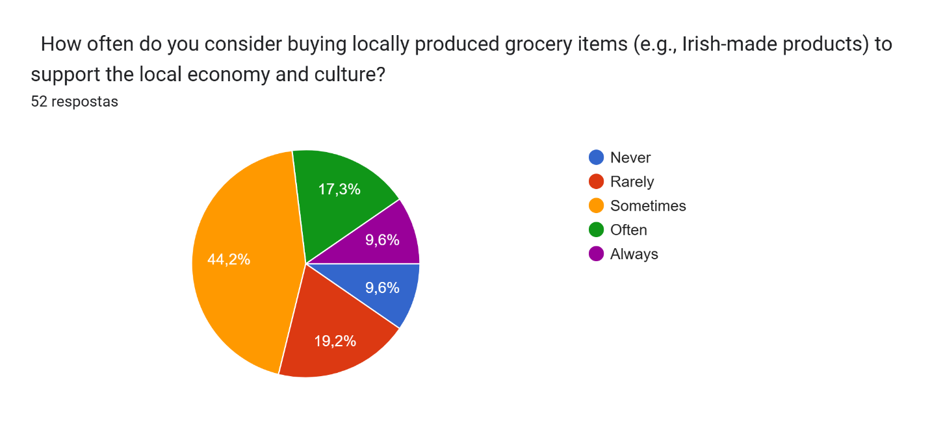
The observations by interviewing the manager of the store. The manager said: “since we live in Irish society, so we are usually created a Irish product sections are perfectly and well-maintained one” This statement reflects how thoughtful presentation of culturally products can enhance costumer identification with local stores.

4.3 Tangible Factors Driving Purchase Decisions
Small local grocery stores have a lot to do with consumer purchasing behavior in terms of tangible factors. The survey of the customers showed that these factors-especially pricing, stock availability, variety of products and convenience have a strong impact on the store’s preference and on repeat visits.
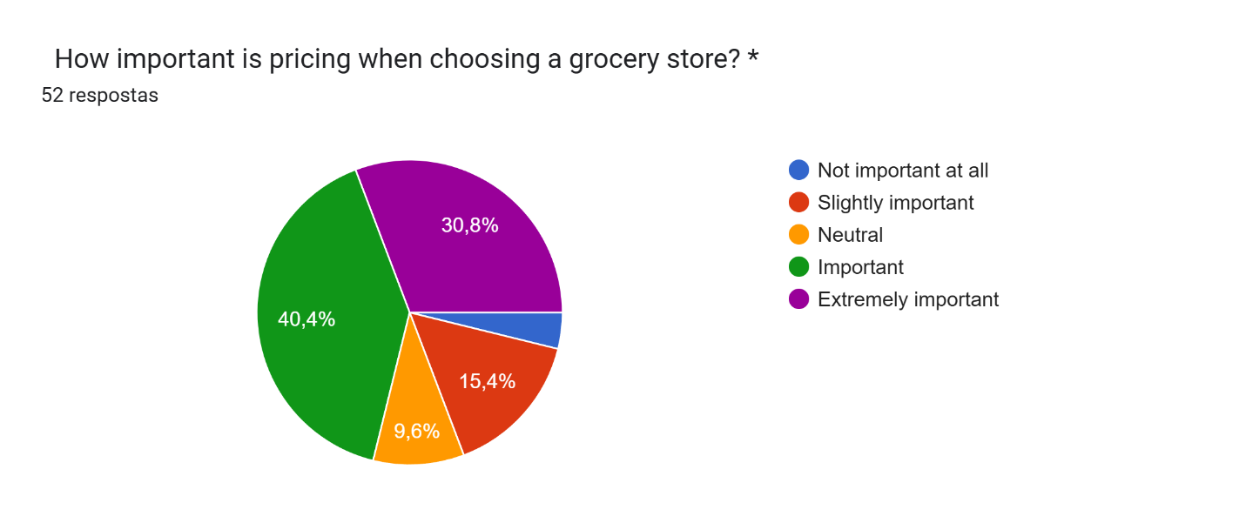
When asked about the importance of pricing, 40.4% of customers indicated that it was "important," and an additional 30.8% rated it as "extremely important." This is an indication that whatever is involved with pricing is still a key issue as the customers evaluate other tangible aspects of their shopping decision. For example, the question of stock availability developed into a decisive factor, with 50% of the respondents mentioning that they would stop purchasing from a grocery store if there were a high number of stock shortages of essential items. Similar to the above, 26.9% mentioned a lack of variety as one of the significant problems that may influence the decision to stop buying in grocery stores.
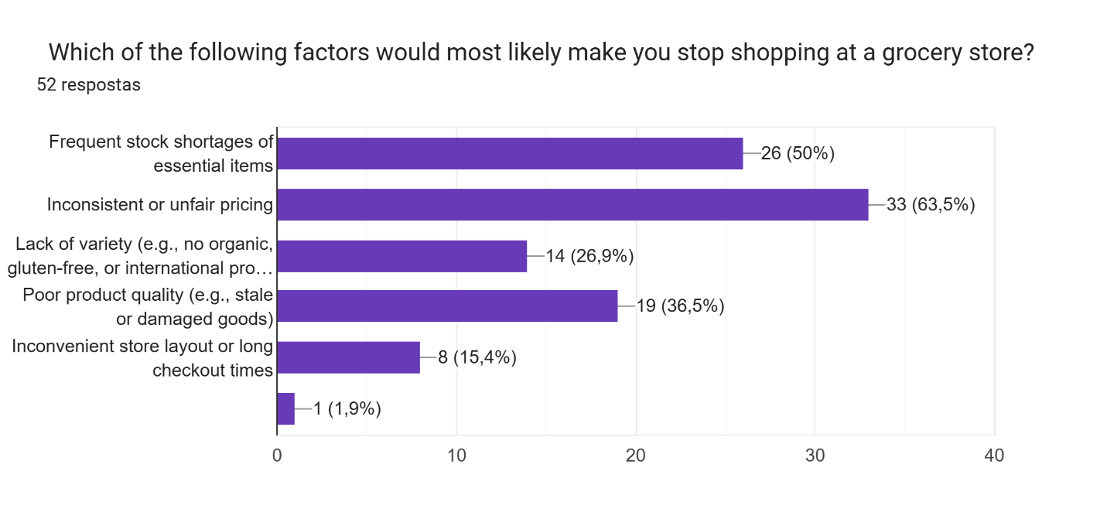
The store manager said that; “Nowadays, we operate in a very competitive environment with many large companies around us. Since we are a small shop it requires a lot of work, we try to maintain fair prices and offer quality products. We also monitor competitors to stay competitive”.
This strategy goes with literature review findings that key physical attributes – fair pricing, steady stock levels, and varied products are critical for maintaining consumer loyalty within local retail shop. Customer choices cannot be attributed to cost alone, but by the value received through consistent service and availability of desired goods.
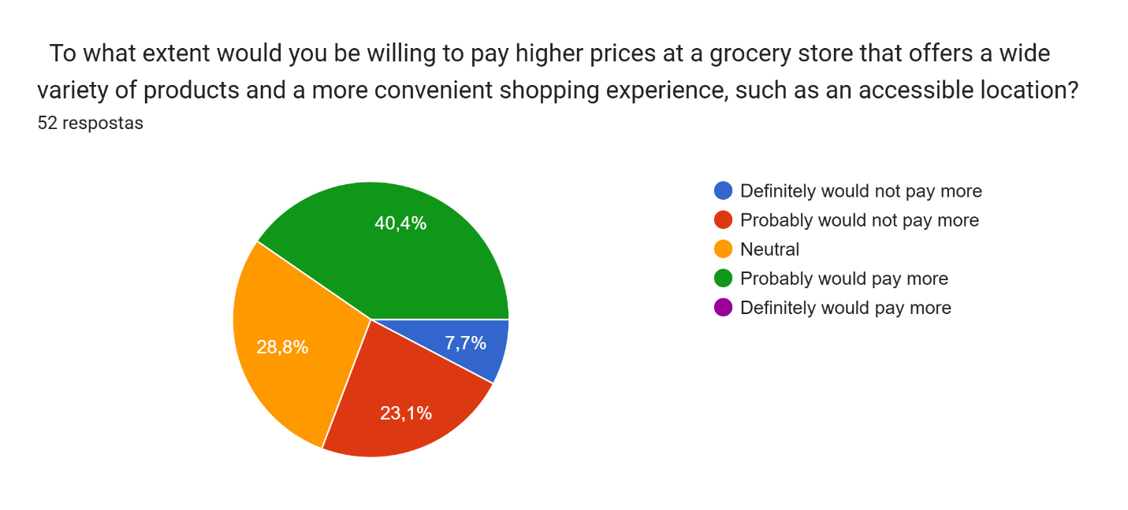
Interestingly, 40.4% of the respondents also indicated that, with added convenience and a bigger range of products, they would “probably” be willing to pay more. This adds to the fact that tangible value is not necessarily price bound but set in a bundle of benefits that enrich the shopping experience.
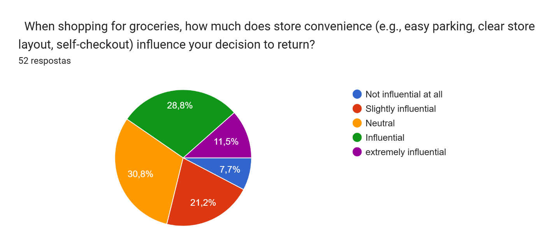
Convenience as another physical variable also played a major role in customer preferences. Approximately 28.8% of respondents described it as “influential” regarding their decision to shop at a particular store, while 11.5% considered it to be “extremely influential”. These insights justify the assertion by literature review that issues such as proximity, ease of navigation, and efficient store layout give smaller retailers the upper hand, especially in competing against bigger supermarket chains. Customers tend to prefer stores which offer easy and easy-to-do shopping, especially for ordinary or instant purchases. In general, tangible factors play the role of the basis for both first impressions and long-term customer satisfaction in local grocery environments.

4.4 Impact of Marketing Strategies on Consumer Choices
The effect of marketing strategies on consumer purchase decisions is very significant in small local grocery shops where personal relationship and quality of store experience means much more than in the larger chain shops. Several marketing elements were identified as influential on the basis of survey data and manager’s interview: to include in-store promotions, loyalty schemes, impulse buying triggers and personalized advertising.
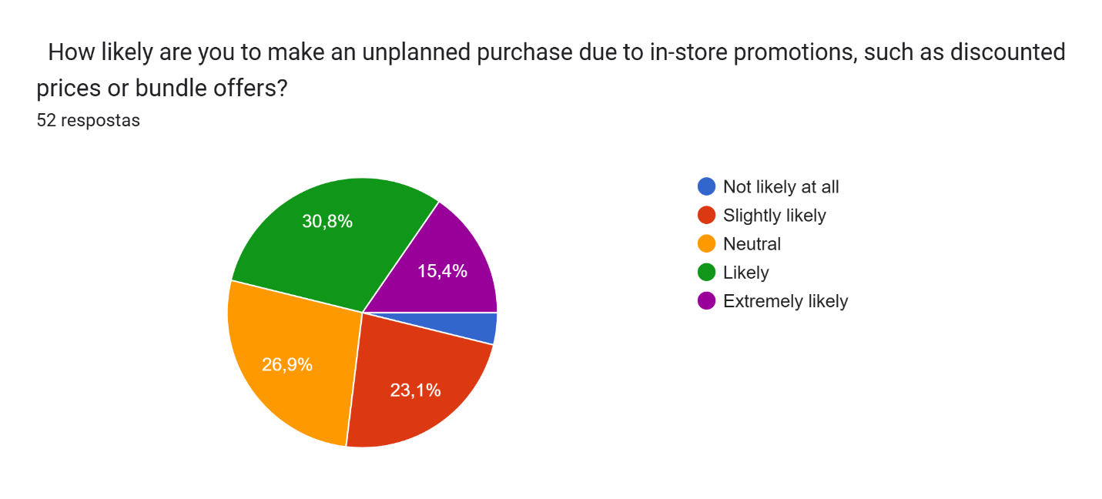
When asking customers how likely they were to make unplanned purchases because of promotional signage or special offers, 30,8% reported being “likely”, and 15.4% said “extremely likely”. This means there is a high correlation between promotional visibility and consumer spontaneity. Promotions played a strategic role, and the store manager confirmed this. “We always offer promotions on popular items.
This relates to literature review that found that visual merchandising and time-limited discounts at point-of-sale locations greatly increase the chances of an impulse purchase. In a similar vein, the work done by (Pallikkara et al., 2021) highlighted how such promotions are particularly effective for neighborhood grocery stores where repeat customer interactions increase their power.
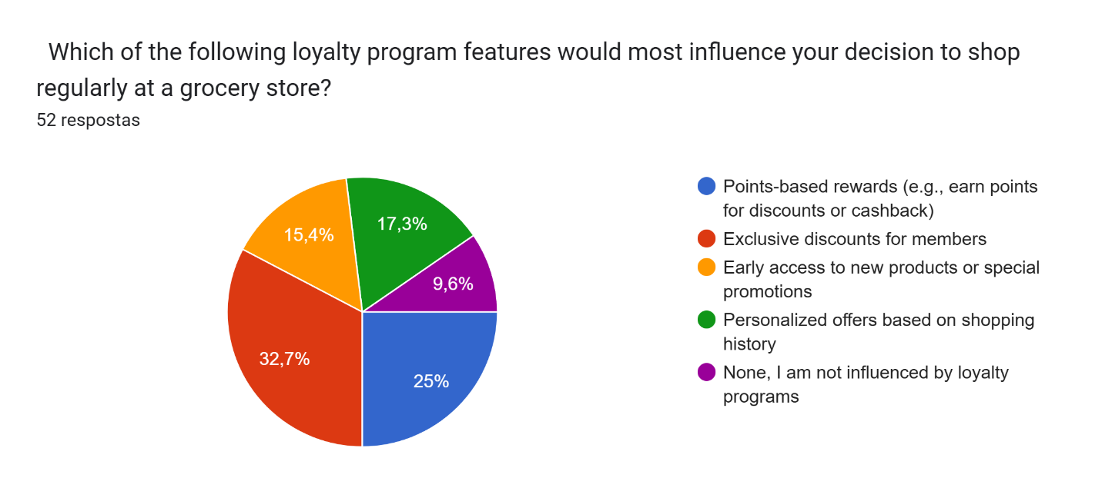
From survey data, more was discovered about customer preferences of loyalty programs. 25% of the participants preferred point-based rewards, cash backs and 17.3% prefer personalized offers. These were coded under categories of, “value-driven retention,” “recognition,” and “exclusive deals,” respectively. Such diversity of preference demonstrates that loyalty can be different for everyone.

The literature review highlights a high influence of marketing strategies on consumer choice, especially with grocery stores and Pallikkara(2021) says that instore promotions, loyalty programs and personalized offers are significant enhance customer engagement and increase sales.
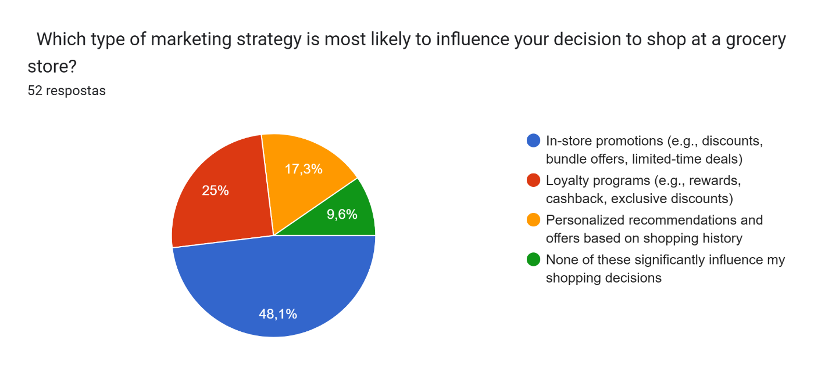
The findings from the survey reflect this theorical perspective. When asked which type of marketing strategy is most likely to influence your decision to shop at a grocery store, 48,1% indicate that in-store promotions are the most influential in their shopping decisions. However, loyalty programs also showed substantial relevance of 25%.
In the interview with the store manager showed an important contrast, the absence of formal marketing strategies like loyalty program. “We currently we don't have any like formal programs like it, but these questions make us, you know, aware of these loyalty programs because we are just a small shop, but we are trying to make something like building promotions and loyalty programs”. This reflects a gap between literature theorical best practices and the operational capacity of small local stores.
Overall, while literature and consumer response show the effectiveness of marketing strategies such as loyalty programs, this practice still limited at small groceries. This suggests a potential investment for small stores to remain competitive and better align with costumers’ expectations.

4.5 Community Engagement and Customer Loyalty
The analysis shows that community engagement and CRS practices can have a significant impact on consumer loyalty in local grocery stores. As viewed in the literature, stores participating in community initiatives tend to foster deep emotional connections with customers, encourage repeat visits and brand trust. This is aligned with the findings from the interview, where the store manager describes efforts such as placing donation boxes (poor box, locally called) at the tills and participating in community events. The manager said “we don't want the people to see it just like a shop. We also want to be a part of the society”. This demonstrates a genuine commitment to community aligning whit literature that claims that ethical engagement fosters long term loyalty.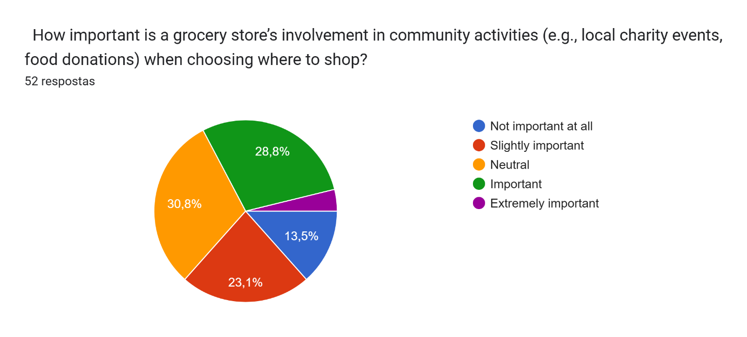 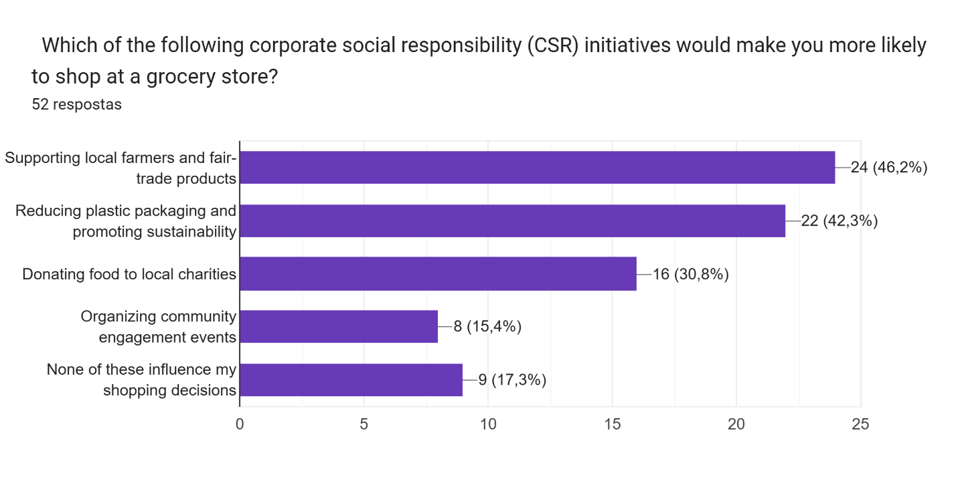
Results from survey shows these insights, while only 23.1% of respondents rated community engagement as “important” and 0% as “extremely important” in choosing where to shop, CRS related to supporting local farmers with 46,2% and promoting sustainability with 42,3% were more influential which indicates that while general community activities might be not primary factor in decision drive. However, supporting local farmer and promoting sustainability resonate strongly.
These observations suggest that to deepen loyalty, small grocery stores should go beyond symbolic engagement and clear communicate their contribution to ethical causes such as reducing plastic waste and sourcing with local producer. As noted in literature review, when customers see their value reflected in a store’s actions, a strong emotional bond forms.

Chapter V

5.1 Conclusion and Recommendation
This research has investigated the multifaceted nature of consumer purchasing behavior in small local grocery stores with an emphasis on psychological, social, economic, marketing, and community engagement influence. From the analysis, it is noted that product availability and prices are not the sole determinants of purchasing choice but are a product of a complex cocktail of trust, culture, economic and emotional attune through community engagement.
Probably, the most striking of the results is the importance of trust in building consumer loyalty. Customers always complained that such familiarity in a store’s conduct like fair pricing, transparent sourcing of products and sane interaction – directly affected their intention of returning. Other psychological factors including value perception and decision fatigue were also very important. consumers are inclined to select shops where shopping is smooth and emotionally pleasing. These psychological dimensions point out the need for consistency, familiarity, and transparency from small grocery stores when offering their services and communication. Social pressures such as recommendations of family, cultural relevance and peer pressure were also significant in determining consumer behavior. The data shows that consumers are more likely to explore or repeat purchases when recommendations are from trusted social circles or comply with customs. This is most apparent with the local festivals and cultural events as the stores which stock culturally relevant products experience a boom. Therefore, local grocery stores have to be socially and culturally relevant to their communities. Economic factors like pricing, availability of products, and store convenience are also some of the key decision drivers that were turned up at bottom. Affordability was the main concern, but customers also complained about stock lack and lack of product variety. The presence of a steady stock of basic necessities plus niche stock to suit varied demands for consumers will enhance customer satisfaction and retention.
Marketing strategies in particular in-store promotions and loyalty programs were seen to have a positive effect on impulse buying and repeat purchases. Although many customers confessed to purchasing items outside their shopping list when given deals, loyalty programs also provided customers with a reason to come back, which based habitual buying behavior. Many customers preferred to shop at places that practice socially responsible behavior, for instance supporting local farmers or donating unsold goods. These actions are not only aligned with the ethical consumer values but also build an emotional bond between the store and its customers. Stores, which play a community stakeholder role, rather than conventional retail ones, are seen more positively.

5.2 Recommendations
Enhance Trust and Transparency
Small stores should consistently follow open communication, fair prices, and ethical sources of their products. Sourcing and complaints handling can be made transparent by posting clear information which will appeal to the customer and make customers trust the organization.
Align with Cultural and Social Norms
Stock up items appropriate to cultural festivals and locals’ preferences regularly. Interacting with community traditions defines relevance and develops social capital.
Ensure Product Availability and Diversity
Keep good stock levels through proper supplier relationship. Provide varying assortment of basic as well as specific products to address diversified consumer needs.
Implement Strategic Marketing Initiatives
Have basic yet effective promotions and loyalty schemes. Personalized offers and in-store discounts and loyalty programs can push impulse purchases as well as customer retention.
Invest in Community Engagement
Collaborate with local producers, implement sustainability, and involvement in local projects. Such efforts make the brand human and raise emotional loyalty.
Through the implementation of these recommendations, small local grocery stores can better serve the needs of their customers and succeed in an increasingly competitive retail landscape.

References

Alagarsamy, S., Mehrolia, S. and Singh, B. (2021). Mediating Effect of Brand Relationship Quality on Relational Bonds and Online Grocery Retailer Loyalty. Journal of Internet Commerce. [online] doi:https://doi.org/10.1080//15332861.2020.1868213.
Ali, A. (2021). Quantitative Data Analysis. [online] ResearchGate. Available at: https://www.researchgate.net/publication/351637670_Quantitative_Data_Analysis.
Akotia, J., Awuzie, B.O. and Egbu, C. (2023) Onto-Epistemological Assumptions Underpinning Mixed Methods Research Designs. In Mixed Methods Research Design for the Built Environment (pp. 17-29). Routledge.
Aldalaty, M. and Piranej, T. (2024). How does Corporate Social Responsibility (CSR) contribute to trust building - through effective social contribution to the society? [online] DIVA. Available at: https://www.diva-portal.org/smash/record.jsf?pid=diva2%3A1862422&dswid=9299 [Accessed 19 Nov. 2024].
Alshurideh, M., Gasaymeh, A., Ahmed, G., Alzoubi, H. and Kurd, B. (2020). Loyalty program effectiveness: Theoretical reviews and practical proofs. Uncertain Supply Chain Management, [online] 8(3), pp.599–612. Available at: https://growingscience.com/beta/uscm/3934-loyalty-program-effectiveness-theoretical-reviews-and-practical-proofs.html [Accessed 19 Nov. 2024].
Alzoubi, H.M., Ahmed, G. and Alshurideh, M. (2022). An empirical investigation into the impact of product quality dimensions on improving the order-winners and customer satisfaction. International Journal of Productivity and Quality Management, [online] 36(2), pp.169–169. doi:https://doi.org/10.1504/ijpqm.2022.124711.
Braun, V., & Clarke, V. (2006). Using thematic analysis in psychology. Qualitative research in psychology, 3(2), 77-101.
Chan, E.Y. (2024). Consumer Behavior in Practice. SpringerLink. [online] doi:https://doi.org/10.1007-978-3-031-50947-6.
Culleton, M.D. (2023). Urban quality related effects on residential property prices in Dublin, Ireland. Polimi.it. [online] doi:https://hdl.handle.net/10589/210776.
Dirwan, D. and Latief, F. (2023) Understanding the Psychology Behind Consumer Behavior. Advances in Business & Industrial Marketing Research, 1(3), pp.130-145.
Dahab, S.A. -, Agag, G. and Abdelmoety, Z.H. (2021). Examining the influence of cultural and ethical ideology on consumers’ perceptions about the ethics of online retailers and its effects on their loyalty. Journal of Retailing and Consumer Services, [online] 61, pp.102559–102559. doi:https://doi.org/10.1016/j.jretconser.2021.102559.
Chabane, N., Bouaoune, A., Tighilt, R., Abdar, M., Boc, A., Lord, E., Tahiri, N., Mazoure, B., Acharya, U.R. and Makarenkov, V. (2022). Intelligent personalized shopping recommendation using clustering and supervised machine learning algorithms. PLOS ONE, 17(12), p.e0278364. doi:https://doi.org/10.1371/journal.pone.0278364.‌Dinah, P., Maria, W., Patarata, L. and Fraqueza, M.J. (2022). Understanding the main factors that influence consumer quality perception and attitude towards meat and processed meat products. Meat Science, [online] 193, pp.108952–108952. doi:https://doi.org/10.1016/j.meatsci.2022.108952.
‌Finegan, T. and Buckley, M.C. (2022). Enhancing well-being and social connectedness of rural communities through community shops. Community Development Journal, [online] 58(2), pp.309–327. doi:https://doi.org/10.1093/cdj/bsac003.
García, N.P., Gil-Saura, I., Orejuela, A.R. and Junior, J.R.S. (2020). Purchase intention and purchase behavior online: A cross-cultural approach. Heliyon, 6(6).
Gelderman, C.J., Jos Schijns, Lambrechts, W. and Vijgen, S. (2021). Green marketing as an environmental practice: The impact on green satisfaction and green loyalty in a business‐to‐business context. Business Strategy and the Environment, [online] 30(4), pp.2061–2076. doi:https://doi.org/10.1002/bse.2732.
Hecht, A.A., Perez, C.L., Polascek, M., Thorndike, A.N., Franckle, R.L. and Moran, A.J. (2020). Influence of Food and Beverage Companies on Retailer Marketing Strategies and Consumer Behavior. International Journal of Environmental Research and Public Health, [online] 17(20), pp.7381–7381. doi:https://doi.org/10.3390/ijerph17207381.
Hossan, D., Mansor, Z.D. and Jaharuddin, N.S. (2023). Research Population and Sampling in Quantitative Study. International Journal of Business and Technopreneurship (IJBT), [online] 13(3), pp.209–222. doi:https://doi.org/10.58915/ijbt.v13i3.263.
Jalolov, T.S. (2024). USE OF SPSS SOFTWARE IN PSYCHOLOGICAL DATA ANALYSIS. PSIXOLOGIYA VA SOTSIOLOGIYA ILMIY JURNALI, [online] 2(7), pp.1–6. Available at: https://bestpublication.net/index.php/psixsot/article/view/30 [Accessed 19 Nov. 2024].
Junjie, M. and Yingxin, M. (2022). The Discussions of Positivism and Interpretivism. Online Submission, [online] 4(1), pp.10–14. Available at: https://eric.ed.gov/?id=ED619359 [Accessed 19 Nov. 2024].
Kullak, F.S., Baier, D. and Woratschek, H. (2022). How do customers meet their needs in in-store and online fashion shopping? A comparative study based on the jobs-to-be-done theory. Journal of Retailing and Consumer Services, [online] 71, pp.103221–103221. doi:https://doi.org/10.1016/j.jretconser.2022.103221.
Mensah, D.O. and Oyinlola Oyebode (2022). ‘We think about the quantity more’: factors influencing emerging adults’ food outlet choice in a university food environment, a qualitative enquiry. Nutrition Journal, [online] 21(1). doi:https://doi.org/10.1186/s12937-022-00801-0.
Nolan, S. (2023). Collaboration for local food systems: The role of government in supporting and fostering conditions for successful local food system collaboration in Dublin, Ireland. Studenttheses.uu.nl. [online] doi:https://studenttheses.uu.nl/handle/20.500.12932/43573.
Peel, K.L. (2020) A beginner’s guide to applied educational research using thematic analysis. Practical Assessment Research and Evaluation, 25(1).
Pallikkara, V., Pinto, P., Hawaldar, I.T. and Pinto, S. (2021). IMPULSE BUYING BEHAVIOUR AT THE RETAIL CHECKOUT: AN INVESTIGATION OF SELECT ANTECEDENTS. Business: Theory and Practice, [online] 22(1), pp.69–79. doi:https://doi.org/10.3846/btp.2021.12711.
Pilarska, J. (2021) The constructivist paradigm and phenomenological qualitative research design. Research paradigm considerations for emerging scholars, 1, pp.64-83.
Pignatiello, G.A., Martin, R.J. and Hickman, R.L. (2018). Decision fatigue: A conceptual analysis. Journal of Health Psychology, [online] 25(1), pp.123–135. doi:https://doi.org/10.1177/1359105318763510.
Qun, C., She, J., Qiqi, Z., Lin, Z., Fan, W. and Lihua, Z. (2024). From Virtual to Reality: What Motivates Consumer Participation in Community-Based Group Buying? [online] doi:https://doi.org/10.2139/ssrn.4970146.
‌Rane, N.L., Achari, A. and Choudhary, S. (2023). ENHANCING CUSTOMER LOYALTY THROUGH QUALITY OF SERVICE: EFFECTIVE STRATEGIES TO IMPROVE CUSTOMER SATISFACTION, EXPERIENCE, RELATIONSHIP, AND ENGAGEMENT. International Research Journal of Modernization in Engineering Technology and Science. [online] doi:https://doi.org/10.56726/irjmets38104.
Ryba, K.L. - and Zimon, D. (2021). Customer Behavioral Reactions to Negative Experiences during the Product Return. Sustainability, [online] 13(2), pp.448–448. doi:https://doi.org/10.3390/su13020448.
Shamsudin, M.F., Hassim, A.A. and Abd Manaf, S. (2024) Mastering Probability and Non-Probability Methods for Accurate Research Insights. Journal of Postgraduate Current Business Research, 9(1), pp.38-53.
Shahid, S. and Paul, J. (2021). Intrinsic motivation of luxury consumers in an emerging market. Journal of Retailing and Consumer Services, [online] 61, pp.102531–102531. doi:https://doi.org/10.1016/j.jretconser.2021.102531.
Sondos, I.A. - A., Alkhwaldi, A., Salhab, H., Shehadeh, M. and Ali, B. (2023). Customer attitudes towards online shopping: A systematic review of the influencing factors. International Journal of Data and Network Science, [online] 7(1), pp.513–524. Available at: https://m.growingscience.com/beta/ijds/5812-customer-attitudes-towards-online-shopping-a-systematic-review-of-the-influencing-factors.html [Accessed 19 Nov. 2024].
Yu, C.-Y. (2024). Influences of Perceived Built Environments and Personal Attitudes Toward Walking to the Grocery Store. Urban Science, [online] 8(4), p.199. doi:https://doi.org/10.3390/urbansci8040199.
Zhang, Y. (2024). The Evolution of Loyalty Programs in the Digital Age: A Review of Consumer Engagement and Retention Strategies. Business, Marketing, and Finance Open, [online] 1(2), pp.1–12. Available at: https://bmfopen.com/index.php/bmfopen/article/view/7 [Accessed 19 Nov. 2024].

