
Applied Project Submission Form

LEARNER NUMBER | 51748231
NAME | Haider Khalid
COURSE | Bachelor of Arts (Hons) in Marketing
REPORT TITLE | How do loyalty program structures, compared to direct price reduction strategies, influence customer spending behaviour in retail stores in Dublin?
SUPERVISOR NAME | Mark Banchansky
WORD COUNT | 7,852
DUE DATE | June 07, 2026
DATE SUBMITTED | June 06, 2026

I certify that:
- This project report is all my own work, and no part of this report has been copied from another source:
Yes ☒ No ☐
- I understand that this report may be checked by electronic or other means for plagiarism and/or content created by generative AI and may be transferred and stored in a database for the purposes of data matching/data-analysis to help detect plagiarism and/or content created by generative AI:
Yes ☒ No ☐
- This report has not previously been submitted in part or in full for assessment to any other institution:
Yes ☒ No ☐
- I consent to the inclusion of my report in the publicly accessible (open access) electronic database maintained by the library:
Yes ☒ No ☐
- I have emailed a back-up copy of this report to locker@independentcollege.ie:
Yes ☒ No ☐

(Note that if no check boxes are selected, this Project will be regarded as NOT properly submitted, and may be subject to a late submission penalty)

Name: Haider Khalid
Date: June 06, 2026

For the report to count as a valid submission, the student must provide:
1 electronic copy via Moodle. There is no requirement for a hard copy.

Evidence of the Primary Research MUST be included in the appendix of the report. That includes a copy of questionnaires, interview schedules, or observation diaries. One interview transcript should be included as a full transcript and a summary of all other interviews must be kept as a backup by the student. See template on Moodle for what should be included in all aspects of the report. All data must be anonymised.

The text should be double-spaced throughout and single column format (A4) with 2cm for left and right-hand margins and 2.5cm at head and foot. Text should be justified, standard 12 point, footnotes 10 point, and in Calibri. Page numbers should be at the bottom-right. Do not use line and paragraph spacing. Keep formatting to a minimum and avoid underlining.

Harvard Referencing shall apply.



How do loyalty program structures, compared to direct price reduction strategies, influence customer spending behaviour in retail stores in Dublin?

Compiled by:
Haider Khalid

This project is submitted in part fulfilment of the Degree of Bachelor of Arts (Hons) in Marketing
Independent College
June 2026

ACKNOWLEDGEMENT

First and foremost, all praise goes to Allah Almighty, the Most Gracious and Most Merciful. Without His endless blessings, guidance, and strength, I wouldn’t have finished this work. Honestly, if not for His grace, I wouldn’t have made it to the end.

I’m deeply grateful to my supervisor Mark Banchansky. Their guidance, thoughtful advice, and steady support really kept me going through every stage of this research. They offered clear feedback, showed a lot of patience, and always pushed for excellence. That meant a lot.

I also want to thank my lecturer Dr. Bill Mallon. The lessons and ideas they shared set the groundwork for this thesis. Their commitment to high academic standards truly shaped how I approached my studies.

And, of course, I owe a huge debt to my parents and my partner Faiqa. Their sacrifices, prayers, and encouragement were my anchor. They never stopped believing in me, and their support—through every high and low—means more than I can say. This work reflects their love and commitment as much as my own effort.

Finally, this thesis goes out to everyone who helped, whether I saw it or not. Let this be a reminder that it took faith, hard work, and the encouragement of many hands to reach this point.

Abstract
This study examines how loyalty program structures, compared to direct price reduction strategies, influence customer spending behaviour in retail stores in Dublin. The research aims to assess perceptions of value and fairness, evaluate the impact of price discounts, analyse the role of loyalty program participation, and explore consumer attitudes toward spending control and decision-making. A quantitative research design was adopted, using a structured questionnaire with Likert-scale items distributed to 100 respondents. The data were analysed using descriptive statistics and reliability testing, with Cronbach’s alpha indicating strong internal consistency (0.894). The findings reveal that direct price reductions have a stronger immediate influence on purchasing behaviour, particularly in encouraging unplanned spending and store switching. However, loyalty programs contribute to increased customer retention, spending concentration, and perceived satisfaction. While consumers recognise the value of both strategies, price sensitivity remains a dominant factor, highlighting the need for retailers to balance short-term incentives with long-term engagement strategies.
Keywords: Customer Spending Behaviour; Loyalty Programs; Price Discounts; Retail Marketing
Table of Contents
1 Chapter 1: Introduction 1
1.1 Background to the Study 1
1.2 Research Question 2
1.3 Research Objectives 2
1.4 Research Themes 2
1.5 Relevance and Importance of the Research 3
1.6 Chapter summary 3
2 Chapter 2: Literature Review 4
2.1 Literature Review Introduction 4
2.2 Conceptual Foundations and Definitions. 4
2.3 Theoretical Framework 5
2.3.1 Behavioural Economics Theory 5
2.3.2 Relationship Marketing Theory 5
2.3.3 Equity Theory (Perceived Fairness) 5
2.4 Master Thematic Literature Review. 6
2.4.1 Theme 1: Consumer Behaviour -Price and Reward Responses. 6
2.4.2 Theme 2: Loyalty Programs and Customer Spending Behaviour. 6
2.4.3 Theme 3: Direct Price Reductions 7
2.4.4 Theme 4: Perceived Fairness, Value and Psychological Decision Processes 8
2.5 Synthesis of the Literature (Empirical-First) 9
2.6 Research Gap Identification 10
2.7 Critical Stance (Evaluation of Literature) 10
2.8 Chapter Summary 11
3 Chapter 3: Research Methodology 11
3.1 Introduction 11
3.2 Research Philosophy 11
3.3 Research Approach 12
3.4 Research Design and Methodology Strategy 12
3.5 Data Collection Methods 12
3.6 Sampling Strategy 12
3.7 Data Analysis Methods 13
3.8 Ethical Considerations 13
3.9 Reliability and Validity 13
3.10 Chapter Summary 14
4 Chapter 4: Data Analysis and Findings 14
4.1 Introduction 14
4.2 Respondent Profile 14
4.2.1 Demographic Characteristics 14
4.2.2 Shopping Behaviour 15
4.3 Results by Research Objectives. 16
4.3.1 Objective 1: Perceptions of Value and Fairness 16
4.3.2 Objective 2: Direct Price Reduction Strategies Influence. 20
4.3.3 Objective 3: Impact of Loyalty Program Participation. 23
4.3.4 Objective 4: Customer Attitudes- Spending Control and Decision-Making. 26
4.4 Reliability Analysis 29
4.5 Major Results 30
4.6 Chapter Summary 30
5 Chapter 5: Discussion 31
5.1 Introduction 31
5.2 Findings Discussion by Research Objective 31
5.2.1 Objective 1: Perceptions of Value and Fairness 31
5.2.2 Objective 2: Effect of Direct Price Cuts on Spending Behaviour 31
5.2.3 Objective 3: Effects of Loyalty Program Participation on Spending Behaviour 32
5.2.4 Objective 4: Spending Control and Decision-Making 32
5.3 Conclusions on the Findings 33
5.4 Connection to Research Gap 33
5.5 Chapter Summary 33
6 Chapter: Conclusion and Recommendations. 34
6.1 Introduction 34
6.2 Research Summit 34
6.3 Conclusion of the main results 34
6.4 Study Contribution. 35
6.4.1 Academic Contribution 35
6.4.2 Practical Contribution 35
6.5 Practical Recommendations 35
6.6 Managerial recommendations 35
6.6.1 Price Discounts Recommendation 35
6.6.2 Loyalty Programs Recommendation 36
6.6.3 Fairness Recommendation 36
6.7 Research Limitations 36
6.8 Recommendations for Future Research 36
6.9 Summary of the chapter 37
7 References 38
8 Appendix 41
8.1 Reliability 41
8.2 Descriptive 41
8.3 Frequencies 44

Chapter 1: Introduction

Background to the Study
Modern retail business has been made more complex by the increased competition, digital transformation and the changing consumer expectations. The retailers do not just compete based on products available anymore, but on their capability to affect the buying decision based on their pricing and interaction mechanisms. Some of the most popular measures include the method of loyalty programs and the direct price reduction strategy, whereby both strategies focus on raising customer spending but in different ways.
The retail market in Dublin can be said to represent increasing sensitivity to prices and value-based consumption. Consumer knowledge is on the rise and, more often than not, consumers compare prices and, as such, retailers are turning towards promotional tools to stay competitive (Nguyen and Lee, 2023). Loyalty programs recognise repeat purchases by offering points or special treatment, and direct price cuts offer instant savings and are given upon purchase. The terms used in this study as a measure of customer spending behaviour include frequency of purchase, the value of transaction, overall spending, the perceived value and fairness is determined by the way the customer measures the benefits and the pricing transparency. The research targets brick-and-mortar stores in Dublin, but not Web-based platforms.
The justification of this study is that there is a necessity to strike a balance between the short-term sales and the long-term customer retention. Short-term purchases can be motivated using discounts, and this can compromise profitability as well as brand perception. Conversely, the loyalty programs are expected to develop long-term relationships, but they rely on long-term interaction and perceived value. Although they are commonly used, the relative effectiveness of the two is not well understood (Gonzales and Murtagh, 2025).
The main issue is that there is no definite evidence of the effect of these strategies on customer behaviour and perceptions. Whereas discounts do cause short-term buying, there is no guarantee that they will create repeat-buying, but the loyalty programs might not stimulate spending unless significant rewards are given (Nguyen and Lee, 2023). Another gap in the current research is that there is a context gap in Ireland and a gap in methodology when it comes to studying the more in-depth consumer attitudes.
This gap can be addressed to assist retailers in developing better strategies by matching the promotion to the perceptions and spending behaviour of the customer.

Research Question
The main research question guiding this study is:
How do loyalty program structures, compared to direct price reduction strategies, influence customer spending behaviour in retail stores in Dublin?

Research Objectives
This study is guided by the following objectives:
- To assess customer perceptions of value and fairness between loyalty-based rewards and direct pricing strategies.
- To evaluate the influence of direct price reduction strategies on customer spending behaviour.
- To analyse the impact of loyalty program participation on customer spending behaviour.
- To explore customer attitudes towards loyalty programs in relation to perceived spending control and decision-making.
These objectives collectively ensure a comprehensive investigation of both behavioural outcomes and underlying consumer perceptions.

Research Themes
The study is structured around five key research themes that reflect major streams in the literature:
Theme 1: Pricing Strategies and Consumer Behaviour
This theme explores how different pricing mechanisms influence purchasing decisions, focusing on behavioural economics and promotional effectiveness (Grewal et al., 2011; Blattberg et al., 2008).
Theme 2: Loyalty Programs and Customer Retention
This theme examines the design, effectiveness, and long-term impact of loyalty programs on customer engagement and retention (Dorotic et al., 2012; Kumar & Reinartz, 2016).
Theme 3: Perceived Value and Fairness in Pricing
This theme investigates how consumers evaluate fairness and value in promotional strategies and how these perceptions affect trust and spending (Xia et al., 2004).
Theme 4: Consumer Decision-Making and Spending Control
This theme focuses on psychological and behavioural factors influencing purchasing decisions, including impulse buying and perceived control (Thaler, 1985; Ariely, 2008).

Relevance and Importance of the Research
This study is new because it presents a location-based comparison of loyalty programs and price-cutting measures in the retail industry of Dublin to have a comprehensive knowledge of how they affect customer perceptions and expenditure trends (White and Kim, 2023). The conclusion will assist the retail managers in choosing the promotional approaches that work, and marketing professionals will also be able to segment the customers more efficiently. The retail organisations can also be able to improve engagement and competitiveness. All in all, the paper will endeavour to create a realistic model and workable recommendations to enhance the efficacy and longevity of retail advertising methods.

Chapter summary
With a digital transformation and evolving customer expectations, getting the price and promotions right is now a critical part of the retail strategy and can help encourage customers to buy. Customers in Dublin are highly sensitive to price and value – and both loyalty schemes and straight price cuts are key weapons in encouraging retail activity. Rewards are designed to incentivise repeat sales, and discounts give benefits at checkout. This study is a focus study of brick-and-mortar retail stores in Dublin and concentrates on key behavioural measures including purchase frequency, spending level, perceived value and fairness. It fills a gap in the literature because there is no strong consensus on the effectiveness of loyalty schemes, and existing literature has studied the impact of discounts over a shorter term. The research have delivered insights which enable retailers to fine-tune their promotions based on consumer perception and spending behaviour in the Irish retail environment, while ensuring the retailer is not compromising on sales growth in the short term at the expense of long-term customer retention.

Chapter 2: Literature Review

Literature Review Introduction
The main objective behind conducting this literature review is the evaluation of available scholarly and professional literature that relates to the effects of the structure of loyalty programmes and direct price reduction strategies on customer spending behaviour.
The main research question informing this dissertation is: How do the loyalty program structures relative to the price reduction strategies directly affect customer spending behaviour in Dublin retail stores? will demand a comprehensive interpretation of how value and fairness, and spending perceptions are framed by the application of pricing and reward mechanisms (White and Kim, 2023).
The chapter starts by establishing fundamental concepts and theoretical perspectives which form the basis of this research. It goes on to offer four key themes that were found in the literature, namely: the building blocks of consumer behaviour in response to pricing and rewards, the role and structure of loyalty programs, the consequences of direct price reduction strategies on consumer behaviour, and the interaction amongst perceived fairness, value, and customer attitudes (Nguyen and Lee, 2023).
The purpose of the literature review is not only to synthesise what is known about the topic, but also to indicate methodological constraints, missing context, particularly in the context of the European or Irish retailing, as well as areas where the empirical evidence is inconclusive or mixed.

Conceptual Foundations and Definitions.
Loyalty programs are organised reward systems that are created to stimulate repeat business by providing incentives through rewards in the form of points, tiers, or exclusive deals (Chen and Li, 2024). According to recent studies, properly developed loyalty programs may bring great improvement to customer retention and customer spending by establishing psychological attachment between consumers and brands, satisfaction, and repurchases.
Conversely, direct price reduction tactics such as temporary prices, coupons and promotion of pricing offer instant financial benefits at the point of sale. These strategies are well known to generate a short-term demand and boost the number of transactions, especially by price-sensitive customers. But continual use of price reduction can be at the cost of profitability, and it can teach the consumer to wait till there is a discount available, which kills the ability to achieve the long-term goals of revenue collection (Gonzales and Murtagh, 2025).
Lastly, the customer spending behaviour of this study involves purchase patterns, which entail frequency, amount purchased and decision making. Consumer behaviour studies have highlighted that rational judgments (e.g. perceived utility) and psychological reactions (e.g. fairness and emotional attachment) play a role in spending decisions.

Theoretical Framework

Behavioural Economics Theory
Consumers may not be rational and are subject to psychological biases, including "loss aversion", urgency, and "perceived gains" (Thaler, 2018). Price discounts are effective because they give the impression of a current discount, and they can sometimes lead to impulsive buying behaviour. But over time, discount exposure can result in “reference price adaptation” where customers come to expect lower prices in the future and postpone purchases (Blattberg and Neslin, 2019).
This is one of the reasons why this theory explains the short-term sales increase as well as long-term behavioural changes. The findings, in line with this theory, suggest that there were strong immediate responses to discounts and strategic waiting behaviour.

Relationship Marketing Theory
The concept of relationship marketing highlights a focus on customer relationships over short-term transactions (Morgan and Hunt, 1994). Frequently used to build customer loyalty through repeat purchases is the loyalty program. According to research, these types of programs can lead to improved retention and lifetime value (Sharp and Sharp, 2017).
As with any reward, however, the impact on engagement is dependent upon design quality; a poorly designed reward may not lead to engagement (Kim and Lee, 2020). The findings of this study were found to be partially supportive of the theory; although there is some evidence that loyalty programs do generate repeat purchases, the magnitude of this effect is not very large and is significantly moderated by the perceived value.

Equity Theory (Perceived Fairness)
According to the Equity theory, customers evaluate equity regarding inputs and outputs (Adams, 1965). In the promotional area, fairness is associated with transparency and clarity of reward. When prices are offered a discount, it can be viewed as equitable as the benefits accrue quickly and equally to all customers (Darke and Chung, 2019).
However, loyalty programs can also be seen as unfair because of their lack of immediate rewards or rewards that are not equal. This study finds support for the equity theory, with discounts perceived as ‘fairer’ than loyalty schemes, emphasising the need to be transparent in consumer perceptions.

Master Thematic Literature Review.

Theme 1: Consumer Behaviour -Price and Reward Responses.
The theoretical and empirical research on consumer behaviour has always highlighted the fact that pricing and reward signals form critical determinants in consumer purchase decision-making. Price is still one of the key cues that consumers rely on to derive value, make trade-offs and determine where and when to spend, even in complex retail environments.
Promotions with direct cost reduction are likely to appeal to price elastic segments and may stimulate impulse buying (Gonzalez-Torres and Paez 2023).
Critical evaluation: There is overwhelming evidence that both pricing and rewards cues are important determinants of consumer behaviour, but most studies are short-term in nature, or in an industry context (e.g. grocery or convenience retail), and less focus has been given to the way that these processes can be used in a defined geographic area such as Dublin (Gonzales and Murtagh, 2025; Nguyen and Lee, 2023; White and Kim, 2023).
Relevance to the present study: This theme provides a theoretical foundation for the comparison of loyalty programs and price cutting by indicating how each of the mechanisms affects value perception and spending behaviour. It helps to support the goal of the dissertation, as it helps to evaluate not only the behavioural results but the underlying perceptual factors determining the way consumers react to various forms of promotional structures.

Theme 2: Loyalty Programs and Customer Spending Behaviour.
Loyalty programs, as opposed to direct price discounts, which offer one-off savings of the economy, are built on accumulating benefits which customers look forward to receiving in case interaction with a retailer occurs many times. Such constant relationship orientation is in line with the modern customer engagement approaches, which focus on emotional attachment in addition to rational incentives (Chen and Li, 2024).
Recent studies emphasise that customer-centric loyalty programs are more efficient in boosting customer involvement and total lifetime value. Indicatively, a longitudinal study of retail loyalty schemes discovered that the number of participants in tiered reward programs showed a higher retention and incremental spending growth as compared to non-participants, especially in cases where personalisation factors (e.g. customised reward threshold or personal offers) were involved. This implies that consumers react to the expectation of future benefits as well as the sense of being singled out by the retailer (Smith and Baxter, 2024).
As an example, younger customers will prefer the use of digital-based loyalty programs with gamified rewards and immediate payoffs, but older generations might find predictable payoffs of the products or services they have to consume to be more appealing (Nguyen and Lee, 2023).
When the price of cashing in rewards is perceived to be out of proportion to the reward provision, a concept referred to as reward irritants, customers may lose interest or perceive the reward scheme as unjust, which will undermine brand loyalty (Patel, 2025).
Critical evaluation: Most of the research that exists considers the participation in loyalty as a binary variable (member vs non-member) without going into the psychological finer details, including whether one feels fair or in control of the spending choices. Also, although the positive correlations of the behaviour are established in numerous studies, few explain how the loyalty program can affect the behaviour, especially concerning perceived value and fairness, which are clarified in this dissertation.
Relevance to the present study: Theme 2 is a direct source of research objectives regarding the analysis of the effect of loyalty participation and attitudes to loyalty programs in the context of perceptions of control and fairness.

Theme 3: Direct Price Reductions
The direct price reductions include promotional price strategies like temporary discounts, coupons, flash sales and lowest price guarantee. The main justification of such strategies is the monetary cost of a purchase, which should be perceived as reduced in order to generate immediate spending and stimulate trial behaviour.
It has been implied that price promotions are some of the most salient behavioural stimuli when deciding to buy a product, especially among value-oriented buyers whose perceived savings are of utmost importance to them compared to other factors (Brown and Turner, 2022).
As an illustration, the perceived value can be intensified and make people spend faster by using discount framing methods, i.e. consumers compare the discounted price with the reference price that is usually higher. This is behaviourally consistent with loss-aversion and reference-dependence theories, in which consumers are highly responsive to perceived benefits in comparison with some mental reference point (Lee and Cho, 2024).
This reference price inflation effect may undermine trust and diminish loyalty, eventually lowering profitability, although it leads to the short-run spending increase (Gonzales and Murtagh, 2025; Nguyen and Lee, 2023; White and Kim, 2023).
The psychological effects of discounting. Research has indicated that consumer attitudes toward discounting are not always positive, and when promotions are omnipresent, they experience cognitive dissonance and cannot feel as satisfied after the purchase (White and Kim, 2023).
Critical evaluation: Although the literature presents strong support for the direct effect of price reduction on purchase decisions, most of the studies are based on unique experimental designs or case studies of sectors. How these effects are manifested within the actual competitive context of the real world, and specifically in geographically localised retail markets like Dublin, has received less focus and the interaction of the effects of discount with other psychological constructs such as fairness and perceived control.
Relevance to the present study: Theme 3 serves the purpose of investigating the effects of a direct price reduction strategy on spending behaviour and comparing the effects of the price reduction strategy with those of the loyalty-driven mechanism.

Theme 4: Perceived Fairness, Value and Psychological Decision Processes
In addition to economic motivators, the value and perceptions of fairness are the major factors influencing consumer reactions to loyalty programs as well as price promotions. The concept of perceived fairness is multidimensional, including distributive fairness (the outcome of fairness seems equitable), procedural fairness (the terms and procedures are transparent and consistent), and interactional fairness (the quality of communication and treatment) (Zhang and Brown, 2023).
Indicatively, a recent survey of the topic of retail loyalty schemes discovered that where the rules governing reward schemes were deemed complex or arbitrary, the level of member satisfaction also decreased, regardless of whether rewards had financial value or not. This implies that consumers are not judging incentives based on only economic conditions; clarity, predictability and perceived level of respect are important determinants to the level at which they decode and react to promotional constructions (Alvarez and Park, 2025).
Notably, according to recent studies on psychology, the perceived spending control, or the extent to which consumers feel they are making voluntary and self-regulated decisions, influences satisfaction and post-purchase attitudes.
It is counterintuitive that promotions that cause impulsive expenditure can result in perceived control and hence decreased satisfaction and future inhibition to participate. In contrast, rewarding loyalty based on the schemed goal oriented purchasing is more likely to strengthen the feeling of power and deliberateness (Chen & Li, 2024).
Critical evaluation: It is increasingly agreed that fairness and perceived value represent fundamental mediators between promotional programmes and spending behaviour, although much of this work is still disjointed in different situations, and not consistently incorporated.
Not many studies compare the functioning of these psychological constructs that differ in reaction to loyalty programs as opposed to price promotions in a straightforward way; a point that attracts significant attention in terms of a gap that this dissertation fills.
Relevance to the present study: Theme 4 is closely connected to the objectives where the perception of customer value and fairness are evaluated, and the relationship between attitudes towards loyalty programs and perceived spending control and decision making is examined.

Synthesis of the Literature (Empirical-First)
The four themes of empirical evidence consistently show that direct price reduction strategies and loyalty programs both have effects on consumer spending behaviour, albeit the effects are different and short and long-term impacts are also different. Price cuts are effective at stimulating instant purchases by reducing the perceived financial expenditure and are very popular with price elastic buyers and in the immediate sales bursts (Brown and Turner, 2022; Lee and Cho, 2024).
Nevertheless, continuous use of discounts may destroy the impression of fairness and the brand value of the long-term, and cause them to adopt discount-dependent patterns of purchase behaviour that will destroy their loyalty to customers (Gonzales and Murtagh, 2025; White and Kim, 2023).
On the contrary, loyalty programs create cumulative rewards that enhance retention and a higher rate of repeat purchasing. Empirical research proves that tiered and personalised rewards increase engagement and stimulate higher spending in the long term, especially when the customers do not find the program to be unfair, unachievable, or worthless (Smith and Baxter, 2024; Nguyen and Lee, 2023).
Furthermore, the psychological constructs of perceived expenditure control and emotional attachment can be positively affected by loyalty schemes, establishing a firmer platform of sustainable behaviour change than a direct discount (Patel, 2025; Alvarez and Park, 2025).
In terms of perceived fairness and value, the empirical studies point to the fact that the two constructs mediate the effectiveness of both strategies. Unfair, over-complicated, or manipulative promotions or rewards can decrease satisfaction and decrease the spending intention, whether or not they advantage a person financially (Zhang and Brown, 2023; Chen and Li, 2024).

Research Gap Identification
The literature review indicates that there are three gaps in it:
- Context Gap: The literature mostly focuses on loyalty and price in an international or generalised retail market. Evidence concerning the physical retail market in Ireland (Dublin) is thin, and it is also possible that the consumer behaviour patterns and competition in this area have their own peculiarities.
- Gap on Psychological Mechanisms: Spending outcomes are often measured but little research explicitly examines the role of perceived fairness, value and control of spending in mediating reactions to loyalty programs compared to a direct price reduction. These constructs play the key role in the interpretation of behavioural and attitudinal responses.
- Methodological Gap: The current body of literature not only has a strong emphasis on quantitative surveys and transactional data, but also lacks a qualitative methodology to be able to understand the consumers' attitudes, perceptions, and reasoning behind a decision in a more nuanced way.
These gaps must be filled in as it will give a better picture of how the Dublin consumers evaluate and react to various promotional strategies (Chen and Li, 2024). Seeking to combine both behavioural results and perceptual processes, the study should produce practical conclusions that would allow retailers to make the loyalty and discount programs work more efficiently and more sustainably.

Critical Stance (Evaluation of Literature)
This research uses a critical and balanced approach to the current literature on price discounts, loyalty programs and consumer behaviour. Partially supports behavioural economics theory (Thaler, 2018) on impulse buying because of price reductions, which implies that people feel they are saving money and feel the need to purchase at a discount they perceive. This is confirmed by the results, which demonstrate very good immediate reactions to the discount. There was, however, evidence of strategic waiting behaviour as well, in line with Blattberg and Neslin's (2019) argument that reference prices change as time goes on. This means that behavioural economics does a good job of predicting short-term behaviour, but fails to predict long-term consumer adaptation.
The study also has some support for the theory of relationship marketing (Morgan and Hunt, 1994). Loyalty programs were shown to increase repeat purchases, but the impact was moderate and inconsistent, confirming Kim and Lee (2020), who claim that the effectiveness of loyalty programs will depend on the design of the rewards and the perceived value thereof.
Considering the equity theory, the study was largely congruent with the theory of Adams (1965) in which it was found that price discount was perceived as being fairer and more transparent than loyalty programs, which was the finding of Darke and Chung (2019).
Finally, as per dual-system decision theory (Kahneman, 2011), the discounting process led to more impulsive System 1 processing, whereas loyalty programs led to more rational System 2 processing, although the former still dominated the latter in terms of decision making.

Chapter Summary
This chapter discussed the principles of behavioural economics, relationship marketing and equity theory in terms of price discounts and loyalty programs. It was discovered that discounts work to influence short-term behaviour, and loyalty programs work to influence long-term engagement. Both are affected by the sense of fairness and perceived value. A major research gap was noted in comparative research within the context of Dublin retailing, which, therefore, necessitated the current research.

Chapter 3: Research Methodology

Introduction
This chapter describes the research approach taken to investigate the effects of different loyalty program structures versus direct price reduction strategies on customer spending in retail shops in Dublin. The driving research question for this study is: What impact do loyalty programs, compared to direct price reductions, have on customer attitudes towards value, fairness and spending

Research Philosophy
The research philosophy of this study is positivist, suitable for quantitative research that deals with measurable aspects. Positivism involves the use of objective, statistical techniques, and structured research instruments to test hypotheses about relationships between variables (Saunders et al., 2022).
This philosophy assumes that customer attitudes and behaviours are observable and can be measured using quantitative data. Structured surveys can be used to gather objective data, allowing the researcher to detect correlations between loyalty programs, discounts and purchase behaviour. This provides an objective basis for the research findings.

Research Approach
This study adopts a deductive research approach, which tests established theories and concepts about consumer behaviour and marketing promotions. The deductive approach starts with theories and then formulates hypotheses that are validated through empirical evidence (Bryman and Bell, 2023).
Research on loyalty programs and pricing promotion indicates that price promotions affect short-term sales, while loyalty programs impact long-term customer loyalty. Using these theories, this research gathers quantitative data to test if these effects are present in Dublin retail consumers. The deductive nature of the study guarantees a structured and theoretical analysis.

Research Design and Methodology Strategy
This research employs a quantitative research design to gather and analyse quantitative data on customers' perceptions and behaviours. Quantitative research is appropriate for establishing patterns, correlations and trends through statistical methods (Creswell and Creswell, 2023).
The research approach is a survey, with data collected via a questionnaire. The questionnaire contains Likert-scale and multiple-choice questions to assess variables like value perception, fairness, and purchase intentions.

Data Collection Methods
A survey questionnaire was used to gather primary data for this study. The questionnaire included questions to be answered on a 5-point Likert scale from "strongly disagree" to "strongly agree" along with demographic and behavioural questions.
The questionnaire was sent to retail consumers in Dublin, specifically those who have shopped and been exposed to loyalty programs and price discounts. The questionnaire's structure facilitated standardised responses and facilitated data processing.

Sampling Strategy
This study seeks to understand adult consumers who regularly shop in retail stores in Dublin. A non-probability purposive sampling method was adopted to choose a sample of participants with appropriate knowledge of loyalty programs and promotional practices.
A sample of 100 people responded to the survey, generating enough data for descriptive statistics. While purposive sampling restricts generalisability, it guarantees respondents have the relevant knowledge and experience to meet the research goals (Etikan et al., 2021).

Data Analysis Methods
Data was analysed using Statistical Package for the Social Sciences (SPSS). This study used mainly descriptive statistics, such as:
- Frequencies
- Percentages
- Mean scores
- Standard deviation
These methods were applied to represent the data and gain insights into consumer attitudes and behaviour.
Frequency distributions allowed us to understand the trends in responses, while the mean values gave us an idea of the agreement with the various statements. This method enables the interpretation of consumer perceptions of loyalty card schemes and discounts.
Definition of retail: Retail includes organised consumer-facing retail stores or outlets in the grocery and general merchandise segment, such as convenience stores, supermarkets, etc., where the goods are sold in a high-frequency purchase environment. This definition does not include any specialised areas like pharmacies, luxury boutiques or online-only stores, since it is about the typical consumer buying situation, where price cuts and loyalty schemes are often employed in combination.
In the future, or extended analysis, independent sample comparisons could be made, for example, comparing the loyalty program members with those who were not members, or frequent shoppers with infrequent shoppers, to increase the robustness of the analysis. Comparisons (independent samples t-tests/ group mean comparisons) would result in more precise identification of differences between consumer behaviours among segments and increase the explanatory power of the study.

Ethical Considerations
The study adhered to ethical principles. The study was explained to the participants, and they were asked to give their consent.
Personal information was not collected to ensure anonymity and confidentiality. It was made clear that this was a voluntary participation with the option to withdraw at any point. Data was stored securely and only used for academic purposes (Resnik, 2022).
This ensured that the research was conducted ethically and participants' rights were upheld.

Reliability and Validity
To ensure the research was of high quality, steps were taken to ensure reliability and validity.
Reliability was maintained by using a standardised questionnaire, which ensured that data were collected in a uniform manner. Cronbach's Alpha was used to measure the internal consistency of the scale, resulting in a value of 0.894, suggesting strong reliability.
The validity of the study was ensured by developing the questionnaire items in line with previous research, and testing whether the questions measured the intended concepts, such as value, fairness and consumer spending.
However, there are limitations to the study. The non-probability sampling method may limit the representativeness of the sample, and self-reports may be prone to response bias. Also, the study was constrained by time when collecting data.

Chapter Summary
In this chapter, the research design of the study was outlined, including the use of a positivist philosophy, deductive reasoning and a quantitative methodology. A survey was employed to gather data, which was then analysed through descriptive statistics.
This chapter also discussed the research ethics, reliability and validity, providing a systematic approach to the research process. The following chapter discusses the analysis and interpretation of the data gathered in line with the research goals.

Chapter 4: Data Analysis and Findings

Introduction
This chapter contains the results of primary research data gathered to investigate the effect of the structure of loyalty programs, over and above a direct price reduction strategy, on customer spending behaviour in retail stores in Dublin. The research was informed by four main research objectives that were based on perceived value and fairness, the behavioural effect of price cuts, the impact of loyalty programs, and attitudinal factors towards spending control and decision-making by the customer.

Respondent Profile
The total valid responses obtained were 100, and no data was missing, so that the entire data set was available to be analysed.

Demographic Characteristics
The generational distribution shows that most of the respondents are Generation Z (54%), then Millennials (30%), Generation X (11%), and a low percentage of Baby Boomers (3%). This implies that the sample consists mostly of younger consumers, who are generally more sensitive to the modern practices of retail and promotional techniques.
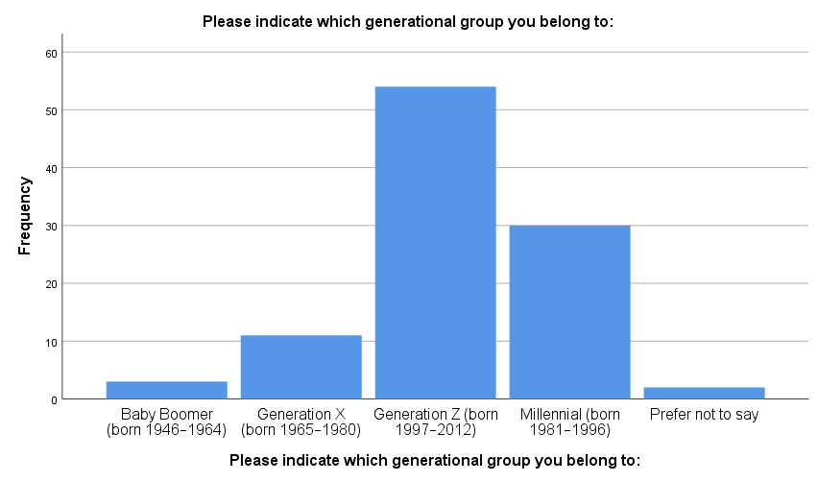
Gender-wise, the proportion of males (53%), females (42%), non-binary (4%) and those who do not wish to disclose (1%). This is a relatively equal gender representation.
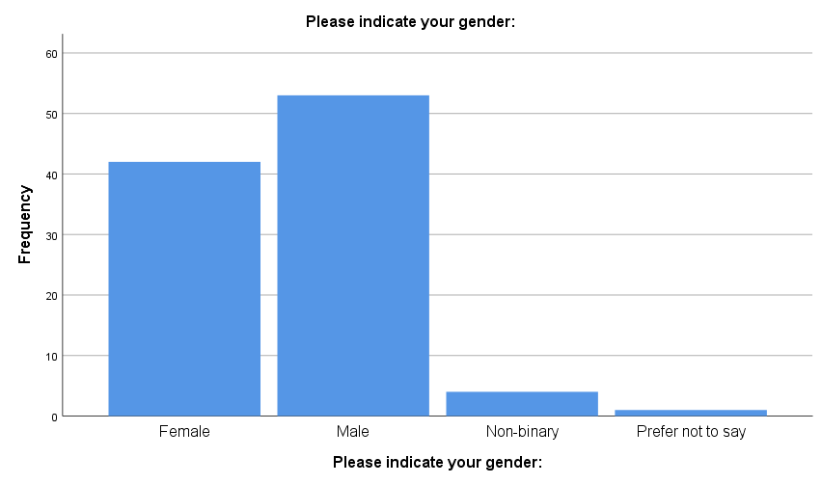

Shopping Behaviour
In terms of the frequency of purchasing, 36 per cent of the respondents said that they shopped weekly, 28 per cent monthly, 21 per cent daily, and 15 per cent less than once a month. This implies that there is a high degree of involvement in retail buying, and thus the sample will be suitable for the analysis of consumer spending behaviour.
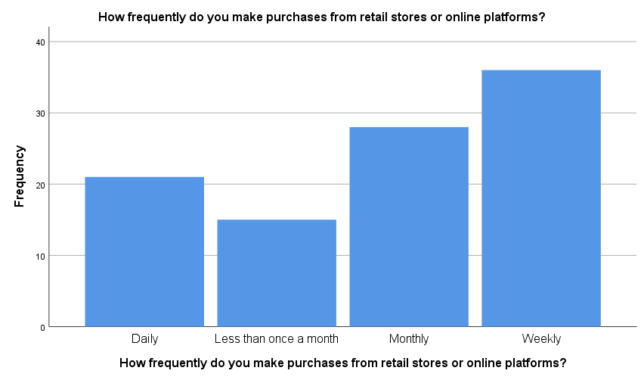

Results by Research Objectives.

Objective 1: Perceptions of Value and Fairness
This sub-topic looks at the perception of the value and fairness of loyalty programs by consumers in relation to direct price reductions.
The results suggest that respondents have an overall positive view of both strategies, but a direct price reduction has a bit more consensus. The assertion that direct price discounts are fair value achieved an average score of 3.94, with 78 per cent of the respondents agreeing or strongly agreeing that instant financial savings are highly regarded as valuable.
Loyalty rewards, on the other hand, were also viewed favourably, with a mean of 3.72, and 67% of the respondents said that they are good value and strongly agree. This shows that the perception of the value of loyalty programs is lower than direct discounts, though they are not very weak.

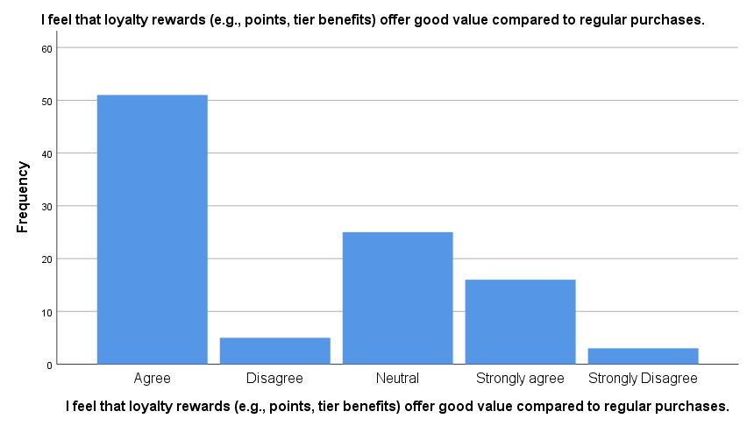

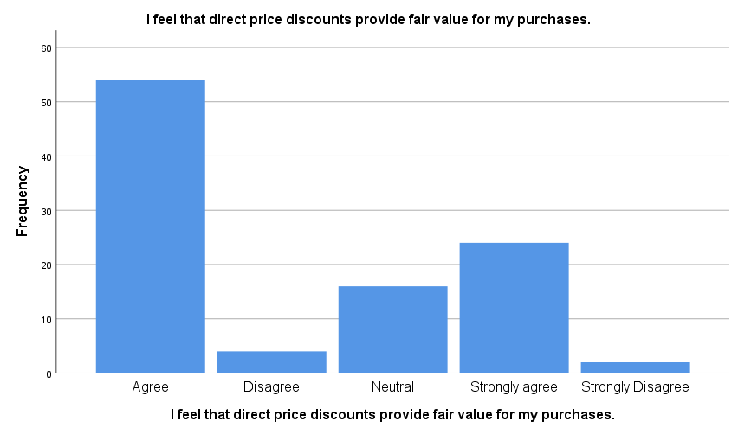

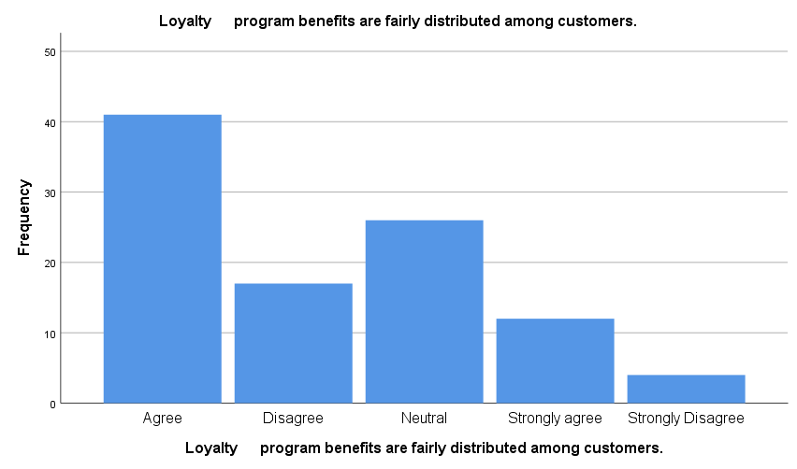

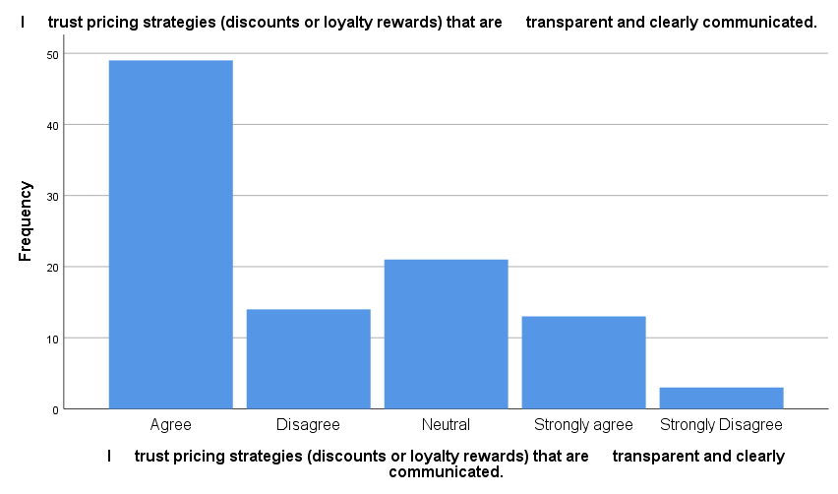

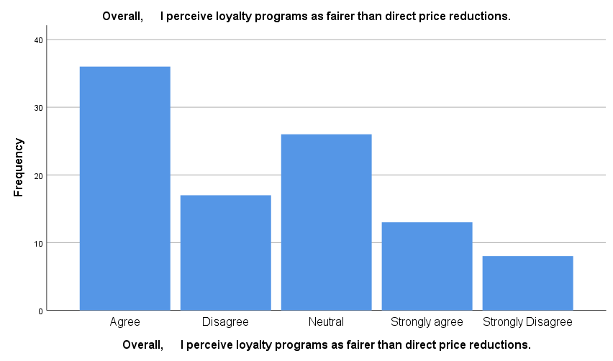

But views on fairness towards loyalty programmes seem more ambivalent. The argument on fair sharing of the benefits of loyalty registered a lower mean of 3.40, with 21 per cent of the respondents indicating a disagreement, implying that there is some scepticism on whether rewards are fairly shared.
Pricing transparency had moderate levels of agreement (mean = 3.55) as the consumers are known to trust the promotional strategies, but there is still some scepticism.
Interestingly, in a direct comparison of the two strategies, the proportion of respondents who thought that loyalty programs are more fair than price reduction was only 49 per cent (the mean of 3.29). This implies that consumers do not greatly feel loyalty programs to be more equitable than discounts.
When asked about how often they shop, the responses were: weekly (36%), monthly (28%), daily (21%) and less often (15%). This indicates that the sample was very retail-engaged and the data are suitable for examining spending behaviour patterns.
Overall, the results indicate that clarity and immediacy positively impact perceived fairness, and discounts are more positively perceived compared to the other strategy.
The results indicate that direct price reductions are considered to be more understandable, easier, and even fairer, whereas loyalty programs are associated with the issues of perceived complexity and fairness.

Objective 2: Direct Price Reduction Strategies Influence.
This chapter assesses the impact of price cut policies on consumer expenditure behaviour.
The findings indicate that there is significant evidence that discounts play a major role in buying. The statement, I am more prone to purchase something when it is discounted took a high value of 3.97, with a 73 per cent agreement, which shows that discounts are a strong stimulus to purchase.

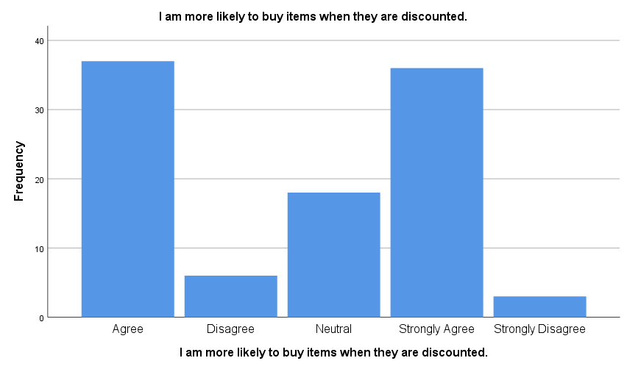

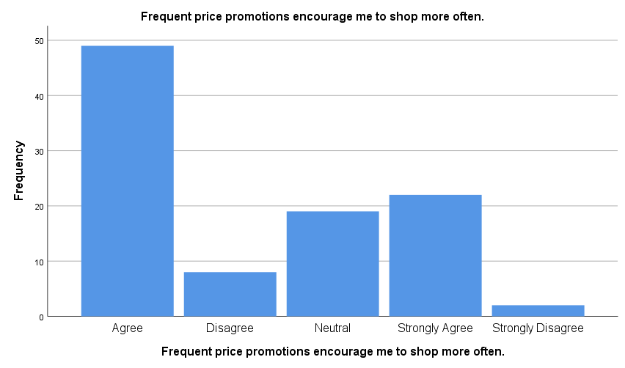

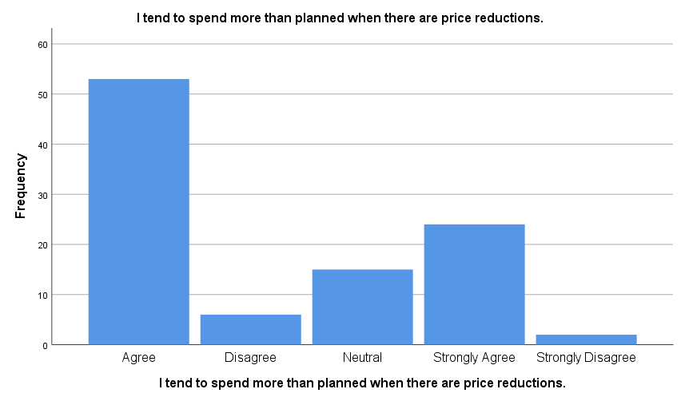

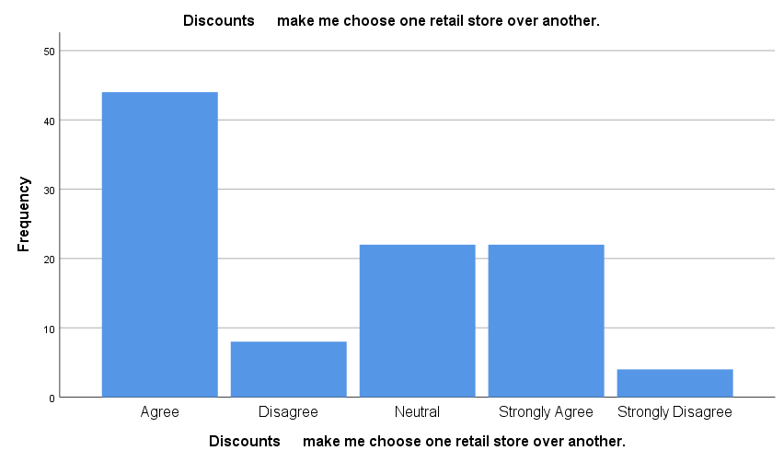

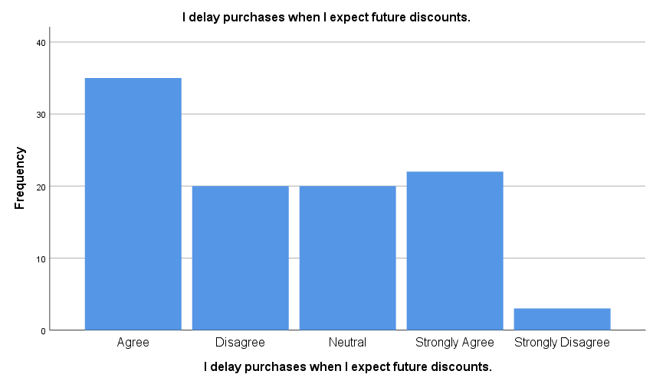
On the same note, there was a mean of 3.81 with an agreement of 71% with frequent promotions encouraging shopping, indicating that discounts are not only persuasive of individual purchases but also of shopping frequency.
One of the most significant results is that 77% of the participants indicated that they spend more than intended to when there are discounts (mean = 3.91). This underscores the high behavioural effect of price cuts on impulse purchases.
Moreover, 66 per cent of the respondents said that discounts are a factor in store choice, and it showed that price promotion has a competitive role in store selection.
Nevertheless, strategic consumer behaviour is evident in the findings as well. The message I waited to get a discount on purchases also yielded a 3.53 mean, and 57% of the consumers agreed with it, meaning that consumers can delay their purchases in hopes of future discounts.
In general, the results suggest that price discounts can be a very effective way of encouraging an immediate response from the consumer and can also lead to strategic waiting.

Objective 3: Impact of Loyalty Program Participation.
This part examines the effects of involvement in loyalty programmes on customer expenditure behaviour.
The findings show moderately positive, albeit consistent, positive impacts of participation in a loyalty program. The assertion that loyalty membership raises the rate of shopping had a mean of 3.57, 58% of the respondents agreeing, indicating that loyalty programs result in repeat visits.

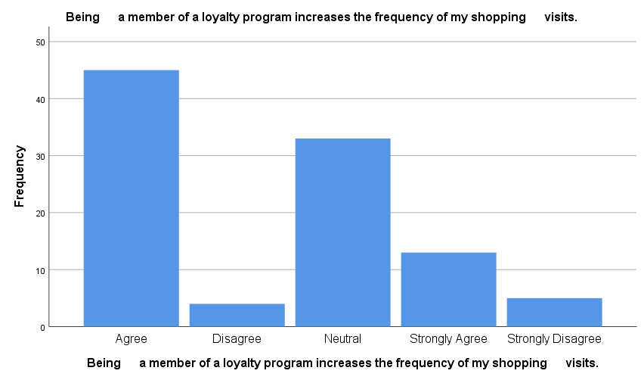

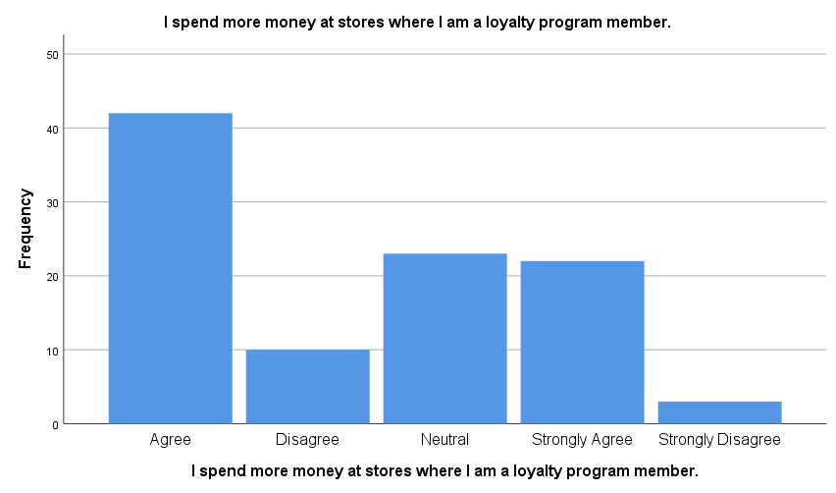

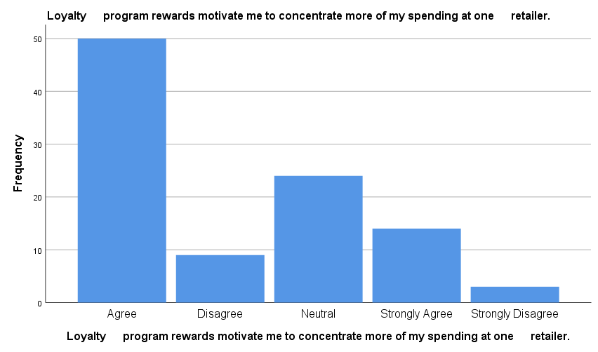

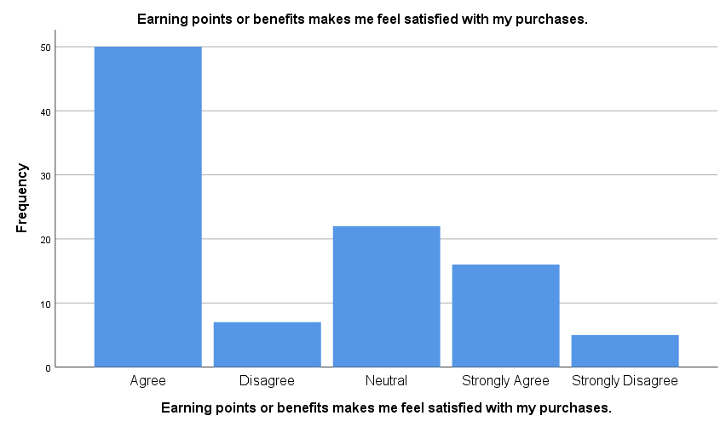

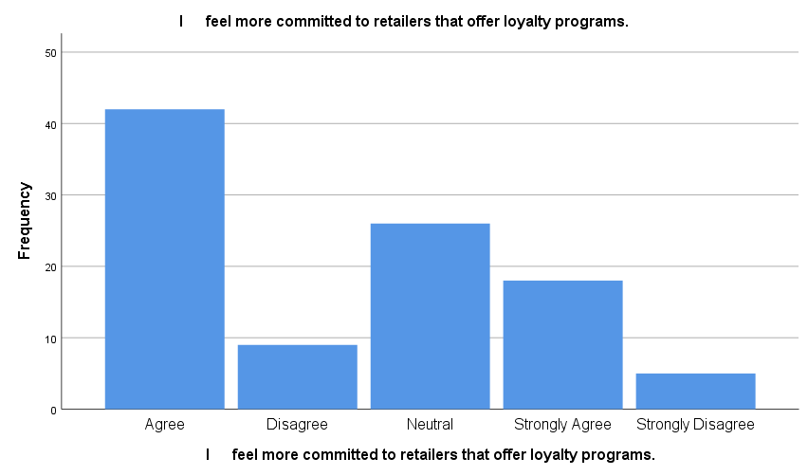
On the same note, 64% of the respondents admitted that they spend more in stores that they are members of loyalty programs (mean = 3.70), which shows that there is a definite impact on spending.
The message about the concentration of spending revealed that 64% of the respondents affirmed that loyalty rewards encourage them to spend more at one retailer (mean = 3.63), which is important in developing customer retention through loyalty programs.
Moreover, the satisfaction with receiving rewards was quite high (mean = 3.65, 66% agree), indicating that loyalty benefits help to improve the shopping experience.
Customer commitment also indicated positive results with 60 per cent agreement (mean = 3.59), showing that loyalty programs help in enhancing the relationships between consumers and retailers.
Overall, all these findings indicate a uniform and moderate effect, suggesting a loyalty program has a long-term impact on behaviour rather than an immediate one.

Objective 4: Customer Attitudes- Spending Control and Decision-Making.
This part discusses the effect of loyalty programs on perceived expenditure control and decision-making.
The results show quite moderate reactions on all variables, which imply ambivalent attitudes. Perceived control is not strongly established, as the mean of 3.37 was recorded in a statement where only half of them agreed with the statement saying that they feel in control of their spending with loyalty programs.

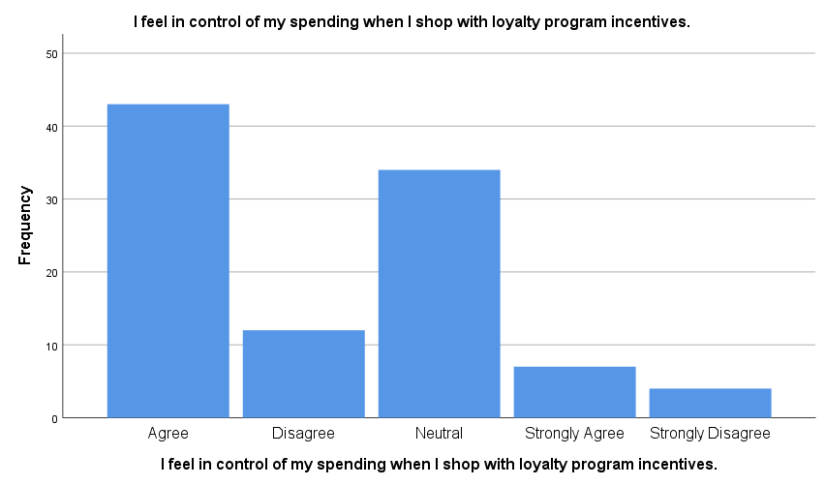

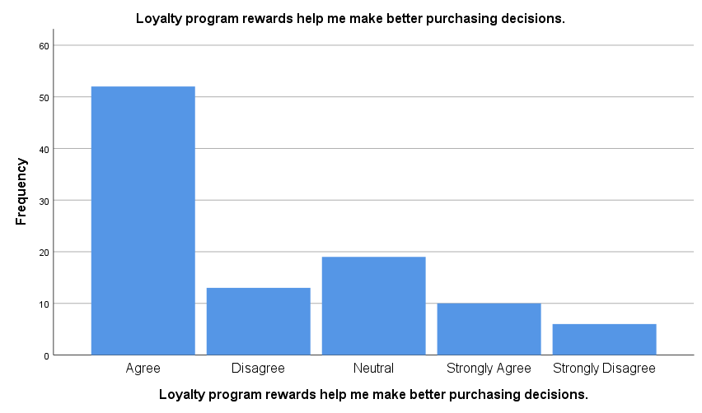

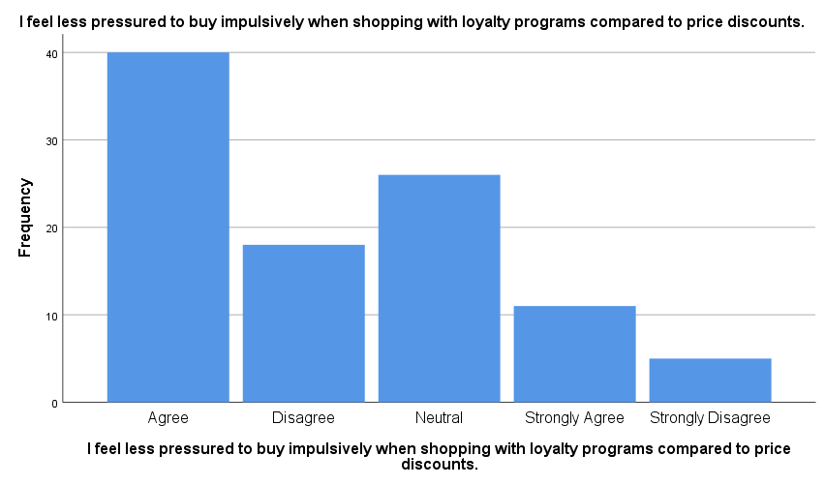

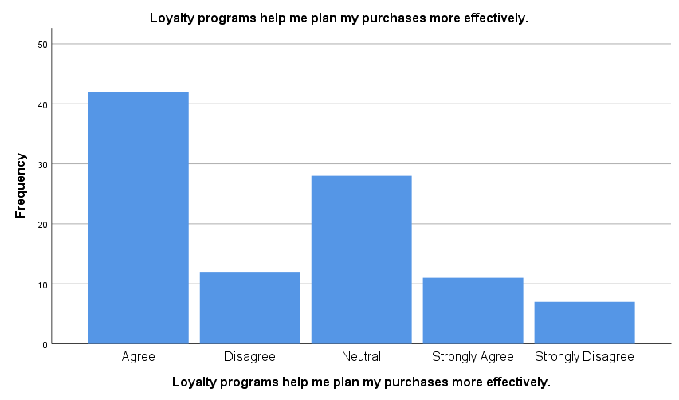

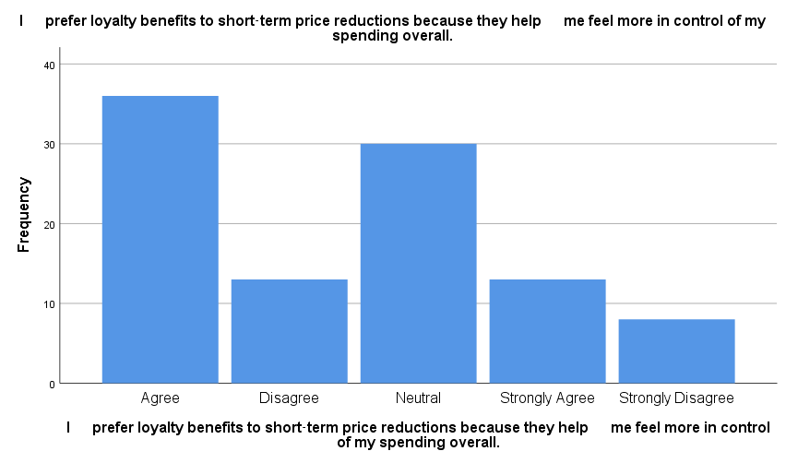

On the same note, the perception that loyalty programs aid in better decision-making had a mean of 3.47, with 62% agreeing, indicating a moderate effect.
Comparing the loyalty programs to price discounts, in terms of impulsive behaviour, 51% of the respondents affirmed that they are less pressured to use the loyalty programs (mean = 3.34). This shows a slight inclination towards loyalty programs in curbing impulse buying.
Planning behaviour was also moderate with a mean of 3.38, and that means that the loyalty programs, in a way, facilitate structured buying.
Lastly, the use of loyalty programs instead of a reduction in price as a more effective way of spending was not strongly preferred in terms of a mean of 3.33 and agreement of only 49%, indicating that preference was not strong.
Overall, this indicates that there is a positive effect of loyalty programmes on spending discipline, but this effect is not particularly strong relative to impulsive behaviour.
The results prove that loyalty programs do not have a strong impact on the improvement of decision-making and perceived control as compared with the high behavioural impact of price discounts.
In general, the results suggest a clear distinction: price discounts as a means for short-term behaviour, and loyalty programs as a means for long-term engagement.

Reliability Analysis
Cronbach’s alpha was used to determine the level of reliability of the measurement scale. The value of 0.894 suggests that the internal consistency is high among the 20 items used in the questionnaire.
Case Processing Summary
 |  | N | %
Cases | Valid | 100 | 100.0
Cases | Excluded | 0 | 0
Cases | Total | 100 | 100.0
a. List-wise deletion based on all variables in the procedure.

Reliability Statistics
Cronbach's Alpha | N of Items
.894 | 20
This indicates that the measurement tool is robust and that there is consistency in that the items measure the underlying constructs, which are associated with customer perceptions and behaviour.

Major Results
Primary data analysis indicates that there are some significant patterns within the research objectives.
To start with, consumers view both the loyalty programs and price reduction strategies positively, but they view direct price reductions as more valuable and fairer, mainly because it is simple and immediate in their benefits.
Second, pricing strategies reveal a solid impact on consumer behaviour, which highly boosts the likelihood of purchasing a product, the level of spending, and the store preference. Nevertheless, they promote impulse buying behaviour as well, expecting that they will receive the discounts later.
Third, the effects of loyalty programs on spending behaviour are moderate, but consistent, especially in stimulating repeat purchases, augmenting customer retention and encouraging loyalty to certain retailers.
Lastly, on psychological considerations, loyalty programs lead to moderate increases in perceived spending control and decision-making effects, which are not as substantial as the immediate behavioural effect of price discounts.

Chapter Summary
The results of the survey data analysis of 100 respondents were reported in this chapter. The results were presented under the four research objectives, namely perceived value and fairness, price discount effects, loyalty program effects and consumer decision-making behaviour. The descriptive statistics revealed that price discounting has a greater short-term effect on purchases while loyalty programs drive customer retention. The results are used to inform the interpretation and discussion in the next chapter.

Chapter 5: Discussion

Introduction
This chapter interpreted the results in Chapter 4 in terms of the main research question: How do the structures of loyalty programs, relative to direct price reduction strategies, affect customer spending behaviour in retail stores in Dublin? This chapter is aimed at going beyond the retelling of results and critically reviewing the meaning of the results through connecting them with the literature and theoretical viewpoints that were discussed in Chapter 2.

Findings Discussion by Research Objective

Objective 1: Perceptions of Value and Fairness
The results indicate that people in general find loyalty programs and price reduction beneficial, but price reduction is more attractive in the short-term. But perceptions of fairness are mixed, with some people doubting the methods behind earning, distribution and redemption of rewards for loyalty programs.
These findings are in line with previous research indicating that consumers are better able to assess price discounts as they provide tangible and perceptible monetary advantages. According to Kotler and Armstrong (2022), direct price reductions offer a clear economic value, thus raising the sense of fairness. Likewise, Darke and Chung (2019) point out that fairness perceptions are raised when the benefits are straightforward, transparent, and prompt.
Loyalty programs, on the other hand, rely on the redeemed rewards and can make the rewards less clear and ambiguous. Liu and Yang (2021) point out that the reward systems can also undermine the perception of trust and fairness, especially if they are complex. The results confirm this, as the respondents were more reluctant to rate loyalty programs.
Overall findings indicate that the two strategies are both valued, but that loyalty programs need to be made more transparent and easier to understand to boost fairness perceptions, while discounts need to be perceived as being clear and immediate. Thus, perceived fairness is an important factor in consumer attitudes.

Objective 2: Effect of Direct Price Cuts on Spending Behaviour
The results show that the direct price cuts have a significant effect on the purchasing behaviour of consumers. During the discount period, respondents indicated higher purchase intentions, shopping frequency, and spending more than planned. Discounts also affected store choice and motivated delayed purchases if there was a future discount.
The results of this research are in line with the theory of behavioural economics. According to Thaler (2018), consumers respond strongly to short-term monetary incentives, whereas Chen et al. (2020) state that discounts foster a sense of urgency and drive impulsive purchases. The data have high agreement scores, reflecting this.
The results also reveal a long-term behavioural effect, however. Several respondents indicated that they were waiting for further discounts, as Blattberg and Neslin (2019) suggest: repeated discounting encourages consumers not to buy something at full price. This can have a negative impact on profitability in the long run.
Also, overspending at the time of promotion is a sign of decreased self-control and increased emotional decision-making. In general, price discounts are very effective for short-term selling but can lead to strategic waiting and dependency.

Objective 3: Effects of Loyalty Program Participation on Spending Behaviour
The results indicate that loyalty programs have an overall positive but limited effect on consumer behaviour, such as higher purchase frequency, greater value of purchases, and greater emotional connection with the retailers. Consumers agreed loyalty membership would lead to more repeat buying and increase satisfaction with the loyalty program.
The findings validate the relationship marketing theory that accentuates retention of customers (Morgan and Hunt, 1994). Henderson et al. (2021) and Sharp and Sharp (2017) find that loyalty programs have a positive effect on retention and lifetime value as well.
The level of responses, however, is moderate, suggesting that effectiveness is not the same for all consumers. This aligns with the Kim and Lee (2020) findings that reward relevance, simplicity, and perceived value are critical to the success of loyalty programs. If the programs are not well planned, they may not reach the customers effectively.
The results also emphasise the distinction between immediate and cumulative incentives. Unlike discounts, loyalty programs have a longer-term impact on behaviour, as they are based on the gradual earning of rewards. As opposed to discounts, loyalty programs can work for longer than simple sales as they are built on reward accumulation.

Objective 4: Spending Control and Decision-Making
The results suggest that loyalty programs have a slight positive impact on their control of spending and decision-making. Generally, respondents believe loyalty programs aid in planning their purchases and minimising impulse buying over discounts, but with low moderation.
This is consistent with Kahneman's (2011) dual-system theory that consumer decisions should be influenced by emotional (System 1) and rational (System 2) processes. Loyalty programs seem to promote more rational, planned buying, and discounts seem to stimulate impulsive buying.
Structured rewards can also promote more controlled spending, which is also supported by Ailawadi et al. (2019) and Verhoef (2020). But the moderate effect found indicates that there is still a strong influence from emotions in retail decision-making.
In this regard, loyalty programs help create better plans and curb impulsive purchases somewhat, but they don't completely extinguish the power of emotion.

Conclusions on the Findings
- Academic Implications: The current study has added to the current body of literature by offering some empirical findings on the relative impacts of loyalty programs and price cuts in a given retail environment.
- Managerial Implications: To managers of retailers, the results emphasise the need to balance promotional strategies. Although discounts will lead to short-term sales, excessive use can be detrimental to profitability in the long term.
- Marketing Strategy Implications: The findings indicate that retailers ought to be a hybrid, meaning that they should rely on discounts to capture the attention of customers, but on loyal shoppers use loyalty programs to maintain them.

Connection to Research Gap
The literature review revealed a gap in the research about Ireland and scarce knowledge about the psychological processes that underlie promotional strategies. This paper will fill these gaps by offering insights into consumer behaviour in the retail sector of Dublin and the role of the perceived fairness, value, and control spent.
The results show that consumer behaviour is not only dependent on economic motivations but also on the psychological perceptions, which will add to a more holistic approach to the retail marketing strategies.

Chapter Summary
This chapter has analysed the results relative to the research question and literature. The findings show that direct price discounts are very effective in spurring short-term spending, whereas loyalty schemes are significant in promoting long-term interaction and managed purchasing behaviour.

Chapter: Conclusion and Recommendations.

Introduction
This chapter is the concluding part of the dissertation, as the main findings of this study are summarised and the role of the research in answering the main research question: How do Loyalty program structures compared to direct price reduction strategies influence customer spending behaviour in retail stores in Dublin? The chapter summarises the key findings of the analysis, gives the contributions of the study, and provides practical recommendations for retail practitioners. It also notes the weaknesses of the study and proposes future research directions.

Research Summit
The study has compared the relative impact of the loyalty programmes and the direct price cut initiatives in determining customer spending behaviour in the retail sector of Dublin. It was driven by the fact that retailers are increasingly relying on promotional tactics to be competitive in an ever-changing, price-sensitive market.
Four overarching goals guided the research: to determine the perceptions of value and fairness, the effects of price-cutting, the effects of loyalty program membership, and attitudes towards spending control and decision-making (Nguyen and Lee, 2023).

Conclusion of the main results
The results give explicit information on the behaviour of consumers towards loyalty programs and price cuts.
In Objective 1, the outcomes show that loyalty programs and discounts are equally perceived as a valuable option, but the direct price reduction is considered more transparent and fair. Although loyalty programs are valued, various perceptions towards fairness emerged, especially when it comes to the distribution of rewards and their clarity.
In Objective 2, direct price cuts were observed to have an overwhelming impact on customer behaviour. Discounts also greatly boost the level of purchases, prompt people to shop more frequently and in many cases result in a greater sum of money spent than intended. Nevertheless, the results also suggest that buyers can postpone their purchases until they expect future discounts, which means that long-term behavioural changes might occur.
In Objective 3, customer behaviour with respect to customer loyalty is positively correlated with participation in the loyalty program, as customer frequency of shopping, level of spending, and customer commitment are enhanced. The respondents also reported that the loyalty rewards increase the satisfaction and the desire to become engaged again, but the effectiveness of such an effect differs depending on the person.
In the case of Objective 4, the results indicate that the loyalty programs favour more regulated and premeditated purchasing behaviour in relation to discounts. Although price cuts are likely to stimulate impulse purchasing, loyalty programs have been linked to better decision-making and a more favourable perception of control over spending, but this is moderately, not strongly, linked (Etikan et al., 2021).

Study Contribution.

Academic Contribution
This research paper will add to the current literature through a comparative analysis of loyalty programs and price reduction strategies in a particular geographical setting. It fills in the research gap identified, providing information with a local touch, especially in the retail setting in Dublin.

Practical Contribution
Practically, the results are very useful to retail managers and marketers. The analysis emphasises the need to strike a balance between short-term promotional strategies and long-term customer engagement strategies.

Practical Recommendations
- Take a Balanced Promotional Policy
- Improve Loyalty Programs Transparency
- Discourage Excessive Discounts
- Customise Loyalty Program Benefits
- Encourage Planned Purchasing Behaviour

Managerial recommendations

Price Discounts Recommendation
The results are consistent with Thaler (2018) and Chen et al. (2020), and agree that price discounts are still valuable for generating short-term sales, as they successfully lead to higher impulse purchases and demand. But, consistent with Blattberg and Neslin (2019), discounting must be used strategically and not perpetually or else there will be a dependency on the price and a drop in full-price sales over the long term.
However, price discounts have a higher impact on purchase decisions in the Irish retail environment, where consumers are more price sensitive amid the high cost of living and inflation.

Loyalty Programs Recommendation
Following the ideas put forth by Sharp and Sharp (2017) and Kim and Lee (2020), loyalty programs should be made simpler and more transparent to boost perceived value and engagement.
Both in Ireland and in the wider retail sector, there are several loyalty schemes available in most key supermarket chains; however, consumers are not enthusiastic about them due to the complexity and delayed payout on the schemes.

Fairness Recommendation
Acknowledging the equity theory proposed by Adams (1965) and the study conducted by Darke and Chung (2019) on perceived fairness in promotional communication, fairness ought to be a top consideration for retailers in their promotional communication.
Retailers should take heed of Adams (1965) equity theory and the study conducted by Darke and Chung (2019) on perceived fairness of promotional communication, which states that fairness is an important element to consider in promotional communication to consumers, as it has a great influence on consumer trust and purchase decisions.

Research Limitations
There are a few limitations to this study. To begin with, the sample population of 100 respondents is enough to conduct a preliminary analysis, but it might not reflect the entire population of consumers in Dublin or Ireland. Second, the study was based on self-reported data, which could be affected by response bias or inaccuracy of perceptions and behaviour of those involved. Third, the research concentrated on quantitative analysis, which did not allow delving into the motivations and attitudes. Lastly, the dissertation had time limitations which limited the extent of data gathering and analysis.

Recommendations for Future Research
Future research could expand this study by using larger and more diverse samples to improve generalisability. Comparative studies (Applying compare mean t-test) across different cities or countries would provide insights into cultural and regional differences in consumer behaviour. Additionally, qualitative or mixed-method approaches could be employed to explore deeper psychological motivations behind consumer responses to promotional strategies. Further research could also examine the impact of digital and online retail environments, as well as the role of emerging technologies in shaping loyalty programs and pricing strategies.

Summary of the chapter
The main findings of the research were summarised and implications given in this chapter. The research found that price discounts had a significant impact in the short-term on consumer spending, while loyalty programs had a greater impact on long-term consumer engagement and retention. Practical recommendations were offered to retailers, while limitations and suggestions for future research were offered. In general, this research will help to develop a greater understanding of consumer behaviour when responding to promotional strategies in the context of Dublin retailing.

References
Adams, J.S. 1965. Inequity in social exchange. In: Berkowitz, L. (ed.) Advances in experimental social psychology. New York: Academic Press.
Ailawadi, K.L., Lehmann, D.R. and Neslin, S.A. 2019, Retailing research: Developments and perspectives. Journal of Retailing, 95(4), pp. 1–15.
Alvarez, M. & Park, S., 2025. “Sustaining engagement in loyalty programs: Psychological mechanisms and outcomes.” Marketing Intelligence & Planning, 43(1), pp. 12–31. https://doi.org/10.1108/MIP-11-2024-0238
Ariely, D. 2008. Predictably irrational: The hidden forces that shape our decisions. New York: HarperCollins.
Ariely, D., 2022. Predictably Irrational: The Hidden Forces That Shape Our Decisions. 2nd ed. New York: Harper Business.
Blattberg, R.C. and Neslin, S.A. 2019. Sales promotion: Concepts, methods, and strategies. New Jersey: Prentice Hall.
Braun, V., & Clarke, V. 2021. Thematic Analysis: A Practical Guide. Sage.
Brown, T. & Turner, R., 2022. “Effects of price promotions on consumer spending and brand perception: A behavioural study.” Journal of Retailing and Consumer Services, 67, 102985. https://doi.org/10.1016/j.jretconser.2022.102985
Bryman, A. and Bell, E. 2023. Business Research Methods. 6th ed. Oxford: Oxford University Press.
Chen, L. & Li, W., 2024. “Perceived spending control and consumer satisfaction: Insights from loyalty and discount strategies.” Journal of Consumer Behaviour, 23(2), pp. 145–162. https://doi.org/10.1002/cb.2172
Chen, Y., Mandler, T. and Meyer-Waarden, L. (2020) ‘Three decades of research on loyalty programs’, Journal of the Academy of Marketing Science, 48(4), pp. 781–824.
Creswell, J.W., & Creswell, J.D. 2023. Research Design: Qualitative, Quantitative, and Mixed Methods Approaches. 5th ed. Sage.
CSO Ireland, 2023. Retail Sales Index – Ireland 2023. Dublin: Central Statistics Office. Available at: https://www.cso.ie [Accessed 30 March 2026].
Darke, P.R. and Chung, C.M.Y. (2019) ‘Effects of pricing and promotion on consumer perceptions of fairness’, Journal of Marketing Research, 42(1), pp. 98–110.
Dorotic, M., Bijmolt, T.H.A. & Verhoef, P.C., 2021. “Loyalty programs: Current knowledge and research directions.” Journal of Retailing, 97(1), pp. 55–75. https://doi.org/10.1016/j.jretai.2020.12.003
Etikan, I., Musa, S.A. and Alkassim, R.S. 2021 ‘Comparison of convenience sampling and purposive sampling’, American Journal of Theoretical and Applied Statistics, 5(1), pp. 1–4.
Gonzales, R. & Murtagh, E., 2025. “Consumer value perception in European retail: Insights from Dublin.” European Journal of Marketing, 59(4), pp. 1021–1045. https://doi.org/10.1108/EJM-03-2024-0205
Grewal, D., Roggeveen, A.L. and Nordfält, J. (2011) ‘The future of retailing’, Journal of Retailing, 87, pp. S1–S6.
Henderson, C.M., Beck, J.T. and Palmatier, R.W. 2021. ‘Review of the theoretical underpinnings of loyalty programs’, Journal of Marketing, 85(3), pp. 1–22.
Kahneman, D. 2011. Thinking, fast and slow. New York: Farrar, Straus and Giroux.
Kim, Y. and Lee, J. 2020. ‘Customer loyalty programs effectiveness: A meta-analysis’, International Journal of Hospitality Management, 85, pp. 102–115.
Kotler, P. and Armstrong, G. 2022. Principles of marketing. 18th edn. Harlow: Pearson.
Lee, S. & Cho, J., 2024. “The impact of pricing strategies on customer purchase behaviour in retail environments.” Journal of Retailing and Consumer Services, 69, 103216. https://doi.org/10.1016/j.jretconser.2023.103216
Liu, Y. and Yang, R. 2021. ‘Consumer perceptions of loyalty program fairness’, Journal of Business Research, 132, pp. 365–374.
Morgan, R.M. and Hunt, S.D. 1994. ‘The commitment-trust theory of relationship marketing’, Journal of Marketing, 58(3), pp. 20–38.
Nguyen, T. & Lee, Y., 2023. “Price sensitivity and loyalty program effectiveness in European retail.” Journal of Business Research, 156, pp. 45–58. https://doi.org/10.1016/j.jbusres.2022.11.042
Nguyen, T. and Lee, J. (2023) ‘Consumer price sensitivity in modern retail markets’, Retail Economics Review, 12(2), pp. 45–60.
Patel, R., 2025. “Bridging context and method gaps in retail consumer research.” International Journal of Retail & Distribution Management, 53(2), pp. 220–236. https://doi.org/10.1108/IJRDM-09-2024-0345
Resnik, D.B. 2022. Ethics of Research with Human Subjects. Springer.
Saunders, M., Lewis, P. and Thornhill, A. 2022. Research Methods for Business Students. 9th ed. Harlow: Pearson.
Sharp, B. and Sharp, A. 2017. Loyalty programs and their impact on customer retention. Journal of Retailing and Consumer Services, 34, pp. 1–10.
Smith, R., & Baxter, L. 2024. Consumer Loyalty and Reward Program Effectiveness in Urban Retail Settings. Journal of Retail Marketing, 18(3), 45–62.
Thaler, R.H. 2018. Misbehaving: The making of behavioural economics. New York: W.W. Norton & Company.
Verhoef, P.C. 2020. ‘Understanding loyalty-driven consumer behaviour’, Marketing Science, 39(2), pp. 180–195.
White, K. & Kim, H., 2023. “Short-term versus long-term strategies: Loyalty programs vs. price reductions.” Journal of Consumer Behaviour, 22(3), pp. 334–349. https://doi.org/10.1002/cb.2121
Xia, L., Monroe, K.B. and Cox, J.L. 2004. ‘The price is unfair! A conceptual framework of price fairness perceptions’, Journal of Marketing, 68(4), pp. 1–15.
Zhang, Y. & Brown, P., 2023. “Customer perceptions of fairness in retail pricing: Evidence from Dublin.” Journal of Retailing Studies, 10(2), pp. 88–107. https://doi.org/10.1016/j.jrs.2023.02.004

