
Applied Project
Submission Form

LEARNER NUMBER | 51802597
NAME | Alejandra Nadir Albornoz Mora
COURSE | BA in International Business
REPORT TITLE | Cross- cultural leadership strategies impact the motivation and performance of international students working in multicultural teams in hospitality industry
SUPERVISOR NAME | Daniel
WORD COUNT | 6050
DUE DATE | 14/12/25
DATE SUBMITTED | 17/12/25

I certify that:
- This project report is all my own work, and no part of this report has been copied from another source: Yes ☒ No ☐
- I understand that this report may be checked by electronic or other means for plagiarism and/or content created by generative AI and may be transferred and stored in a database for the purposes of data-matching/data-analysis to help detect plagiarism and/or content created by generative AI: Yes ☒ No ☐
- This report has not previously been submitted in part or in full for assessment to any other institution: Yes ☒ No ☐
- I consent to the inclusion of my report in the publicly accessible (open access) electronic database maintained by the library:
Yes ☒ No☐
- I have emailed a back-up copy of this report to locker@independentcollege.ie:
Yes ☒ No ☐

(Note that if no check boxes are selected, this Project will be regarded as NOT properly submitted, and may be subject to a late submission penalty)

“Cross- cultural leadership strategies impact the motivation and performance of international students working in multicultural teams in hospitality industry”

Compiled by:
Alejandra Nadir Albornoz Mora

This project is submitted in part fulfilment of the Degree of Bachelor of B A IN international Business

Independent College, Dublin
Dec 2025.

Abstract
The hospitality industry in Dublin is characterised by a highly cultural environment, where the majority of the workforce is made up of international students, i.e. employees, especially in Dublin. As a result, one of the most significant factors is leadership in this sector, which is highly valued and very important for effective management in culturally diverse contexts. Similarly, motivation must be maintained and employees must perform productively in work teams. In this regard, this study analyses how intercultural leadership strategies can influence or affect, either positively or negatively, the motivation and performance of international students working in the hospitality sector in Dublin who face working in multicultural and diverse environments.
In order to answer the research question, a mixed methods approach was used. All quantitative data was collected through digital online surveys of people working in the hospitality sector in Dublin who are also studying.Qualitative data was obtained through semi-structured interviews with managers or supervisors with experience in managing multicultural teams. All research analysis focused on five themes that will be developed in the literature review, and a triangulation process was applied to compare the findings in the primary research with the literature.
The results indicate that participatory, transformational, and flexible leadership styles have a positive influence on the motivation and performance of diverse teams. Likewise, it was identified that factors such as flexible hours, communication that supports students, and leadership focused on empathy are key to job satisfaction among international students. It was also discovered that leadership is fundamental, as it helps international students deal with the challenges of living in another country, such as language barriers, cultural adaptation, and, above all, the balance between studies and work, which will have a direct impact on their confidence and productivity.
The results of this study show us that there is a need to develop more specialised and structured programmes in international leadership. Practical recommendations are also offered for improving leadership strategies, which will be reflected in the motivation and performance of international students in multicultural teams.
Contend table
Chapter 1 7
1.2 Introduction 7
1.2 Justification and rationale for the study 7
1.3 Problem statement and research question 8
1.4 Information gathering techniques 8
1.5 Expected results 9
1.6 Project Structure 9
Chapter 2 10
2.1 Literature review 10
2.2 Cross- Cultural Leadership in hospitality industry 10
2.3 Motivation and Job Satisfaction 11
2.4 Challenges Faced by International Students in Hospitality Workplaces 13
2.5 Impact of Leadership Strategies on Team Performance 14
2.6 Best practices for leadership development 15
Chapter 3 Methodology 18
3.1 Research approach and paradigm 18
3.2 Research Design 18
3.3 Sampling and Participants 19
3.4 Data Collection Methods 19
3.5 Data Analysis 20
3.6 Ethical Considerations 20
3.7 Limitations of the Method 21
3.8 Justification of the methodological Choices 21
Chapter 4 22
4.1 Introduction 22
4.2 Cross- Cultural Leadership in hospitality industry 24
4.3 Motivation and Job Satisfaction 25
4.4 Challenges faced by international students in hospitality workplace 26
4.6 Best practices for leadership development 30
Chapter 5 33
5.1 Conclusions 33
5.2 Recommendations 35
5.3 Limitation 36
5.4 Advice for another researches 36
References 38
Apendix 41
1.1 Survey and Graphics 41
1.2 Interview 52
1.3 Informed concern 60
1.4 Ethical form 61
1.4 Literature review table 66

Graphic content
Figure 1: Age of respondents 23
Figure 2:Gender of respondents 24
Figure 3:countries of origin of respondents 25
Figure 4:Cross- Cultural Leadership in hospitality industry 26
Figure 5: Motivation and Job Satisfaction 28
Figure 6: Challenges faced by international students in hospitality workplace 30
Figure 8: Impact of leadership strategies on team performance 31
`

Chapter 1

1.2 Introduction

Dublin is characterised by its high level of multiculturalism in the hospitality sector. We can also recognise that Dublin is considered one of the most attractive places for students, thanks to the different study programmes offered by the country and the employment opportunities available. Therefore, students combine employment and academic training in most cases, which contributes to the rapid expansion of cafés, restaurants and hotels, generating labour demand that is largely met by young students from different cultures and countries. This environment mostly favours integration between different cultures, but it can also generate different challenges, such as leadership styles, communication, cultural adaptation and motivation of international students in this industry.
In this context, it is very important to highlight that the value of international talent has become a key factor for companies to have efficient diverse teams, which leads us to understand and analyse how cultural leadership strategies can be adapted to different perspectives and how they can influence employee performance and motivation.

1.2 Justification and rationale for the study

The relevance of this study focuses on the need to understand how leadership can impact the experience of international students working in the hospitality sector in Dublin who operate in multicultural environments. The literature agrees that cultural diversity can generate innovation within teams but at the same time can lead to tension, misunderstandings and communication barriers when clear and appropriate leadership is not developed for these work environments. Therefore, it is essential to analyse whether the leadership styles developed and employed in this sector actively and effectively respond to the needs of international students from different national contexts.
Likewise, we can observe that there is a lack of research specifically applied to the context of Dublin and international students within the hospitality sector, whether in restaurants, cafés or the hotel sector, which reinforces the study and its contribution to future practices in more inclusive and effective management in multicultural contexts.

1.3 Problem statement and research question

The increase in international workers in Dublin raises questions about the influence of leadership strategies on performance and the working environment. Although it is recognised that multiculturalism can generate benefits in terms of innovation and creativity, much will depend on how leadership manages cultural differences, which is a decisive factor in the integration, motivation and satisfaction of multicultural teams.
Research question:
How do cross-cultural leadership strategies impact the motivation and performance of international students working in multicultural teams in the hospitality industry?
Research objectives:
- Identify different leadership styles and how they affect teams in the hospitality industry.
- Examine what factors influence motivation and job satisfaction.
- Identify the main challenges facing international students and how leadership strategies can address them.
- Examine the connection between different leadership styles and how they affect team productivity in the hospitality industry.
- Develop adequate recommendations for businesses to improve leadership strategies for multicultural teams.

1.4 Information gathering techniques

The study uses a mixed approach through the implementation of structured questionnaires that were distributed to international workers and semi-structured interviews conducted with supervisors or managers in the sector. This technique was chosen because it allowed for the collection of qualitative data on perception, motivation and satisfaction, as well as qualitative data based on personal and individual experience, leadership styles and intercultural interactions.

1.5 Expected results

We expect to discover a positive relationship between leadership strategies and cultural sensitivity, inclusiveness, and participatory leadership. Likewise, the research aims to reveal that leaders do not adapt their leadership style to different cultures, thereby generating solutions and suggestions that can be used in areas such as communication, work-related stress, satisfaction, and how these characteristics influence performance.

1.6 Project Structure

Chapter 2: Literature review of five topics, including intercultural leadership, motivation, challenges faced by international students, the impact of leadership on teams, and best practices.
Chapter 3: Methodology, instrument design, research approach, and ethical considerations.
Chapter 4: Presentation of triangulation with survey and interview results, compared with literature review.
Chapter 5: Conclusions, limitations, recommendations, and proposals for future researchers.

Chapter 2

2.1 Literature review

This literature review analyses and presents the main studies related to leadership, motivation and multicultural dynamics within the hospitality sector. The evidence presented is organised into five themes that provide an understanding of how leadership styles can influence international workers and what factors affect employee motivation and performance. In addition, gaps in the literature are identified, particularly in the Irish context or in Dublin, thereby justifying the importance of conducting this research and analysis.

2.2 Cross- Cultural Leadership in hospitality industry

Multicultural teams in the hospitality industry rely heavily on different leadership styles that are capable of managing and directing the cultural differences that exist within teams. Rigidity or a lack of adaptability can lead to many conflicts, low productivity, and communication difficulties.
Nwokorie and Onyeonoro (2014) and Al Rahbi, Khalid and Khan (2017) agree on the different leadership styles, such as autocratic, participative and laissez-faire: Employees have complete freedom to make decisions where the leader provides minimal direction, which means that leadership directly influences motivation and performance, highlighting the importance of adjusting the style according to the situation, which will be reflected in employee satisfaction and productivity, thus contributing to their long-term performance. Schneider and Somers (2006) state that leadership styles are not limited to direct and rigid authority, but function as a catalyst for relationships, and that these overly mechanical and direct leadership styles can influence adaptation and the emergence of creative solutions in teams, negatively affecting dynamics and good communication, as well as team trust and sense of belonging. Tsai (2022) emphasises that effective leaders with clear strategies modify their behaviour according to culture, although he indicates that there is still a lack of clarity about how this adjustment process occurs in practice. Khan (2019) highlights the flexibility of leaders with multicultural teams, which supports the importance of leaders developing intercultural competencies; cultural awareness and effective communication are mentioned as key to managing teams effectively.
There is little evidence focusing on how these leadership adjustments occur specifically in Dublin, especially how this may affect international students working in this sector. That is why this analysis supports the need to analyse and investigate how leaders in the hospitality sector in Dublin will adapt their leadership styles in multicultural teams and how that adaptation will influence the experience of international students. In this regard, the literature highlights that flexible and culturally aware leadership is essential for the smooth functioning and productivity of multicultural teams.

2.3 Motivation and Job Satisfaction

Motivation and job satisfaction can be affected by poorly managed cultural differences, which can lead to miscommunication and misunderstandings, as well as demotivation and low retention in multicultural teams.
Moniker and Lukic (2022) point out that social, cultural, personal and environmental factors significantly influence job satisfaction and employee performance, and that the relationship between job satisfaction and performance is bi-directional and is measured by these factors. Organisational culture is also mentioned as playing a role in defining the internal work environment, directly impacting employee motivation, commitment and retention, and it is also mentioned that strong positive work cultures positively encourage employee participation and reduce employee turnover. Arm, Sohaib, Begum, and Alkharman (2024). They mention that cultural differences can lead to misunderstandings and conflicts that negatively affect job satisfaction and performance. However, cultural diversity can enhance creativity and innovation, and effective communication, support networks, and personal adaptation are very important to minimise these cultural challenges. Zhao and Pan (2017) mention in their study that employees from different cultures share very similar work needs, such as: security,relationships, self-actualisation . In addition, international companies must design incentive mechanisms tailored to cultural characteristics in order to maximise motivation and performance. Asrifan and Dewi (2023) reveal in their study that there is a high correlation between student motivation and learning performance. Motivation explains that 72.59% of academic achievement is driven by motivation, demonstrating that a high level of motivation greatly promotes learning success. We can therefore highlight the importance of strategies that foster motivation to improve performance, in this case in educational contexts. Sohail, Khan and Raza (2023) point out significant differences in motivational and transformational growth strategies between public and private educational leaders. Private schools employ better incentives, environments and motivation that positively impact educational quality. However, they mention that transformational leadership strategy is better linked to behaviour, environment and professional development.

The lack of evidence applicable to international students in non-academic work environments working in the hospitality sector in Dublin. These findings justify conducting a study to investigate how leadership affects the motivation of workers who are international students, taking into account their cultural differences and needs in the workplace. Motivation depends largely on leadership that can understand and respond to cultural factors and organisational environments.

2.4 Challenges Faced by International Students in Hospitality Workplaces

International students working in hospitality face additional challenges in the workplace, which can be considered cultural adaptation, language barriers, lack of clarity in roles, and very little support.
Zopiatis (2007) This study mentions that internships in hospitality face significant challenges, including a lack of clarity in roles, insufficient evaluation, and a misalignment between theory and practice. However, international students report problems related to accommodation, finding work, and government requirements. This study shows that significant differences can be identified between international and local students, especially in administrative and accommodation issues that significantly affect their work experience during their internships. Baklashova and Kazakov (2016) mention that Russian international students face academic, social, and cultural difficulties, including language barriers and differences in cultural expectations. Zopiatis and Constanti (2010) mention that transformational leadership is more closely linked to a sense of personal achievement and lower levels of emotional exhaustion and depersonalisation among hospitality leaders. On the other hand, passive/avoidant leadership is more associated with exhaustion and symptoms of burnout. They therefore indicate that active and committed leadership can mitigate the negative effects of work-related stress,while promoting well-being and performance effectiveness. Passive leadership, on the other hand, can exacerbate challenges. Shneikat, Cobanoglu and Tanova (2021), who analyse international students in hospitality, found relevant information on how the internationalisation of higher education generates opportunities and challenges. However, while students enrich host communities culturally and economically, they also face difficulties related to cultural integration and academic satisfaction. Qiu, Alizadeh, Dooley, and Zhang (2019). They mention that an analysis and evidence on the impact of authentic leadership in the context of Chinese hospitality highlight its relevance as a strategy for very common work challenges in multicultural environments. This study also demonstrates that authentic leaders, by fostering employee trust, enhance customer-centric organisational behaviours and consequently improve service quality. However, it is mentioned that authentic leadership naturally aligns with Confucian cultural values, promoting self-evaluation, ethics and a positive work environment. This study is highly relevant as it shows the connection between culture and leadership, pointing out that cultivating authentic leaders can strengthen employee commitment and performance, helping them to face structural challenges.
Almost all studies on this topic focus on higher education or contexts outside Ireland, so we can see a lack of studies on international students who work simultaneously and face cultural pressure. Understanding deeply these challenges helps to identify leadership styles that can be developed to facilitate adaptation, good communication, and well-being in multicultural teams in Dublin. In this sense, international students require leadership that provides support, clarity, and cultural adaptation to overcome their workplace challenges.

2.5 Impact of Leadership Strategies on Team Performance

Team performance in the workplace depends particularly on how leadership influences the integration of multicultural teams, satisfaction and clarity of roles to be performed within a multicultural environment.
Hinkin and Tracey (1994) analyse the transformational impact on the hotel industry, where the authors highlight the direct influence on employee satisfaction and the effective perception of the leader. In this type of leadership, it is defined more by the clear articulation of the message, individual consideration, and open communication. They point out that all of this generates positive attitudes in employees and improves their organisational performance. However, factors such as clarity of roles and communication do not alone explain the effectiveness of leadership, but they do reinforce satisfaction.Fouad, M.(2019). This study analyses the impact of different leadership styles on job satisfaction within the hotel industry, highlighting three approaches: transformational, transactional and laissez-faire. These have a significant positive influence and have the power to promote key factors such as professional development, recognition and promotion opportunities, which improves team performance and reduces staff turnover. However, autocratic leadership decreases satisfaction and negatively affects organisational performance .Sürücü, L. and Sağbaş,(2021). These authors also highlight the transformational, transactional and laissez-faire approaches, mentioning that they have a positive influence and that leaders should create environments of trust through motivation, individual support and open communication. Ogdol,( 2018). In this study, we can see that fast food restaurants in the United Arab Emirates stand out, where the workforce is made up of expatriate employees from diverse cultures. Leaders use these flexible and adaptive leadership styles.Nwokorie and Onyeonoro (2014) In this study, the authors emphasise that leadership is crucial in the hospitality sector to motivate and guide employees towards high levels of productivity. Three main styles are defined: autocratic, democratic and laissez-faire, highlighting that leaders who combine task orientation with employee orientation achieve better results. They also mention that participatory leadership promotes shared decision-making, which leads to positive team behaviour and, as a result, better performance.
There is very little evidence directly related to teams composed mainly of international students in the hospitality sector in Dublin. Therefore, the results will allow us to better analyse how to direct and propose leadership strategies applied in Dublin.
These results allow us to analyse how leadership strategies can have an impact if applied in the Dublin hospitality industry and whether they affect the motivation and performance of young international workers. Leadership strategies directly influence team performance of the team and the integration of different cultures.

2.6 Best practices for leadership development

Traditional leadership training programmes often fail to prepare leaders for multicultural contexts, limiting their ability to manage diversity in multicultural contexts effectively with the tools they need to manage multicultural teams.
Siyal, Kumari, Saeed, and Hussain( 2023) In this study, the authors demonstrate that inclusive leadership has a direct and positive impact on the performance of employees in the hotel sector in China. This effect is measured by psychological empowerment. It is also mentioned that trust in leaders significantly reinforces this relationship, thereby increasing both empowerment and work performance.
Nosratabadi, Bahrami,Palouzian, and Mosavi,( 2020). This study shows us that the cultural intelligence of leaders has a positive and more significant impact on the performance of organisations, either directly or through mediation in the organisational structure.Leaders with high cultural intelligence can adjust to internal structural dynamics and leverage performance in multicultural contexts in the hotel sector, as the industry has diverse teams and customers from multiple cultures. Leaders must therefore interpret and adapt to different cultural behaviours. Normore, Hamdanand Esposito, (2019). In this study, the authors criticise traditional educational leadership training programmes for their lack of preparation for diverse cultural contexts and for not proposing innovative approaches that integrate culture and history to train more inclusive and equitable leaders. From this perspective, it is very important that in hospitality, where cultural diversity exists, there are also sensitive and adaptable leaders.Celestin and Vanitha(2020). In this study, the authors mention that inclusive leadership drives organisational innovation by taking into account diverse perspectives, leading to fostering environments of psychological safety. The study shows that teams led with inclusion make better decisions and come up with more creative ideas, especially when there is a specific training programme in place.Ashikali, Groeneveldand Kuipers ( 2021). These authors show in their study that ethnic and cultural diversity in teams does not guarantee an inclusive climate and that this is why inclusive leadership is necessary to avoid negative relationships between diversity and an inclusive climate. They also mention that inclusive leaders promote the value of different contributions, Which resulted in creating environments where differences become advantages.
There is a lack of studies applying these leadership training practices in multicultural contexts in local hospitality businesses in Dublin. Therefore, the findings help to identify in a practical way which leadership practices could be incorporated to improve inclusion in teams and the performance of international students in the sector. Best leadership practices should primarily include inclusion, cultural intelligence and training tailored to multicultural and diverse teams.

Chapter 3 Methodology

3.1 Research approach and paradigm

This study applies a mixed-methods approach, combining qualitative and quantitative techniques to obtain a much more comprehensive understanding of the topics under study. The paradigm guiding this research is constructivist, as it considers the experiences, perceptions and interpretations of the participants to be fundamental to understanding how intercultural leadership is perceived and whether it influences the motivation and performance of international students working in the hospitality industry.
Therefore, the mixed approach makes it possible to explore both broad trends in a large group and deeper personal experiences that cannot be analysed numerically with data.

3.2 Research Design

A mixed sequential design was used, beginning with a quantitative questionnaire aimed at international students working in the hospitality sector, followed by semi-structured interviews with supervisors or managers who have experience managing teams, particularly multicultural teams, in the hospitality industry in Dublin.
The quantitative method focuses on conducting questionnaires that allow for the collection of data on perceptions of leadership, how motivated international students are, and their work experience. On the other hand, the qualitative method was also taken into account, based on semi-structured interviews with managers or supervisors in the hospitality sector with the aim of understanding the leadership strategies they apply in practice and the challenges they face when organising multicultural teams.
Combining both methods facilitates the triangulation of data, enhancing the validity of this analysis by comparing the results and contrasting them with the information from the literature review.

3.3 Sampling and Participants

- Questionnaires
The questionnaires were designed to gather quantitative information from international students working in restaurants, hotels, and cafés in Dublin. The questions were structured around the five themes identified in the literature review: intercultural leadership, motivation and cultural satisfaction, work challenges, and the impact of leadership on leadership practices.
A Likert scale was used for the questions, with most questions rated on a scale of 1 to 5, ranging from strongly disagree to strongly agree, which made it possible to measure perceptions and attitudes. The survey was distributed online using Google Forms, facilitating access and taking into account that participants came from different countries.
- Semi-structured interviews
Semi-structured interviews were conducted with managers and supervisors in the hospitality sector. This method allowed for a more in-depth analysis of leadership practices, how multicultural teams are managed, whether they do so consciously, and the strategies used to keep workers motivated.
The flexible structure allowed the interview to help participants share real examples based on their experiences, thus contributing to the qualitative analysis of the research. All interviews were conducted confidentially and with the formal consent of the participants.

3.4 Data Collection Methods

The study employed a non-probabilistic convenience sampling technique, as participants were selected based on their relevance to the research topic and their relevance to the development of the research.
This technique is considered feasible due to time and access limitations, as well as the exploratory nature of the study.
The quantitative sample includes international students working in the hospitality sector in Dublin, while the qualitative sample focuses on managers or supervisors with experience in managing, organising and leading multicultural teams. The names of the participants were not taken into account; they were referred to by codes (see appendix).

3.5 Data Analysis

Quantitative analysis
All data was obtained through questionnaires, where descriptive statistics such as percentages and frequencies were analysed in order to identify general patterns related to motivation, perception of leadership and challenges in the workplace. This allowed us to visualise the most common factors among participants, compare differences and analyse how relevant these factors are to the study.
Qualitative analysis
This qualitative analysis was developed through a thematic analysis, following the approach proposed by Braun and Clarke. In this process, we took into account familiarity with the data and the identification of recurring themes, and we interpreted this data to obtain a result. The results obtained were aligned with the themes defined in the literature review, thus allowing a direct comparative analysis between the characteristics and the theoretical framework.

3.6 Ethical Considerations

The ethical principles established by the academic institution were complied with in the conduct of the research. All participants were informed about the purposes of the study, how will be conducted and how their data would be used, and their right to withdraw at any time before data collection. This was done by means of a consent form that they could accept or decline. See appendices.
Confidentiality and anonymity were guaranteed and emphasised in the consent forms. The data was collected and used specifically for academic purposes and is stored securely.
Likewise, the possible influence of the researcher on the interpretation of the data was recognised, so a more reflective approach was taken. The triangulation of methods and data sources strengthened the credibility and reliability of all the results.

3.7 Limitations of the Method

The main limitations of the study include the use of convenience sampling, which may restrict participation and therefore lead to more limited and less general results. Likewise, the availability and diversity of participants in terms of cultures and different interpretations of the questions may have influenced the responses. On the other hand, these limitations also contributed to the study by showcasing multicultural environments.

3.8 Justification of the methodological Choices

The use of mixed methods was appropriate because:
- In the quantitative part, it is permissible to have general patterns in motivation and perception of leadership and the challenges it entails.
- The qualitative part allows for a better understanding of personal experiences and contexts more specifically than numerical data can provide.
- The approach is constructivist, which is consistent with the study of human behaviour in a cultural context.
- Data triangulation strengthens the credibility and validity of the research.

Chapter 4

4.1 Introduction

This chapter presents the analysis and discussion of the results obtained from the primary research. The objective is to perform a qualitative and quantitative analysis through the triangulation process using literature review.
Before analysing the results, we will examine the demographic characteristics of the participants, as this will give us a clearer context for the findings and help us understand the profile of the research sample.
The graph shows that most participants are in the younger age ranges, which is related to the study's focus on international students working in the hospitality industry. There is a greater predominance of respondents aged 29 to 44 years, while in the other age groups from 18 to 28 years, the older age ranges predominate, but even so, the representation of minors is considerable.

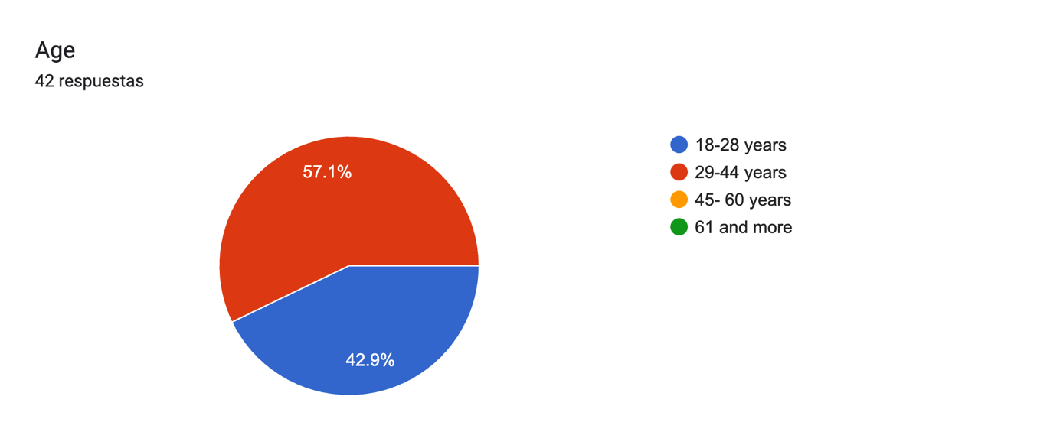
Figure 1: Age of respondents

In terms of gender, the results indicate participation by both men and women, with a slight predominance of Male. This shows a balanced and diverse view of perceptions of leadership, motivation, and performance in the hospitality sector in Dublin. This is relevant as work experiences and perceptions vary around gender and cultural background.
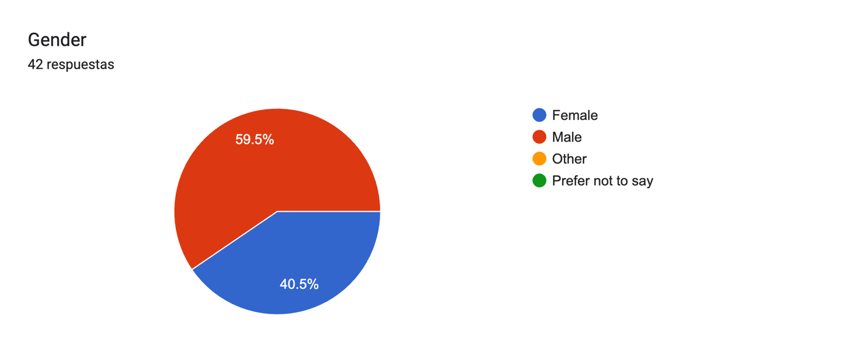
Figure 2:Gender of respondents

This analysis identifies a diverse sample, comprising respondents from Latin America, Europe, Asia and other areas, demonstrating participants from multiple countries and revealing the multicultural nature of the hospitality industry in Dublin.

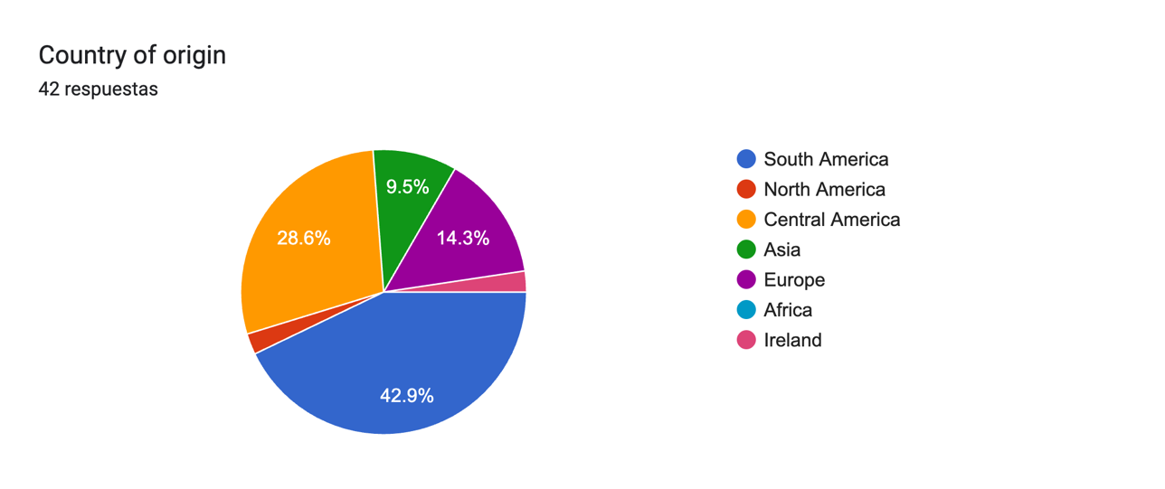

Figure 3:countries of origin of respondents

4.2 Cross- Cultural Leadership in hospitality industry

In this analysis, the results indicate that intercultural leadership in the hospitality industry cannot be understood as rigid, but rather as a process of adaptation across different cultures. It was found that leaders with effective strategies adopt more participatory and flexible approaches with their teams and adjust their communication and behaviour according to the team's requirements, which coincides with the literature review but also provides practical information specifically from Dublin.
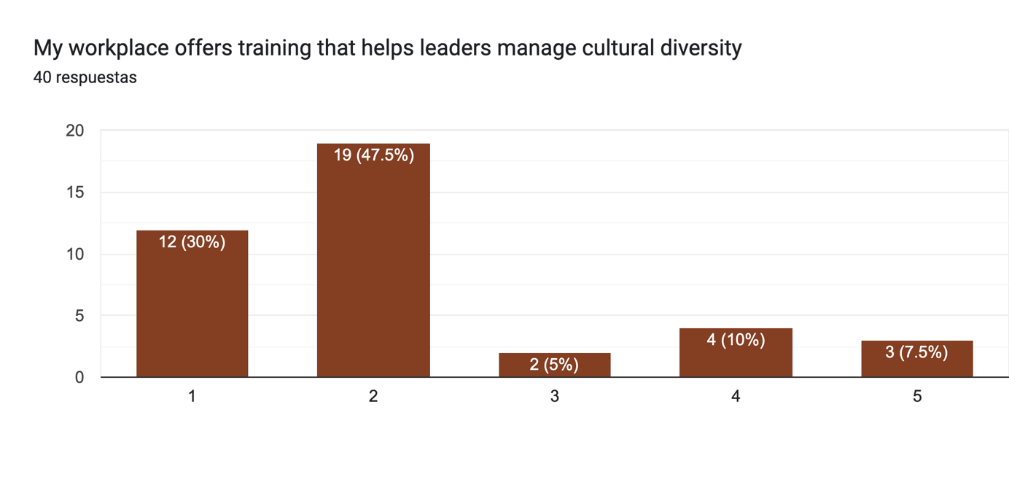
Figure 4:Cross- Cultural Leadership in hospitality industry

Authors such as Nwokorie and Onyeonoro (2014) and Al Rahbi et al. (2017) highlight the importance of participatory and transformational styles, while Tsai (2022) points out that there is no lack of clarity about how adaptation develops in practice. The results show that intercultural is able to use adaptation occurs mainly through day-to-day interactions, informal communication, and leadership by example, rather than through formal strategies. Therefore, we can also mention that there is no structured training provided by organisations to guide leaders.
Both managers use a participative style. Manager 1 adapts to culture “more tact with Irish and Indian staff, more direct with Latins.” Manager 2 adapts more to individuals “I focus on personality and abilities, not nationality.” This shows leadership is flexible but applied differently. These findings show that leadership is mostly participative and supportive, which increases motivation and teamwork among international student employees. However, not all managers adapt to cultural or language differences consistently.
From this perspective, the results indicate that without formal intercultural leadership training, managers are forced to rely entirely on their intuition and personal experience. While this may be helpful in the short term, it is neither sustainable nor consistent in the long term.

4.3 Motivation and Job Satisfaction
These results show that student motivation and satisfaction are relatively low. This may be determined by economic, organisational or work environment factors. It is important to mention that salaries are a very important element, but even though satisfaction is relatively high, this does not mean that leadership strategies are optimal.

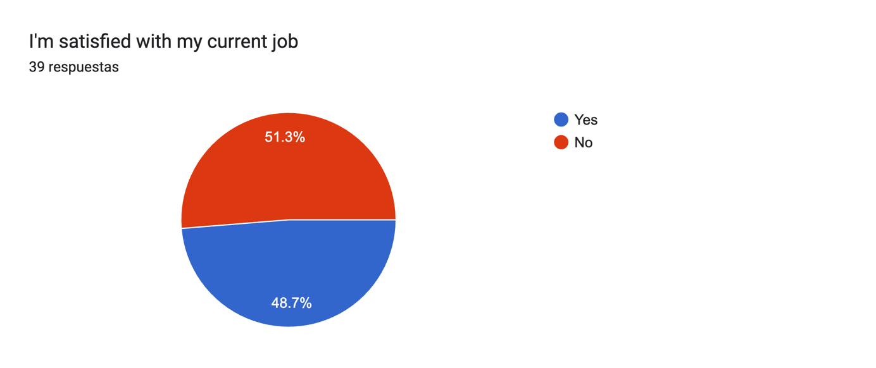
Figure 5: Motivation and Job Satisfaction
These results support authors Moniker and Lukic (2022), who argue that job satisfaction can be considered a multidimensional phenomenon that is influenced by social and cultural factors. Similarly, Zhao and Pan (2017) argue that work needs are similar across cultures, but that the development of motivation must be adapted to the cultural and organisational context. This adaptation can manifest itself through flexible working hours, informal recognition, and emotional support at work or on a personal level from leadership.
The managers considered that international students are motivated by fair wages, as they face many challenges living alone, paying high rents, lifestyle, etc. Manager 1 points out that empathy and simple appreciation, such as saying thank you, can help employees feel a little satisfaction, so both use satisfaction informally through conversation.
The results may also reveal an excessive reliance on informal leadership to maintain motivation. The absence of clear organisational policies or regulations regarding the well-being and motivation of international students can lead to a poor work experience and, above all, a lack of awareness, depending on the style and sensitivity of each manager or leader within the organisation. This raises a great need to propose motivational practices that go beyond individual leadership.

4.4 Challenges faced by international students in hospitality workplace
The results show that the challenges international students face in the hospitality industry are related to language barriers and cultural, emotional, and structural adaptation. These challenges will not only affect job performance within organisations, but also psychological well-being and the sense of belonging within the team.
The findings coincide with Baklashova and Kazakov (2016) and Zopiatis (2007), who identify linguistic barriers and administrative barriers as key factors hindering the integration of international students. However, the emotional impact of these challenges is analysed in greater depth, showing how linguistic insecurity in the workplace and a lack of support networks can reduce confidence and active participation in the team, leading to low productivity in the organisation's activities.
From a leadership perspective, the results support Zopiatis and Constanti (2010), who argue that active and committed leadership can mitigate emotional exhaustion and work stress. We can therefore conclude that the practices described by managers, such as open communication, flexibility and informal support, demonstrate that leadership can act as an important factor in addressing these challenges.

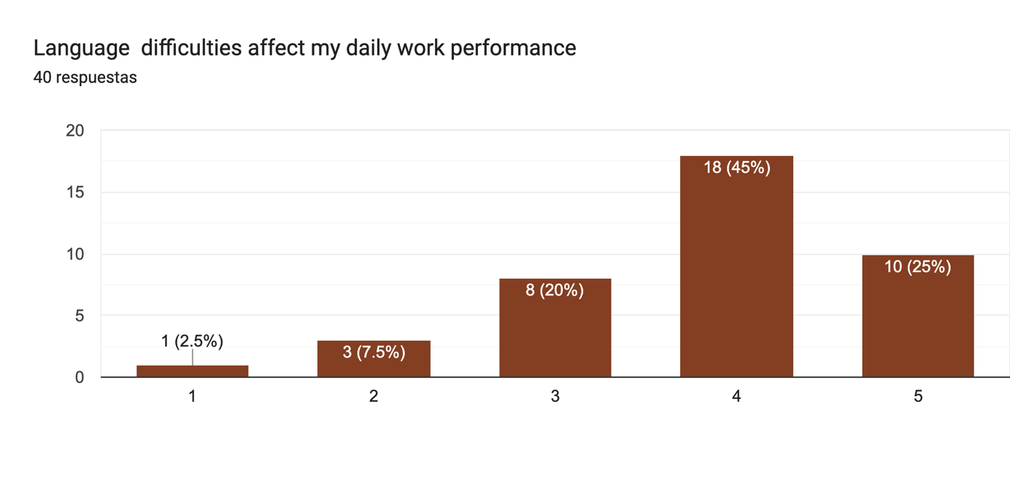
Figure 6: Challenges faced by international students in hospitality workplace
Therefore, it is important to mention that international students face many difficulties, whether it be stress and balancing work and study, or being in environments with high workloads and low stress, which can be very challenging and affect motivation and long-term satisfaction. They also have to deal with cultural differences, different languages, visas, and financial pressure. In this context, we can mention that supportive leadership can help, but if it is not consistent, it will not be sustainable in the long term. Therefore, leadership will not only influence motivation but also the resilience and well-being of multicultural teams.

4.5 Impact of leadership strategies on team performance
The results demonstrate that leadership strategies can have a direct and highly significant impact on the performance of multicultural teams within the hospitality industry in Dublin. The findings indicate that team performance does not depend solely on the skills or previous experience of employees, but rather on the interactions promoted by leadership, the management of difficulties arising from cultural differences, and the resolution of conflicts due to misunderstandings. The results show that the majority of international students point out that there are many misunderstandings and conflicts due to multicultural differences. Although there is good communication and feedback from leaders, it is not optimal.
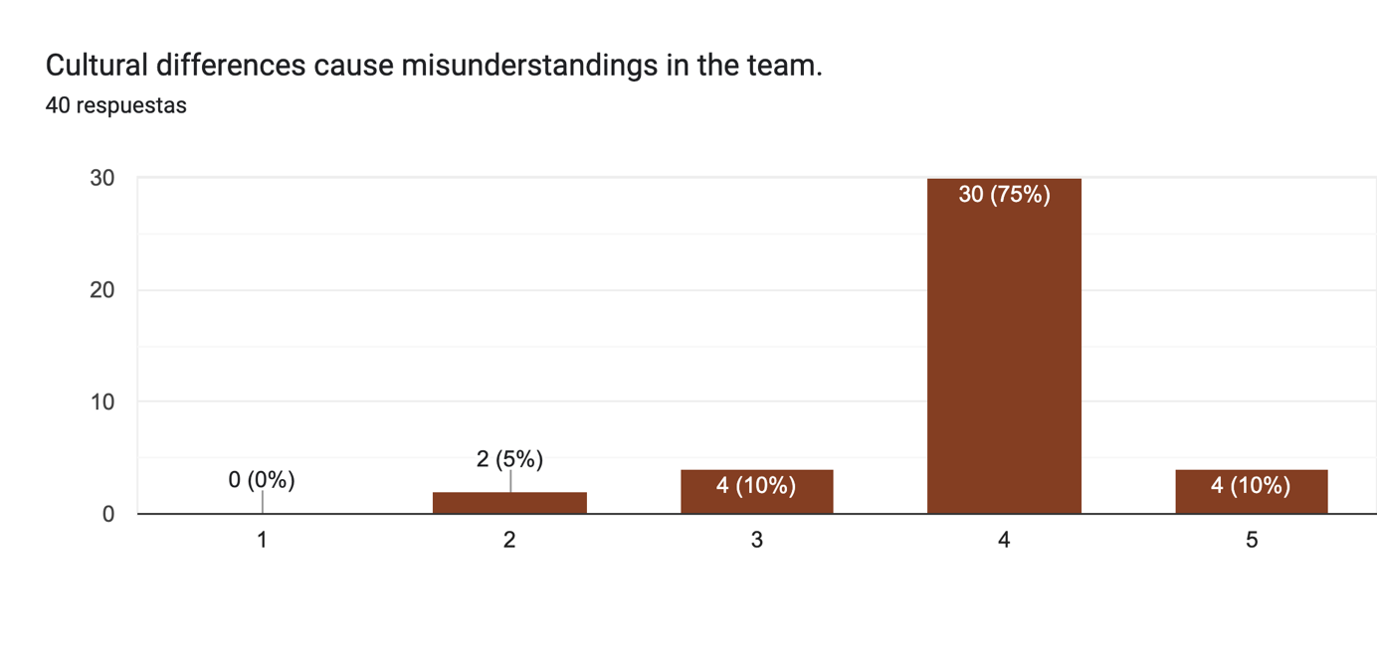
Figure 8: Impact of leadership strategies on team performance
Hinkin and Tracey (1994) point out that participatory and transformational leadership styles are associated with helping to improve the coordination of multicultural teams, internal communication, and operational efficiency, especially when workers face high-pressure environments. Transformational leadership improves organisational performance through clarity of objectives, consideration, and positive attitudes towards work.
From the perspective of Manager 1, he mentions how an intervention based on empathetic communication and active leadership can transform individual behaviour and, therefore, team performance. This example supports the idea of Fouad (2019), who points out that leaders who are able to promote professional development, recognition and participation generate more committed and productive teams. Similarly, Sürücü and Sağbaş (2021) emphasise that leaders who create environments of trust by taking into account individual support and open communication achieve performance improvements and reduce staff turnover.
Leadership that will have positive effects will generally focus on teamwork, adequate communication, and building employee trust, as well as adapting to different cultures. On the contrary, poor communication or sudden decisions will damage employee trust. In this context, we can conclude that empathy and feedback in multicultural teams are very important, as international students can feel confident in their abilities. Likewise, inclusion activities will be very important for teams to feel integrated, which shows that leadership not only motivates individuals, but can also shape how teams collaborate with each other, or find themselves in scenarios where they can solve problems and handle pressure.

4.6 Best practices for leadership development
The results reveal that there is a very significant difference between the leadership practices applied to managing multicultural teams and the leadership development programmes available in the hospitality industry. The findings show that most intercultural practices and information are acquired informally, through personal experience and daily interaction, rather than through structured training with adequate information.
This coincides with Normore et al. (2019), who criticise traditional leadership training programmes for their lack of preparation for culturally diverse contexts in organisations. Siyal et al. (2023) highlight that inclusive leadership will have a positive impact on how employees perform, which is driven by trust and psychological empowerment. Although the managers interviewed do not have formal training in inclusive leadership, their practices may reflect many of the principles mentioned by the authors, suggesting that certain skills can be developed intuitively. However, the lack of information and structured systems limits their proper and continuous development.
Similarly, Nosratabadi et al. (2020) emphasise the importance of cultural intelligence as a key competency for leaders in multicultural environments. The results of this study show that managers demonstrate very low levels of cultural intelligence when adapting their communication and leadership styles within their teams, meaning that the individual needs of international students are not being met. Likewise, the absence of specific training can restrict the development of leaders.
Both managers said their workplaces do not provide formal leadership or intercultural training. Manager 1 said leadership is learned “from daily experience,” and trust is built through “communication, fairness and leading by example.” Manager 2 added that hospitality training focuses on operations, not leadership, and that being “approachable, consistent and fair” helps avoid cultural misunderstandings.
Finally, the results show that leadership has a positive influence on team performance, whether through support or equality, but it should be emphasised that these practices are informal and do not form part of formal, structured training. Likewise, the results confirm that employees feel supported, but leadership development depends largely on individual managers and not on the organisation. Likewise, the literature suggests that without structured intercultural training, inclusion and performance are much more difficult to manage and maintain in the long term.

Chapter 5

5.1 Conclusions

The main objective of the research was to analyse how intercultural strategies can influence the motivation and work performance of international students who interact and work with multicultural teams in the hospitality sector. Based on the data obtained through triangulation analysis, it can be stated that the research question has been answered clearly and consistently.
The findings of the research show that intercultural leadership strategies have a direct impact on the motivation of international students and also have a direct impact on work performance. Specifically, participatory, transformational, and flexible leadership styles have been shown to be the most effective when managing multicultural teams, as they promote trust and open communication and generate a sense of belonging. All of these factors are key to maintaining and continuing to improve motivation levels and facilitating better integration and inclusion of international students in the workplace.
In relation to team performance, leadership strategies focused on fairness and empathy are accepted, and leading by example can directly contribute to productivity, teamwork, cooperation, and efficiency in these operations. Teams that are mindful of unity are influenced by leaders who promote collaboration and the ability to support them, enabling them to respond effectively to the demands of the hospitality sector. This also demonstrates that the impact of intercultural leadership is not focused on and limited to individual improvements, but rather on overall team performance.
The results also reveal that the impact of intercultural leadership has its limits. In situations where leadership strategies are not supported by adequate working conditions, such as formal training and inclusion-related policies, they can have a negative effect or fail to meet the needs of multicultural teams. In this sense, intercultural leadership is most effective when it is part of a comprehensive organisational approach that includes leadership practices with organisational support and professional development.
Finally, intercultural leadership strategies will positively influence motivation and student performance, but it is important to mention that maximising their impact is only achieved when they are consistently applied and integrated into a broader organisational strategy.

5.2 Recommendations

Based on the findings of the research, the following recommendations are proposed, aimed at the hospitality sector that manages multicultural teams with international students.
1.⁠ ⁠Implement formal training in intercultural leadership: Companies should offer programmes and training that are specifically focused on cultural intelligence, intercultural communication, and inclusive leadership, especially for managers who deal with diverse teams.
2.⁠ ⁠Develop inclusion and support policies: Establish clear induction regulations, especially for those with an international student profile, including cultural orientation on what the work environment is like and how all employees interact and communicate within the company, as well as language support and access to wellness resources. Propose small inclusion activities within the team, providing information about different cultures and how the company promotes inclusion creatively and effectively.
3.⁠ ⁠Encourage participatory and empathetic leadership styles
Managers should foster environments where employees feel heard, valued, and supported, without fear of saying what they feel and what they are going through, whether due to language barriers or personal issues, which will help improve the motivation and performance of the team within the company and in their work.
4.⁠ ⁠Improve structural working conditions:Adjust schedules depending on students' needs, offer stability in contracts, and consider workers who are students so that they can develop professionally. This will help increase job satisfaction levels.
5.⁠ ⁠Encourage constant communication and feedbackOrganise brief, regular meetings to clarify expectations of employees or how they can deal with stressful situations, as well as to resolve any doubts they may have about their daily tasks and when new tasks or implementations are introduced in the company, thereby strengthening team integration.

5.3 Limitation

Despite the study's contributions, there are some limitations that should be considered. For example, the sample size was small, with only 40 surveys, and in the qualitative section, only two managers were interviewed. This may lead to generalisations in the results for the entire hospitality industry.
The data is based on the more subjective perceptions of the participants, and the study also focuses specifically on Dublin, so the results may not apply in other cultural contexts.

5.4 Advice for another researches

Recommendations for future research include expanding the sample size to include a greater diversity of organisations and leadership roles in the hospitality sector. It would also be beneficial to incorporate more direct perspectives from international students through more in-depth interviews that provide more extensive information.
Future studies could also focus on other cities, not just Dublin, which would allow for comparisons to be made, identifying similarities or differences in the leadership developed in multicultural teams. Finally, an analysis of formal intercultural leadership training programmes could be carried out to see if they are effective and have any impact, evaluating whether they are effective in improving performance and motivating multicultural teams.

References

Nwokorie, E.C. and Onyeonoro, C., 2014. The impact of leadership style on effective human resources management and productivity in hospitality organizations. Journal of Technical Education and Management Sciences, 9(2).

Al Rahbi, D., Khalid, K. and Khan, M., 2017. The effects of leadership styles on team motivation. Academy of Strategic Management Journal, 16(2), pp.1-14.

Schneider, M. and Somers, M., 2006. Organizations as complex adaptive systems: Implications of complexity theory for leadership research. The Leadership Quarterly, 17(4), pp.351-365

Khan, M.Y.H., 2019. Cross cultural leadership and the hospitality industry: a leadership style towards success in organizational goals in France. Art. Human Open Acc J, 3(1), pp.25-30.

Tsai, C.-J. (2022) ‘Cross-cultural leadership behavior adjustment and leader effectiveness: a framework and implications’, International Studies of Management & Organization, 52(3/4), pp. 205–225. doi:10.1080/00208825.2022.2131232.

Imonikhe, A. and Lukic, D., 2022. Social and cultural impacts on employee job satisfaction and commitment to organisations. International Journal of Applied Management Theory and Research (IJAMTR), 4(1), pp.1-16..

Arman, A., Sohaib, O., Begum, V. and Alkharman, A.A., 2024. Impact of Cultural Diversity on Employee Performance: A Study of Expatriates. International Journal of Service Science, Management, Engineering, and Technology (IJSSMET), 15(1), pp.1-14.

Zhao, B. and Pan, Y., 2017. Cross-cultural employee motivation in international companies. Journal of Human Resource and Sustainability Studies, 5(4), pp.215-222.

Asrifan, A. and Dewi, A.C., 2023. Leadership Strategies for Motivating Students: Insights from English Language Learning in Indonesian Senior High Schools. Development: Studies in Educational Management and Leadership, 2(2), pp.169-184.
Sohail, A., Khan, B.S. and Raza, S., 2023. Educational Leadership's Motivational Strategies for Transformational Growth of Teachers: A Comparative Analysis of Public and Private Schools. Pakistan Journal of Humanities and Social Sciences, 11(2), pp.1198-1205.

Zopiatis, A., 2007. Hospitality internships in Cyprus: a genuine academic experience or a continuing frustration?. International Journal of Contemporary Hospitality Management, 19(1), pp.65-77.

Baklashova, T.A. and Kazakov, A.V., 2016. Challenges of International Students' Adjustment to a Higher Education Institution. International Journal of Environmental and Science Education, 11(8), pp.1821-1832.

Zopiatis, A. and Constanti, P., 2010. Leadership styles and burnout: is there an association?. International Journal of Contemporary Hospitality Management, 22(3), pp.300-320.

Qiu, S., Alizadeh, A., Dooley, L.M. and Zhang, R., 2019. The effects of authentic leadership on trust in leaders, organizational citizenship behavior, and service quality in the Chinese hospitality industry. Journal of Hospitality and Tourism Management, 40, pp.77-87.

Shneikat, B., Cobanoglu, C. and Tanova, C. eds., 2021. Global perspectives on recruiting international students: Challenges and opportunities. Emerald Publishing Limited.

Hinkin, T.R. and Tracey, J.B., 1994. Transformational leadership in the hospitality industry. Hospitality Research Journal, 18(1), pp.49-63.

Fouad, M., 2019. Impact of leadership style on employee job satisfaction in the hospitality industry. International Journal of Heritage, Tourism and Hospitality, 13(1), pp.1-12.

Sürücü, L. and Sağbaş, M., 2021. The impact of leadership styles on job satisfaction: A study of the hospitality industry. Yönetim Bilimleri Dergisi, 19(40), pp.323-346.

Ogdol, R.E.R., 2018. Impact of leadership styles on employee job satisfaction within quick service restaurants (QSRs) in the UAE (Doctoral dissertation, Doctoral dissertation, Cardiff Metropolitan University, United Kingdom).

Siyal, S., Liu, J., Ma, L., Kumari, K., Saeed, M., Xin, C. and Hussain, S.N., 2023. Does inclusive leadership influence task performance of hospitality industry employees? Role of psychological empowerment and trust in leader. Heliyon, 9(5).

Nosratabadi, S., Bahrami, P., Palouzian, K. and Mosavi, A., 2020. Leader cultural intelligence and organizational performance. Cogent Business & Management, 7(1), p.1809310.

Normore, A.H., Hamdan, K. and Esposito, M.C., 2019. A cross-cultural perspective on leadership development programmes. Journal of Educational Administration and History, 51(1), pp.1-4.

Celestin, M. and Vanitha, N., 2020. The diversity dividend: Why inclusive leadership drives innovation. International Journal of Applied and Advanced Scientific Research (IJAASR), 5(2), pp.47-54.
Ashikali, T., Groeneveld, S. and Kuipers, B., 2021. The role of inclusive leadership in supporting an inclusive climate in diverse public sector teams. Review of public personnel administration, 41(3), pp.497-519.

