Applied Project
Submission Form


LEARNER NUMBER | 51734567
NAME | Lucas Gonzatti Marques
COURSE | BAAF
REPORT TITLE | How financial aspects and other challenges influence the expected outcomes of international students in higher education moving into Ireland?
SUPERVISOR NAME | Dr Daniel O’Sullivan
WORD COUNT | 7683
DUE DATE | 12/05/2025
DATE SUBMITTED | 09/05/2025

I certify that:
- This project report is all my own work, and no part of this report has been copied from another source: Yes ☒ No ☐
- I understand that this report may be checked by electronic or other means for plagiarism and/or content created by generative AI and may be transferred and stored in a database for the purposes of data-matching/data-analysis to help detect plagiarism and/or content created by generative AI: Yes ☒ No ☐
- This report has not previously been submitted in part or in full for assessment to any other institution: Yes ☒ No ☐
- I consent to the inclusion of my report in the publicly accessible (open access) electronic database maintained by the library:
Yes ☒ No☐
- I have emailed a back-up copy of this report to locker@independentcollege.ie:
Yes ☒ No ☐

(Note that if no check boxes are selected, this Project will be regarded as NOT properly submitted, and may be subject to a late submission penalty)

Name: Lucas Gonzatti Marques
Date: 09/05/2025

Abstract
Despite the increasing number of international students in higher education enrolling to study overseas, little is known about their financial challenges and other aspects, which may impact their lifestyle in a host country, decision to stay or leave , during and after competition of their courses. This study aimed to demystify challenges and support this community enhancing a better experience for them in Ireland.
The comprising data obtained with both methods, quantitative and qualitative enhanced the answers of the themes, building in up evidence and supporting elements of this project, therefore, the research question. The quantitative interview was executed with managers of the hospitality sector, and the quantitative survey was answered by 53 international students in higher education in Ireland, complemented with 2 in depth interviews with international students for further evidence.
It was found that this group represent an important part of Irish economy but faces challenges around its inclusivity within the community due to mainly lack of communication/ language barrier, the fact of sharing accommodation impacting directly their experience in Ireland and facing considerable disadvantage for not holding European passport/work permit/visa, which culminates with dissatisfaction, stress and ultimately, their return to their home countries.
International Students in higher education in Ireland are found to not struggle with their monthly budget, even though they have to destinate most of their income with accommodation and food expenses, relying on loans to pay their tuition fees and being affected due to cost of inflation.
As major findings, the themes have led the answer to the research question to be struggles of International students around their mental well-being and increasing difficulties to progress their career in Ireland. This may damage the attractiveness of Ireland as a destination for international students and its retention of talent work labour. ISHE are assets to the companies bringing diversity, innovations and betterments, resulting in stronger teams and may in the long run affect their competitive advantages and lack qualified workforce.

List of acronyms
ISHE- international students in higher education
A1- manager 1 in hospitality industry
A2- manager 2 in hospitality industry
ST1- interviewee student 1
ST2- interviewee student 2

Table of figures
Figure 1 Calculator sample representing the ideal size of sample 23
Figure 2 Proportion spent with Accommodation 28
Figure 3 Difficulties to find accommodation 29
Figure 4 Language barrier 30
Figure 5 Integration with the culture 30
Figure 6 Network integration 31
Figure 7 Intention to stay in Ireland after graduation 31
Figure 8 Peer support 33
Figure 9 Examples of difficulties suffered by ISHE due to visa status 34
Figure 10 ISHE demotivation due visa status 35

List of tables
Table 1 Coding managers' interview under themes 18
Table 2 Stakeholders’ code table 18
Table 3 Recommendations 32

Table of Contents
List of acronyms 5
Table of figures 6
List of tables 7
Chapter 1: Introduction 10
1.1Introduction 10
1.2 Rationale for the study 10
1.3 Statement of the research objectives 11
1.4 Information gathering & data collection technique used 11
Chapter 2: Literature Review 13
1 Introduction 13
1.1 What is the financial importance of international students, in higher education, for a country? 13
1.2 What are the main financial challenges, in the host country, for international students? 14
Conclusion of the literature Review 19
Chapter 3: Methodology 21
3.3 An outline of sampling technique and sample size 23
3.3.1 Sample size calculator 23
3.4 Method employed for the quantitative analysis 24
3.4.1 Table of Coding by themes 24
3.4.2 Table of Stakeholder interviewed for the study- qualitative analysis 24
3.5 Ethical section 25
3.5.1 Confidentiality 25
3.5.2 Consent form/plain language statement 25
3.5.3 Research instrument 25
3.5.4 Clarity and Understandability of the questions 25
3.5.6 Themes coding 25
3.5.7 Care to treat, conduct and analyze data 25
Chapter 4: Findings and Discussion 26
4.1 Interpretation of the themes 26
4.1.1 Theme 1: Recognition of the importance of international students for Ireland 26
4.1.2 Theme 2: The main financial challenges, in the host country, for international students 27
4.1.3 Theme 3 How does culture define an international student journey and influence their decisions? 29
4.1.4 Theme 4: What are the considerations in an ISHE’ point of view when deciding to move, stay or leave a host country? 32
4.1.5 How financial planning may change the experience of international students in a host country and shape its future? 35
Chapter 5: Conclusion 37
5.1 Limitations 37
5.1.1 Under theme 1 37
5.1.2 Under theme 2 37
5.1.3 Under theme 3 37
5.1.4 Under theme 4 37
5.1.5 Under theme 5 37
5.2 Main findings 38
5.3 Recommendation table 38
Bibliography 40

Chapter 1: Introduction

1.1Introduction
The idea of developing this project was idealized based on the author’s relation with this niche, being part of ISHE in Ireland. The objective of this study was to create visibility for financial and non-financial challenges of international students in higher education in Ireland, understand their needs and provide guidelines to future policies to support them. Furthermore, this study opened a topic to deeply understand students’ experience in Ireland, their decision to come, leave or stay.

1.2 Rationale for the study
The research question, “How financial aspects and other challenges influence the expected outcomes of international students in higher education moving into Ireland?” aimed to understand the ISHE’s struggles and to help them to surpass it, post-pandemic until 2025. Furthermore, other studies were mostly based on research about emotional and psychological aspects of ISHE’s experience or were not deep into the financial aspects experienced by them. Thus, this study tried to explore those factors and tried to prove how financial planning could help and improve the ISHE’s expected outcome.
Complementary, with a new party elected in America with negative bias about foreigners and other countries with English as an official language adopting policies to restrict the acceptance of new ISHE, Ireland may be impacted, in the nearest future, with an increase in the number of international students moving in. In this line, this study attempted to provide help to official bodies and Educational Institutions to establish a contingency plan to assure, support and improve the experience of current and new ISHE in this country.

1.3 Statement of the research objectives
The expected outcome for this study was to find the correlation of variables that influences ISHE to come, study in Ireland, stay or leave after graduation and their expected financial outcomes. Those variables, crystallized as challenges and opportunities, such as level of remuneration in the country, cost of accommodation, expenses with food, visa requirements, culture interaction, proficiency level of English language and peer support were taken into consideration.

1.4 Information gathering & data collection technique used
This study was carried on mix-methods based, using a semi-structured interview base, within 2 managers at the hospitality sector, which directly work with international students and, close questionnaires, with 53 international students. To amplify the evidence, two students were randomly selected to be interviewed to obtain a better understanding of the scenario.
1.5 Expected Outcomes of the study.
This study expected to validate the idea of the struggles faced by ISHE, regarding sharing accommodation, affordability of their cost of livings after the Covid 19 Pandemic until 2025, their difficulties to save money after paying for those and evaluate the impact of sharing accommodation on their jobs, student performance and their experience in Ireland.
Additionally, this study aimed to demonstrate that the attractiveness for the international students moving into Ireland were based mainly on the pillars of having a high minimum wage in Ireland and its neutral political affairs.
Furthermore, this study expected to prove that difficulties to obtain, or not holding a valid visa, could cause stress, especially in the last year of academic studies. Lastly, this study wanted to portray the challenges surrounding the culture integration and difficulties due to lack of language skills.
1.6 Chapter by chapter Overview.
This study was structured with an introduction, which summarized the idea of the challenges and importance of ISHE for Ireland, followed by the chapter 2, the Literature review comprising 5 themes, creating a base for discussion and comparison with the data obtained for this study.
In the section 3, the methodology chapter, was comprised by a brief definition of the epistemology/ ontology, justifying the reasoning and adoption of the methodology and methods used in this assignment, followed by the next two chapters , which are interchanged and contain the center of this study, with are the analysis of the primary data, findings, comparisons and justificative for the conclusion, with suggestions of improvement and final disclosures.
Lastly, the reader can find the bibliography that supports this assignment and Annexure/ appendix table with complementary information.

Chapter 2: Literature Review

1 Introduction
In 2025, similarly to previous years, the flow of international students has increased and has brought some challenges. This study approached, in a thematic structure, some of these challenges, focused on financial and non-financial aspects, which impacted the ISHE’s decision to move, stay or leave the country. The 5 themes below, under 5 sub questions were exploited to explain their relevance to answer the research question.

1.1 What is the financial importance of international students, in higher education, for a country?
Almost a century ago (Smith, 1904) studied and published aspects related to the importance of skilled workforce for the development, competitiveness and wealthiness of a country (Glaeser, et al., 2000). This workforce, nowadays could be supplied with international students that immigrate to other countries (Koenings, et al., 2020), as Ireland (Rodrigues, 2022), which has received a lot of international students in the past few years. The challenge though, is to retain those skilled individuals (Glaeser, et al., 2000).
Additionally, (Stuen & Ramirez, 2018) state that today’s flow of students has increased and has brought significant importance, through revenue, to host countries receiving those students. In the same line (Rodrigues, 2022), defend that Ireland has been one of the favourite destinations of international students and according to (Wang & O'Connell, 2020), it is important to foment the arrival of new international students and support them with their needs (Glaeser, et al., 2000), especially by Universities and Government, which can provide a proper quality of live for them.
This theme is an introduction to the research topic , and aims to show the importance of ISHE to the host country as mentioned by (Stuen & Ramirez, 2018), (Rodrigues, 2022) and (Smith, 1904), but clarifying that not only Universities and Government are responsible for international students as mentioned by (Glaeser, et al., 2000), but for general public in the host countries (Koenings, et al., 2020) and by the students themselves, interacting, creating network (Stuen & Ramirez, 2018) and enhancing real willingness to stay in the country.
This study, under this theme, focused on establishing a connection between the relevance of ISHE to Ireland and the perception of managers about employing international students in the actual conjuncture.

1.2 What are the main financial challenges, in the host country, for international students?
As temporary immigrants, international students will have benefits and challenges when living in a host country (Khanal & Gaulee, 2019). Some authors such as (Dabrowski, et al., 2024) and (Schofield, 2024), gave emphasis on the hardship that international students face when moving to a host country, such as the UK, and are directly affected by the cost of living. Complementary, (Lewis, 2024) mentioned the increase in the price of accommodation as a major factor that brings concerns and stress among international students. As this study is concerned with financial aspects intrinsic to international students in a host country, some considerations such as homesickness and other emotional aspects, mentioned in other studies will not be covered, even though those aspects contribute to an individual deciding to stay or not in a host country.
Financial problems can affect the academic performance (Dabrowski, et al., 2024) and due to more hours worked (Chalmers & Waddoups, 2007) to cover increase in cost-of-living, the commitment to studies decline (Schofield, 2024). With a different point of view, (De Haas & Fokkema, 2011) defend the idea of creating relations with the host country, and mentioned that the longer an international student stay in that country, the more likely for him/her to stay in it, suggesting a counter measure to overcome this challenges are integration and enhancement of social and economic attachments.
1.3 How does culture define an international student journey and influence their decisions?
Previous studies mentioned the culture or culture shock as one of the main challenges faced by international students (Nicolescu & Galalae, 2013), which this study aimed to validate but with focus on the financial benefits intrinsic to this phenomenon.
Authors such as (Nicolescu & Galalae, 2013) and (Waxin, 2004) hold the idea of students being impacted by the difference of the culture from their home country to the culture of the host country. In the same line, (Kusumawardani, et al., 2024) mentioned the self-adjustment challenges that students face in international assignments can be minimised through peer support and resilience. Additionally, other studies of Asiatic culture in Universities in USA and Canada, indicate that language barrier and culture differences were the main challenges from international students (Alam & Modh Angsor, 2024).
Nevertheless, (Waxin, 2004) appoints that international students that socialise and communicate better have a better experience when living abroad, suggesting openness and stress control to overcome cultural challenges, and in a similar way, (Stuen & Ramirez, 2018) suggest interactions and expansion of network would help. Additionally, (Sam & Berry, 2010) suggest that the process of adaptation in the short term may cause disruptions and some level of stress, but in the long term the benefits arising from the experience are enormous.
Lastly, (Baum, et al., 2018) state that the culture of the host country influences the international students when deciding to live abroad, and this is one of the reasons Ireland has become one of these destinations.
Concluding this section, the sample was questioned, how they overcome the challenges of language barrier, culture shock, homesickness or loneliness feeling and how the use of technologies could reduce the emotional pressure (video calls) and boost their learning (free tools of translation and apps to meet people with same interest) and keep connecting with relatives in their home country, not found in this literature. Additionally it was encouraged to deeply immerse in the local culture and be open to fully enjoy the experience in a host country.
1.4 What are the considerations and aspects that may influence in the decision of ISHE, stay or leave a host country?
There are several factors that influence the decision of international students when moving abroad. Some authors as (Khanal & Gaulee, 2019) mentioned in their publications several aspects and categorise them into pre-departure, post-departure and post-graduation segments, comprising the significance of tax and financial benefits for students when taking decision to move abroad to study in addition to uncertainty related to future, immigration rules, culture shock , visa and finance aspects. For another authors such as (Rose-Redwood & Rose-Redwood, 2004) suggest that international students should overcome challenges such as government policies, political decisions, which directly impacts their experience of studies, work and consequently, their decision to stay or not in the host country. In a different approach (Kouba, 2029) offers an insight about Universities being a major determinant of success in the overseas assignment and source of reliability and guidance.
In another line of studies, (Crumley, 2024) emphasised the importance of international student’s interaction in the host country and emphasises specially the possession of visas and study permit (Khanal & Gaulee, 2019), facts that will have a direct impact in international students’ experience in foreign country. (Crumley, 2024) defends that international students holding a legal and valid visa are likely to encounter less emotional burden and can focus more on academic subjects.
It is know that countries as Australia, the USA, Ireland and Canada are very strict in relation to concession of visas (Euronews, 2024) , but going in a different path, in the UK, according to (Sumption & Brindle, 2024), a new system to grant visa for students took place to ensure long term commitment between them and the country, propitiating certain distress to international students, going in the same line as (Rose-Redwood & Rose-Redwood, 2004) and (Crumley, 2024). In this assignment, in the qualitative interview there is a section where ISHE were asked about their experience related to visas, costs and any financial hardship related to the topic. According to (Department of Justice, 2025), international students should enroll in an educational institution, regulated by the Irish Government to be able to hold Stamp 2 and then be entitled to work 20 hours per week. The main concern origins in the fact that a students can remain studying under a limited period of years, which ceases after attending university/ college/master’s programs, demanding after this period a work permit visa, under specific contracts, which brings additional expenses to the employer or alternatively, lead ISHE to leave the country.
Complementary, (Kritz, 2016) defends that international students make their decision to live abroad based on lack of opportunity in their home countries, and found in her study that there were fewer students that speak Portuguese or Spanish. This study tried to select a sample of ISHE in Ireland, compared it to those studied samples from The USA (Kritz, 2016), aiming to demonstrate inverse results regarding Portuguese and Spanish speakers.
1.5 How financial planning may change the experience of international students in a host country and shape its future?
In the USA, (Jenny, 2017) concluded a research and found some challenges related to language and finance as main issues for international students. In the same line, (Rodrigues, 2022) tried to associate the importance of education in personal finance to overcome challenges related to finance aspects for international students in Ireland. This study covered those subjects regarding higher education students in Ireland with intention to further discuss the subject and enhance betterments for this group.
Additionally, (Morris, et al., 2023) perceives in Australia, during and prior to pandemic, a substantial increase in the cost-of-living, especially related to accommodation, bringing stress to students that have to improvise ways to cope with payment of bills, and destinating more effort and time for work and reducing engagement in College (Schofield, 2024).
In the point of view of Australian residents, according to (Forbes, et al., 2007), international students are considered as customers to be milked, which for the authors is unacceptable. In their work, they incentivise the research in the area and foments its publication, once international students bring revenue to the country and are important for the host country (Stuen & Ramirez, 2018).
In a different approach, (Sarigul, 2014) in Turkey, published a research that describes levels of finance knowledge and stresses the importance of finance knowledge and planning to international students to overcome challenges in their diverse experience in life, including overseas assignment. In agreement with this subject, (Rodrigues, 2022) states that finance knowledge should be taught from early stages of international assignment, to help to minimise hardship, and students’ level of stress and a more enjoyable experience.

Conclusion of the literature Review
According to these authors, under theme 1 and 2 international students are the needed skilled labour force in several countries, which should be valued and retained, to aggregate value to the country. This study agreed with them and therefore tried to confirm this argument asking ISHE their experience with the increase in cost of living, accommodation directly impacts the experience of international students. Parallelly, this study will try to come up with suggestions about how to retain these students, not mentioned by these authors previously.
Other important aspects defended by some authors, under theme 3 are based on the language barrier and interaction with the culture of ISHE, and defend the idea of peer support and social network to help in the process of adaptation and better experience in the host country. This study aligned with those authors’ idea, asking the sample if they had this support, and if yes, by whom, and its relevance to them. Additionally, this study investigated ISHE about work, to understand pattern and relevance in the hospitality industry, due to level of language, validating this assumption and check if the language barrier is something that influenced their experience in Ireland, and then compared with the opinion of manager in the hospitality industry to ratify it or not.
Some challenges, approached by the authors under theme 4, are related to visa entitlements that cause stress and disruption in performance of ISHE. This study intended to prove the positive or negative relation of this factor, as a crucial motivator or demotivator to ISHE deciding to stay or leave the country. Little has been published about ISHE and their challenges in Ireland, but driving more attention to the matter as it happens in Australia, USA and Canada for example.
Nevertheless, under chapter 5, this study intended to solidify the importance of personal finance planning and awareness of growth in cost of living in Ireland, brough by some authors in the UK, and Australia, for example.

Chapter 3: Methodology
This study utilised a mixed methods approach, based on constructivism and interpretivist ontology and epistemology, trying to explore multiple points of view to better understand the answer for the research question.
3.1 Theoretical Paradigm / Philosophy employed
The quantitative data was collected utilising the survey method. Closed questions were developed to explore the individual conception of truth, with ontological approach, post positivism, constructivist. The data was coded, analyzed and compared with other primary qualitative data obtained to formulate this study.
Complementary, the qualitative data extracted through open questions, in questionnaires, presented deductive epistemology with the discussion of multiple realities compared with the assumption of this project in an interpretivist approach. Additionally, the principle of multiple realities, especially regarding individual experience and his/her point of view, combined quantitative and qualitative tried to aggregate new insights and betterments for ISHE in Ireland.
Constructivism better represented the combination of mixed methods and created elements, trought questions evaluating feelings and perceptions of the ISHE. Furthermore, this approach propitiated a more empathetic view of the word, resulting in better evaluation of facts, enhancing recommendations for ISHE, helping to answer the research question.
3.2 Justification for the adoption of the method.
For this study, Interpretivism/constructivism was found to be the philosophical approach, using mixed methods, quantitative and qualitative, supported by surveys and interviews.
To collect primary data around the challenges involving ISHE, closed ended questions were pre developed and distributed among the population. The sample was studied through questions that were self-assessed and easy to respond to. To have a better dimension of this sample, after their consent, questions such as nationality and industry of work were asked. Hospitality was found to be the preferred industry of the sample and in order to gather additional data, other questions about financial challenges, culture, language, accommodation, network were asked being aggregated in sections, by themes, on google forms. Tools as scale, yes or no questions, multiple choice were executed.
The qualitative method was semi-structured and aimed to bring new evidence with different points of view of 2 managers , who work in the hospitality industry and directly work with ISHE. Additionally, 2 ISHE, were interviewed to deep understand their challenges in Ireland. The interviews were conducted individually, in different days that better suited the participants.
In the case of the managers in Hospitality, they were asked questions related to their perception of international students, potential issues related to language , support available for ISHE at the workplace, culture and integration. Based on these, a scenario was constructed of their workforce in order to prove the importance of international students in Ireland.
The interviews were carried out first, based on the themes, involving, culture, financial and non-financial challenges of ISHE, culture, work relations and support, language barrier, personal budgeting and network regarding the literature review, focusing on possible gaps in it, and tailoring those findings and gaps to develop the questionnaires to gather quantitative data. As the questionnaires brought complexity and demanded additional attention about the themes, interviews with ISHE were carried out to clarify those complexities.

3.3 An outline of sampling technique and sample size
The technique used in this study was convenience sample, also known as accidental sampling, which according to (Nikolopoulou, 2023), is the easiest to access, due to geographical proximity, availability at given time and willingness to participate.
For this study it was used a sample of the population of ISHE, reached through network and social media in order to obtain the necessary data. The results were satisfactory, regarding the number of responses in the survey, 53, plus 2 managers and an in-depth interview with 2 ISHE. The interviewees were easy to access and interview, having the coding, interpretation and summary parts of their responses more challenging and time consuming.

3.3.1 Sample size calculator
Due to some restrictions such as time, resources, and the participants’ willingness to respond, the sample of the population achieved the minimum requirements of the study but was not sufficient to represent the reality of the whole population, which could be improved in further studies. To better understand the data, the ideal sample size to analyze this population would be 381, utilizing (Calculator.net, 2025). According to (ICEF, 2025) 40,000 international students enrolled in higher education In Ireland in 2023/2024.
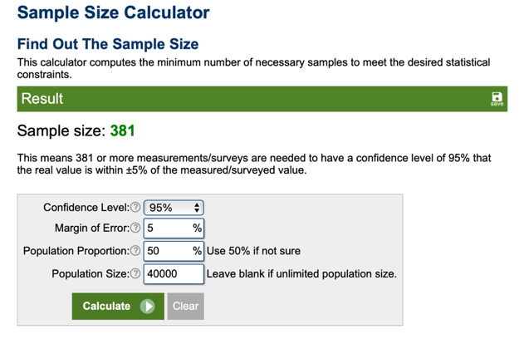
Figure 1 Calculator sample representing the ideal size of sample

3.4 Method employed for the quantitative analysis
The method used was Coding, obtained through Google forms, built in an ethical way, ensuring privacy, accuracy and confidentiality. Additionally in the quantitative questionnaires, participants were asked to consent to the use of the information provided, resulting in singular data, stratified for the purpose of academic purpose.

3.4.1 Table of Coding by themes
Regarding qualitative data, thematic analysis was carried out, assigning codes to the participants, with allocation and finding of patterns produced into a table under each theme. Subsequently, that information was transcribed into answers and compared against the literature review.

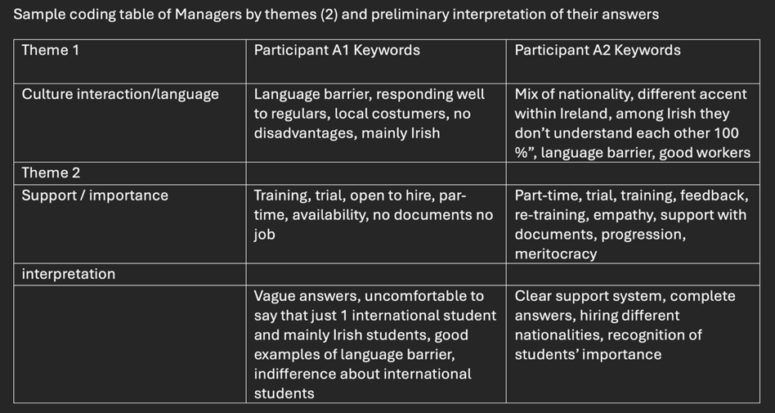
Table 1 Coding managers' interview under themes

3.4.2 Table of Stakeholder interviewed for the study- qualitative analysis
Following ethical standards, all stakeholders part of this study were allocated in a table and have designated a code to them, assuring confidentiality and discretion.
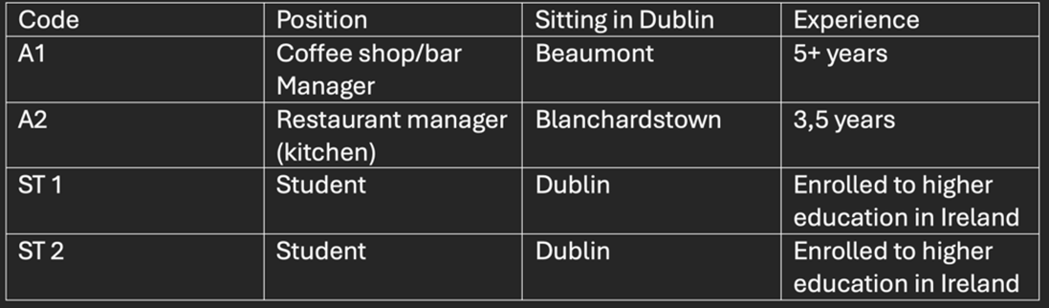
Table 2 Stakeholders’ code table

3.5 Ethical section

3.5.1 Confidentiality
All research in this study was developed following strict rules of conduct and ethical behavior, respecting privacy of the participants, anonymizing their identification, and having their approval to use the information given.

3.5.2 Consent form/plain language statement
For this study, it was used an informed consent form/plain language statement to tell the interviewees about the subject of this project.

3.5.3 Research instrument
An important aspect of this study was that prior to making the survey and questionnaires, a pilot survey and questions were developed, tested and formatted.

3.5.4 Clarity and Understandability of the questions
Considerable time was spent preparing the questionnaires and interviews to make it easy, clear, simple and comprehensive to the participants, avoiding subjects that could trigger a discomfort or mental illness, excluding minors or any vulnerable group.
3.5.5 Transcript
A copy of the interview was sent to interviewees for their acknowledgement, and a copy is available in the section Appendix below.

3.5.6 Themes coding
This study used thematic coding to interpret the primary raw data, analyzing theme by theme and interpreting the results to develop this report.

3.5.7 Care to treat, conduct and analyze data
The questionnaires and surveys were carried out with avoidance of bias by following the accepted format of investigation triangulating primary and secondary research to answer the themes, and therefore, the research question.

Chapter 4: Findings and Discussion
This project had unveiled the importance of ISHE for the Irish economy directly impacting sectors such as Government, food, accommodation, transport, culture events and integration, clothing, leisure, education, industries and security and well-being. All these considerations were explored in this chapter and brought additional information to the 5 Apriori themes mentioned in the literature review.

4.1 Interpretation of the themes
The sample was composed by 53 respondents, being 73.6% from South America, and out of them, 60,4% work in the hospitality sector.

4.1.1 Theme 1: Recognition of the importance of international students for Ireland
The primary data of this study brought aspects such as the relevance of international students as workforce in hospitality, but with different opinions of the interviewees. The first interviewee mentioned the preference of local workers, who are native speakers interacting more with the regular customers “My place is very specific for the reason that it is located in the small neighbourhood, so everyone is very local. So, the main thing we need is someone who responds well to our regulars” (interviewee A1), disregarding previous experience, which aligns with the company culture and goal, whereas the second interviewee expressed the importance of diversity of team members “I have a mix of workers in my team, have Irish students and other half made up international students” (interviewee A2). For both interviewees, training was said to be provided , but only interviewee A2 mentioned further following up with international students and constant feedback, bringing interpretation of support for ISHE.
According to (Koenings, et al., 2020) and (Smith, 1904), to maintain a country productive, it needs skilled workforce that could be supplied by internationals students and skilled people are essential to build the wealth of a nation. With the data collected, it is possible to infer that international students are somewhat important in the hospitality industry according management’s point of view , agreed with the secondary research, but still undermined and non-proper valued, potentially bringing lack of interest of international student to work in this industry in the nearest future. It is though that internationals students should not be just a tool to achieve company’s financial goal, but should be valued as an employee and as person , being offered sense of belonging and rewards, financial and non-financial, which could improve their experience in Ireland, and even productivity levels and levels of motivation. Simultaneously, when renovating annually their GNIB/VISA permits, the government could implement a set of question to ask the ISHE their level of satisfaction, main challenges, suggestions and main rewards during the year, observing their trajectory over the years and making available support whenever needed.
Attracting international students has been a business for many Schools and people, according to (Glaeser, et al., 2000), injecting a significant amount of money in the local economy. With a different line of thought, (Forbes, et al., 2007) mentioned Australians’ perception of international students as “customers to be milked”. This is the reality in Ireland, according to ST1 and ST2. ISHE feel themselves abandoned with low or no support from the Government through their overseas assignments. Nevertheless, this study support the idea of discase of government related to students, mostly due the significant number of new students every year. In this matter, what is seen in Australia, is reality in Ireland, and ISHE can be easily replaced by other students, which caused demotivation and additional stress.
This study recommends the creation of Policies of retaining, attracting , training and supporting international students, which should be implemented based on the industry needs alongside with students’ needs, the ultimate tax payers and skilled labour, contributing then, for the development of Ireland.

4.1.2 Theme 2: The main financial challenges, in the host country, for international students
The primary research found the sample to be concerned with increase in cost-of-living post pandemic up until now, with 39 out of 53 participants responding to be very affected or extremely affected by it. Complementary, out of this sample, more than 50 % of them described spending 25 to 50% of their income with accommodation, and further 37.7% spending even more, between 51 to 75% of their income.
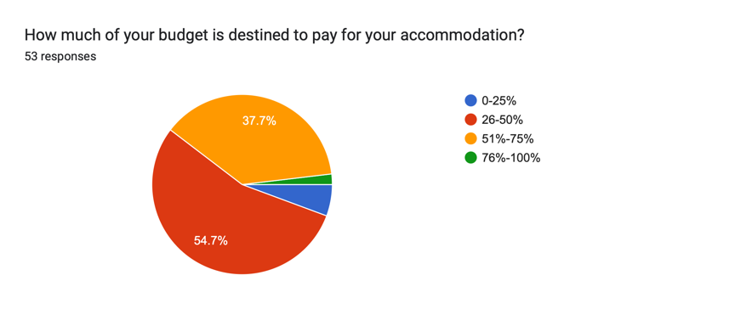
Figure 2 Proportion spent with Accommodation
Some authors such as (Dabrowski, et al., 2024) and (Schofield, 2024), gave emphasis on the hardship that international students face when moving to the UK, being directly affected by the cost of living. According to ST2 , the same happens in Ireland, noticing that 5 years ago she used to do groceries shopping with way less amount of money than she needs today, stating that “everything is way more expensive nowadays” (ST2). Complementary, to afford tuition fees and accommodation’s expenses, ST2 , when on holidays, needs to work in two jobs to afford such a cost, stating that “20 hours per week is not enough to survive in Ireland”(ST2). ST1 mentioned to share a house, but not the bedroom, given emphasis to a quiet place to study, focus and relax in her free time, influencing significantly her performance as a student. This factor is in accordance with the amount paid for accommodation, and cited by both students ST1 and ST2, who appoint a battement of condition of accommodation within the years, but for a premium price. This premium price should be earned with more hours at work, as stated by ST1 and ST2 confirming the secondary data (Chalmers & Waddoups, 2007), mentioning the decline in the commitment to studies (Schofield, 2024).
Complementary, (Lewis, 2024) mentioned the increase in the price of accommodation as a major factor that brings concerns and stress among international students. This factor is proved to happen in Ireland too, according to findings of the primary research with 52 out the 53 participants appointing the rent and food as their main expense. Another finding of this study was the fact that finding accommodation in Ireland is still a negative factor that impacts ISHE’s experience.
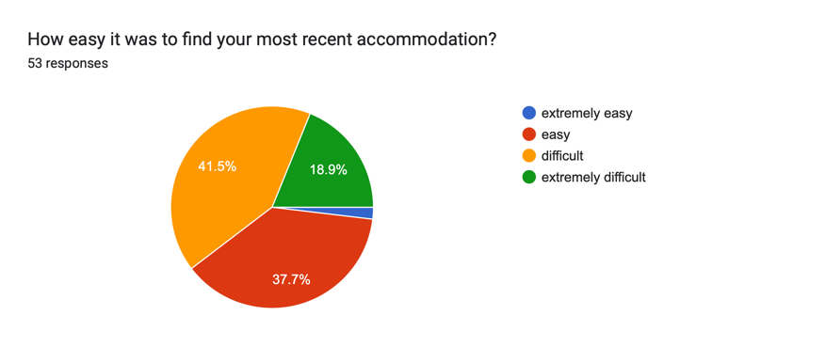
Figure 3 Difficulties to find accommodation
Some students alternatively have to work between two jobs. Based on the literature review and data from primary research, some improvements could be done towards ISHE experience in Ireland. Firstly, the amount of hours, as a student, could be amended to 35 hours weekly, complementary to the mandatory enrolment to a School or University already in place. Additionally, changes in legislation to provide further benefits to ISHE and national students to cope with increase in prices of accommodation could be implemented, such as increase in the amount of rental relief in an extension up until full subside of accommodation, respecting limits of reasonable amounts spent for higher education students, or incentives to mitigate excessive costs to obtain a 3 level degree. Some of these benefits could be recovered, after graduation, in the form of working days for the government to repay partially the incentives. Alternatively , government and educational institutes could adopt policies to reduce tuition fees to incentivise students to come and stay in Ireland for their higher education, attracting students to the country.

4.1.3 Theme 3 How does culture define an international student journey and influence their decisions?
Culture was selected as part of this study with the aim to prove difficulties that ISHE had with language barrier and culture shock when studying in Ireland. The results obtained with the sample demonstrated that the major challenge when ISHE moved to Ireland was indeed language barrier, or lack of English skills, corroborated by the managers in hospitality A1 and A2 point of view.
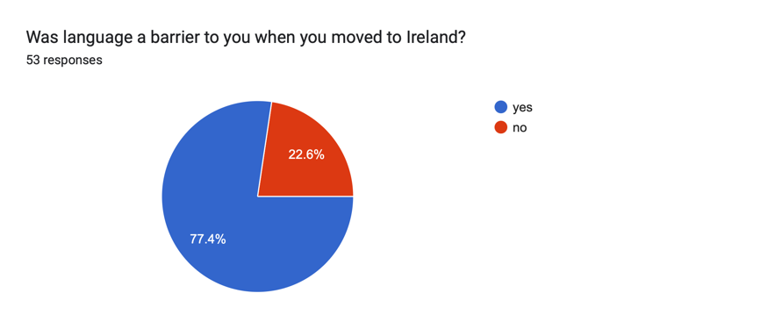
Figure 4 Language barrier
This information aligns with results obtained by secondary research brought by (Alam & Modh Angsor, 2024), finding this factor to also happen in USA and Canada, related to Asian international students. Complementarily, (Nicolescu & Galalae, 2013) brought the factor of culture shock as challenges faced by Romanians within the EU. The primary data found students managing to integrate with Irish culture, but only 11 felt very integrated.
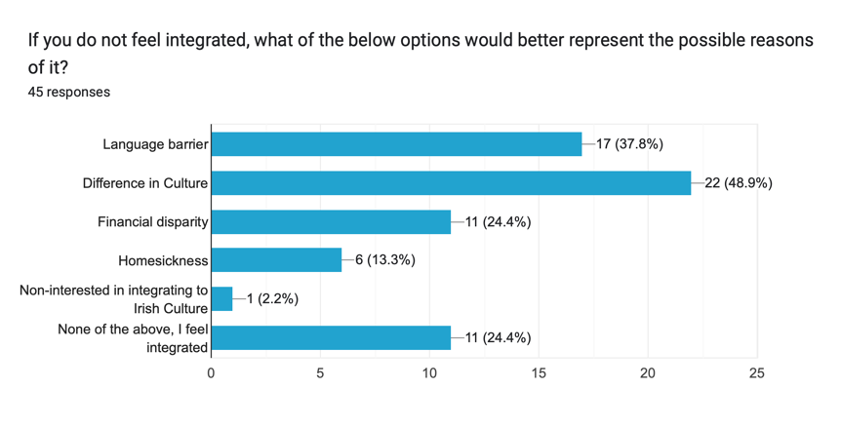
Figure 5 Integration with the culture
With another point of view, ST2 presents an argument that she attends Irish events whenever possible, not presenting challenges for her to integrate with Irish culture, different from ST1 that interacts more with Irish culture at work, not much in social events. Due to this divergence of opinions, the study suggests further complementary questions to understand the reasons for these findings and further studies about the theme. Additionally, further incentives to attend Irish events such a discount for ISHE could be implemented and other policies that aim social interaction could be implemented, spreading sense of belonging and integration of ISHE
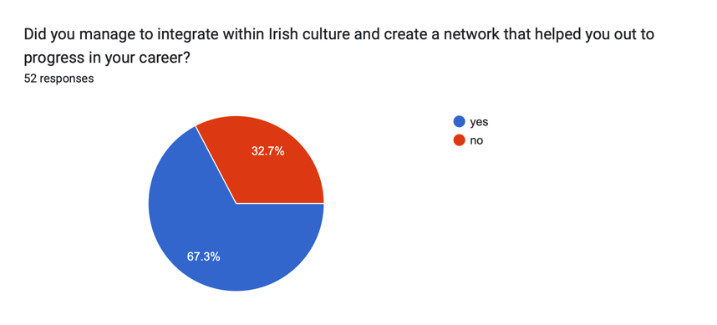
Figure 6 Network integration
(De Haas & Fokkema, 2011) stated that integration enhances a better experience in the host country and the longer the students stay in that country, the more likely it is for he/she to stay in that country. In this regard, the primary search showed deep interest in staying in Ireland after graduating.
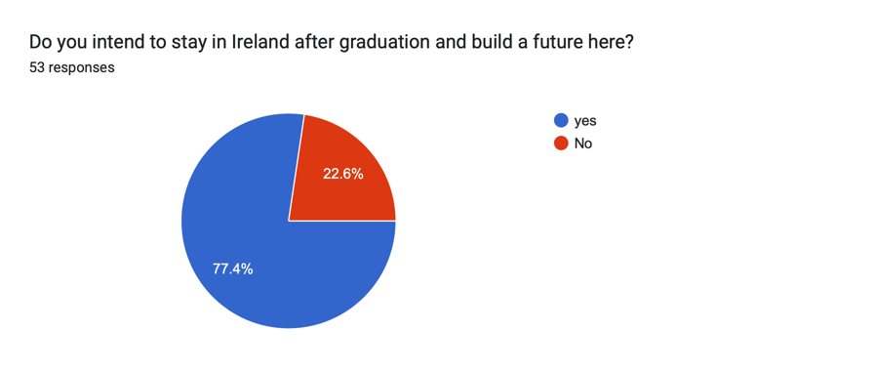
Figure 7 Intention to stay in Ireland after graduation
Complementing this data, ST1 and ST2 demonstrated interest to stay in Ireland to shift their career and enjoy the country “…I can enjoy properly everything that the country can offer us”. ST2. The complexity unveiled by this study relies on the fact that notwithstanding the desire of ISHE to stay in Ireland needs to be fulfilled but the legalities for them to stay should be provided.
With a different approach (Waxin, 2004) stated that international students who socialise and communicate better have a better experience when living abroad. After coding the data extracted from ST2, the interpretation of her interview suggested that over the past 5 years she has improved her language skills, interacted with Irish culture and intended to further integrate in Ireland, demonstrating that culture of the host country contributed to her decision to stay in Ireland. This interpretation of ST2 aligns with (Baum, et al., 2018) .
In this line, this study suggest improvements in legislation allowing ISHE to stay after graduation and advance their career while enhancing the country development through diversity, and also strongly recommending additional effort of the ISHE to integrate and learn the country language and its culture, in a sign of respect and good faith for the country they have chosen to live.

4.1.4 Theme 4: What are the considerations in an ISHE’ point of view when deciding to move, stay or leave a host country?
This study, aimed initially to relate the fact of Ireland as a Neutral political country and the fact of Ireland having a high minimum wage would attract international students to the country. The results, though, were adverse to the initial expectancy and the factor brought by (Rose-Redwood & Rose-Redwood, 2004), which discuss the movements of international students due political reasons in the USA. The majority, 71,7% of all 53 respondents said that they didn’t move into Ireland due political reasons. Additionally, 52,8 %, said that minimum wage did not impact their decision to move to Ireland., but is a factor to be considered to stay in the country after graduation, according to ST1 and ST2. (Glaeser, et al., 2000) pointed out that better wages would attract more human capital for a country. The results aligns with (Glaeser, et al., 2000) but represented slightly more than 50% of the sample, suggesting further investigation of the topic, additional questions of other potential reasons or the fact of never had tough about it before, expanding sample range to prove strongly the argument and furthermore, corroborate as conclusive factor.
This study advanced some factors unexplored as an attempt to understand the challenges of international students in Ireland. St1 and St2 were asked about homesickness and whether the weather would influence their decisions to stay or leave Ireland. Both students agreed that weather is irrelevant for their decisions to stay in the country, even though ST2 mentioned a discomfort, especially at winter time. In the same way, both ST1 and ST2 agreed that they miss their family, but eventually this feeling fades and with the help of Technology, video calls compensates partially the feeling of homesickness, allowing connectivity and real time conversation. Technology has been an ally to international students in this way, and has gained more relevance day by day, helping them to improve language skills, through AI systems to elaborate studies plans and build social digital networks. Those assumptions were based on St1 and ST2 interviews, but not found in current literature. In this regard, some additional studies may deeply analyse this theme and bring new insights to the ISHE’s experience.
Complementary, The government could request in the curricular grade of international students , in early stages or while studying in higher education to complete mandatory AI training, to incentivise studies in that field, due a market demand, but most importantly to make available techniques for betterments in the experience of ISHE in Ireland. In this regard, ISHE would be able to cope with modern challenges at the same time that Ireland would be aggreging value to its workforce enhancing a competitive advantage.
This project also aimed to identify the occurrence of support to ISHE in Ireland, and if existent, to exemplify and understand what are the actions and benefits from it. According to secondary research, authors such as (Stuen & Ramirez, 2018) tried to understand the relation of network and the lowering of hardship of International students in The USA, which is confirmed to happen in Ireland through the primary research findings, showing that the majority of the sample, 92,5%, 49 ISHE have support from someone in his/her network , which help them to overcome challenges and facilitate their experience as an international student and worker. In the same line (Kusumawardani, et al., 2024) believes that peer support helps international students while studying abroad.
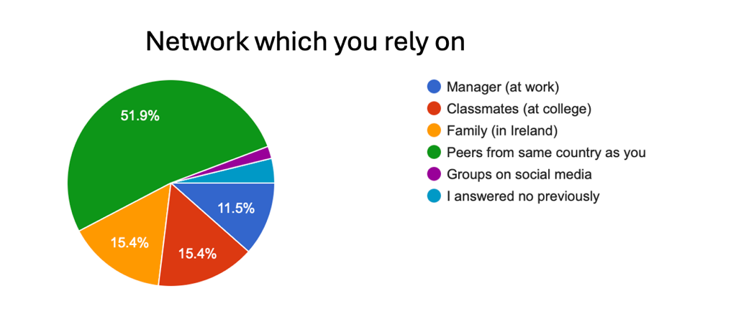
Figure 8 Peer support
Even though the majority of the sample was found to receive support, especially for peers from the same country as them, the primary data obtained with managers in hospitality showed that companies don’t support legalities or help the international students to obtain a visa in Ireland. Interviewee A1 affirmed vehemently “no documents, no job!”, in a similar way interviewee A2 stated “nowadays the company does not support visa grants”. Main reasons cited by both interviews were abuse of privileges in the past, fear to pay fees and fines due inconstancy documentation or inadequate terms and conditions of employment, generating extra cost for employers, which culminate in limitation of support with legal support, penalizing, therefore, students with additional burden regarding visa requirements while studying and working in Ireland. ST2, complementary, mentioned having her applications for the job denied twice for not holding EU passport or stamp 4 visa, which is frustrating, according to her. Below, some examples of what was collected online regarding this matter.
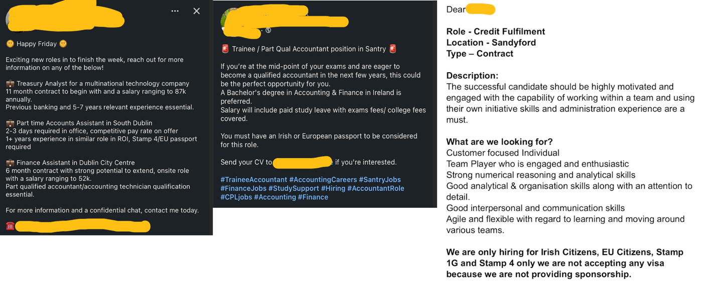
Figure 9 Examples of difficulties suffered by ISHE due to visa status
Authors such as (Sumption & Brindle, 2024) in the UK, (Crumley, 2024) in Canada and Australia, provide their concerns regarding stress caused due to visa requirement for international students, either for payment of expensive tuition fees or either for difficulties to get a legal visa to grant the rights to study and work in the foreign country. This was confirmed by the quantitative data gathered for this study, with 39 out of the 48 students experiencing difficulties to apply for a vacancy as an international student. This reflected the sense of concern and demotivation regarding ISHE experience and willingness to remain in Ireland.
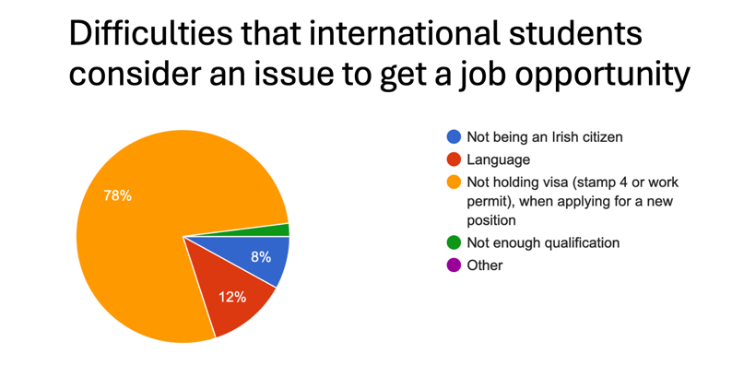
Figure 10 ISHE demotivation due visa status
Not limited to that, ISHE mentioned high levels of stress and incremental level of anxiety due visa concerns. Student ST1 found undervalued if compared to European citizens or stamp 4 holders stating that “ISHE should be treated as professionals, independent where they are from, and they should be given the same value as a European citizen! They should be treated as equal, even though I know it is not what happens in the market right now” ST1. International students, spending 2-year average studying English, attend higher education, for additional average 3-years, can request a 1G visa for additional year, to apply for a job in their area, and if not successful, they have to go back to their countries. In this line, some policies could be amended to extend this period for a further year, as it is for master program students, or creation of a department that enroll these students and help them to connect with employers and entry level vacancies. Countries such as Portugal, for example, are trying to attract young international students, offering a tax-regressive scheme for 10 years (The Guardian, 2024).

4.1.5 How financial planning may change the experience of international students in a host country and shape its future?
Adversely from initial expectations from this study, ISHE did not present major concerns about savings, budgeting expenses and incomes. The initial idea was to find the difficulties to save money due to the rise in cost of living and accommodation in Ireland. The primary data showed that 77,4% of the respondents, 41 ISHE, manage to save some money, after paying the main bills. ST1 and ST2, responded in the same way, confirming to use financial planning to manage their personal expenses and incomes, destinating, even as a little , some money to their saving account for a rainy day. This factor also aligns with the secondary research which associates the importance of education in personal finance to overcome challenges related to finance aspects for international students in Ireland . ST2 additionally mentioned the use of AI tools to help her to manage her budget. This study recommends the use of AI tools, subsidized by the government to enhance general understanding and use of tools to minimize related to financial planning and personal budgeting.
In this matter, (Sarigul, 2014) in Turkey, published a research that describes levels of finance knowledge and stresses the importance of finance knowledge and planning to international students to overcome challenges in their diverse experience in life, including overseas assignment. In agreement with this subject, (Rodrigues, 2022) stated that finance knowledge should be tough from the early stages of international assignment, to help to minimise hardship, and students’ level of stress and a more enjoyable experience. The interview with ST2 demonstrated that she acquired this skill since early stages of her life, propitiating a better understanding of finance, personal finance and being prepared for financial emergencies, or even planning for trivial transactions.
Another financial aspect was asked to ISHE, regarding bank loans to help them to pay tuition fees. The results were expected to show the majority of ISHE recurring to bank loans to subsidise their tuition fees. Although, the results showed that just slightly more than 50%, 54,7% relied on bank loans to pay for tuition fees. This data may point to the preparedness of the ISHE questioned, with high level of knowledge of savings and financial planning, or the absence of knowledge of this option or either the excess of rigorous criteria asked by the banks. Further studies should be carried on to unveil the reasons for these results, improving questions to obtain more detailed information.
According to (Department of Justice, 2025), from July onwards, International students with courses over 8 months should prove the amount of €7000 to enter and support themselves in Ireland. This study understood that this fact, in isolation, does not guarantee ISHE a secure assignment in the country, but adding courses of personal financial awareness to international students moving into Ireland as mandatory discipline, would ease and trigger betterments for ISHE’s experience in Ireland. This could protect the student and the country in an unexpected event of downturn in the global economy and it would better support international students than just stipulating a certain amount as a requirement. Without proper guidance, this amount could be spent quickly and inefficiently by ISHE.

Chapter 5: Conclusion
The research question was answered successfully under the 5 themes, regardless of some limitations mentioned below.

5.1 Limitations

5.1.1 Under theme 1
Sample size should have been wider regarding the number of managers in Hospitality, and other stakeholders such as Irish citizens could have been consulted regarding their opinion of ISHE in Ireland and then contrast with the literature review. Additionally, non-information was brought regarding the amount generated by ISHE in Ireland to demonstrate their importance for the Irish Economy.

5.1.2 Under theme 2
The result was extremely satisfactory but could be further improved if questions regarding age, range of income of the sample and average hours of work weekly could provide extra value to this study.

5.1.3 Under theme 3
To clarify the divergent opinion of ST1 and ST2, a more complex question should have been asked to investigate intrinsic reasons for not full integration with the Irish community, with wider sample size to help in the conclusion of this theme.

5.1.4 Under theme 4
Further questions related to financial rewards received for ISHE in Ireland and their possible impacts in their decisions to stay should have been asked, once the results showed the minimum wages were not a main factor that influenced the sample to move to Ireland. Additionally, this study could have asked, in the quantitative questionnaires about which actions ISHE are taking to expand and enhance their online network to overcome stress and pressure to advance their career and continuity in the country.

5.1.5 Under theme 5
Additional investigation about the sample background, about their profession field of studies, about the degree of knowledge of Financial planning and budgeting to endorse the results obtained should have been asked.

5.2 Main findings
ISHE are found to be financially aware on a certain level, propitiating understanding of financial planning and orientation to save money, even under rise in cost of living, as experienced by them in Ireland. The study evidenced the major concern with uncertainty of possibility of staying, rather than with accommodation, as in early stages of their studies in Ireland, revealing a sense of lack of support from Irish authorities. Although, this study concluded that ISHE’s main expenses are related with food and accommodation, being necessary for extra hours of work and decrease in academic performance due this factor, to be able to afford better accommodation where it is possible to concentrate and relax.
Furthermore, their importance as an asset for the Irish economy is still undermined, and has caused demotivation among ISHE, bringing precedent to leave the country and possibility of Ireland losing competitive advantage, if they do.
Complementary, this study proved that peer support is the main source of reliability among ISHE, helping this group to overcome challenges in a host country. On the contrary, managers in the hospitality sector revealed that companies are not supporting legalities for ISHE to obtain a work permit.
Furthermore, language barrier was appointed as the main barrier to integration and interaction within Irish culture. AI could help in this regard, advancing language learning and mitigation of homesickness.
Lastly, regarding Visa, this theme, represented the major dissatisfaction among students, appointed as the main source of stress and undoubtedly the factor that most contributes to students’ opinion to leave the country.

5.3 Recommendation table

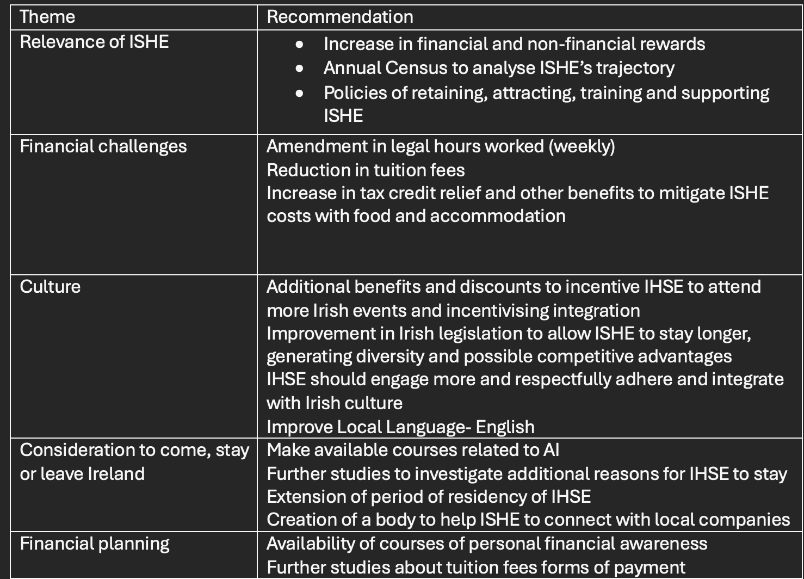
Table 3 Recommendations

Bibliography
Smith, A., 1904. OLL. [Online]
Available at: https://oll.libertyfund.org/titles/smith-an-inquiry-into-the-nature-and-causes-of-the-wealth-of-nations-cannan-ed-vol-1
[Accessed November 2024].
Glaeser, E. L., Kolko, J. & Saisz, A., 2000. Harvard Institute of Economic Rsearch. [Online]
Available at: https://scholar.harvard.edu/files/glaeser/files/consumer_city.pdf
[Accessed 12 Novembr 2024].
Koenings, F., Haussen, T., Toepfer, S. & Uebelmesser, S., 2020. Journal of Rgional Science Wiley. [Online]
Available at: https://onlinelibrary.wiley.com/doi/10.1111/jors.12511
[Accessed November 2024].
Rodrigues, R., 2022. Indedepndent College. [Online]
Available at: https://dspace.independentcolleges.ie/items/a3465d4f-3574-4996-afeb-f26bf5c630af
[Accessed 12 November 2024].
Stuen, E. T. & Ramirez, S., 2018. Wiley:The effects of social networks on the flow of international students. [Online]
Available at: https://web.p.ebscohost.com/ehost/viewarticle/render?data=dGJyMPPp44rp2%2fdV0%2bnjisfk5Ie45PFKrquySLak63nn5Kx95uXxjL6nr0evrq1KrqiyOLSwskq4q7U4zsOkjPDX7Ivf2fKB7eTnfLurt0q3rrZNr6aki%2bfau1C0qrBP46mvRbXctH2rquJL36O3SLGpq1Dk2bJM4qviS7GssVjw2%2bKB8Zzqeezdu33sn
[Accessed 12 November 2024].
Wang, Z. & O'Connell, P. J., 2020. The Economic and Social Review. [Online]
Available at: https://www.esr.ie/index.php/esr/article/view/1518
[Accessed 12 November 2024].
Khanal, J. & Gaulee, U., 2019. Ojed:Challenges of International Students from Pre- Departure to Post-Study: A Literature Review. [Online]
Available at: https://files.eric.ed.gov/fulltext/EJ1222429.pdf
[Accessed 15 November 2024].
Dabrowski, V., Atas, N., Ramsey, T. & Howarth, N., 2024. wiley: ‘Money anxiety’: Understanding HE students' experiences of the cost-of-living crisis. [Online]
Available at: https://onlinelibrary.wiley.com/doi/pdf/10.1111/spol.13048
[Accessed 12 November 2024].
Schofield, C., 2024. Routledge. [Online]
Available at: https://www.tandfonline.com/doi/epdf/10.1080/13596748.2024.2371643?needAccess=true
[Accessed 12 November 2024].
Lewis, A., 2024. Uk Parliament. [Online]
Available at: https://commonslibrary.parliament.uk/how-is-the-rising-cost-of-living-affecting-students/
[Accessed November 2024].
Chalmers, J. & Waddoups, C. J., 2007. Hilda Surveyv Research Conference at University of Melbourne: Is casual employment a bridge or a trap?. [Online]
Available at: https://melbourneinstitute.unimelb.edu.au/assets/documents/hilda-bibliography/hilda-conference-papers/2007/Waddoups,-Jeff_final-paper.pdf
[Accessed 19 November 2024].
De Haas, H. & Fokkema, T., 2011. Demographic Research: The effects of integration and transnational ties on international return migration intentions. [Online]
Available at: https://www.demographic-research.org/volumes/vol25/24/25-24.pdf
[Accessed 12 November 2024].
Nicolescu, L. & Galalae, C., 2013. Ebsco: A SYSTEMATIC LITERATURE REVIEW ON STUDENTS’ INTERNATIONAL MOBILITY AND CULTURAL ADJUSTMENT. [Online]
Available at: https://web.p.ebscohost.com/ehost/detail/detail?vid=0&sid=5f19531e-c1bd-4bb5-9397-adc74ea417d0%40redis&bdata=JkF1dGhUeXBlPXNoaWImc2l0ZT1laG9zdC1saXZl#AN=90507048&db=buh
[Accessed November 2024].
Waxin, M. F., 2004. Science Direct. [Online]
Available at: https://d1wqtxts1xzle7.cloudfront.net/67088898/j.ijintrel.2003.12.00620210505-31717-e9dobf-libre.pdf?1620212018=&response-content-disposition=inline%3B+filename%3DExpatriates_interaction_adjustment_the_d.pdf&Expires=1731969930&Signature=T7PwNlO~78kSuBKCQD
[Accessed November 2024].
Kusumawardani, N. A., Suharyanto, P. P. B. I. & Keguran, d. I. P. F., 2024. UMSL Library. [Online]
Available at: https://eprints.ums.ac.id/128564/1/JURNAL%20ARTIKEL%20%281%29.pdf
[Accessed 12 November 2024].
Alam, T. & Modh Angsor, M. A., 2024. Research in Management of Technology and Business:Language Barrier, Academic Stress and Cultural Differences Towards International Students’ Satisfaction. [Online]
Available at: https://penerbit.uthm.edu.my/periodicals/index.php/rmtb/article/view/15979
[Accessed 15 November 2024].
Sam, D. L. & Berry, J. W., 2010. Researchgate: Acculturation: When Individuals and Groups of Different Cultural Backgrounds Meet. [Online]
Available at: https://www.researchgate.net/publication/240286013_Acculturation_When_Individuals_and_Groups_of_Different_Cultural_Backgrounds_Meet
[Accessed 18 November 2024].
Baum, T., Hearns, N. & Devine, F., 2018. Research Gate: Place branding and the representation of people at work: Exploring issues of tourism imagery and migrant labour in the Republic of Ireland. [Online]
Available at: https://www.researchgate.net/publication/247479181_Place_branding_and_the_representation_of_people_at_work_Exploring_issues_of_tourism_imagery_and_migrant_labour_in_the_Republic_of_Ireland
[Accessed 12 November 2024].
Rose-Redwood, C. A. & Rose-Redwood, R., 2004. Journal of international students: ethinking the Politics of the International Student Experience in the Age of Trump. [Online]
Available at: https://www.researchgate.net/publication/317761559_Rethinking_the_Politics_of_the_International_Student_Experience_in_the_Age_of_Trump
[Accessed 15 November 2024].
Kouba, K., 2029. Journal of International Students:Balancing Study Abroad Student Inflows and Outflows: An Institutionalist Perspective. [Online]
Available at: https://www.researchgate.net/publication/332381831_Balancing_Study_Abroad_Student_Inflows_and_Outflows_An_Institutionalist_Perspective
[Accessed 16 November 2024].
Crumley, M., 2024. Journal of International Studentens. [Online]
Available at: https://files.eric.ed.gov/fulltext/EJ1416593.pdf
[Accessed 15 November 2024].
Euronews, 2024. Euronews: Which country is the most welcoming? It's all down to visas, according to this new index. [Online]
Available at: https://www.euronews.com/travel/2023/03/01/which-country-is-the-most-welcoming-its-all-down-to-visas-according-to-this-new-index
[Accessed 19 November 2024].
Sumption, M. & Brindle, B., 2024. The immigration Observatory: BRIEFING: Work visas and migrant workers in the UK. [Online]
Available at: https://migrationobservatory.ox.ac.uk/wp-content/uploads/2022/08/MigObs-Briefing-Work-visas-and-migrant-workers-in-the-UK-2024.pdf
[Accessed 19 November 2024].
Kritz, M. M., 2016. Journal of studies in International Education. [Online]
Available at: https://www.webofscience.com/wos/woscc/full-record/WOS:000373952600001
[Accessed 19 November 2024].
Jenny, S. E., 2017. Journal of Education Research. [Online]
Available at: https://www.academia.edu/39978107/UNIVERSITY_STUDENTS_PERCEIVED_AND_EXPERIENCED_CHALLENGES_AND_BENEFITS_TO_STUDYING_ABROAD_GENDER_CLASS_YEAR_AND_LENGTH_OF_EXPERIENCE_COMPARISONS?email_work_card=view-paper
[Accessed 15 November 2024].
Morris, A. et al., 2023. Routlege:International students struggling in the private rental sector in Australia prior to and during the pandemic. [Online]
Available at: https://research.ebsco.com/c/e5psid/viewer/pdf/idvgygmmcb
[Accessed 15 November 2024].
Forbes, M. H. et al., 2007. Monash University of Business and Economics: Australian University International Student Finances. [Online]
Available at: https://www.researchgate.net/profile/Gaby-Ramia/publication/32036113_Australian_University_International_Student_Finances/links/0fcfd509723a593028000000/Australian-University-International-Student-Finances.pdf?origin=journalDetail&_tp=eyJwYWdlIjoiam91cm5h
[Accessed 19 November 2024].
Sarigul, H., 2014. The Journal of Accounting and Finance: Survey of Financial Literacy Among University Students. [Online]
Available at: https://dergipark.org.tr/tr/download/article-file/427561
[Accessed 16 November 2024].
Kritz, M. M., 2016. Journal Of Studies In international Education:Why Do Countries Differ in Their Rates of Outbound Student Mobility?. [Online]
Available at: https://www.webofscience.com/wos/woscc/full-record/WOS:000373952600001
[Accessed 19 November 2024].
Cheung, C. K. A. & Xu, L., 2015. Eric: To Return or Not to Return: Examining the Return Intentions of Mainland Chinese Students Studying at Elite Universities in the United States. [Online]
Available at: https://eric.ed.gov/?id=EJ1074224
[Accessed 12 November 2024].
Reiner, C., 2010. Wiley. [Online]
Available at: https://onlinelibrary.wiley.com/doi/abs/10.1111/j.1435-5957.2010.00298.x
[Accessed 12 November 2024].
Hanushek, E. A. & Woessmann, L., 2015. The Knowledge Capital of Nations : Education and the Economics of Growth. [Online]
Available at: https://web.p.ebscohost.com/ehost/ebookviewer/ebook/bmxlYmtfXzk4MDc0N19fQU41?sid=d69fdb94-1665-44a8-9d52-723f5ea9e605@redis&vid=0&format=EB&rid=1
[Accessed 12 November 2024].
Polek, E. & Van Oudenhoven, J. M. F. ,. t. B., 2004. International Journal of Psichology: Attachment styles and demographic factors as predictors of sociocultural and psychological adjustment of Eastern European immigrants in the Netherlands. [Online]
Available at: https://onlinelibrary.wiley.com/doi/10.1080/00207590701484835
[Accessed 18 November 2024].
Chalmers, J. & Waddoups, C. J., 2007. HILDA survey research conference at University of Melbourne: Its casual employment a bridge or a trap?. [Online]
Available at: https://melbourneinstitute.unimelb.edu.au/assets/documents/hilda-bibliography/hilda-conference-papers/2007/Waddoups,-Jeff_final-paper.pdf
[Accessed 19 November 2024].
Sumption, M. & Brindle, B., 2024. The Migration Observatory : Briefing: Work visa and migrant workers in the UK. [Online]
Available at: https://migrationobservatory.ox.ac.uk/wp-content/uploads/2022/08/MigObs-Briefing-Work-visas-and-migrant-workers-in-the-UK-2024.pdf
[Accessed 19 November 2024].
Nikolopoulou, K., 2023. Scribbr: What Is Convenience Sampling? | Definition & Examples. [Online]
Available at: https://www.scribbr.com/methodology/convenience-sampling/
[Accessed 23 March 2025].
Calculator.net, 2025. Calculator.net. [Online]
Available at: https://www.calculator.net/sample-size-calculator.html
[Accessed 23 March 2025].
ICEF, 2025. ICEF Monitor. [Online]
Available at: https://monitor.icef.com/2025/01/irish-higher-education-booked-another-strong-year-of-foreign-enrolment-growth-in-2024/#:~:text=The%20number%20of%20international%20students,increase%20over%20the%20previous%20year
[Accessed 23 March 2025].
Depatment of Justice, 2025. Department of Justice. [Online]
Available at: https://www.irishimmigration.ie/coming-to-study-in-ireland/frequently-asked-questions-for-students/
[Accessed 1 April 2025].
The Guardian, 2024. The Guardian. [Online]
Available at: https://www.theguardian.com/world/2024/oct/10/portugal-proposes-decade-of-tax-breaks-for-the-young-to-stem-brain-drain
[Accessed 8 April 2025].
Department of Justice, 2025. Department of Justice. [Online]
Available at: https://www.irishimmigration.ie/coming-to-study-in-ireland/what-are-my-study-options/a-fee-paying-private-primary-or-secondary-school/information-on-student-finances/
[Accessed 8 April 2025].

