Applied Project
Submission Form


LEARNER NUMBER | 51728982
NAME | Roberta Marcondes Alves da Silva
COURSE | BA(Hons) Marketing
REPORT TITLE | The impact of visual Merchandising on consumer behaviour- Why a good visual merchandising strategy is crucial to invite the customer to buy and create branding.
SUPERVISOR NAME | Dr. Daniel O’Sullivan
WORD COUNT | 9100
DUE DATE | 12/05/2025
DATE SUBMITTED | 12/05/2025

I certify that:
- This project report is all my own work, and no part of this report has been copied from another source: Yes ☒ No ☐
- I understand that this report may be checked by electronic or other means for plagiarism and/or content created by generative AI and may be transferred and stored in a database for the purposes of data-matching/data-analysis to help detect plagiarism and/or content created by generative AI: Yes ☒ No ☐
- This report has not previously been submitted in part or in full for assessment to any other institution: Yes ☒ No ☐
- I consent to the inclusion of my report in the publicly accessible (open access) electronic database maintained by the library:
Yes ☒ No☐
- I have emailed a back-up copy of this report to locker@independentcollege.ie:
Yes ☒ No ☐

(Note that if no check boxes are selected, this Project will be regarded as NOT properly submitted, and may be subject to a late submission penalty)

Name: Roberta Marcondes Alves da Silva
Date: 12/05/2025

For the report to count as a valid submission, the student must provide:
1 electronic copy via Moodle. There is no requirement for a hard copy.

Evidence of Primary Research MUST be included in the appendix of the report. That includes a copy of questionnaires, interview schedules, or observation diaries. One interview transcript should be included as a full transcript and a summary of all other interviews must be kept as a backup by the student. See the template on Moodle for what should be included in all aspects of the report. All data must be anonymized.

The text should be double-spaced throughout and single column format (A4) with 2cm for left and right-hand margins and 2.5cm at head and foot. Text should be justified, standard 12 point, footnotes 10 point, and in Calibri. Page numbers should be at the bottom right. Do not use line and paragraph spacing. Keep formatting to a minimum and avoid underlining.

Harvard Referencing shall apply.

(Insert work here)

The impact of visual Merchandising on consumer behaviour- Why a good visual merchandising strategy is crucial to invite the customer to buy and create branding.

Compiled by
Roberta Marcondes Alves da Silva

This project is submitted in part fulfilment of the Degree in of Bachelor of Art (Honours) in Marketing.

Independent College, Dublin
April 2025

ABSTRACT

All major fashion retailers are experiencing rising market saturation while E-commerce introduces new challenges due to the changing consumer behaviour.
This research explores why visual merchandising is a powerful tool to establish and maintain brand consistency, attract new customers and create competitive advantage. The study applied ad-hoc structure for its explanatory purpose, even though it was structured according to the college rules. The research employed quantitative surveys and qualitative interviews with professionals. The study applied convenient sampling to gather data from 40 participants and 2 visual merchandisers professionals.
This research showed that visual merchandising plays a crucial role in enhancing brand and differentiation when dealing with marketplace saturation. The strategies used in visual merchandising do impact customer purchase behaviour, it is a key element to overall maximizing sales and should be used together with other fundamental decision-making factors.

Keywords: Visual Merchandising, Retail, Fashion, Store, Layout, Display, Purchase, Decisions, Sales, Strategy, Storytelling, Window

Table of Contents
1.INTRODUCTION_______________________________________________________
  - Objective of Study Pg 8
  - Aims and Objectives Pg 8
  - Purpose of the Study Pg 10
  - Significance of the Study Pg 10
  - Limitations Pg 10

2.LITERATURE REVIEW___________________________________________________
  - What is the role of Visual Merchandising in retail and its benefits? Pg 11
  - Which are the elements of visual merchandising and why they are relevant? Pg 13
2.2.3 Store exterior Pg 14
2.2.4 Interior display Pg 14
2.2.5 Store Interior Pg 20
2.3 How the psychology of visual merchandising affects consumer emotion, behaviour and purchase decision? Pg 20
2.4 What is the role of Visual Merchandising on brand image? Pg 21
2.4.1 The influence of visual merchandising in brand’s image? Pg 22
2.5 Online Visual Merchandising (OVM) is applicable? Pg 23
3. METHODOLOGY_____________________________________________________________
3.1 Research Method Pg 24
3.2 Research Approach Pg 24
3.3 Data Collection Method Pg 24
3.4 Sampling Pg 25
3.5 Research Process Pg 25
3.6 Data Analysis Pg 25
4. FINDINGS____________________________________________________________
4.1 Introduction Pg 26
4.2 Data Analysis Pg 26
  - Empirical Findings Pg 26
4.3.1. The role of Visual Merchandising in retail and its benefits Pg 27
4.3.2. Elements of visual merchandising Pg 28
4.3.3 The psychology of visual merchandising and consumer emotion- consumer behaviour Pg 29
4.3.4. Visual Merchandising and Brand image Pg 32
4.3.5 E-Commerce and Visual Merchandising (OVM) The rise of e-commerce Pg 33

5.CONCLUSION, RECOMMENDATION AND REFLECTION__________________________
5.1 Conclusion Pg 35
5.2 Recommendation Pg 36
5.3 Reflection Pg 36
REFERENCES____________________________________________________________Pg 37
APPENDICES _ ___________________________________________________________Pg 40

LIST OF FIGURES, PICTURES, TABLES AND CODES
Figure 1 - Bitner, M.J. (1992) ‘Servicescapes’ Model Pg 12
Figure 2 - Visual Merchandising Communication Process Pg 15
Figure 3 – Brown Thomas store layout Pg 19
Figure 4 - Visual merchandising displays’ effect on consumers Pg 20
Figure 5 - Sample Questionnaire question 1, pie chart Pg 27
Figure 6 - Sample Questionnaire question 2, bar chart Pg 28
Figure 7 - Sample Questionnaire question 3, bar chart Pg 30
Figure 8 - Sample Questionnaire question 4, column chart Pg 30
Figure 9 - Sample Questionnaire question 5, column chart Pg 30
Figure 10 - Sample Questionnaire question 6, column chart Pg 31
Figure 11 - Sample Questionnaire question 7, column chart Pg 31
Figure 12 - Sample Questionnaire question 8, column chart Pg 32
Figure 13 - Sample Questionnaire question 9, column chart Pg 33
Figure 14 - Sample Questionnaire question 10, column chart Pg 34
Figure 15 - Sample Questionnaire question 11, column chart Pg 34
Figure 16 - Sample Questionnaire question 12, column chart Pg 34
Figure 17 - Sample Questionnaire question 1, column chart Pg 48
Figure 18 - Sample Questionnaire question 1, column chart Pg 48
Figure 19 - Sample Questionnaire question 1, column chart Pg 49
Figure 20 - Sample Questionnaire question 1, column chart Pg 49
Picture 1 - BROWN THOMAS, Grafton Street, Dublin, Ireland Window Pg 13
Picture 2 - BROWN THOMAS, Grafton Street, Dublin, Ireland Window Pg 13
Table 1 - Codes Pg 8
Table 2 –VM #1 Interview Theme 1 Pg 26
Table 3 - VM #1 Interview Theme 2 Pg 31
Table 4 - VM #1 Interview Theme 3 Pg 29
Table 5 - VM #1 Interview Theme 4 Pg 32
Table 6 - VM #1 Interview Theme 5 Online Pg 33
Table 7 - Interview Schedule Pg 60
Table 8 – Parts of Interview #1 Pg 62
Table 9 - Parts of Interview #2 Pg 62
Table 10 - Literature Review Table Question 1 Pg 63
Table 11 - Literature Review Table Question 2 Pg 63
Table 12 - Literature Review Table Question 3 Pg 64
Table 14 - Literature Review Table Question 4 Pg 64
Table 15 - Literature Review Table Question 5 Pg 65

LIST OF APPENDICE ___________________________________________________________Pg 40
Appendix 1: Informed Letter of Consent Plain Language Statement Pg 41
Appendix 2: Ethical Form A Pg 45
Appendix 3: Questionnaire transcript Pg 46
Appendix 4: Sample Questionnaire Pg 48
Appendix 5: Interview Schedule Pg 53
Apendix 6: Questionaire Interview Pg 53
Appendix 7: Interview Transcription Pg 55
Apendix 8: Literature Review Table Pg 63

Table of VMs interviewed
Code |  | Position |  | Setting | Experience
VM #1 |  | Head of Fashion Portobello Institute Dublin and Retail Trainer/Leading Global Retail Companies such as Sacks 5th Avenue |  | Portobello Institute | 30 years +
VM #2 |  | Retail Visual Display Lecturer- Portobello Institute/Fashion stylist Brown Thomas |  | Portobello Institute | 20 years +
Table 1

CHAPTER 1
Why a good visual merchandising strategy is crucial to invite the customer to buy and create branding: The impact of visual Merchandising on consumer behaviour
1.INTRODUCTION
This project is called “The impact of visual Merchandising on consumer behaviour- Why a good visual merchandising strategy is crucial to invite the customer to buy and create branding.” This paper focuses on the fashion industry and explores visual merchandising strategies which helps businesses establish visual consistency while attracting new customers through distinctive brand positioning.
This study objective focuses on exploring both current theoretical visual merchandising knowledge alongside contemporary information about branding, consumer behaviour, e-commerce and market competition in today’s fashion industry. The research findings will lead to conclusion regarding VM’s relationship with brand image, consumer purchase behaviour and competitive market benefits. Both desk and field research were conducted, through surveys and interviews with professionals of the field.
1.1 Objective of the Study - Research Question
This paper investigates brand image consistency through an analytical framework. This theme holds merit because current fashion consumers have the biggest selection of brands in history. Brands require clear distinctive personalities that establish their uniqueness in the marketplace. Visual Merchandising functions as a tool for fashion brands to develop brand recognition and penetrate targeted market segments. This paper explores how physical store interactions remain essential despite the growth of online shopping.
1.2 Aims and Objectives
The aim of this research is to validate the research questions by proving how visual merchandising an important tool is, to attract customers and build brand image.
1. What is the role of visual merchandising and its benefits
2. Understand which are the elements of visual merchandising
3. How the psychology used in visual merchandising affect consumer emotion, behaviour and purchase decision
4. What is the role of visual merchandising on brand image
5. Online Visual Merchandising

1.3 Purpose of the Study
This project has the purpose to serve as the final project for the completion of a degree in Marketing. Due to the proximity of the researcher in visual merchandising and sales field that creates a desire to explore the theme and go further into the literature knowledge of strategies and the psychology in visual merchandising.

1.4 Significance of the Study
This research aims to understand the relationship between visual merchandising and consumer buying behaviour and determine the significance of visual merchandising for building and keeping brand identity. This research focused exclusively on the fashion industry (big department stores, small retailers, luxury boutiques). It could be beneficial for marketing students to understand how visual merchandising is important, all the psychology involved in the theme, and how the theme could be more explored in marketing degrees.
1.5 Limitations
Visual merchandising holds limited visibility as an academic subject which leads to insufficient online availability of relevant materials among researchers, even though the subject has been explored since 1981. It was a little bit difficult to find professionals that were available to do the interviews, however I am very grateful to the ladies who helped me accept and answer the questions related to the project. The amount of people that answered the survey was limited and would be better to have more questions to understand better why people were neutral is some questions. Also, more questions related to brand equity, how companies can use visual merchandising to attract customers, engagement and loyalty.

CHAPTER 2
2. LITERATURE REVIEW
2.1 What is the role of Visual Merchandising in retail and its benefits?
Introduced by Booms & Bitner (1992), the Servicescape Model highlights how the impact of the physical environment can define consumer experiences. Components such as layout, signage, and displays promote sensory and emotional responses. When these factors align, consumers perceive higher value, which enhances brand loyalty. The service environment is the first aspect of service that the customer creates their impressions of the company and how they are going to be treated. For example, an elegant store using soft lighting, accurate displays, and luxurious textures communicates exclusivity and quality, is connected to emotions and brings luxury and indulgence.
Visual merchandising is a marketing-based terminology which presents some of the most critical forms of marketing tools and which at the same time refers to the most direct method of promoting a product. Any company, shop or brand promotional signatures of any form that a buyer can sight while shopping includes billboards, banners, posters, panaflexes, buntings, placards, pamphlets, shop boards, shelf markers, and handbills. Visual merchandising also involves the layout of the stores including the shelving and sections, the atmosphere the stores possess and the brands.
Visual merchandising combines artistic techniques with scientific approach to boost visual appeal and brand presence, to strengthen brand identity, guiding buying behaviour through aesthetically pleasing displays for an exciting experience. Experts confirm that visual merchandising involves more than just attractive visual presentation since it generates multi-sensory brand messages that influence customers to buy.
Louis Cheskin (1951) pioneer of marketing psychology, established that customer perceptions deeply respond to visual signs such as colours, lighting and layout elements. According to his theory, sensation transfer, says that visual merchandising is crucial to perceive quality and create emotional connections, since the customer can transfer their emotions from products displays.
Robin Mathew (2008, p. 48) provides a definitive understanding of visual merchandising through his description “The stage, the oomph and sparkle that surrounds a store and makes the customer stop, look, and buy what has been placed together with care and presented skills.” Visual merchandising’s strategic elements merge with creative techniques to drive consumer behaviour changes during the shopping process. According to colour psychology expert Karen Haller (2019) visual merchandising works because “colour triggers emotional responses” therefore helping businesses to create emotional mood, building trust and driving urgency.
Storytelling is a powerful tool and through visual merchandising builds an emotional connection by aligning with customers values and desires. Displays that portray a lifestyle or narrative can bring feelings of aspiration and identity, motivating consumers to purchase products associated with that story. We can easily see this on the Brown Thomas holidays windows, they always create the most beautiful and impactful storytelling through the clothes, shoes and bags. And lots of people go there just to take pictures and be part of the fantasy. For Madhavaram and Hunt (2008) displays it is not just about aesthetics but should show values and history of the brand. Through storytelling, brands can build a strong emotional relation with their customer, fostering loyalty, broadens the experiences of consumers, enhances their experiences, and is sales-boosting for the brand.
The online purchases are increasing every day, so now, more than ever, making physical stores appealing to customers is crucial for the business. Liu, Y., Li, H. and Hu, F. (2013) suggests that the visual aspect of an online store has a positive effect on customer’s normative evaluation and immediate fulfilment. Furthermore, Thomas, T., Joseph, J. and Thomas, A., (2018), highlighted that the product presentation in an online store, impacts purchase intentions of the consumer which can be considered as an outcome of approach-avoidance behaviour. Kim, J. and Lennon, S.J. (2009) suggests that effective visual presentation creates a positive emotion and ultimately increases positive buying response. For Eroglu, S.A., Machleit, K.A. and Davis, L.M. (2003) the layout and graphics of a website has a positive influence on the behavioural outcome of a customer, so as we can conclude the layout affects how customers approach or avoid a web store.
In summary, visual merchandising is essential to online stores, that is the first thing that the consumer is going to face, and make the person stay in the site or not, make a purchase or not.
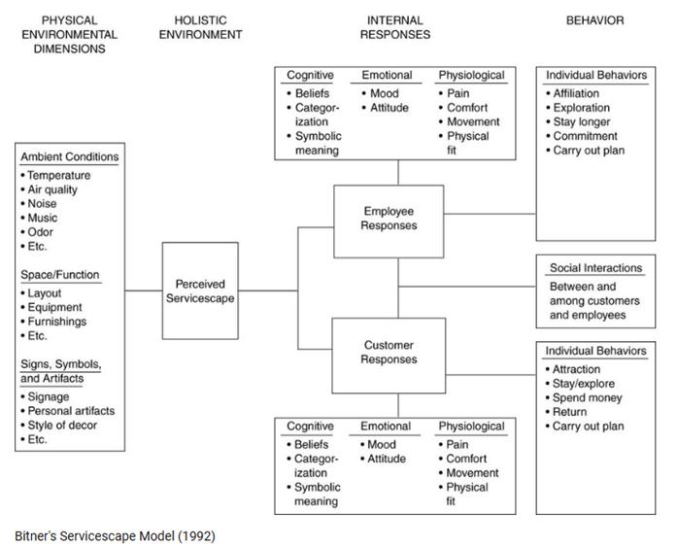
Figure 1- Bitner, M.J. (1992) ‘Servicescapes: the impact of physical surroundings on customers and employees’, Journal of Marketing, 56(2), pp. 57–71.

2.2 Elements of Visual Merchandising
Visual merchandising is a strategic tool to create attractive retail environments, using sensory elements and design principles. Dash and Akshaya (2016) to create appealing displays, using a variety of elements such as colours, fixtures, mannequins, fabrics, furniture, wall decoration, lighting and music, are necessary.
Visual merchandising becomes successful by applying fundamental design principles which creates a better shopping experience for the customer in these ways: balanced proportions, product emphasis and focal point. A cohesive visual presentation should bring out brand identity by using all the elements quoted above. The use of fixtures including furniture such as tables and shelves allows an effective organized display. A combination of appropriate colours and textures help to create a specific emotion and desire while maintaining visual balance.
Additional items such as props and accessories can create thematic displays to support storytelling as we can see in pictures 2 and 3, both windows created by Ton Der Veer. In Ireland, Brown Thomas, is known for creating appealing windows with amazing and strong storytelling.
The visual merchandising elements will be deeply explored in the following research.

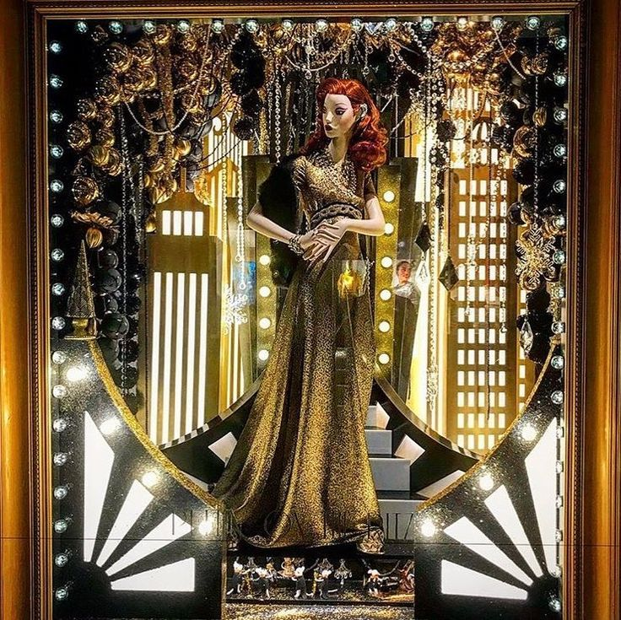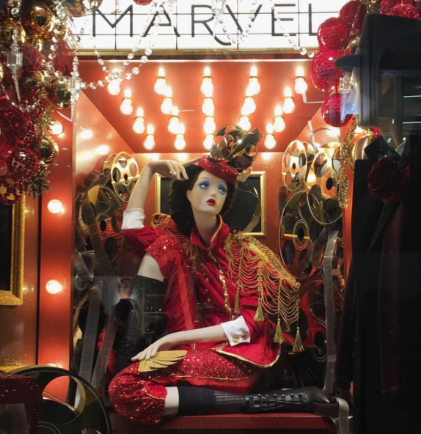
Pictures 1 and 2 by Eamonn McGill: Put On The Ritz - It's Showtime BROWN THOMAS, Grafton Street, Dublin, Ireland, Picture 2 “The Ticket Booth Girl” BROWN THOMAS, Dublin, Ireland, available at: https://ie.pinterest.com/vanderveerton/ Accessed on 05/05/2025

2.2.3 Exterior
Window
One of the first points of contact between the retailer and potential consumers is the exterior of the store. To attract foot traffic and communicate the brand’s identity, the design elements like window displays, lighting, façade materials and signage are used.
A carefully designed window creates curiosity and will attract customers however a neglected exterior maintenance can push away potential visitors and consequently buyers. As Eddie Miles highlights in his book “A store planner’s handbook” (2011), the exterior design performs dual functions which safeguards the interior from external elements while expressing brand identity along with its product information to potential shoppers.
Marquees
Architecture defines marquee as an extended awnings that shield the entrances from external elements, having two main purposes, customers security and convenience. Usually, small stores have only one entry, while large department stores and boutiques have multiple entrances. The store's colours and texture create long lasting memories and customers will typically observe store exterior elements as the primary visual experience before any other interaction. The exterior should be pleasant, having a proper selection of colours and materials. Materials like brick, rough-sawn wood creates a positive aesthetic, steel brings the impression of strength while glass leads to a modern perception, brick and with concrete materials give the impression of low cost and inexpensive value.
Entrance
The first significant customers’ impression starts from the moment they enter a store. The entrance has multiple purposes, such as security, shielding from any exterior element and welcoming guests. A store entrance needs to carry an appealing individuality and sends a welcoming message, having an easy entry and match the store design.
Signs
The signs are used to communicate business nature, promote the brand, establish the brand identity and build brand awareness through logos. Any exterior artwork installed on the building must follow design principles while being attractive for customers and harmoniously blend with existing architectural elements.
2.2.4 Interior Displays have an important role in a store, their prime position has a direct influence in sales production, that’s why displays must be attractive to help sell goods, poor display design choices can destroy visual spaces and bring an unpleasant atmosphere.
Visual merchandising display is supposed to create the finest presentation of the merchandise. In Apparel Merchandising, Robin Mathew (Mathew 2008, p 48) “Display is the glamour, the spark, the stage, the oomph and sparkle that surrounds a store and makes the consumer stop, look, and buy what has been placed together with care and presented with skill. These displays are also known as feature areas.
Displays implement creative methods to facilitate time efficiency for salespeople and customers through an effortless shopping experience. According to Bhalla & Anuraag (2010) visual merchandising displays acts as the “silent salesperson” which delivers visual information while offering selling suggestions to increase customer purchase. Retailers establish significant communication with customers through their visual merchandising store displays. Retailers conduct this communication to customers using their store space, décor, layout arrangement, atmosphere and promotional displays, as shown in Picture 3.

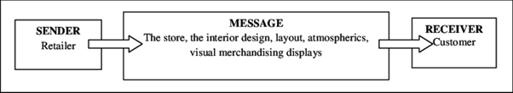
Figure 2: Visual Merchandising Communication Process Source: Adapted from Bell, J. & Ternus, K (2006). Silent selling. 3rd ed., New York: Fairchild Publications, p. 21
Multiple fundamental rules determine the effectiveness of the displays:
Balance: when constructing displays, customers should experience equilibrium through the layout, a symmetric arrangement helps to find this balance, and this balance can be formal or informal. An equal distance between similar items and the display centre brings a formal balance, while placing products with different sizes away from the centre, based on their relative size.
Dominance: the idea is to create a focal point, using a central element to attract viewer’s attention to develop engagement with key products. Display with a strong focal point leads to quick and clear communication, increasing its effectiveness to influence consumer purchase behaviour.
Eye movement: the display layout should lead customer’s eyes smoothly away from focal points while organizing eye movements through a purposeful sequence rather than randomly shifting across the space. A disorganized/random eye movement throughout the display causes customers to overlook important merchandising and can miss important information.
Gradation: the gradation means how items should be organized one after another. The display presentation starts with small items located at the front while medium items follow further back and large items remain in the rear section; this pattern creates harmony and appealing illusion.
Height of the merchandising: the natural human tendency is to face in a direct line ahead, so merchandise should be displayed at eye level to receive maximum visibility. Products that generate stronger impacts should be displayed at this level.
Grouping merchandising: this practice is common for retailers, for example a single line with items one after another, largely used in shoes, jewellery or mass retailers. Shops that have many identical products or one line of goods usually build long displays, which can create difficulty for the customer to pick the goods. To help consumers navigate their selection effortlessly, retailers must group product displays in a way that diverts eye movement from groups to maintain focus on specific items.
Appeal: an overwhelming number of items displayed together can create confusion in the shopping experience while creating feelings of chaos.
Colours
Colours have a psychological effect on the human brain since they affect peoples’ emotions, that’s why is considered a critical element of the visual merchandising, and when selected properly can attract customers, influence purchase decisions, enhance shopping experience and drive sales. The visual balance is necessary, and colours play a significant part of this equilibrium. This balance impacts how customers feel and perceive brands that understand colours are a valuable visual merchandising tool.
Karen Haller, observes in her book The little book of colours, investigates how colours shape both emotional response and behavioural responses. She quotes in her book: “colours create distinct emotional reactions because blue generates calm feelings and red excitement.” Social and psychological foundations create these colours meanings
Mannequins
Gaynor Lea-Greenwood (2012) says that mannequins are “The silent brand ambassador”, playing a valuable role for visual merchandising because they instantly communicate the store’s identity target market while offering products and information for the customer to make a choice if the fashion goods are going to suit them. Lea-Greenwood recognizes different types of mannequins, each one with a particular function.
Realistic mannequins: realistic mannequins build emotional bonds with customers, whereas abstract shapes attract a more modern type of shoppers. Mannequins usually match the store’s customer base by ethnicity and demographic while expressing lifestyle choices to deliver an image that people can identify with.
Semi-realistic mannequins: maintain realistic proportions but simplify facial details to highlight the product rather than the figure itself.
Abstract mannequins: with the idea to highlight only the product, this type of mannequins is used to create a contemporary and avant-garde aesthetic.
The strategic selection of mannequins impacts customer perception of both brand and products.
Lightning
The correct choice of lighting is essential for the store design; the human eye naturally gravitates towards the most illuminated area of the store. That’s why the lightning system should create illumination that enhances visible objects while creating reflective effects. According to Kerfoot, S., Davies, B. and Ward, P., (2003) there are 3 main types of lighting: primary lighting provides general store illumination; accent light emphasizes specific areas and atmosphere light that creates defined lighting without shadows.
According to research led by Kerfoot, Davies and Ward, respondents described lightning as a positive experience that makes displays appear inviting while creating feelings of private intimacy and uniqueness, making the customer feel special. Perceptions were negative when the respondents found the lighting basic or dull, and in this case, the displays sent a message of “coldness”, “uninviting”. (Kerfoot, S., Davies, B.J. and Ward, P., 2003) Running a store without a proper visual merchandising consideration, presents a real possibility of losing potential buyers.
Shelving + Planograms
Usually when entering a store, they often believe that store merchandise displays are randomly placed, decorated for visual appeal. However, there is a scientific process with a powerful impact which drives how consumers behave and how sales perform. And understanding shelf space planning techniques leads to increased store revenue.
There is a retail term called “Shelf Prime Real Estate”, which refers to shelves that are accessible to the customer, at the eye level, usually between 4 to 5.5 feet from the ground. The prime shelf real state can either be a single shelf located at eye level, or it can include an entire designated compartment. Products displayed in this area experience higher sales because of the visibility, that's why retailers strategically place their best-selling products there.
Promotional displays must be filled with merchandise, independently of the space of size, the main point is to make sure the customer will touch the product, that they can purchase from that area. Using matching products in windows for promotional displays that correspond with the prime shelf real state show a smart and straightforward path to purchase strategy. The material used for the shelves must match the image of the brand and design store, because every material passes a specific idea. Also, retailers use another two strategies for shelving:
1.Impulse purchase: placing small low-cost items near to the checkout area or paths leading to checkout stations trigger impulse purchases.
2. The Power of three: consumers naturally feel attracted toward three-group of items, does not matter if it is similar or complementary products.
The retail industry follows the rule of two distinctive areas: hot and cold. The area that has a bigger customer flow is the hot area, and the retailers must recognize this area in the store, so they can strategically display the merchandise. The first point of customer's interest is the hot zone, usually that is the place they are going to explore in the first place.
Planograms are used as a guideline to show how the products should be displayed to maximize sales and improve customer satisfaction. Well positioned products prevent crowded shelves and highlight essential merchandise. Grouping the products creates easier navigation for customers throughout similar products categories and boosting sales via cross-selling. Since planograms uses data analysis and customer behaviour, they can be updated regularly to show current sales activity. Continuous adjustments to the planogram layout, it allows maximizing shelf performance and increasing sales performance. Products strategically placed attract customer attention more effectively and increase visibility, which help new items or promotional offers, customer to find the products they want, and improving the shopping experience.
Pricing
Usually, customers start their shopping journey with the question: “how much does it cost?” The way the price of the products is placed is relevant for visual merchandising, they must be clear and simple, same design and should match brand elements and product scale. Finally, they must be right, wrong prices can affect the customer experience and cost money for the store.
Negative spaces
Different from supermarkets, in fashion retail the idea is to create a value proposition of the product. If the store is crowded the message is that the product has low value, and using an effective visual merchandising strategy called negative space, which means adding space between displayed products, helps to create this value proposition. Through this method, customers can have a better understanding of the product which enhances their interest, because products displayed in negative spaces imply that the product is worth value, since a substantial space was dedicated to that merchandise. At this point the perception of value is developed.
Music
Levy, M. & Weitz, B.A. (2012) Retailing Management, chapter “Store Layout, Design and Visual Merchandising” 2012, pp. 450–470, explain that to create a multi sensorial shopping experience, shops can use other senses such as scents, hearing and touch.
Music and sensory elements are more than background noise, they function as a strategic branding tool to develop an immersive retail environment, though music brands can show their personality, Mold customer perception in a subtle but powerful way. Music can influence how long the customer will stay, how they feel and their perception of the brand and its products. Levy, M & Weitz, B.A. (2012) also explain that the speed of the music and volume of the music control how fast customers move through the store. Listening to slow music leads people to take their time while hearing fast-paced music shortens shopping duration.
Even though music it's not visual, it can be correlated to visual merchandising because it can intensify the emotional experience, support the narrative of the theme of seasonal or promotion campaigns, create an atmosphere’s strategy and brand identity.
Fixtures
Levy, M. & Weitz, B.A. (2012) explain that store fixtures act as a central element for branding communication and shape the store layout. A strategic fixture placement impacts traffic flow pattern, stimulating customer check more products, which leads to a higher sales number.

Layout
Michael J. Lopes, explains in his book Retail Store Planning & Design Manual, that strategic store layouts aligned with customer behaviour patterns help to improve shopping efficiency and increase customer satisfaction. The store layout refers to these elements: selling space (aisles for example), merchandising space, customer flow path and personal space. These elements when well-designed will guide shoppers efficiently, because they influence how customers navigate around the store, how long they are going to stay and make purchase decisions. Also, a proper layout design has a direct effect on business operational productivity including stock management and employee’s flow.

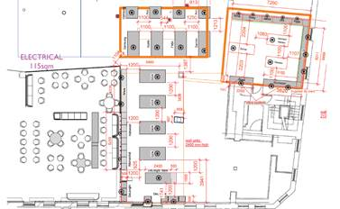
Figure 3: Brown Thomas store layout available at: https://cglretailsolutions.com/portfolio/brown-thomas-dublin/
The retailer’s essential objectives are basically lowering operational costs, maximizing revenue production and customer satisfaction which leads to profits. And to achieve these goals, the retail space needs to offer a welcoming atmosphere, comfortable features and convenient shop conditions. The store needs to be designed in a way that both customers and retailers use the space in an efficient manner, since the layout and design communicate a large amount of information about the retailer.
One of the main visual merchandising tools is called focal point. They display vignettes with a combination of various products, strategically placed at the end of store traffic patterns as destinations to guide customers.
All the elements carry a relevant number of psychological techniques that if combined and well-designed can attract customers, keep them in the store longer and with more interest in the product and the brand, build trust and customer loyalty. Of course, the work of the salesperson is necessary, however, if we take Zara as an example, sales assistants don't sell anything, they help with organization of the store (visual merchandising) and passing information to the customer. Visual merchandising techniques and strategies do most of the work.

2.2.5 Interior
Stephen Anderson explains in Basic Interior design 01: retail design (2010), how the perception and customer’s behaviour can be influenced by the interior elements such as lightning, colour scheme, ambient conditions. For Martin M. Pegler, a well-designed interior display makes all components work together to translate product presentation into meaningful narratives which connect with customers to create engagement shopping experience, appeal to the target marketing and pass a cohesive brand’s identity message.

2.3 The psychology of visual merchandising and consumer emotion- consumer behaviour
Consumer behaviour can be defined as: “ The study of individuals, groups or organizations and the processes they use to select, secure, use and dispose of products, services, experiences, or ideas to satisfy needs and their impact that these processes have on the consumer and society…” (Cant, Van Heerder & Ngambi, 2015) The definition of consumer behaviour presented by Kardes, Cline and Cronley (2018) includes the expressive tendencies which lead to these responses as illustrated in figure 2.
Figure 2 shows consumer behaviour results from 2 elements: activities and responses that influence each other. Therefore, their social psychological emotional behaviours will affect the purchase, utilizing and disposing activity and vice-versa. The figure also discusses the psychological and emotional reactions, how customers think and response which includes mental process, principle, character and judgement about a particular clothing store. The atmosphere created by retailers, through visual merchandising affects how consumers make purchase decisions.
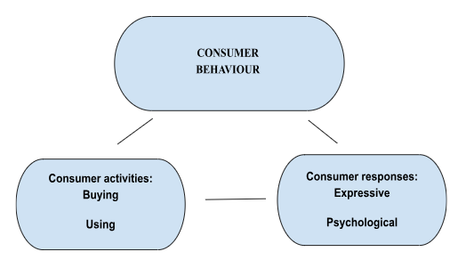
Figure 4: Hefer, Y. and Cant, M.C. (2013) ‘Visual merchandising displays’ effect on consumers: An asset or an unnecessary burden for apparel retailers’, International Business & Economics Research Journal (Online), 12(10), pp. 1217–1225. (no date) http://dx.doi.org/10.19030/iber.v12i10.8132.

Consumer behaviour stands as an essential component for marketing because all marketing goals turn around it. Other studies like Rita & Ramos (2022) explain that consumer behaviour is a complex discipline that includes multiple concepts. To effectively impact the target consumer, management requires understanding consumer psychology along with knowledge of purchase decisions processes, cultural dynamics and behavioural economics principles. The choices that consumers make are substantially influenced by social factors which include family relationships and reference groups, for decision making process peers along trendsetters hold great power. Chandra, B., Goswami, S. and Chouhan, V.S. (2022). Customer behaviour receives shape from these elements which consequently affect market behaviour. Understanding consumer behaviour is essential to create effective marketing strategies. Using tailored strategies, companies can shape their price structure, distribution methods, product offering and promotional efforts to fit the demands of their target customer base.
The consumer environment is rich in ambience elements. Consumers in apparel retail stores exhibit contrasting behaviour towards surrounding stimuli, they either notice or not pay attention to those elements. Every message created by the apparel retailer has a particular goal, they have a specific strategy in mind. Consumers transform messaging through exposure to stimuli such as visual merchandising displays into decisions that suit their experiences, desires and beliefs. (Cant, Brink & Brijbal, 2006)
According to research led by Shona Kerfoot, Barry Davies and Phillipa Ward, respondents described lightning as a positive experience that makes displays appear inviting while creating feelings of private intimacy and uniqueness, making the customer feel special. Perceptions were negative when the respondents found the lighting basic or dull, and in this case, the displays sent a message of “coldness”, “uninviting”. (Kerfoot, S., Davies, B.J. and Ward, P., 2003) Running a store without a proper visual merchandising consideration, presents a real possibility of losing potential buyers.
Mannequins and colours are another tool of Visual Merchandising that has the effect to attract customers, to influence their behaviour. For Haller, K. (2019) it is important when choosing colours to pass the image of authenticity and alignment with the brand personality, because if the colour scheme is inconsistent, it can send a message of confusion or discomfort.
Lea-Greenwood G. (1998) conducted a study which revealed that merchandising colour immediately influenced most participants who had a lot of responses. The search showed colour is an essential display element, receiving positive feedback for its colour coordination/combination across the items, also in many cases the reason to make multiple purchases.
Dash M. and Akshaya (2016) demonstrated that store layout has the biggest impact on impulsive purchases, followed by promotional signs, mannequins and product display, whereas promotional signs and mannequins have more effect on women and men are more affected by the store layout. Even though product displays do not have a substantial impact on impulse purchase, they bring a pleasant environment attracting customers.
For Hefer, Y., and Cant, M, C. (2013) retailers must figure out how customers will interpret their visual merchandising displays, because when creating the layout, they need to take account of what customers expect. These are a few examples of how the environment in the retail store can affect the customer purchase behaviour also attract new customers.
2.4 Visual Merchandising and Brand image
Brand image is an essential factor for business analysis which applies to every sector, independent of the product type. J. Davis, B. and Ward, P. (2005) says “Retailers have been just as engaged in branding challenges as the manufacturers of consumer goods, or those trading business‐to‐business services.”
According to Jared Cullop (2016): “A visual identity is the visual aspect of branding the businesses create in order to evoke certain feelings and experiences with the brand.” Brands communicate to the audience and pass through the message and value via fonts, logos, photos, designs and any other visual tools.
“The store environment, through its layouts, displays, colour and lightning, helps communicate the retailer’s image and influence the customer’s perception of the brand”. Lea-Greenwood, G (2013)
2.4.1 How can Visual Merchandising influence and maintain brand’s image
Visual merchandising is more than aesthetics, it is the way that brands communicate their message, personality, value proposition using visual tools, and if they are properly used, it can help the brand consistency, image, brand recall and consumer loyalty.
The strategic integration of visual brand elements including bespoke fixtures, thematic displays, music playlist and colour palette through spaces, creates a cohesive brand experience at every point of contact. (Kerfoot, Daves & Ward, 2003). A fashion house focused on luxury products, for example, will present their store with luxury materials with soft lightning to establish exclusivity. (Diamond & Diamond, 2014) On the other hand, a contemporary sports brand will use industrial shelving and LED lightning to create energy and innovation.
Levy and Weitz (2012), explain that a consistent atmosphere strengthens emotional engagement that leads customers to automatically recognize the brand characteristics. Using visual elements in repetition contributes to brand equity and develops trust along with customers loyalty because they recognize brand value embodiment through the store entrance. Is crucial to have the same brand identity in all channels, for example, using the same colour scheme to create consistency, in-store and online (Aaker, 1991).
For Belk, Wellendorf and Sherry (1989), bring the idea of sacred and profane in consumer behaviour, where the products and services go beyond utility and gain substantial symbolic and emotional value. Considering the capacity to turn a simple retail environment, visual merchandising becomes impactful in build emotional importance to purchases. Through design, atmosphere and storytelling, visual merchandising can shape how consumers see the brand, how they align values and identity, creating the emotional connections with the consumers.

2.5 Online Visual Merchandising (OVM)
Levy, M. and Weitz, B.A., (2012) discuss the growing importance of integrating visual merchandising into digital platforms to create an appealing environment, clean and easy to navigate. Videos, high-quality products, 360° views and try-outs help stimulate feelings that the consumers can't have online, like touch and feel, which helps decrease doubts about the purchase. Cant, M.C., Brink, A. and Brijball, S., (2006) explains how these tools can influence consumers to make decisions. Lea-Greenwood, G., (2012) says that online visual merchandising significantly helps a creation of a cohesive brand identity, building customer trust. Hefer, Y. and Cant, M.C., (2013) found out that a clear link between well-presented products and boosting sales, since clear sizes, zoom features and detailed product description help shoppers be more confident and assertive, leading to less returns. For Eroglu, S.A., Machleit, K.A. and Davis, L.M. (2003) the layout and graphics of a website has a positive influence on the behavioural outcome of a customer, so as we can conclude the layout affects how customers approach or avoid a web store.
According to Morgan (2016), visual merchandising is about telling a story and guide the customer to a journey, and not just aesthetics. The use of thematic layouts, product grouping and lifestyle to replicate the physical store experience and develop emotional connections. “The principle of storytelling and thematic consistency are vital online as they are in-store; they guide the customer’s journey and foster brand loyalty.”
Martin & Kong (2018) say “Effective visual merchandising taps into the subconscious desires of consumers, using colour, form, and spatial arrangement to evoke emotions and drive actions.” The main psychological factors that make consumers to impulse buy online shopping are, need for instant satisfaction combined with the fear of running out, so applying this principle reduces friction and stimulate buying impulse.
For Katrandjiev & Velinov (2014)” Online visual merchandising is not just about aesthetics; it’s about creating seamless and engaging shopping experience that mirrors the tactile sensations of physical stores”. They also emphasise that visual merchandising must be aesthetically pleasant, functionally optimised by consistence across devices, interactive features and product visibility.
Online visual merchandising techniques, such as clear interface and easy navigation boost online performance. Featured products and product bundles will maintain the brand consistency using uniform colour scheme and image design, increasing sales. While 360° product image, well detailed information about the product, products carousel guide customers through their online shopping journey, enhancing conversion rates.
Also, the modern online visual merchandising approach uses data-driven techniques for personalisation. Browsing data allows marketers to customize content based on user’s behaviour and preferences which they can optimize through A/B testing results. (A/B results come from 2 versions tested against each other)

CHAPTER 3
3. Methodology
3.1 Introduction
For Verhoeven the use of quantitative surveys methodology is suitable when the goal is to confirm some theories and generate data. (Verhoeven, N.2015. Ch. 1, pp.30-32)
According to Bryman, qualitative research methods are for exploring deep insights into how people experience and understand their social situations because this approach provides better analysis of complexities than quantitative measurement does. (Bryman, 2016, pp 384-387).
The research design required literature review, questionnaire and interviews, to gather both qualitative and quantitative findings. The research method needs a detailed investigation “researcher to study a situation in detail, including historical, geographical and socio-cultural contexts in order to understand what is happening or how realities are being experienced” (Saunders, Lewis and Thornhill, 2007).
This research investigates the relationship between visual merchandising and consumer behaviour and brand recognition which makes the study explanatory. This research follows an ad-hoc methodology conducted only one time for a specific situation. This project will conduct desk research while performing field research by analysing both current data and new data collection from the field. Field research techniques will be used to obtain new data as part of the methodology. (Verhoeven, N. 2015. Ch. 4, pp. 117-120)
3.2 Research Methodology
When selecting the research method, the goal was to validate the link between well-designs visual merchandising, consumer behaviour and create branding. This work can be classified as exploratory research, and the method used to conduct this research was mixed, by using quantitative (survey) and qualitative (interview) data. According to Saunders (2017):“this method allows the triangulation, two or more independent data source or collections methods to corroborate research findings with a study.”
3.3 Research Approach
For this paper a deductive approach was used, and it was used because it builds upon established theories about how visual merchandising influences consumer behaviour. The researcher collected quantitative e qualitative data to verify existing academic concepts. Using theoretical models from other studies as the foundation and using main collected data to validate the conclusion. This research approach provided an organized framework to examine how visual merchandising strategies affect consumer buying behaviour and brand image.
3.4 Data Collection Methodology
As said before, two types of research were used to collect data, quantitative and qualitative. The questionnaire questions and interviews were included in the Appendix 1. It was a little bit harder to find professionals to engage in the interviews than people to answer the questionnaire, probably because it was multiple choices and didn’t take too much time to answer, while the interviews took around 30/35 minutes.
3.5 Sampling
Glentles,2016 at Merriam Webster (2015) explains “Sampling is the act, process or technique of selecting part of the population for the purpose of determining parameters or characteristics of the whole population.” Lumpur (2016) characterize sampling as one of the most often used form for a case study, that’s why non-profitability sampling was chosen. I have chosen to conduct a survey (convenience sampling) with people without knowledge of the theme from different countries and a questionnaire with professionals (purposive sampling) of the visual merchandising field.
3.6 Research Process
The research was conducted in different steps. First the literature review that helped to create a theoretical framework and the construction of que questions. The survey helped collect data to verify the existing information about the subject. Same for the interviews, having a point of view from professionals, once again proved the role of visual merchandising and its benefits. And then from all the data collected, literature review, survey and interviews create a triangulation that proves all the approached topics.
3.7 Data Analysis
The interpretation and analysis of the collected data through the survey and interview should focus on research relevant information. The analysis of the data represents an essential research stage which leads to understanding the gathered information. The literature review provided the foundation to interpret the data collected through the interviews and survey. The research’s goal was to investigate, analyse, compare similarities and asymmetry in the data and find themes and patterns that should be related to the research question.

CHAPTER 4
4. Findings
4.1 Introduction
This chapter presents the findings of the current research that considers how visual merchandising affects consumer behaviour. The main purpose was to analyse the role that visual merchandising plays in catching consumer attention, purchase decisions and creating brand recognition. Furthermore, the chapter offers a critical analysis that connects following findings to relevant previously presented literature and emphasizes the influence of visual merchandising on consumer perception.
4.2 Data Analysis
The study conducted quantitative and qualitative analysis, also the interpretation of previous literature.
4.3 Empirical Findings
Empirical findings aim to gather data and compare it against the literature review or hypothesis, but the outcome is based on real life evidence. Therefore, in this study, five important themes were identified under the literature presented in Chapter 2. This study was proposed with the objective to find out the relationship between visual merchandising, consumer behaviour and brand identity. Due to the necessary triangulation, the conclusion and results were compiled with the literature review.
4.3.1 What is the role of Visual Merchandising
Results for question 1:
The literature review shows that visual merchandising combines artistic techniques and scientific approach to boost visual appeal and brand identity. Experts confirm that visual merchandising is more than attractive visual presentation and is essential to create the “correct” environment, because the environment can define consumer experience and consequently change their behaviour and boost sales. Louis Cheskin (1951) pioneer of marketing psychology, established that customer perceptions deeply respond to visual signs such as colours, lighting and layout elements. Displays that portray a lifestyle or narrative can bring feelings of aspiration and identity, motivating consumers to purchase products associated with that story. Both survey and interviews bring the same idea as the literature review, how visual merchandising can impact consumer behaviour.
According to the first interviewer:
1. What is the role of Visual Merchandising in retail and its benefits? | “It's a key element to the overall maximizing sales. It’s important that a store's layout or a website layout is very cohesive to greater customer experience and that product is accessible. How it's merchandised, a lot of people don't know what they want when they go into a store so the idea that products are put together cohesively to tell a story for that person or to it helps them make decisions, it helps them with ideas and then it also helps for add-on sales, for upselling, so products that go together, products that work together, your core lines and then your additional products.”
Table 2
According to the survey, 52.5% of people said that an attractive layout and product display influences them the most to enter in a store. However, 62.5% of people answered that competition prices and promotions influence them the most. First, we need to consider the clientele, the type of product and market target. Also is clear that using visual merchandising wisely is possible to boost sales, displaying products in pairs, for example, to enhance KPI’s when doing a promotion.
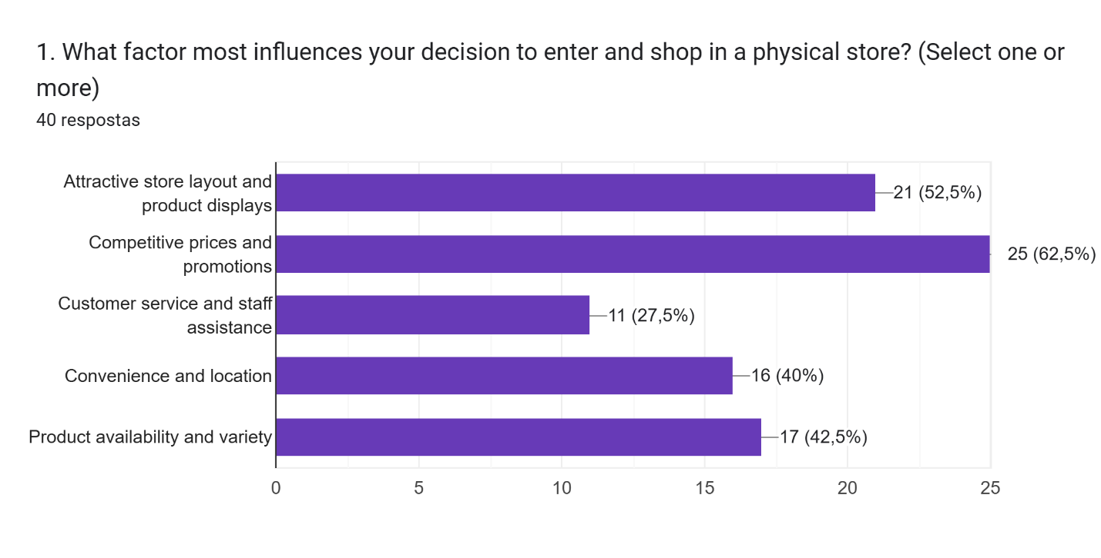
Figure 5

4.3.2 Elements of visual merchandising
Results for question 2: Which are the elements of visual merchandising?
Visual merchandising is a strategic tool to create attractive retail environments, using sensory elements and design principles. Dash and Akshaya (2016) to create appealing displays, using a variety of elements such as colours, fixtures, mannequins, fabrics, furniture, wall decoration, lighting and music, are necessary. Every element was explored on the literature review, and all the elements carry a relevant number of psychological techniques that if combined and well-designed can attract customers, keep them in the store longer and with more interest in the product and the brand, build trust and customer loyalty.
The second interviewer says:
2.The Strategic Benefits of a Well-Executed Visual Merchandising Strategy | “It helps to maintain customers, to keep customers in the business. I think the identity of the brand. Yeah, the identity of the brand, to maintain that, to keep the customers coming back. Because people will come into a store and if it isn't what they expect it to be or what they're used to coming in to see, then they get put off. Then they go somewhere else. I think it's maintaining that and understanding. You should have a complete open to close business strategy within the VM space. Because it's a pathway, it's like breadcrumbs leading someone into your business so all of that needs to scream the brand, I suppose, for want of a better explanation. To me, the key elements are what the brand is, what message you're trying to give to the customer, are the products easily accessible?”
Table 3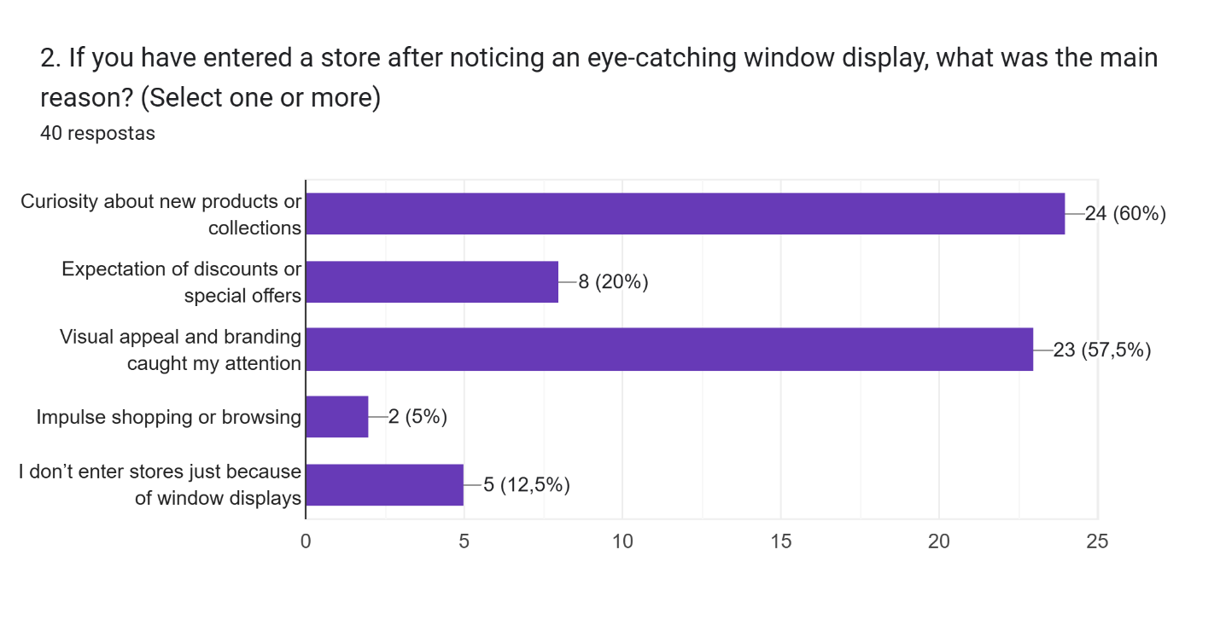
Figure 6
According to question #2, 60% of people feel curious about new products or collection, after an eye-catching window, also, the visual appeal and branding. From that and the professional interviewed, is a solid proof that the window when well-designed is capable to attract people to enter in a store.

4.3.3 The psychology of visual merchandising and consumer emotion, behaviour and purchase decision
Results for question 3: How the psychology of visual merchandising affects consumer emotion, behaviour and purchase decision?
Customer behaviour receives shape from the visual merchandising elements which consequently affect market behaviour. Understanding consumer behaviour is essential to create effective marketing strategies. Using tailored strategies, companies can shape their price structure, distribution methods, product offering and promotional efforts to fit the demands of their target customer base. For Hefer,Y., and Cant, M, C. (2013) retailers must figure out how customers will interpret their visual merchandising displays, because when creating the layout, they need to take account of what customers expect.
Interviewed point of view:
4. The Psychology of Visual Merchandising: Consumer Emotion & Behavioural Influence | When you profile a customer, their behaviours, there's, you know, the psychographics, the demographics of a consumer. It really informs the decision making, because you want to appeal to that customer base. Obviously, you have all kinds of customers, but you still have only one main person. Everyone else is a bonus, but you're appealing to one age group, one particular type of person. And so you use the psychology of that, you know, in sense of their behaviours, how often they shop, what they look for in store, you know, what makes them tick. You use all of that information to inform your planograms and your visual merchandising.
5. Colour Psychology in Visual Merchandising and Retail Displays | I suppose there's a general consensus on the strategy for the business each year. And what do you want to focus on? What areas of the business? I mean, it's not just the VM team. It's the marketing team, it's the buying team, the merchandising team, the visual merchandising team. And it's a consensus of what the brand wants to do for the upcoming year and what campaigns do they want to focus on. So then what trends are the buyers buying into to produce their ranges? What are those colour trends? You know, what's popping for the season? So, all of that, then the decision making then with the VM is supporting all of that.
Table 4
Taking both interviewed point of view and the survey, we can conclude that visual merchandising has an important role on the consumer purchase behaviour and decision. How the psychology is involved in the process, again, would be valuable for the research and findings have more people answering the survey, also more questions to understand why people are neutral or disagree that visual merchandising has a huge impact on their behaviour when doing a purchase.
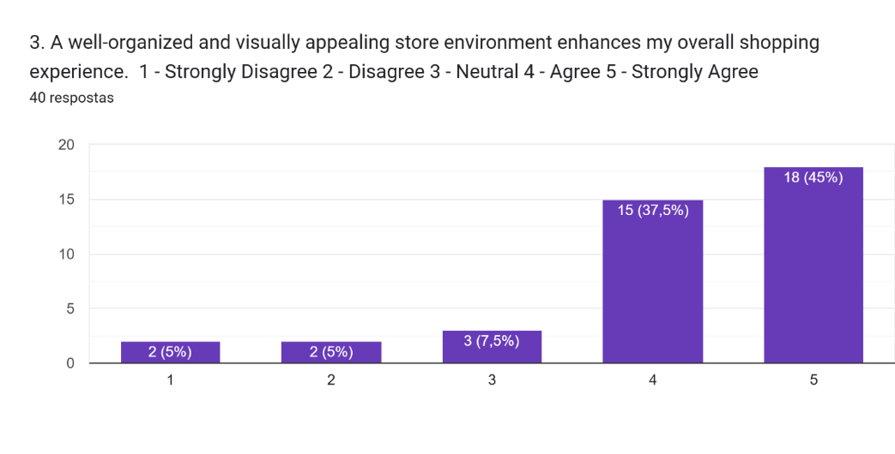
Figure 7
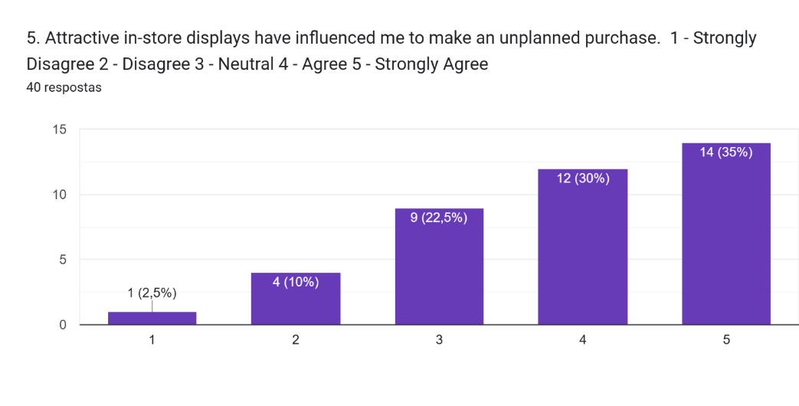
Figure 8
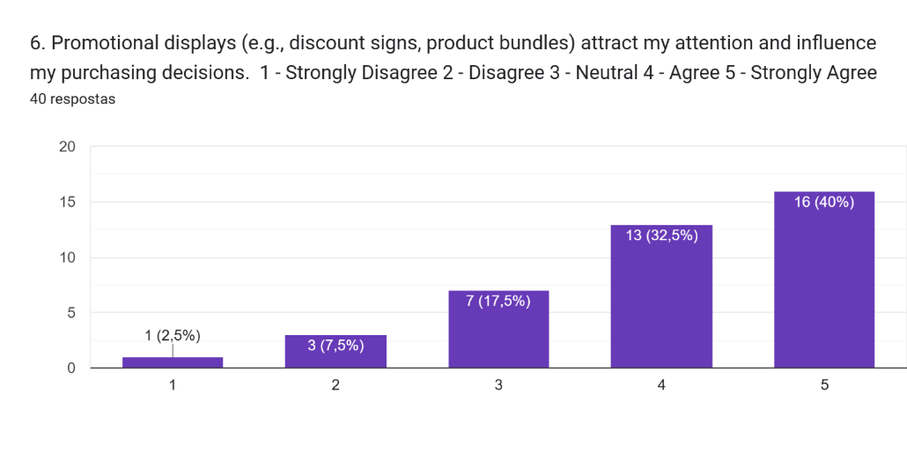
Figure 9
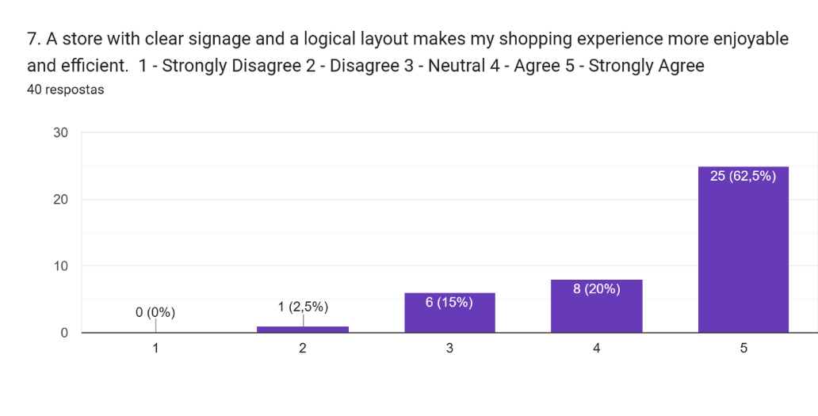
Figure 10
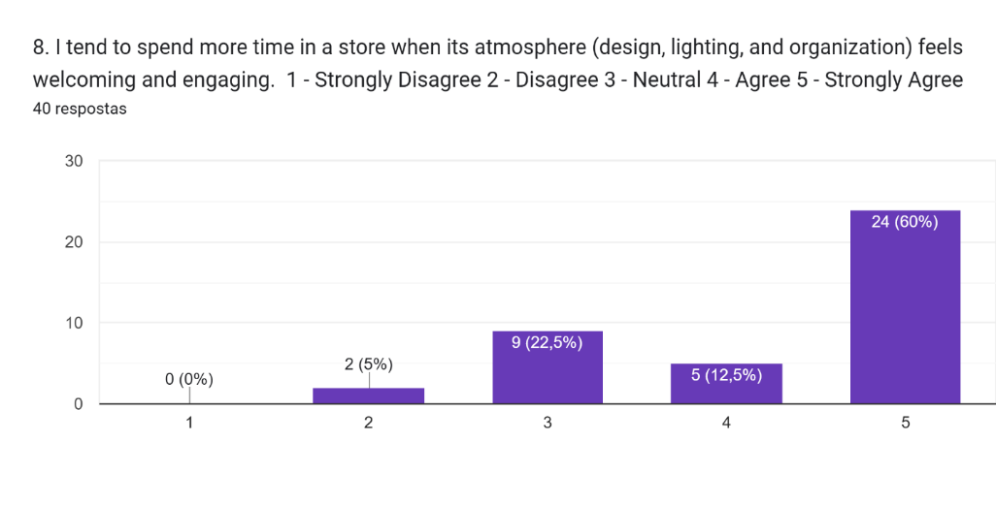
Figure 11

4.3.4 Visual Merchandising and Brand image
Results for question 4: What is the role of Visual Merchandising on brand image?
Brand image is an essential factor for business analysis which applies to every sector, independent of the product type. J. Davis, B. and Ward, P. (2005) says “Retailers have been just as engaged in branding challenges as the manufacturers of consumer goods, or those trading business‐to‐business services.”
For the question #4
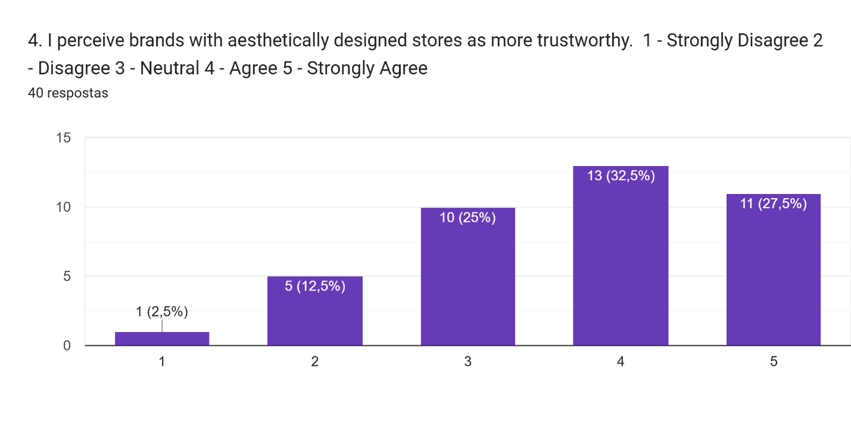 Figure 12
32.5% said that they agree and 27.5% strongly agree with the statement. However, would be important to have more and deeper questions to understand why 25% were neutral on their answers. Showing how visual merchandising can influence brand image and connect to people’s emotions. According to interviewed #1:
Visual Merchandising as a Branding Tool | I just think that visual merchandising is it's very much a part of the process. It ties in very much with buying merchandising. It ties in with marketing, you know, and then the retail teams in the store. I mean, it's a vital part of the customer experience. It has to look right. It has to, it has to pop. It has to appeal. Beyond sales, what are the long-term business benefits of maintaining a strong visual merchandising strategy? It helps to maintain customers, to keep customers in the business. I think the identity of the brand. Yeah, the identity of the brand, to maintain that, to keep the customers coming back. Because people will come into a store and if it isn't what they expect it to be or what they're used to coming in to see, then they get put off.” However, would be important to have more and deeper questions to understand why 25% were neutral on their answers.
Table 5

4.3.5 Online Visual Merchandising (OVM)
Results for question 5: What is Online Visual Merchandising (OVM)?
Analysing both quantitative and qualitative answers, I believe that visual merchandising must be applied on web stores. The consistence, brand image and having an easy online site to navigate complement each other, and visual merchandising is about all this. It is necessary to have as much as information as possible, Videos, high-quality products, 360° views and try-outs help stimulate feelings that the consumers can't have online, like touch and feel, make the customer experience great and make them to come back. Cant, M.C., Brink, A. and Brijball, S., (2006) And we can check that on questions 09, 11 and 12.
However, on question #10 most people were neutral on their answers, I believe this is because people are not aware of what visual appealing elements are. Maybe questions with specifics elements would give me better answers.
E-Commerce and the Evolution of Online Visual Merchandising (OVM) | I think one of the things that's really important is the size of the product on the screen, the accessibility to look at it closer, the availability of information all in one space that you don't have to keep flicking. The scroll down speed shouldn't be to me more than three seconds on a page. You know, I think the negatives in some companies are there's too much. So I think more, you know, less is more in a lot of ways. Also the ease that you can manage, you can go through the exercise and to reach the cart and complete your transition. The returns policies are really important, but as far as VM goes, you know, it's the clarity of the image. It's how the image is presented, how looks are put together. Again, it's the same idea, but putting ideas together, giving people extra help in that, being able to, you know, to see the product, but to see the sizes and the relevant material breakdown information that you don't have to look for that, that it all should be there. I think people are, it's always at speed. So people are looking for convenience and speed. So the, as far as the visuals need to be really strong, but then the information, you know, and to be able to find what you're looking for in the search and not give me everything but give me what I'm looking for.
Table 6
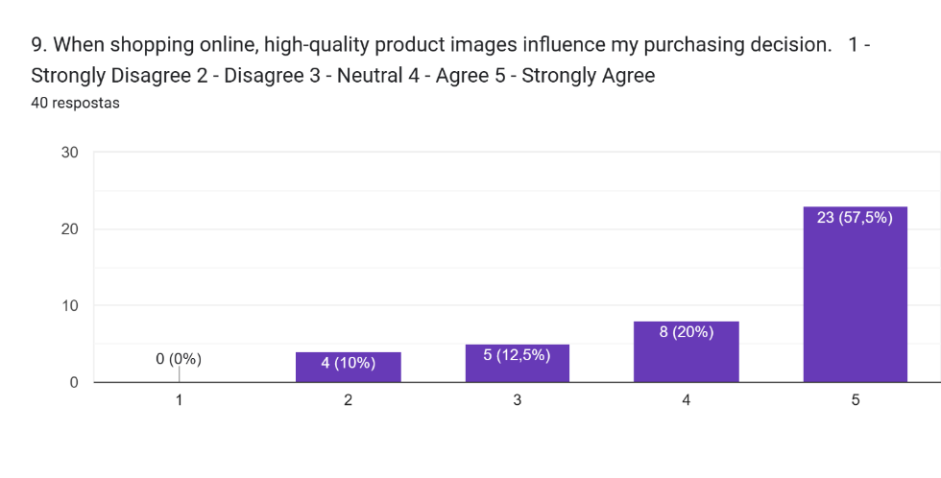
Figure 13
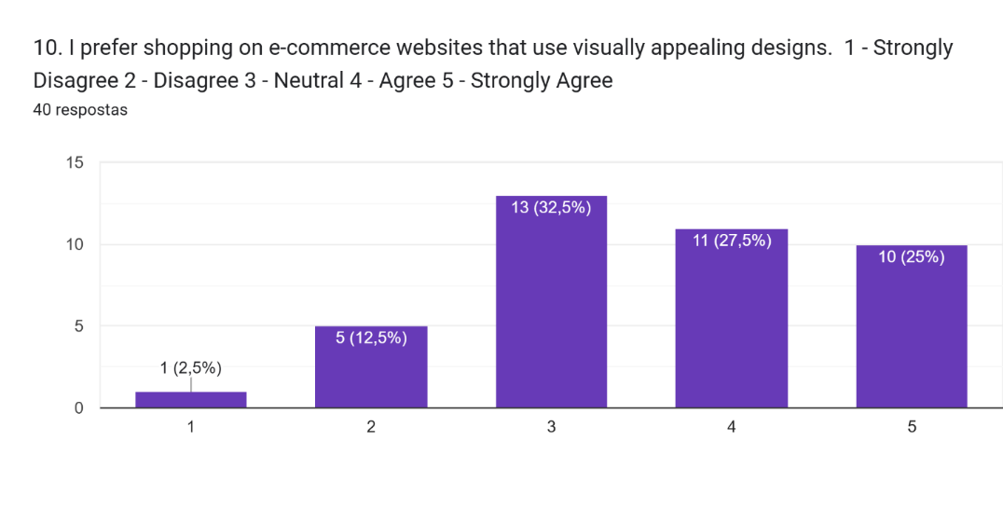
Figure 14
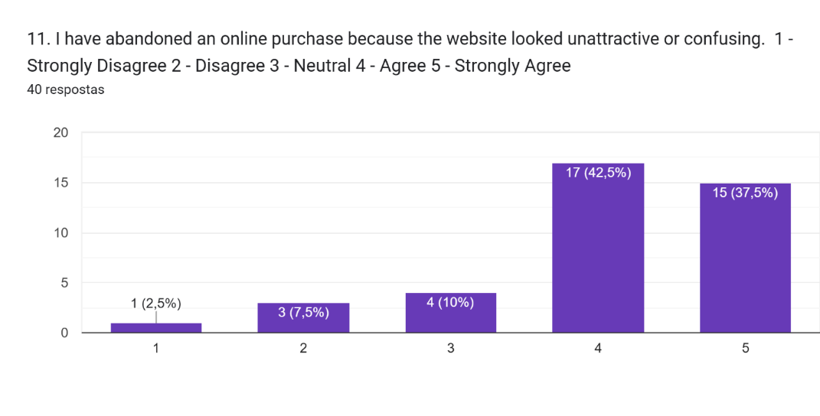
Figure 15
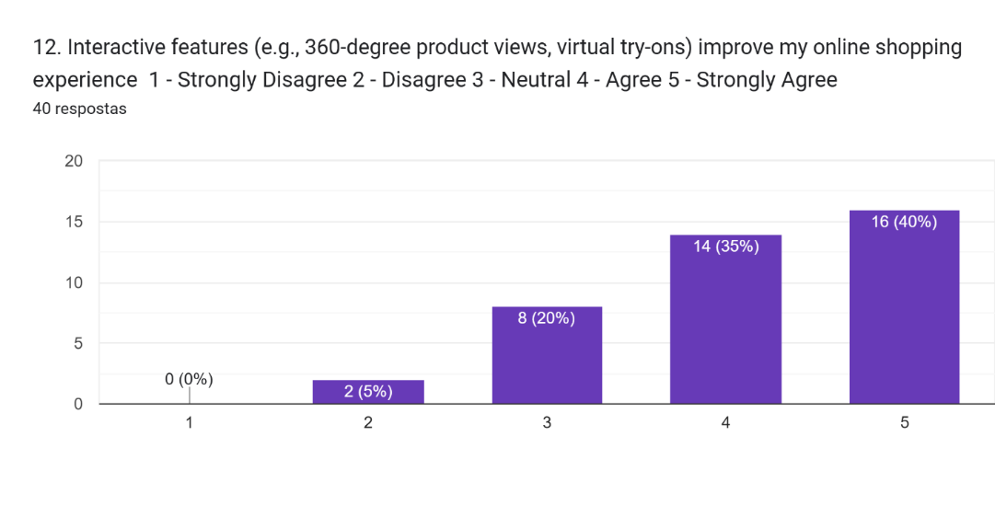
Figure 16
CHAPTER 5
5. Conclusion
5.1 Conclusion
This research investigated how visual merchandising can influence purchase behaviour, and the importance in image brand’s image creation and recognition. Analysis results demonstrate that well-designed stores can help businesses to enhance not only sales but also customer experience. Strategic designed windows can attract customers, a well thought interior layout can keep the customer inside the store, evoke feelings and help them to make purchase decisions by breaking down their psychological resistance. These results partly proved the theory, since visual merchandising is a tool to attract customers, and salespeople have a crucial role to make the purchase happen. The theory presented by Robin Mathew (2008, p. 48) “Visual merchandising is the stage, the oomph and sparkle that surrounds a store and makes the customer stop, look, and buy what has been placed together with care and presented skills.” is supported, because according to the survey carried out to support this project, 52.6% of the responders said that attractive store layout and product displays influences them the most to enter a store. Also, 55.3% of the responders said that visual appeal and branding caught their attention, and that’s why they entered a store.
Michael J. Lopes, explains in his book Retail Store Planning & Design Manual, that strategic store layouts aligned with customer behaviour patterns help to improve shopping efficiency and increase customer satisfaction. The store layout refers to these elements: selling space (aisles for example), merchandising space, customer flow path and personal space. These elements when well-designed will guide shoppers efficiently, because they influence how customers navigate around the store, how long they are going to stay and make purchase decisions. Also, a proper layout design has a direct effect on business operational productivity including stock management and employee’s flow. And this theory was proved by the survey, when 42.1% of the people said that they strongly agree that a well-organized and visually appealing store environment enhances their overall shopping experience. And 63.2% said they strongly agree that a store with a clear and logical layout makes their shopping experience more enjoyable and efficient.
Even though the quantitative and qualitative research aligns with the literature review, the amount of answers is not enough to prove a 100% the impact of visual merchandising on customer behaviour and purchase decisions. Would be necessary at list 100 + people answering the survey, since quantitative research requires larger samples for statistical generalisation. “For most research, a sample size of 100 is often regarded as the minimum number of responses needed to conduct meaningful statistical analysis and to allow generalisation to a larger population.” Hair, J.F., Money, A.H., Samouel, P. and Page (2011) and at list 6 people to validate a thesis. “Data saturation occurred within the first twelve interviews. Basic elements for meta-themes were present as early as six interviews.” Guest, Bunce and Johnson (2006).

6.2 Recommendation

This project is focused on the fashion industry, and not in a specific market. Maybe more specific questions, also a bigger number of people answering the questions, would give more accurate results, even though it was possible to prove theories through the survey. Also, some of the questions were answered as neutral, would be interesting to understand why, making a deeper analysis of people’s behaviour and reaction to visual merchandising.

Based on these findings, it would be interesting for a marketing degree course to have this theme- visual merchandising more explored. Visual merchandising is an important tool that can be very helpful, when properly done. Understand the psychology behind consumer purchase behaviour, how to use this tool to influence their decisions and use visual merchandising strategies to create and maintain strong brand identity. There is a BA (hons) in fashion visual merchandising course in London among others around the world, just proving the importance of visual merchandising and how Independent College should explore this theme more deeply.

6.3 Reflection
I should have written most part of the research or at list organized better my ideas and after that create the questions. Also, I could have put more specific and deeper questions in my survey, so I would have more information to proof the questions of the research. It was much more detailed that I thought would it be, so be prepared is important. Have in mind exactly what I want to explore.

REFERENCES
Aaker, D.A. (1991) Managing Brand Equity: Capitalizing on the Value of a Brand Name. New York: The Free Press.
Bhalla, S., & Anuraag, S. (2010) Visual merchandising. Tata McGraw-Hill Education.
Belk, R., Wallendorf, M. and Sherry, J.F. Jr. (1989) ‘The sacred and the profane in consumer behaviour: theodicy on the odyssey’, Journal of Consumer Research, 16, pp. 1–38.
Bell, J. and Ternus, K. (2006) Silent Selling. 3rd edn. New York: Fairchild Publications.
Bitner, M.J. (1992) ‘Servicescapes: the impact of physical surroundings on customers and employees’, Journal of Marketing, 56(2), pp. 57–71.
Booms, B.H. and Bitner, M.J. (1981) ‘Marketing strategies and organization structures for service firms’, in Donnelly, J.H. and George, W.R. (eds.) Marketing of Services. Chicago: American Marketing Association, pp. 47–51.
Bourton, L. (2018) ‘Wang and Söderström stop time in new Selfridges window display’, It’s Nice That. Available at: https://www.itsnicethat.com/news/wang-and-soderstrom-time-warp-selfridges-set-design-170518 (Accessed: 8 April 2019).
Buchanan, C., Simmons, C.J. and Bickart, B.A. (1999) ‘Brand equity dilution: retailer display and context brand effects’, Journal of Marketing Research, 36(3), pp. 345–355.
Cant, M.C., Brink, A. and Brijball, S. (2006) Consumer Behaviour. Cape Town: Juta.
Chandra, B., Goswami, S. and Chouhan, V.S. (2022) ‘Consumer decision-making style of Gen Z: A generational cohort analysis’, Global Business Review, 23(4), pp. 803–818. doi: 10.1177/0972150919846812. (Accessed on 10 March 2025)
Cheskin, L. (1951) Color for Profit: How to Use Color to Influence Buying Decisions. Chicago: Liveright.
Chevalier, M. and Gutsazt, M. (2012) Luxury Retail Management. Singapore: Wiley & Sons.
Crosno, J.L., Freling, T.H. and Skinner, S.J. (2009) ‘Does brand social power mean market might? Exploring the influence of brand social power on brand evaluations’, Psychology and Marketing, 26(2), pp. 91–121.
Cullop, J. (2016) ‘The difference between visual identity and branding’, JCI Marketing. Available at: https://blog.jcimarketing.com/business-marketing/the-difference-between-visual-identity-and-branding (Accessed: 15 March 2019).
Dash, M. and Akshaya, L. (2016) ‘A study on the impact of visual merchandising on impulse purchase in apparel retail stores’, International Journal of Marketing & Business Communication, 5(2). Available at: https://search-proquest (Accessed: 14 March 2025).
Davies, B. and Ward, P. (2002) Managing Retail Consumption. London: Wiley.
Davies, B.J. and Ward, P. (2005) ‘Exploring the connections between visual merchandising and retail branding: An application of facet theory’, International Journal of Retail & Distribution Management, 33(7), pp. 505–513. Available at: https://www-emeraldinsight-com.ezproxy.puv.fi/doi/full/10.1108/09590550510605578 (Accessed: 10 March 2025).
Diamond, J. and Diamond, E. (2014) Visual Merchandising and Display. 6th edn. New York: Fairchild Books.
Dion, D. and Arnould, E. (2011) ‘Retail luxury strategy: assembling charisma through art and magic’, Journal of Retailing, 87(4), pp. 502–520.
Edwards, S. and Shackley, M. (1992) ‘Measuring the effectiveness of retail window display as an element of the marketing mix’, International Journal of Advertising, 11(3), pp. 193–202.
Erlick, J. (1993) ‘Visual merchandising: seeing is believing’, Home Furnishings Daily, 27 September, pp. 13–14.
Eroglu, S.A., Machleit, K.A. and Davis, L.M. (2003) ‘Empirical testing of a model of online store atmospherics and shopper responses’, Psychology & Marketing, 20(2), pp. 139–150.
Fernandez, C. (2017) ‘Turning physical stores into living advertorials’, Business of Fashion. Available at: https://www.businessoffashion.com/articles/professional/turning-physical-stores-into-living-advertorials (Accessed: 20 March 2025).
Forrester (2023) Online Retail Sales In Europe’s Big 5 Forecast, 2022 To 2027. Available at: https://www.forrester.com (Accessed: 10 April 2025).
Forrester (2023) US Online Retail Forecast, 2023 To 2028. Available at: https://www.forrester.com (Accessed: 10 April 2025).
Gentles, S.J., Charles, C., Ploeg, J. and McKibbon, K.A., 2015. Sampling in qualitative research: Insights from an overview of the methods literature. The qualitative report, 20(11), pp.1772-1789.
Guest, G., Bunce, A. and Johnson, L., 2006. How many interviews are enough? An experiment with data saturation and variability. Field Methods, 18(1), pp.59–82.
Hair, J.F., Money, A.H., Samouel, P. and Page, M., 2011. Essentials of Business Research Methods. 2nd ed. Armonk, NY: M.E. Sharpe.
Haller, K. (2019) The Little Book of Colour: How to Use the Psychology of Colour to Transform Your Life. London: Penguin Life.
Hefer, Y. and Cant, M.C. (2013) ‘Visual merchandising displays' effect on consumers: A valuable asset or an unnecessary burden for apparel retailers’, The International Business & Economics Research Journal (Online), 12(10), pp. 1217–1225. Available at: http://dx.doi.org.ezproxy.puv.fi/10.19030/iber.v12i10.8132 (Accessed: 7 April 2025).
Hughes, D.E. and Ahearne, M. (2010) ‘Energizing the reseller’s sales force: the power of brand identification’, Journal of Marketing, 74, pp. 81–96.
Ind, N. (1992) The Corporate Image. London: Kogan Page.
Katrandjiev, H. and Velinov, I., 2014. Online visual merchandising: Structural elements and optimization for apparel web stores. Saarbrücken: LAP LAMBERT Academic Publishing, pp 58-64.
Kardes, F.R. (2002) Consumer Behavior and Managerial Decision Making. 2nd edn. Upper Saddle River, NJ: Prentice Hall.
Kerfoot, S., Davies, B.J. and Ward, P. (2003) ‘Visual merchandising and the creation of discernible retail brands’, International Journal of Retail & Distribution Management, 31(3), pp. 143–152. Available at: https://doi.org/10.1108/09590550310465521 (Accessed: 5 March 2025).
Kim, J. and Lennon, S.J. (2009) ‘Effects of visual and verbal information on attitudes and purchase intentions in internet shopping’, Psychology & Marketing, 26(2), pp. 146–178. (Accessed: 5 March 2025).
Koehler, E. (2019) Store Fixtures and Visual Merchandising. Available at: https://ekmarketingblog.com/store-fixtures-and-visual-merchandising (Accessed: 19 April 2025).
Kotler, P. (1974) ‘Atmospherics as a marketing tool’, Journal of Retailing, 49(4), pp. 48–64.
Lamba, A.J. (2003) The Art of Retailing. New Delhi: Tata McGraw-Hill.
Lea-Greenwood, G. (1998) ‘Visual merchandising: a neglected area in UK fashion retailing?’, International Journal of Retail & Distribution Management, 26(4), pp. 21–31. Available at: https://www.emeraldinsight.com/doi/abs/10.1108/09590559810231797 (Accessed: 13 March 2025).
Lea-Greenwood, G. (2012) Fashion Marketing Communications. Chichester: Wiley. Available at: http://ebookcentral.proquest.com/lib/vamklibrary-ebooks/detail.action?docID=1040816 (Accessed: 8 April 2024).
Levy, M. and Weitz, B.A. (1996) Essentials of Retailing. Chicago, IL: Irwin.
Levy, M. and Weitz, B.A. (2012) Retailing Management. 9th edn. New York: McGraw-Hill Education.
Liu, Y., Li, H. and Hu, F. (2013) ‘Website attributes in urging online impulse purchase: An empirical investigation on consumer perceptions’, Decision Support Systems, 55(3), pp. 829–837. https://doi.org/10.1016/j.dss.2013.04.001 (Accessed: 19 March 2025)
Madhavaram, S. and Hunt, S.D. (2008) ‘The Service-Dominant Logic and a Hierarchy of Operant Resources: Developing Masterful Operant Resources and Implications for Marketing Strategy’, Journal of the Academy of Marketing Science, 36(1), pp. 67–82. doi: 10.1007/s11747-007-0063-z.
Mathew, R. (2008) Apparel Merchandising. New Delhi: Book Enclave.
McGoldrick, P.J. (1990) Retail Marketing. Maidenhead: McGraw-Hill.
Moore, C.M., Birtwistle, G. and Burt, S. (2004) ‘Channel power, conflict and conflict resolution in international fashion retailing’, European Journal of Marketing, 38(7), pp. 749–769.
Moore, C.M., Doyle, S.A., Doherty, A.M. and Hamilton, M. (2008) ‘Brand context and control: the role of the flagship store in B & B Italia’, International Journal of Retail & Distribution Management, 36(7), pp. 551–563.
Morgan, T., 2016. Visual merchandising: Windows and in-store displays for retail. 3rd ed. London: Laurence King Publishing.
Nobbs, K., Moore, C.M. and Sheridan, M. (2012) ‘The flagship format within the luxury fashion market’, International Journal of Retail & Distribution Management, 40(12), pp. 920–934.
Oakley, M. (1990) Design Management: A Handbook of Issues and Methods. Oxford: Oxford University Press.
Omar, O. (1999) Retail Marketing. London: Pitman Publishing.
Pegler, M.M. and Kong, A., 2018. Visual merchandising and display. 7th ed. New York: Fairchild Books.
Rita, P. and Ramos, R.F. (2022) ‘Global research trends in consumer behaviour and sustainability in e-commerce: A bibliometric analysis of the knowledge structure’, Sustainability, 14(15), p. 9455. Available at: https://www.mdpi.com/2071-1050/14/15/9455 (Accessed: 20 April 2025).
Sherman, L. (2018) ‘Everlane’s five tactics for winning at physical retail’, Business of Fashion. Available at: https://www.businessoffashion.com/articles/professional/everlanes-five-tactics-for-winning-at-physical-retail (Accessed: 28 October 2024) Statista (2024) ‘Retail e-commerce sales worldwide from 2014 to 2028’. Available at: https://www.statista.com/statistics/379046/worldwide-retail-e-commerce-sales/ (Accessed: 10 April 2025).
Suleman, A. (2018) ‘Aren’t physical flagships meant to entertain? Jil Sander has other ideas’, Business of Fashion. Available at: https://www.businessoffashion.com/articles/intelligence/arent-physical-flagships-meant-to-entertain-jil-sander-has-other-ideas (Accessed: 28 October 2024).
Thomas, M. and Mathew, S. (2018) ‘Online merchandising cues influencing the purchase intention of Generation Z mediated by emotions using S-O-R framework’, Indian Journal of Commerce & Management Studies, 9(1), pp. 13–21 (Accessed: 18 March 2025)
Thomas, T., Joseph, J. and Thomas, A., 2018. Online merchandising cues influencing the purchase intention of Generation Z mediated by emotions using S-O-R framework. International Journal of Pure and Applied Mathematics, 118(24), pp.1–12.
Verhoeven, N. (2015) Doing Research: The Hows and Whys of Applied Research. Oxford: Oxford University Press.
Walters, D. and White, D. (1987) Retail Marketing Management. Basingstoke: MacMillan Press.

