

LEARNER NUMBER | 79511838
NAME | SHIRLEY LELIA CAMPOS SOLIZ
COURSE | INTERNATIONAL BUSINNESS
REPORT TITLE | FOOD WASTE ANALYSIS IN DUBLIN’S RETAIL SECTOR : SUSTAINABILITY AND PROFITABILITY PERSPECTIVE
SUPERVISOR NAME | GARETH LEECH
WORD COUNT
DUE DATE | 12/05/2025
DATE SUBMITTED | 11/05/2025

I certify that:
- This project report is all my own work, and no part of this report has been copied from another source: Yes ☒ No ☐
- I understand that this report may be checked by electronic or other means for plagiarism and/or content created by generative AI and may be transferred and stored in a database for the purposes of data-matching/data-analysis to help detect plagiarism and/or content created by generative AI: Yes ☒ No ☐
- This report has not previously been submitted in part or in full for assessment to any other institution: Yes ☒ No ☐
- I consent to the inclusion of my report in the publicly accessible (open access) electronic database maintained by the library:
Yes ☒ No☐
- I have emailed a back-up copy of this report to locker@independentcollege.ie:
Yes ☒ No ☐

(Note that if no check boxes are selected, this Project will be regarded as NOT properly submitted, and may be subject to a late submission penalty)

Name: _SHIRLEY LELIA CAMPOS SOLIZ_____________________________
Date: _11/05/2025____________

For the report to count as a valid submission, the student must provide:
1 electronic copy via Moodle. There is no requirement for a hard copy .

Evidence of the Primary Research MUST be included in the appendix of the report. That includes a copy of questionnaires, interview schedules, or observation diaries. One interview transcript should be included as a full transcript and a summary of all other interviews must be kept as a backup by the student. See template on Moodle for what should be included in all aspects of the report. All data must be anonymised.

The text should be double-spaced throughout and single column format (A4) with 2cm for left and right-hand margins and 2.5cm at head and foot. Text should be justified, standard 12 point, footnotes 10 point, and in Calibri. Page numbers should be at the bottom-right. Do not use line and paragraph spacing. Keep formatting to a minimum and avoid underlining.

Harvard Referencing shall apply.

(Insert work here)

AGRADECIMIENTO

In summary
Food waste in Ireland is estimated at around 750,000 tons per year, despite the country and Europe's goal of halving it by 2030. Much of this waste comes from the retail sector. Using mixed methods to analyze current practices, the Dublin study aims to provide a solution to the question of how to reduce food waste in Dublin retail.
The results present both problems and opportunities, reflecting a significant percentage of shoppers who report seeing sustainability initiatives, and more than half stating that they choose where to shop based on the store's environmental friendliness. Retail managers, on the other hand, state that limited sales and promotions are their primary tactics, but legal and practical challenges hinder wider redistribution of products.
Additionally, a high percentage of customers say they would use digital apps to purchase products close to expiration date at a lower price. This demonstrates how technology can help retailers generate revenue while being environmentally friendly, fostering loyalty and positive attitudes.
TABLE OF CONTENT
CHAPTER 1.INTRODUCTION

5 cap
Biogra
Appendix

LIST OF ACROHNYMS
CAPTER 1. INTRODUCTION
Food waste is one of the silent and urgent challenges that society must currently address, although it may be underestimated. It is reported that globally, more than a third of food produced is lost, damaged, or wasted, contributing to greenhouse gas emissions, large-scale pollution, as well as ethical concerns about hunger, and significant economic waste. In Ireland alone, more than 750,000 tons of food are wasted each year, and the figure is increasing due to consumerism, with the retail sector also playing a significant role. Much attention has previously been paid to food waste at the consumer and agricultural levels, but this sector, which has gained momentum in high-income countries like Ireland, remains a critical factor, increasing the problem.
This research project is grounded in a simple but strong question: What strategies can the retail sector in Dublin implement to reduce food waste while promoting environmental sustainability and maintaining profitability? Supporting this inquiry are five sub-questions:
•What sustainability practices are currently employed in Dublin’s retail sector?
•What inventory technologies are utilized and how effective are they perceived to be?
•What barriers exist to redistributing unsold food?
•How aware are consumers about food waste and how does it affect their behavior?
•What are the economic implications for retailers adopting waste-reduction strategies?
For the research, convenience sampling was considered prudent, and qualitative interviews were conducted with three retail store managers, as well as quantitative surveys with 75 consumers in Dublin. This mixed-methods approach allows for the triangulation of corresponding perspectives with actual consumer perceptions and behaviors. In addition to validating the findings from multiple perspectives, this design ensures that they are based on both theory and practice and allows for a comprehensive triangulation analysis.
Regarding the literature, various theories were found that were consistent with and highlighted in the literature review, such as discounted prices, food donations, and the use of innovative technologies such as current-day forecasting, such as Artificial Intelligence, and RFID sensors to improve inventory management.
However, considering the broad and well-structured theory, practical implementation may have some logistical limitations, which could be limiting, as well as a lack of awareness of different practices related to environmental improvement and care. Regarding regulatory and organizational barriers, these could lead to some difficulties, as could the donation of unsold but edible food, despite the presence of charities such as FoodCloud, among others.
Preliminary findings show that consumers are not only concerned about food waste in Dublin, but can also take steps to reduce it if they are provided with the right tools and incentives by creating a form of alliance, such as discounted prices on products close to expiration date, which is very convenient for some, or applications that send alerts about promotions that have more than one purpose, not just sustainability. However, there can be a discrepancy between what retailers do and how consumers experience them, mainly because sustainability initiatives tend to be poorly publicized and less visible to the general public. Furthermore, some retailers partner with various organizations that benefit from these products, strengthening their image.
In this sense, it is hoped that this research can be useful, providing some viable ways for retailers in the Dublin sector to transform the hidden problem of food waste into a visible opportunity that generates value for the environment, consumers, and retailers. This sector can lead the way toward a more sustainable, friendly, profitable, and socially responsible future by incorporating operational improvements with technological innovation and opportunities for consumer engagement.
CHAPTER 2: THEORETICAL FRAMEWORK
2.1 Introduction to the Food Waste Problem
Food waste presents a grand-scale concern of enormous complexity. As per the Food and Agriculture Organization (FAO, 2011), approximately a third of all food produced for human consumption, about 1.3 billion tons, is wiped off into food loss or wasted every year. It has economic, environmental, and ethical ramifications, all the while confronting the global problem of food insecurity. Food waste accounts for about 8-10% of global greenhouse gas emissions (FAO, 2014), approximately 830 million people remain hungry (Gustavsson et al., 2011). In developed countries such as Ireland, food waste is derived more from surplus than scarcity, guided by overproduction, appearance standards, marketing, and consumer behaviour (Thyberg & Tonjes, 2016).
2.2 Historical and National Context: Food Waste in Ireland
The history of Ireland, especially in food management, has reflected global trends alongside several uniquely national developments. Until about the mid-twentieth century, families depended on locally seasonal produce and traditional preservation methods such as pickling and fermentation, mainly for economic reasons (EPA, 2023). The ecological development and emergence of supermarkets changed consumer patterns. Speed and variety, as well as aesthetics, started to dominate considerations, leading to the sudden rise in food wastage (Quested & Johnson, 2009).
About 1,000,000 tonnes of food waste are estimated to be created per annum in Ireland, while households contribute about 250,000 tonnes, which accounts for almost 30% of the total production (Broderick and Gibson, 2018; EPA, 2022). The retail and distribution sector adds some 90,000 tonnes (12%) to this food waste (EPA, 2023). Ireland produces 16 kilograms bigger amount of food waste per capita compared to the EU average. Therefore, the Irish Government has set food waste reduction targets at 50% by the year 2030 (Government of Ireland, 2019). The ambition to halve food wastage may thus be slightly too much because Ireland embarked on segregating and treating biodegradable waste only in 2008 (EPA, 2006), and a large majority of biodegradable waste, including food, still goes to landfill. To illustrate, more than 206,000 tonnes of biodegradable waste were landfilled in that country in 2017 alone (EPA, 2019). Despite these alarming figures, a considerable lack of research has been conducted on consumer behaviour towards food wastage within the country, particularly at the household level. Besides, very few food waste campaigns have targeted the consumer's view (Secondi et al., 2015).
2.3 Structural Causes of Fresh Food Waste in the Retail Sector
The retail industry is a key player in food wastage, mainly when inventory inefficiencies are in place, demand forecasting is faulty, and perishables such as fruits, vegetables, dairy, and bakery items are involved (Galanakis, 2015). Except when integrated with ICT support like real-time tracking or RFID technology to detect spoilage or stocks nearing expiry, conventional inventory systems such as simply FIFO may sometimes prove insufficient (Gustavsson et al., 2011; Galanakis, 2015). Some retailers use static forecasting models that fail to incorporate essential real-time variables such as the weather or promotions, which results in overstocking and spoilage ((Riley, 2016).
Marketing strategies contribute to great food wastage, besides consumer expectations. More stringent cosmetic standards, referred to as "cosmetic filtering mechanism," force retailers to discard edible but ugly produce, especially fresh produce (Eriksson et al., 2012). Le Borgne, Sirieix, and Costa (2014) argue that such promotions appeal more to perceived value than to a rational mode of consumption, thereby increasing the probability of food disposal in homes.
2.4 Environmental and Social Implications
Food waste results in enormous environmental issues, primarily because methane, a short-lived greenhouse gas, has more than 80 times the global warming potential of carbon dioxide (FAO, 2014; IPCC, 2021). Although Ireland is a somewhat tiny emitter of GHGS on a global scale, it still lags in attaining climate targets under the European Green Deal (European Commission, 2023). Conversely, reducing food waste is one of the immediate means to reduce emissions, bearing in mind the environmental footprint of food production-land degradation, water usage, and energy consumption, all of which are wasted if the food is thrown away (Thyberg and Tonjes, 2016; Poore and Nemecek, 2018).
On the social front, food waste highlights the inequalities that exist. While a good portion of Irish households suffer from food insecurity, large amounts of food are being thrown away at present (Safefood, 2021; EPA, 2023). FoodCloud and BiaFood work to bridge this gap by taking surplus food from retailers to charities to alleviate food waste and social decline (FoodCloud, 2023; BiaFood, 2020). However, the Environmental Protection Agency (2023) indicates that these activities ought to be underpinned by broader prevention strategies, including education, policy reform, and business accountability (WRAP, 2022; European Court of Auditors, 2016).
2.5 Technological Innovations to Minimise Retail Food Waste
Technological innovation thus serves as a tool to mitigate food wastage in the retail trade-i.e., with changes like food being stored, transported, and managed. Perishable items, using real-time temperature and humidity sensors placed in transport and storage systems, are provided with the optimal environmental conditions so that the shelf life can be extended, and spoilage is curtailed (FAO, 2019; Bosona and Gebresenbet, 2013). Keeping further track of the location and conditions of products via RFID (Radio Frequency Identification) technology aids in optimising inventory rotation and detects any cold chain failures (Regattieri et.al., 2007; Galanakis, 2015).
Another prevention for retail food waste comes from integrated data systems. Such platforms pool data arising through environmental reach, sales, and stock, providing the basis for judicious and predictive decision-making (Eriksson et al., 2012; Ghosh et al., 2021). Through the use of predictive analytics coupled with automated replenishment, the mismatch between supply and demand-whether the cause be human error or simply unforeseen circumstances be reduced (FAO, 2019; Otles et al., 2015).
Evolution in AI and machine learning has been increasingly applied to forecasting techniques to improve on-demand prediction. Unlike conventional techniques, the modern ones take into consideration changes in variables like weather, holidays, and even social media trends to affect dynamic stock adjustment (Zhang et al., 2021; Ghosh et al., 2021). This dynamic capability permits retailers to better characterise stock levels vis-à-vis consumer conduct and significantly alleviate overstocking and resultant food wastage (Otles et al., 2015; FAO, 2019).
All in all, the technological approaches-evident from environment monitoring to intelligent forecasting good weapons in battling retail food wastage. Their integration not only fares well in protecting perishables but also aids in setting up a more sustainable and efficient supply chain that minimises resource waste and economic loss (Bosona and Gebresenbet, 2013; Zhang et al., 2021).
2.6 Operational and Strategic Interventions
Operational and strategic interventions (initially definitive interventions (or pre-defined things that will be done to a system for a known outcome))
Operational practices in retail outlets largely set the level of food waste; when viewed through the lenses of economic and logistics paradigms, these interventions can thus serve to significantly reduce food disposal. Among the popular methods is dynamic pricing, which discounts items when they are close to expiry to increase the likelihood of sale (WRAP, 2022). Sell-through rates have significantly improved with the widespread use of such strategies, thereby minimising wastage. Demand for a product is, in theory, elastic; perishable items of decreased price exert a higher demand (Tsiros and Heilman, 2005; Liu et al., 2021). This model finds purchasers in retailers such as Tesco and Sainsbury's, who on several occasions witnessed measurable reductions in food disposal (WRAP, 2022; Ghosh et al., 2021).
Another useful food-waste-reduction technique is assortment optimisation, processing historical sales data, turnover, and spoilage incidents. This approach empowers retailers to stock items that rotate quickly while restricting items prone to expiry with no sales (Quested and Johnson, 2009; Stenmarck et al., 2016). Waste reduction is further supported by the Pareto Principle, which claims for inventory decisions that 20% of products typically contribute to 80% of sales (Garrone et al., 2014; Quested and Johnson, 2009). Targeted inventory control based on sales data aids in forecasting and replenishment cycles to curtail overstocking (Wunderlich and Martinez, 2018; Ghosh et al., 2021).
Food donations work on both environmental and social fronts by creating a channel through which surplus edible food reaches those organisations in need. The most efficient donation systems are supported by reverse logistics frameworks through the structure of goods' flow back from retailers through the supply chain for reuse or redistribution (Galanakis, 2015; Eriksson et al., 2012). Strategic partnerships with food banks or charitable organisations, such as FareShare in the UK or FoodCloud in Ireland, have been successful in significantly reducing waste while promoting community wellbeing (Alexander and Smaje, 2008; WRAP, 2022). The advent of digital platforms and real-time inventory systems enhanced coordination and traceability for food donations (Garrone et al., 2014; Ghosh et al., 2021).
Finally, consumer-facing interventions are crucial for waste reduction from consumer misunderstanding of labels and wrong disposal practices. The confusion reigning around "best before" and "use by" labels often leads to inglorious premature disposal of food that is otherwise edible (WRAP, 2013; Watson and Meah, 2012). Retailers have been experimenting with behavioural nudges to assist consumers in making better decisions: displaying shelf-edge signs, running information campaigns, and developing mobile applications (Kallbekken and Sælen, 2013; Stöckli et al., 2018). These measures not only reduce the level of waste in households but also increase consumer awareness and promote sustainable behaviours (Aschemann-Witzel et al., 2015; WRAP, 2013).
2.7 Food Waste Valorization and Circular Economy Perspectives
Food waste valorisation is of crucial importance as the circular economy aims at doing something useful with the waste. Instead of burying the unavoidable food waste, it is transformed into valuable inputs for other industries: animal feed, compost, biofuels, or high-value compounds used in food, cosmetics, or pharmaceuticals (Galanakis, 2015; Mirabella et al., 2014). On the one hand, this reduces environmental pressure, while on the other, it promotes economic circularity and industrial sustainability (Papargyropoulou et al., 2014; Caldeira et al., 2019).
The process of valorisation occurs through several operations such as sorting, pre-treatment, extraction, purification, and application. This model is considered resource-efficient and innovation-driven by Galanakis (2015). For instance, by-products such as fruit peels or vegetable pulp can be extracted to obtain dietary fibre, natural colourants, antioxidants, or antimicrobial compounds. This type of ingredient is progressively used in clean-label food, biodegradable packaging, and cosmeceutical products (Caldeira et al., 2019; Struck et al., 2016). These new functional uses thus lower the pressure on demand for crude materials and create new revenue streams (Mirabella et al., 2014; WRAP, 2021).
Anaerobic digestion is one of the most widespread processes applied to food waste valorisation, especially concerning organic wastes that are unsuitable for human or animal consumption. This is a biological treatment generating biogas (renewable energy containing mainly methane) and digestate as the final product, which is then applied in organic fertilization (FAO, 2014; European Commission, 2020). Biogas acts as a substitute for fossil fuels in electricity production or transport, helping with the alleviation of greenhouse gases and meeting EU energy objectives (Scarlat et al., 2018; WRAP, 2021).
At the retail stage, circular economy activities would furnish multiple benefits. These incentives would help in cutting down disposal costs as well as the carbon footprint, and in elevating brand reputation and consumer expectations of sustainability (Ghosh et al., 2021; Papargyropoulou et al., 2014). Practical implementation, however, depends on cross-sector collaboration, regulatory support, and investment in logistics, traceability systems, and safety assurance mechanisms (Caldeira et al., 2019; European Commission, 2020).
2.8 Policy Framework and Support System
Several policies have been implemented by the Irish government and EU institutions to curb food waste. Both the Waste Action Plan for a Circular Economy and the Climate Action Plan have identified food waste as an area of focus (EPA, 2023). Ireland has also signed up to the United Nations Sustainable Development Goals, notably Target 12.3 to have per capita food waste at the retail and consumer levels by 2030 (FAO, 2011).
Regulatory instruments, awareness-raising and voluntary commitments, such as the Food Waste Charter, also constitute elements of the national strategy (Piras, et al., 2018). But the implementation has to be done in an effective way, which requires intersectoral collaboration. Universities, private enterprise, government and civil society organisations need to cooperate to coordinate efforts and achieve results (Thyberg and Tonjes, 2016).
Conclusion
Unleashing food waste on the environment is highly detrimental; therefore, curtailment is trending towards a more sustainable model. Throughout the analysis, we have witnessed operating and strategic practices in retail food such as inventory optimisation, dynamic pricing, and food donation being implemented to dread food wastage in one form or another. The application of economic theories and logistics management shows that these practices of better planning and inventory management not only benefit the environment but also benefit the business by creating another stream of revenue.
Technologically, sensor- and AI-based innovations are changing the landscape of product management for retailers, thus ensuring better demand forecasting and minimising losses. But the challenge then becomes one of integrating these technologies with consumer behaviour interventions such as better labelling and mobile apps that could drive positive changes in the purchase and discard habits of consumers.
Another level of politics, both local and international, sets the stage for the global reduction of food waste as well. Inter-sectoral cooperation is crucial if these targets are to be met; hence, governments, businesspeople, and civil society organisations need to join forces in promoting solutions to tackle food waste effectively.
Meanwhile, valorisation of food waste of food through a process of circular economy provides for a reduction of waste and concomitant generation of useful products from food by-products, either in the form of biogas or as raw materials for other industries. These measures, when joined together, will create a sustainable future where the maximisation of resources and near-zero food waste will be true to practice.

CHAPTER III: METHODOLOGY
3.1 Introduction
This chapter describes and discusses in depth the chosen methodology for the work carried out as part of this research into food wastage reduction within the retail sector in Dublin. It explains how the central research questions were addressed, the research methods and tools used, the data types collected, the sampling strategy, and analysis procedures. It also gives reasons for the choice of this approach, demonstrating the way the researcher can use it in exploring the managerial perspective and consumer behaviour in food waste.
The cause of food waste in the retail sector is not only related to sustainable management and supply chain issues, but also to consumer behavior, and therefore a rigorous methodological approach is relevant to ensure comprehensive, reliable, and efficient results.
3.2 Research Approach
This study’s central objective is to determine which sustainable, effective and profitable strategies can be adopted to reduce food waste in Dublin’s retail sector. . The strategy was planned to get a good mix and depth of understanding on how food was being wasted, how this waste was being perceived and how the wastes were being managed at different stages and how this could be changed with strategic interventions or by applying technology.
This analysis employs a mixed-methods design, in which both qualitative and quantitative data are collected in parallel and with equal interest and informative importance, but from different perspectives. This design allows for the exploration of different behaviors, relying on extensive stratified information from multiple perspectives (Creswell and Plano Clark, 2011).
The qualitative approach uses semi-structured interviews with some retail store managers responsible for managing perishable food categories, which are the focus of the analysis. On the other hand, the quantitative approach is more robust as it includes structured surveys administered to consumers who frequent supermarkets in Dublin, who have full participation and opinions regarding their preferences and the current situation of the retail sector.
It can be said that the mixed methods approach was selected for its ability to answer "how" and "why" questions, as well as for quantifying and emphasizing consumer preferences, inclinations, information, and behaviors related to the retail environment as well as sustainability. Taking into account the qualitative method, which facilitates in-depth understanding as well as nuances, on the other hand, quantitative methods provide participation, generalization, and pattern recognition (Bryman, 2012).
With the backing of the academic literature and the common sense of supermarket managers and shoppers, this method has allowed for the triangulation of the data and a grounded view of the problem.
3.3 Research Method
The philosophy employed was pragmatism, which claims that the judgment of beliefs should focus on the outcomes instead of theoretical concepts (Ormerod, 2006). A very flexible worldview encourages mixed-methods and “focuses instead on ‘what works’ as the truth regarding the research questions under investigation (Tashakkori & Teddlie 2003, p. 713). Pragmatism recognises the assumptions of interpretivism and positivism similarly, it identifies the importance of empirical observation, yet, through the researcher's interpretation.
The method of mixed design was utilized to allow for both exploratory and explanatory analyses. The qualitative aspect was in the form of semi-structured interviews with store managers with responsibility for fresh food operations, and the quantitative studies were based on a survey of consumers who regularly retail sector at Dublin supermarkets. This methodological crossover permitted the study to accomplish both the technical and strategic aspects of food waste management and the public’s opinions, attitudes and behaviors. Interviews, conducted interviews to learn about the real-world practice of consumer's awareness, motivations, and purchasing behaviour regarding food waste were quantified in surveys.
3.4 Data Collection Method
Two similar tools were used to collect data:
Semi-structured, qualitative interviews were held with managers of grocery chains. There were 3 managers in charge of fresh food inventory. Interviews were conducted by phone and presentialy according to availability, and were conducted using an open-ended questionnaire focused on sustainability approaches, technologies, logistics of re‐distribution and economic issues.
Structured and semistructured question-based quantitative studies were developed and implemented in online and pressential . This integrates retail managers qualitative opinions with quantitative views of consumers, these data were applied separately and subsequently interpreted together.
3.5 Sampling
This was purposive sampling method was utilized, the qualitative component approached managers involved in directly managing perishable products and sustainable practices. The choice enabled access to expert knowledge in inventory management, waste-reduction technology, and operational hurdles in retail food waste of retailers.
Regarding the quantitative, sampling was carried out through stratified convenience methods. Recruits came from a broad set of demographics (age, gender, and profession) to gather a consumer-relevant representation. Surveys were administered in store and on-line in key retail sites.
3.6 Research Process
The research spanned around 2 weeks. Developed the instruments (interview and consumer survey) by drawing from literature and project aims. Following a chat with de Owner and according everything about of the process and results started with the interviews and surveys, considerations around sensitivity to the topic and sampling limits, were released.
The owner approached managers through professional meeting, and interviews were arranged by telephone and presently. Answers to the interview questions were also in some cases provided in different times or meetings because they were busy enough by managers. The consumer poll was aplied in traditional way and online ways and featured anonymous responses submitted via Google Forms. Data collection stopped when got 75 valid surveys were received and all interviews had been conducted and transcribed. Also looking the partial results in Google forms.
3.7 Data Analysis
“Every researcher that hopes to be good at qualitative analysis should learn to code well and easily“.Anselm Strauss (1987)
3.7.1 Qualitative Analysis
The qualitative data were analysed thematically drawing on Braun and Clarke’s (2006) six-phase model, which consists of the stages: familiarisation with the data, generating initial codes, searching for themes, reviewing themes, defining and naming the themes and then, presenting the findings. Interview recordings were transcribed after which a coding and comparison of responses was carried out in NVivo to serve as an intermediary data storage and analysis tool. A priori codes and new codes were created from the common issues identified in both the interviews and new categories were developed when new themes appeared.
Key topics included markdown pricing, reticence in food donation for fear of regulation and the growing appeal of inventory tech as a waste reducer.
3.7.2 Quantitative Analysis
Excel Microsoft and Google Form, has been used for analysing the consumer data. Frequency, means and standard deviations were used to explore survey questions. Cross-tabulation and Chi-square analyses were used to compare demographic variables and consumer attitudes. The data from the two strands were subsequently brought together and triangulated in relation to those results that were convergent or divergent.
3.8 Limitations of the Study
Although careful efforts were made to avoid limitations. The fact that only three managers were interviewed may indeed not reflect the various retail strategies in all supermarket chains. Furthermore, survey information may be biased, particularly when it comes to questions associated with consumer activity or environmental consciousness.
The study also targeted a particular city (Dublin) and its rural findings may no therefore represent all rural consumers’ behaviour or limitations in smaller towns. Finally, because of time, the effectiveness of strategies over time as established through longitudinal data was not included.
3.9 Conclusion
The methodology to study the food waste in the retail sector of Dublin was described in this chapter. Through a mixed-methods methodology brokered through pragmatism, the study combined qualitative and quantitative methods for a comprehensive perspective of the ways food waste is perceived, tinkered with and reduced.
Triangulation between interviews and consumer surveys provided both in-depth and broad understanding. The following chapter will report on our findings and start to explore how theory and practice meet on the ground in retail.

CHAPTER 4: ANALYSIS OF RESULTS AND TRIANGULATION
This chapter presents an analysis of the results of the customer survey and interviews with three retail sector managers in Dublin. Each objective is analyzed with the results, their relationship to theory, and the managers' opinions.
Quantitative data were complemented with qualitative information to triangulate the findings. Responses from interviews with industry managers directly involved in fresh food processing and from structured surveys conducted with retail sector customers in Dublin were analyzed. Charts were used to ensure a comprehensive and structured presentation of the results, meeting the study's objectives and examining their influence on the perception, management, and treatment of food waste.

4.1 General Data
The following are the general characteristics of the people who participated in the survey, beginning the analytical part of this project. Initially, indicate that the survey was carried out on 75 people of whom 56% were women and 44% men, of which the mandatory age range was between 36-45 years and 26 - 35 years with 34% and 32% respectively, followed by 17% of people between 46-60 years who answered the survey in a friendly manner. Another hand, there was also a similar percentage among customers who shop 2 to 3 times a week (46%) and those who shop weekly (45%).

4.2.Sustainability Strategies in Retail
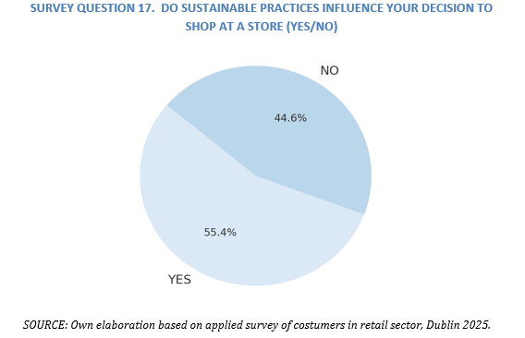
Analyzing the number of responses proportionally in terms of the level of influence they have when making purchases, considering the sustainability practices that the Dublin retail sector has been adopting, shows a slight difference of 10%, given that 55% of respondents indicated they would be inclined to buy more from retailers that are more committed to these practices. While almost 45% would not be influenced by considering these practices when making purchases.
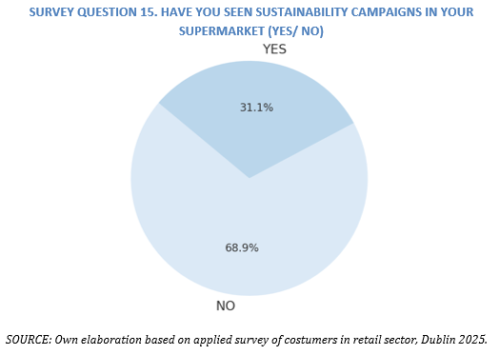
In the graph above you can see a relatively high percentage (68%) of people who indicate that they have not seen any campaigns or other types of dissemination or communication on sustainability issues in the retail sector, which could be considered a weakness in the sector resulting from a lack of visibility of these strategies. In the other hand, we have people who have some kind of knowledge about different campaigns or support for sustainability efforts, resulting in 31%, which could be improved in the future.
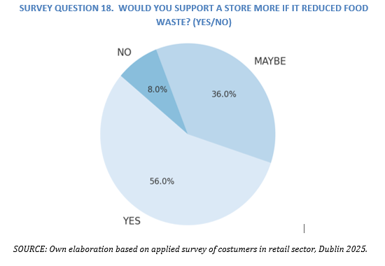
In this case, there is a 20% difference between those who say they would actively support a supermarket in managing waste, considering 56% and an additional third of respondents who said they could do so, but were not entirely sure.(36%)
4.2.1. Triangulation of the Results in Relation to the first Aim
The results show that 55% of people say that sustainability practices influence their shopping choices. In addition. . Also, 61% of people would join a loyalty program if the program supports sustainability. More than half (56%) indicate would support stores that work on food waste reduction This shows that the retail sector have a great opportunity to improve how they communicate these actions to their customers. .And only 31% have seen any real campaignn about sustainability in Retail sector of Dublin.
Now according to EPA (2023) and Thyberg and Tonjes (2016), indicate, poor communication is a common problem in Ireland. WRAP (2022) explain that when stores communicate their efforts correctly, customers feel more loyal and the store improves its public image in the society.
- Manager 1 (Mg1): Customers do not clearly see our sustainability campaigns or sales
- Manager 2 (Mg2): Small visible actions, like reducing packagings, or eco packets make customers feel positive.
- Manager 3 (Mg3): A loyalty program that rewards sustainable choices could bring more loyal customers.

4.3 Inventory Management Technologies
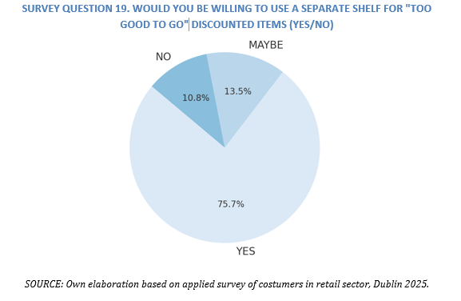
As can be seen, a large majority of respondents (75%) indicated that they would be willing to use systems such as Too Good To Go, which would be useful for visual inventory separation strategies. This is in contrast to customers who are not sure they would use these apps (13%) and those who definitely would not use them (10%), which is a low percentage.
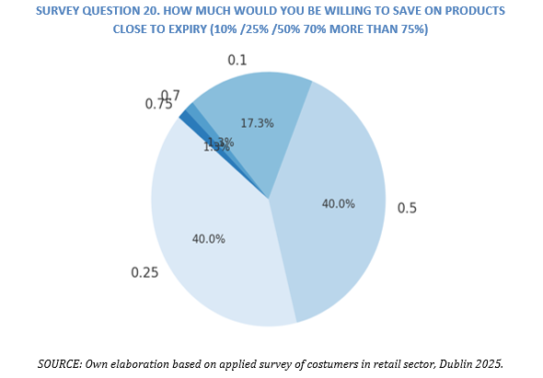
An analysis of the graph above indicates that 40% of respondents want to save more than 50% of their budget on discounted products in that sector, while another 40% expect to save 25% of their budget on food purchases. A lower percentage of 17% plan to save between 10% and 25% of their budget on discounted products in the retail sector, and consider products with a short shelf life.
4.3.1. Triangulation of the Results in Relation to the Second Aim
Most people, (75%) said they would buy food close to the expiration date if there is a special shelf. But they expect to save at least a 25% discount, as 80 %( in total 40% and 40%) of people answered.
More than half (56%) also said they would use a mobile apps to get updates on these discounts. This shows that customers are open to using technology to reduc food waste and save money as well. Retail sector can use smart price tags or mobile apps, and special areas to sell products that are still good but close to their expiry date.
Galanakis (2015) and FAO (2019) explain that technologies like RFID, sensors, and digital tools can help manage products better and reduce food waste. These tools make stock control easier and help stores sell products before they expire.
- MG1: Electronic price tags help us sell products faster when they are close to the expiration date.
- MG2: Many customers have asked us for an app that tells them about discounts on fresh food.
- MG3: Our 'Too Good To Go' shelf is popular. People like finding good deals and saving food.

4.4 Barriers to Food Donation
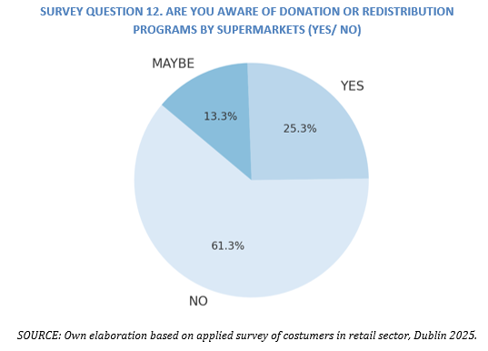
This result reflects the opinions of participants who are not aware of the redistribution programs. The majority of respondents responded "NO" as the most common response, with 61% revealing a lack of communication or different promotions from the retail sector, compared to 25% of respondents who are aware of them.
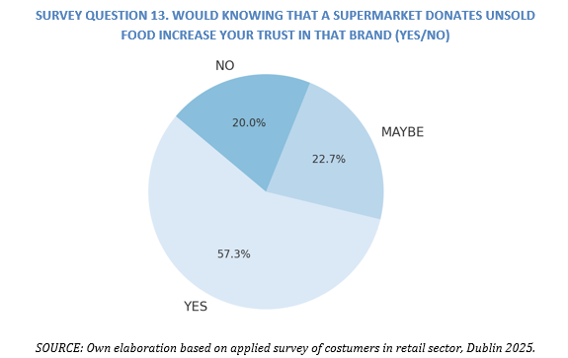
The majority of respondents indicate YES as the most common response, can see that more than half (57%) would increase their confidence if the supermarket they frequent donated food, demonstrating that redistribution can also strengthen the reputation of this sector under analysis. This is in contrast to 22% who are indifferent to the topic of donations, and finally 20% of them indicate they have no positive inclination toward the subject.
4.4.1. Triangulation of the Results in Relation to the Third Aim
More than half (57%) said they trust stores more if they donate extra food. But 61% said they don’t know if their store donates food. This shows that stores are not sharing this information well. Managers also said they have problems with finding food banks or charities to collect the food. They also feel unsure about the rules or laws about food donation.
Galanakis (2015) and WRAP (2022) explain that problems like transport, lack of partners, and unclear the laws stop stores from donating food. Garrone et al. (2014) suggest building better partnerships with food banks to improve donation systems.
- Manager 1: We want to donate more, but there are no food banks that can pick up food every day.
- Manager 2: When we tell customers we donate food, they feel more trust in our store.
- Manager 3: We need better rules and more support to make daily donations possible.

4.5 Consumer Awareness and Behavior
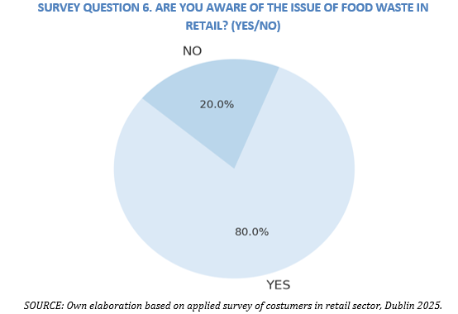
In this case 80% (60 answers) of respondents responded affirmatively as the most common response, compared to 20% who indicated they had no knowledge on this topic. This supports the idea based on the literature, furthermore, interviews with fresh food managers corroborate this trend, as many observed that they have greater involment with some costumers who are in contact with this sector and comment that practices should be improved.
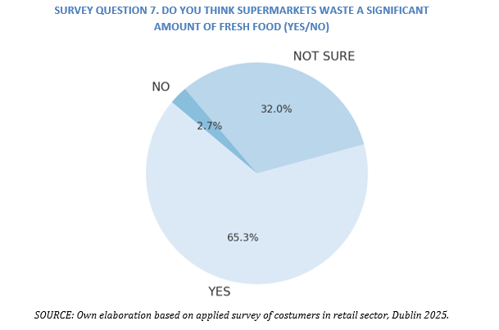
In Dublin's retail sector, 65% of those surveyed said supermarkets waste food, while a third (32%) were unaware, reinforcing the need for greater operational and educational transparency from the retail sector.
4.5.1. Triangulation of the Results in Relation to the Fourth Aim
The majority of people (80%) said they are aware that food waste is a big problem. 65% believe that supermarkets waste a lot of food. 81% said they already separate food waste at home, and 77% think food waste is very bad indicator for the environment in Dublin. This percent shows that costumers are ready to help reduce food waste if stores make it easier for them.
Thyberg and Tonjes (2016) and Safefood (2021) explain that consumers are becoming more aware of food wastes. WRAP (2013) suggests that stores should share information with customers to help them make better choices.
- Manager 1: Many customers ask us what we do with food that is not sold.
- Manager 2: We know most of our customers already separate their food waste at home.
- Manager 3: Being open about our actions makes customers feel closer to our brand.

4.6 Economic Implications of Food Waste Strategies
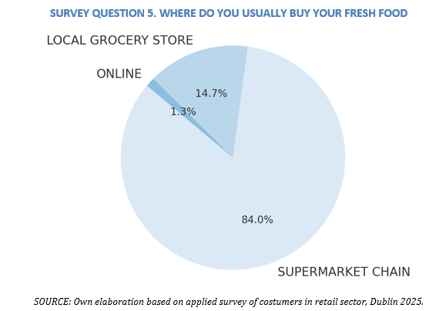
As can be seen in the graph, the dominant channel is clearly the traditional supermarket, with a significant 84% share, which implies that economic and sustainable strategies should focus there to maximize impact. While only 14% of respondents indicated they shop in local stores, and a minimum of 1.3% shop online.
An analysis of the graph above indicates that 40% of respondents want to save more than 50% of their budget on discounted products in that sector, while another 40% expect to save 25% of their budget on food purchases. A lower percentage of 17% plan to save between 10% and 25% of their budget on discounted products in the retail sector, and consider products with a short shelf life.
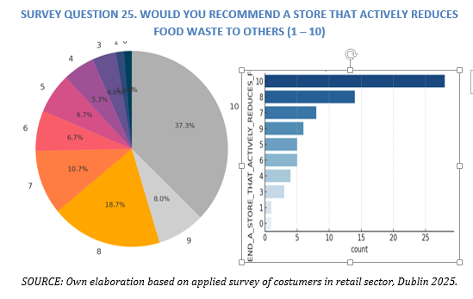
Of the total respondents, 64% stated they would highly recommend supermarkets with the highest sustainable market share, which implies a very significant potential for word-of-mouth marketing and improved brand image. This is in contrast to the 17% who indicated their recommendation would be between 6 and 7 points, somewhat similar to the 18% who indicated a lower score of less than 5 points, which indicates a very low recommendation.
4.6.1. Triangulation of the Results in Relation to the Fourth Aim
Most people (84%) buy fresh food at supermarkets. Most people chose high scores like 8, 9, and 10. this means customers have a very positive view of stores that take action to reduce waste. Very few people gave low scores. But they also want discounts. 80% said they only buy food close to expiry if there is at least a 25% discount. At the same time, 64% of people said they would recommend stores that take action to reduce food waste between 8-10 points. This shows that being sustainable is not only good for the planet but also good for business.
WRAP (2022) and Tsiros and Heilman (2005) explain that strategies like smart pricing and better stock control help reduce waste and improve profits. Customers feel happier and more loyal to stores that show they care about the environment.
- Manager 1: Customers still care about price first, but they like to see that we also care about the planet.
- Manager 2: Our waste reduction campaigns have helped us stand out from other stores.
- Manager 3: More customers tell their friends about us since we started showing our actions more clearly.
This is good news for businesses because it shows that working on food waste can improve their public image and bring more customer recommendations. This study looked at how supermarkets in Dublin can reduce food waste, help the environment, and still keep customers happy.
First, the results show that many people care about food waste. More than half of the people in the survey said that sustainability is important when they choose where to shop. But only 31% have actually seen real campaigns in stores. This shows that stores need to communicate better and show customers what they are really doing.
Secondly , people are open to technology. Most people said they would buy food close to the expiry date if it has a good discount (25% or more). Many people (56%) would also like to use an app to find these offers. Stores can use special shelves, digital prices, and apps to sell these products and reduce waste.
Third, many people trust stores more if they donate extra food. But 61% do not know or dont have any information, if their store does this. Stores need to share this information and work with food banks to improve their donation programs.
Fourth, customers already have good habits at home and clear the importance of the selection waste in general. Most people separate food waste and care about the environment. This is a great chance for retail sector in Dublin to connect with these customers and work together.
Finally, people still care about price, but they also like stores that help the planet. Many would recommend stores that reduce food waste. This shows that sustainability is good for business, not just the environment. Making a balance in general and improving the style of life and quality.
In short, Retail Sector in Dublin have a big opportunity, by using smart strategies and and new technologies , clear communication, socialization as well, and finally they can reduce waste, help the planet, and build customer loyalty at the same time.
CONCLUSION

RECOMMENDATION

REFERENCES
Alexander, C. and Smaje, C. (2008) ‘Surplus retail food redistribution: An analysis of a third sector model’, Resources, Conservation and Recycling, 52(11), pp. 1290–1298. doi:10.1016/j.resconrec.2008.07.009.
BiaFood (2020) Our mission. Available at: https://www.biafoodbank.ie (Accessed: 8 May 2025).
Bosona, T. and Gebresenbet, G. (2013) ‘Food traceability as an integral part of logistics management in food and agricultural supply chain’, Food Control, 33(1), pp. 32–48. doi:10.1016/j.foodcont.2013.02.004.
de Hooge, I. E., van Dulm, E., & van Trijp, H. C. M. (2018). Cosmetic specifications in the food waste issue: Supply chain considerations and practices concerning suboptimal food products. Journal of Cleaner Production, 183, 698–709. https://doi.org/10.1016/j.jclepro.2018.02.132
EPA (2023) Food Waste in Ireland. Environmental Protection Agency. Available at: https://www.epa.ie/our-services/monitoring--assessment/waste/national-waste-statistics/municipal/food-waste/ (Accessed: 8 May 2025).
European Commission (2023) Ireland – climate action progress. Available at: https://climate.ec.europa.eu (Accessed: 8 May 2025).
European Court of Auditors (2016) Combating Food Waste: an opportunity for the EU to improve the resource-efficiency of the food supply chain. Available at: https://www.eca.europa.eu/en/Pages/DocItem.aspx?did=36880 (Accessed: 8 May 2025).
FAO (2014) Food wastage footprint: Full-cost accounting. Food and Agriculture Organization of the United Nations. Available at: Food Wastage Footprint: Fool cost-accounting (Accessed: 8 May 2025).
FAO (2019) The State of Food and Agriculture 2019: Moving forward on food loss and waste reduction. Rome: Food and Agriculture Organization of the United Nations. Available at: https://www.fao.org/publications/sofa/2019/en/
FoodCloud (2023) Impact Report. Available at: FoodCloud: Hungry for a kinder world (Accessed: 8 May 2025).
Galanakis, C.M. (2015). Food Waste Recovery: Processing Technologies and Industrial Techniques. Academic Press.
Galanakis, C.M. (2015) Innovation Strategies in the Food Industry: Tools for Implementation. Amsterdam: Academic Press.
Ghosh, S., Ghosh, R. and Mahanty, B. (2021) ‘An AI-based framework for managing retail food waste’, Computers and Industrial Engineering, 160, 107586. doi:10.1016/j.cie.2021.107586.
Government of Ireland, 2019. Climate Action Plan (September 1, 2019). Retrieved from. https://www.dccae.gov.ie/en-ie/climate-action/publications/Pages/Climate-Action-Plan.aspx.
Gustavsson, J., Cederberg, C., Sonesson, U., van Otterdijk, R., & Meybeck, A. (2011). Global Food Losses and Food Waste – Extent, Causes and Prevention. FAO.
IPCC (2021) Climate Change 2021: The Physical Science Basis. Intergovernmental Panel on Climate Change. Available at: Climate Change 2021: The Physical Science Basis | Climate Change 2021: The Physical Science Basis (Accessed: 8 May 2025).
Le Borgne, G., Sirieix, L., & Costa, S. (2014). Food waste and promotions. Working Papers MoISA 201405, UMR MoISA: Montpellier Interdisciplinary center on Sustainable Agri-food systems. https://ideas.repec.org/p/umr/wpaper/201405.html
Otles, S., Kartal, C. and Ozden, H. (2015) ‘Food waste and sustainable food systems’, in Food Waste Recovery: Processing Technologies and Industrial Techniques. Amsterdam: Academic Press, pp. 3–22.
Poore, J. and Nemecek, T. (2018) ‘Reducing food’s environmental impacts through producers and consumers’, Science, 360(6392), pp. 987–992. doi:10.1126/science.aaq0216.
Regattieri, A., Gamberi, M. and Manzini, R. (2007) ‘Traceability of food products: General framework and experimental evidence’, Journal of Food Engineering, 81(2), pp. 347–356. doi:10.1016/j.jfoodeng.2006.10.032.
Riley, G.L. (2016). Food Waste: Practices, Management and Challenges. Nova Science Publishers.
Safefood (2021) Food Poverty and Policy in Ireland. Available at: Healthy Eating | Safefood (Accessed: 8 May 2025).
Secondi, L., Principato, L., Laureti, T., (2015). Household food waste behaviour in EU-27 countries: a multilevel analysis. Food Pol. 56 (3), 25–40.
Thyberg, K.L. and Tonjes, D.J. (2016) ‘Drivers of food waste and their implications for sustainable policy development’, Resources, Conservation and Recycling, 106, pp. 110–123. doi:10.1016/j.resconrec.2015.11.016.
WRAP (2022) Courtauld Commitment 2030: Progress report. Available at: The Courtauld Commitment 2030: Progress and Insights Report 2022 | WRAP - The Waste and Resources Action Programme (Accessed: 8 May 2025).
Zhang, Y., Daryanto, Y. and Wang, L. (2021) ‘AI-based demand forecasting in perishable food supply chains: a systematic review’, Journal of Cleaner Production, 314, 127957. doi:10.1016/j.jclepro.2021.127957.

